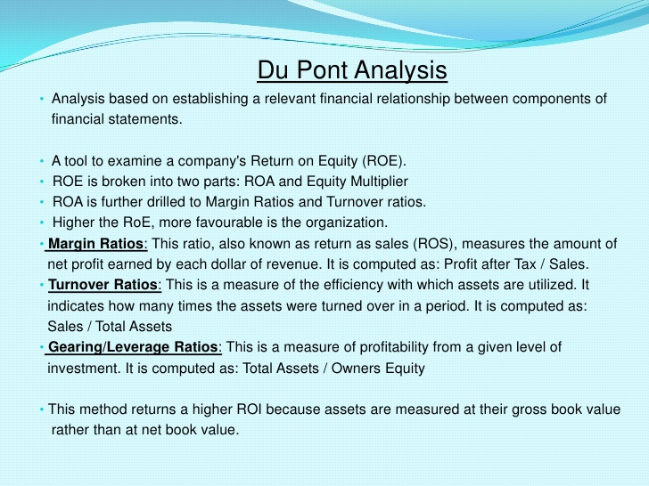

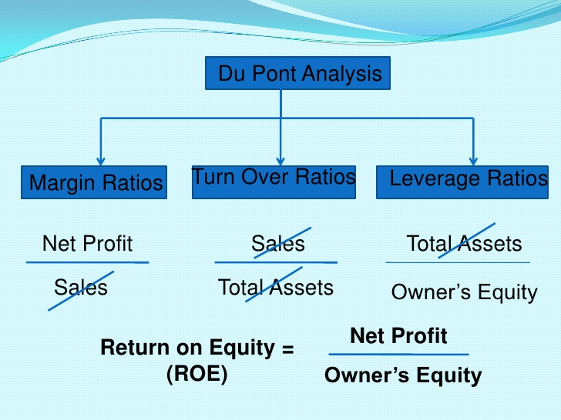

Dhanendra Goyal! (CMA Final)
Sssdgoyal86@gmail.com
7869389671/

