Lessons from PM

CVP ANALYSIS & DECISION MAKING

A6.
In absorption costing, fixed overhead expenditure is attributed to output at budgeted rates. The underrecovery or overrecovery is charged/credited in P&L A/c. However, same is not done for fixed marketing costs. That is treated the same way as in Marginal Costing.

A11.
Increment given in percentage: Simply multiply.
Example:
Q1 Sales 3000
Reduction in the selling price by 10%.
Increase in the quantity sold by 50%.

Q2 sales=
3000*0.9*1.5

A13.
- To find cost of sales, firstly determine no. of units manufactured.
Example:
Stock analysis:
Units
Opening stocks 15,000
Add: Production 2,40,000
Total 2,55,000
Less: Sales 2,25,000
Closing stocks 30,000

From Cost of goods produced, add Cost of Opening stock and reduce cost of Closing stock to arrive at COGS.
Example:
Total production costs 99,60,000
Less: Closing stock
12,45,000
87,15,000
Add: Opening stock 6,15,000
Production cost of goods sold 93,30,000

- Difference between Absorption Costing(AC) and Marginal Costing(MC):

AC | MC
FC and VC are deducted from sales at once, to determine profit. | All kinds of VC are grouped desperately from all FCs. Such grouped VCs are then deducted from sales to determine contribution. FCs are then deducted from contribution, to determine profit.
In addition, FCs are attributed to actual output at budgeted rates. The under recovery or over recovery thereby adjusted to determine profit (charged/credited in P&L A/c). | Since actual FCs are charged without considering any rate, no question of under recovery or over recovery arises.

A14.
Per unit contribution is not the sole factor in determining no. of units to be produced from a no. of products, when there are specific fixed costs attached to any of them. (See the Screenshot)

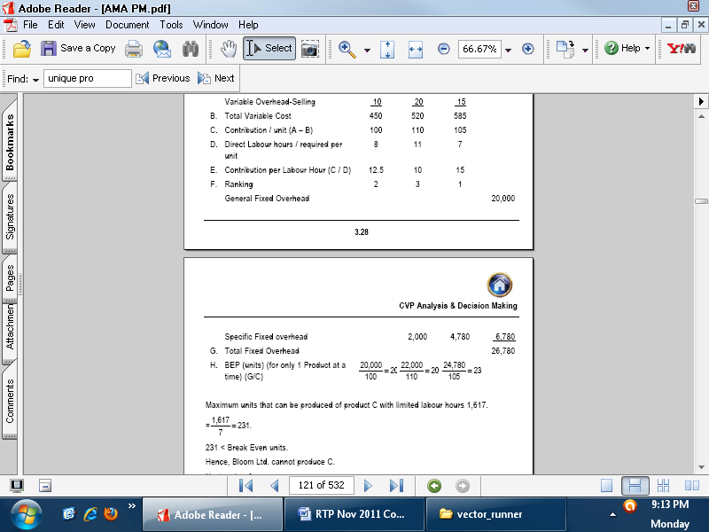

A15.
- Sales commission payable on general sales are to be excluded for computing cost of direct sales (for e.g. orders bagged through tender)
- If budgeted sales are achieved, then all fixed overheads are recovered. Hence,
no fixed overheads will be chargeable to the special/additional order.

A18.
When several fixed costs are to be incurred at various sales volumes(SV), contribution/unit fluctuates accordingly. Until there are no additional FCs arising at a particular SV, contribution/unit remains the same. Thus, contribution has to be computed for all those SVs whose cost structure differs from other SVs. (For a range of SV with consistent cost structure, upper limit of the range should be chosen to compute highest possible profitability, since FC/unit is least at such level).

A20.
Required: To list and comment on cost and non-costs factors which might to relevant to
the discussion.

Opinion of self on non-cost factors such as economies of scale, customer/labour/industry relations, competitions, quality concerns depending on the problem should be included in the answer. Apart from that, points commenting on computation on which decision was based should be given.
A21.
Instead of commenting that “loss is due to FC exceeding contribution and profits could be earned by increasing SV” language used should be “loss is due to SV below break-even level.”

A22.
- Note that the question requires “contribution that covers 21 p.c. rate of return on investment” and not profit. It means Contribution=21%*Investment is required.

- Investment=Plant & Machinery + Working Capital

- Minimum Selling Price (MSP) when good is established is equal to VC+FC and when product is new in market is equal to VC only.

STANDARD COSTING
SC=Std. contribution
A/B/ST=Actual/Budgeted/Std. Time
A/SY=Actual/Std. Yield

- Material yield variance is also known as Material revised usage variance or material sub – usage variance. (SQ-RSQ)*SP or (AY-SY)*Std. Output Price

- Labour efficiency (or time) variance

- Labour yield variance (or Labour revised-efficiency variance)

- Labour revised efficiency variance i.e. LREV = (ST – RST) x SR is also known as
Labour yield variance = (Actual yield–Std. yield from actual input) x Std. labour cost per
unit of output
LYV = (AY – SY) x SLC

- Standard overhead = Actual hours × Std. overhead rate per hour while,
Budgeted overhead = Budgeted hours × Std. overhead rate per hour

- FO/h Volume variance is BT-AT not ST-AT.

- If FO calendar variance is not computed, then FO capacity variance is (AT-BT)*SR.
If FO calendar variance is computed, then FO capacity variance is (AT-RBT)*SR.

A1.
If the numerical hasn’t any variable o/h then possibly there aren’t any.

A2.
Since controllable and uncontrollable variances are to be computed, aggregate costs are found for categories Std. price, Revised Std. Price and Actual Price. Difference between SP and RSP is uncontrollable and RSP and AP controllable.

A3.
Where BoA/c are maintained at standard costing method, Value recorded in Material A/c, Labour Wage A/c etc. are standard figures. Deviations are recorded at respective variance A/c. In material variance A/c dr. side stands for favourable and cr. Side for adverse variance.

A6.
SC=SCpu*Actual SV

Contribution Qty. variance is similar to SM Qty variance.

FYI: Budgeted profit 15000= {(Budgeted SV 10000* Budgeted Contribution p.u. 3=Rs.30000)-Budgeted Fo/h 15000}.

A9.
When a previous year is to be taken as standard, it is the standard ratio relation that is standard. Adjustments are required for increase in production volume in current year, otherwise material and labour variance will show increase due to increased SV as variance only.

LEARNING CURVE THEORY

A2.
For determining price of an additional order, appropriate assumption regarding SV should be that it is aggregate of normal sales and additional order, instead of the additional order only.

A5.
For the order of Rs. 82000, sales commission is payable since there is no indication that prospective customer’s order is obtained out of the normal course such as through tender where no commission is payable.

COST SHEET, PROFITABILITY ANALYSIS AND
COMPARISON

A4.
The differences between costs in 2007 and 2008 are trifurcated for reasons of: Growth in SV, Price differences and Yield; similar to standard costing method. Example:
Direct Material 2007 2008
Price p.u. 100 110
Units used 120000 123000
Output 40000 42000

Where, 123000*42000/40000=126000

PRICING DECISION

Note: Required rate of return always means after tax.

Q2.
On a value basis, the supply, in terms of the FOB price will be 50% thereof.
FOB price agreed $510.

The first line means “the value of supply is 50% of FOB price”. FOB price agreed is based on various considerations such as profits, taxation etc. Such transfer price agreed is independent of pricing of output. For all purposes of pricing decision, value of supply shall not be $510(FOB), but 50% of it.

(vi) The estimated cost of materials and supplies to be obtained in India will be 140% of
the cost of supplies made by Z.

This means that cost of supplies not to C (the importer) but to Z (the exporter).

A14.
When one cost is directly related to another cost, then both should be considered together. In the question: Variable overheads are 25% of direct wages in each dept.
So,when Cost of control device to be used in another job is computed and direct wages are incurred, simultaneously Variable overheads should also be added to cost:
Cost of control device 10,500
Less: Dismantling & removal cost of control mechanism 120
(1 man day × Rs.120)
Less: Variable cost )25% × Rs.120) ___30
Balance cost of control device 10,350

A15.
For purpose of calculating rate of return, Return=TR-TC; TC should include FO/h too.

COST CONCEPTS IN DECISION MAKING

A6.
Since the equipment can also be used on this contract. Its current replacement price is Rs.32 lacs, and after one year its cost will be Rs.25 lacs. Therefore the relevant opportunity cost of machine is: (Rs.32 lacs – Rs.25 lacs). For the contract Rs.7 lacs in cash are required to be spent by the company, if the company actually buys for 32 and sells for 25 lacs.

A8.
Hence the relevant labour cost will be Rs.6 (contribution lost per hour) + Rs.5 (hourly rate of
skilled labour) i.e. Rs.11 per hour.
The TC actually incurred as well as OC need to be included in calculating cost of output since both are to be recovered. But if profit/loss from output is obtained without taking into a/c the OC, then only OC is to be reduced/added, not the TC of resource.

Semi-skilled labour is part of the permanent labour force, but the company has temporary excess supply of this type of labour at the present time.
Although Semi-skilled labour wages are unavoidable (irrelevant cost) whether the the job is undertaken or the labour is left free, corresponding Vo/h can be avoided (relevant ) if the labour is left free and the job is not undertaken.

Fixed costs are not relevant when deciding among alternatives which have same fixed costs, but are relevant for pricing decisions.

A11.
Cost indifference points are found out between 2 alternatives. So if there are 3 alternatives A,B & C, then there are cost indifference points for A&B, B&C, A&C each.

PERT

A2.
Normal cost means TC for completing the work in given normal durastion while Crash cost means TC for completing the work in reduced duration.

BUDGET & BUDGETARY CONTROL

A2. Calculate the Growth, Price-recovery and productivity component that explain the
change in operating income from 2003 to 2004.
This means calculate variances arising due Growth, Price-recovery and productivity component to so that aggregate of them equals the change in operating income from 2003 to 2004.

THE TRANSPORTATION PROBLEM

A4.
The constraint can be a single element constraint too like

TRANSFER PRICING

Q3.
Thus current sales at 80% are 500,000*50%=Rs.250,000 and 500,000*30%=Rs.150,000 to outside market and process house respectively. Thus, initially the given details and any relevant computations should be noted before solving to avoid wrong figures from very start of solution

Q5.
Sub-assembly refers to the bicycle frame i.e. output of Div.A and final product refers to aggregate of Div. A and Div. B to make complete bicycle.

Often, when a standard (long-run avg. market price in this case) is stated and is then the figure given in the question, the figure has no other use except for the purpose specified in the question (determining transfer price in this case).
A5.
The transfer price, for motivating manager of Div. B should not be to the detriment of Div. A also. So, CP of Div. A cannot be an appropriate Transfer price. Division of profits is takes care of both A & B.

Q7. Do read. transfer price = Marginal cost plus opportunity cost

A11.
If a transfer price range can be determined at the very beginning, it should be found at the beginning.

A12.
At various levels of contribution, preferred level of production units changes.

DEVELOPMENTS IN THE BUSINESS
ENVIRONMENT

Q2.
However, savings in material used will cause reduction in inspection and storage costs. Better is to note down cost criteria ahead of solution instead of ignoring cost determination on basis of “no change” statement.
A2.
Note that 5250 and 5125 are units excluding downgraded units, so downgraded units are 12..5/87.5 instead of 12.5/100.

A8.
The reason of choosing only following components for computing “Effect of design change and pricing decision on operating income of ABC” is this statement in question.

A9.
The method of costing to be used as specified in the question should be considered before attempting the solution instead of solving the question in the conventional way. Remedy is to read the question 2 times.

