Forward Rate Agreements
A forward rate agreement (FRA) is a
- bilateral contract
- ﬁxing the rate of interest that will apply to
- a notional principal sum of money
- for an agreed future time period
Buyer: The buyer of the FRA contract is compensated by the seller if the benchmark interest rate turns out to be above the contractual rate.
Seller: The seller of the FRA contract is compensated by the buyer if the benchmark interest rate turns out to be below the contractual rate.
The natural buyers of FRAs are corporate borrowers who wish to hedge against rising interest rates. Money market investors who wish to protect against declining interest rates are natural sellers of FRAs
An FRA is a derivative instrument because its value is derived from spot or cash market interest rates, that is, the interest rates on deposits and loans starting now rather than in the future.
FRAs are over-the-counter (OTC) transactions. FRAs are now dealt by banks in a wide range of currencies and contract periods
To illustrate the applications of the instrument, we will consider the case of a corporate borrower that has an outstanding loan of £100 million. The interest rate on the loan is re-ﬁxed twice a year at six-month sterling LIBOR plus a margin of 50 basis points (0.50%) p.a.
In the case of our corporate, we will assume that the borrowing rate for the next six-month period has just been ﬁxed. However, the ﬁnance director is concerned that interest rates for the subsequent time period might turn out to be appreciably higher; increased borrowing costs would have a detrimental effect on the company’s proﬁts, and potentially on the performance of the share price. To protect against such an eventuality the ﬁnancial director decides to buy an FRA from a dealer. The terms of the contract are set out in Table 3.1.
The company will be compensated in cash by the FRA dealer if six-month sterling LIBOR for the contract period turns out to be above the contractual rate of 5% p.a. If LIBOR is ﬁxed below 5%p.a. the company will have to make a settlement payment to the dealer. The payment will be based on a notional principal of £100 million. Both parties, the company and the dealer, sign the FRA contract, which is a legal and binding commitment. Typically deals are based on outline legal terms drawn up by the British Bankers’ Association

The settlement date in this case is six months after the contract starts. At that point the actual BBA six-month sterling LIBOR rate for the period covered by the FRA will be known to both parties. It will be announced on market information systems such as Reuters or Bloomberg. If we suppose that the LIBOR rate gets set at 6% p.a., the dealer who sold the FRA will have to compensate the company (the buyer) since LIBOR is above the contractual rate of 5% p.a. The payment due at the FRA maturity date is calculated as follows (note that the interest rates are expressed per annum but the FRA covers a six-month time period):
Compensation payment = £100 million × (6% – 5%) × 6/12
= £0.5 million
The company can then use this money to partially offset the interest payment it has to make on its borrowings. It has a £100 million bank loan on which it pays a rate of interest of LIBOR plus 0.5% p.a. If LIBOR for the period is ﬁxed at 6% p.a. then its loan rate for the period wil be set at 6.5% p.a. Including the compensation payment received on the FRA, its payments for the period are as follows:
Interest paid on loan = £100 million × 6.5% × 6/12 = £3.25 million
Less: Compensation received on FRA = £0.5 million
Net cost of borrowing = £2.75 million
Effective borrowing rate = £2.75 million / £100 million
= 2.75% per six months = 5.5% p.a.

Results of the FRA hedge
By entering into the FRA the corporate has in fact locked into an interest rate of 5.5% p.a. for the period of time covered by the agreement.
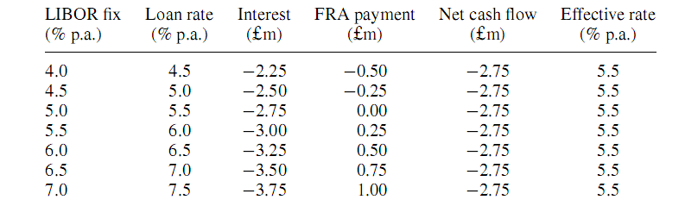
If it buys the FRA the company is locked into a funding rate for the period of 5.5% p.a. It is protected against increases in interest rates for that period. By the same token, however, it cannot beneﬁt from a fall in interest rates
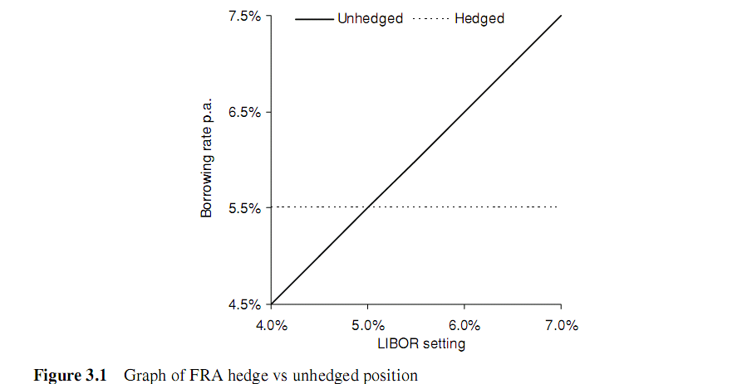

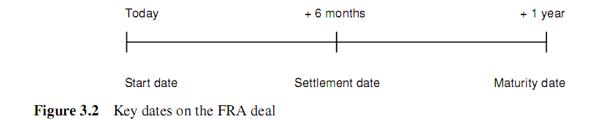

The contract period is a period of time starting in six months and ending 12 months from today
In practice, the settlement amount on a FRA is normally paid up front on the settlement day rather than at maturity, and by convention is discounted back at the LIBOR rate. If the LIBOR rate for the contract period in our example was ﬁxed at 6%p.a., then the compensation amount would be calculated as follows:
Amount at maturity = £100 million × (6% − 5%) × 6/12 = £0.5 million
Amount if paid on settlement day = £0.5 million / 1 + (0.06 × 6/12)= £485 437

FUTURES
A futures contract is an agreement
- made through an organized exchange
- to buy or to sell a ﬁxed amount of a commodity or a ﬁnancial asset
- on a future date (or within a range of dates)
- at an agreed price.
A trader who contacts a broker and buys futures is said to have a long position. One who sells futures has a short position. The value of a trader’s position is adjusted on a daily basis.
To set up a long or a short position a trader has to have a margin account with a broker and must deposit initial margin into the account.
At the end of each day a trader’s margin account is adjusted in line with the closing price of the futures contract – a process called marking-to-market.
If at the end of a trading day the futures price has fallen from yesterday’s close then the accounts of the longs are debited with their losses and the accounts of the shorts are credited with their proﬁts. If the futures price has increased then the situation is the reverse.
There are three main types of end-users of futures, although the same organization or individual may take different roles in different circumstances.

Interest Rate Swaps
A swap is a contract between two parties
- agreeing to exchange payments
- on regular future dates
- for a deﬁned period of time,
- where the two payment legs are calculated on a different basis.
The most common type of interest rate swap (IRS) is a ﬁxed/ﬂoating deal in which the payment made by one party is based on a ﬁxed rate of interest, and the return payment is based on a variable or ﬂoating rate. The ﬂoating rate is reset periodically according to a benchmark such as LIBOR. A variant on this type of structure is the cross-currency swap in which the payments are made in two different currencies, based on ﬂoating or ﬁxed interest rates.

A is a Floating rate Interest payer (LIBOR+ 0.5) on his loan
B is a Fixed rate payer on his loan (say 5%)
Case 1 : Suppose LIBOR turns out to be 3.75%
Case 2: Suppose LIBOR turns out to be 6%
IRS works like this:
A shud enter into an IRS deal and pay a fixed Int rate (contract rate) to B
B inturn shud pay LIBOR to A
Case 1:- If LIBOR turns out to be lower than the fixed rate -- B wud be benefitted
B wud pay A 3.75%
B wud receive 5%
Benefit to B
So B’s Net cost wud be
Cost on Loan = -5
Swap deal Net Gain = -3.75+5 = 1.25
Total Net Cost to A = 3. 75%

A wud pay B 5%
A wud receive 3.75%
No benefit to A
So A’s Net cost wud be
Cost on Loan = -(3.75+0.5) =-4.25
Swap deal Net Cost = -5+3.75 = -1.25
Total Net Cost to A = 5.50%

But in real life situations such benefit of 1.25% is shared by A & B in agreed proportions. If there is a broker arranging a SWAP transaction, he would also get a share in the net benefit of Swap as per agreements b/w the parties. In IRS, one important thing to remember is the Loan Principal amounts of the two parties are assumed to be/ infact same.
How SWAP has benefitted the parties in the above transactions ???
- Let’s consider A’s position
Under the normal loan contract he wud have paid 3.75%+0.5% = 4.25%
But now he is paying 5.5% - 0.625%(share in the Swap profit = 50% of 1.25) =4.875%
- Now Let’s consider B’s position
Under the normal loan contract he wud have paid 5%
But now he is paying 3.75% + 0.625%(share in the Swap profit = 50% of 1.25 shared wid A) =4.375%
So B has saved interest cost of 5-4.375 =0.625% by entering into IRS

Case 2 : If LIBOR turns out to be more than the fixed rate – A wud be benefitted
B wud pay A 6% (LIBOR rate)
B wud receive 5%
No benefit to A
So B’s Net cost wud be
Cost on Loan = -5%
Swap deal Net Cost = -6+5 = -1
Total Net Cost to A = 6%
A wud pay B 5% (fixed rate)
A wud receive 6% (floating rate)
Benefit to A
So A’s Net cost wud be
Cost on Loan = -(6+0.5) =-6.5
Swap deal Net gain = -5+6 = 1
Total Net Cost to A = 5.50%

In the above case , the net gain of 1% arising to A is shared b/w A& B as per the agreement (say 50:50)
So A’s net cost would be 6.5 -6 + 5 + 0.5 (sharing gain in 50:50 ratio) = 6%
Without IRS A would have paid 6.5%
Gain = 0.5%
B’s net cost = 5+6-5-0.5 =5.5%

In real life situations, the IRS contract rate would be different than the fixed rate. So there is greater opportunity to gain for the parties.

CROSS-CURRENCY SWAPS (Notes to be typed _ written in Diary)

OPTIONS
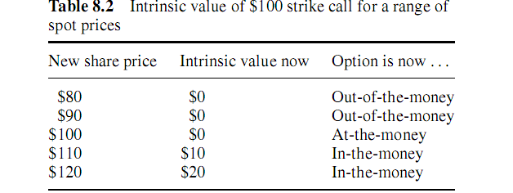
The intrinsic value of an American-style call option can be deﬁned as the
( Spot price - strike,) or 0 , whichever is the greater of the two.

Any money paid for an option in addition to its intrinsic value is called time value
The two components – intrinsic and time value –
together make up the total premium paid for an option

Option premium = Intrinsic value + Time value
Long call expiry payoff
If an option is at- or out-of-the-money at expiry it has zero intrinsic value. The contract will simply not be exercised and will be worthless. On the other hand, if the option is in-the-money it will have positive intrinsic value.

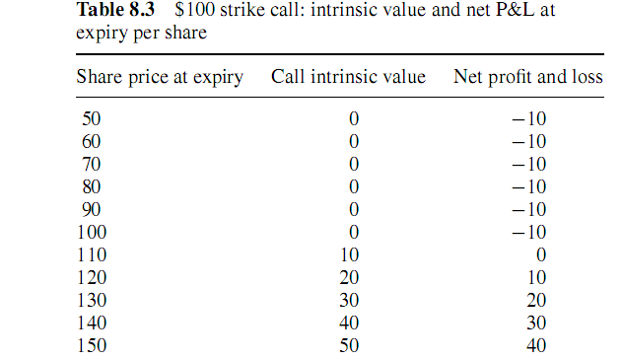
The maximum loss to the buyer of the call is $10 per share. The maximum proﬁt is unlimited since
the share price (in theory) could rise to any level.
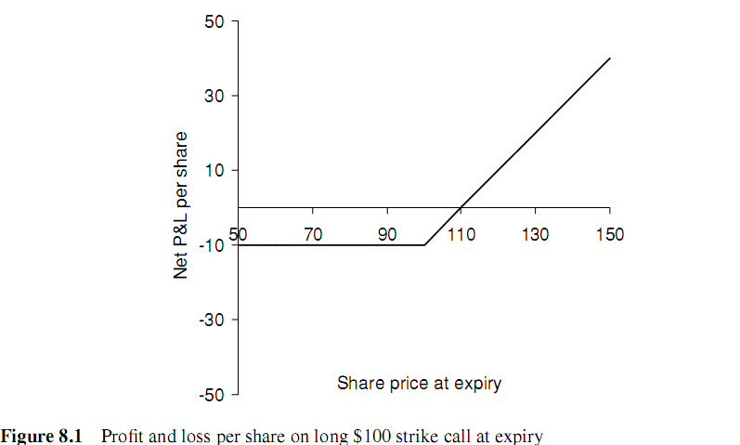

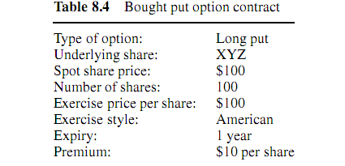
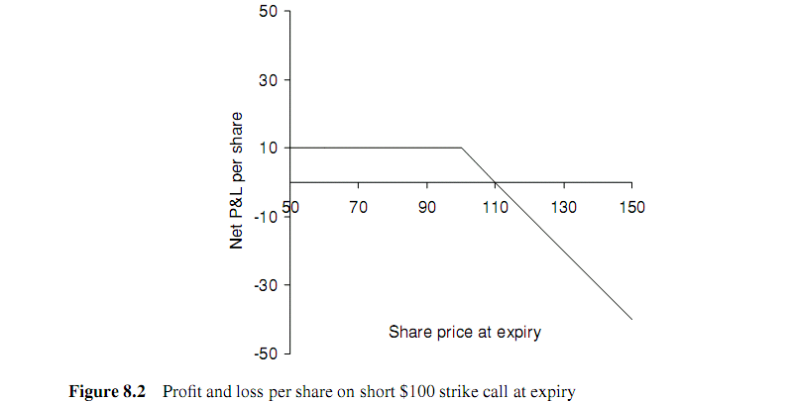

PUT OPTION: INTRINSIC AND TIME VALUE
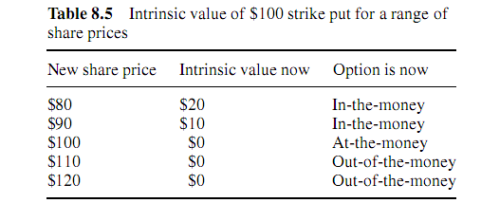
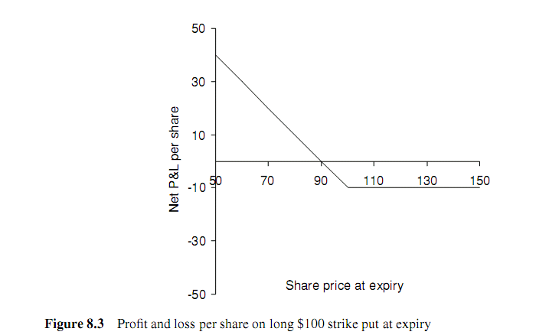
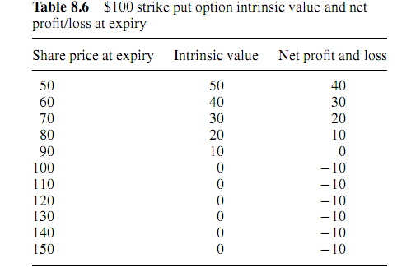

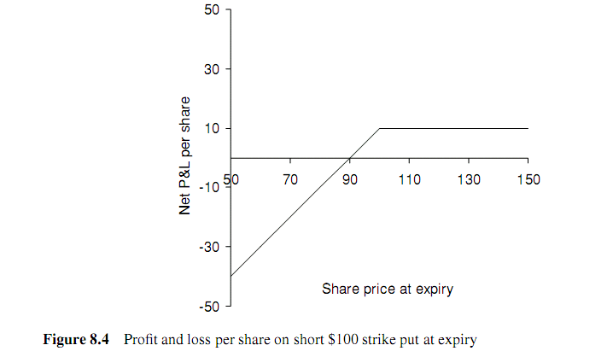

How to Hedge fall in share prices in a long position on shares?? (Means investor has already bought shares)
Strategy 1
Take a short position on Forward Contract on Shares
Eg: Current MPS is 100. Investor is worried that the share price may fall heavily and his long position in shares is affected.
The interest rate is 4% p.a. and the share pays a dividend yield of 2% p.a. The net carry on the stock is therefore 4% − 2% = 2% p.a. or 0.5% for the quarter year. The theoretical forward price of the stock in three months is given by
Three-month forward price = 100 + (100 × 0.5%) = 100.50
- Share price = 90. The investor has lost 10 on the share but has made 100.5 – 90 = 10.5 on the short forward. The net ﬁgure is plus 0.5.
- Share price = 110. The proﬁt on the share is 10 and the loss on the short forward is 100.5 − 110 =−9.5. The net ﬁgure is once again plus 0.5.
Overall, however, the beneﬁt of the hedge is that the investor is insured against falls in the stock price over a three-month period. The downside is that he or she cannot beneﬁt from an increase in the price. The gains would be paid to the counterparty on the forward contract.

Strategy 2
Buy a Put Option i.e. Take a Long Put position
Put Premium = Cost =Rs 3.46 (say)
Strike = 95
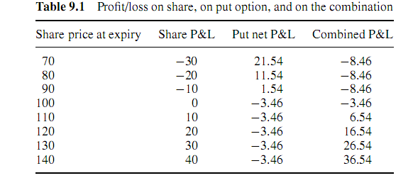

In both the above strategies, the settlement is not by delivery of the share. Only the difference b/w the 1. Contract Price and Spot Price@ expiration (incase of Fwd contract)
2. Strike Price and Spot Price @ expiration (incase of Options)
Net P/L is arrived after deducting Premium of Rs 3.46 on options above
The break-even point on the combined position at the expiry of the option is reached when the share is trading at 103.46.

EQUITY COLLARS
The combination of a bought put option and a sold call with a long position in the underlying
share creates an equity collar.
The options will be settled in cash without a physical delivery process. If, at expiry, the share price is below 95 the dealer will pay the intrinsic value of the put to the investor. If the share price is above 110, the investor will pay the intrinsic value of the call to the dealer.
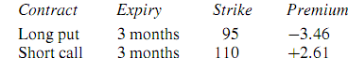
A very important principle for European options, known as Put–call parity. (The rules do not hold for American options.)
Short forward: The combination of a long put and a short call on the same underlying with the same time to expiry both struck at the forward price produces a short forward position.
Long forward: The combination of a long call and a short put on the same underlying with the same time to expiry both struck at the forward price produces a long forward position.

