Advance Tax Law and Practice
Test paper 4

PART A
Q1. (A)
- The MAT Credit can be carried forward for:
Ans: (b) 10 years
- The following shall be reduced from the net profit while calculating book profits under Minimum Alternate Tax:
Ans: (d) all the above
- A company is said to be a resident in India in any previous year, if:
Ans: (C)Either it is an Indian Company or the control and management is wholly situated in India
- __________ is tax planning under the express provisions of Tax laws:
Ans: (b) Permissive Tax Planning
- An Appeal to High Court shall be filed within ________ of the date on which the order appealed against is received:
Ans (d) 120 days

Q1. (b) Residential Status of a Company is determined under income tax act 1961 as follows:
A company may be either Resident or Non-resident of India. It cannot be ordinary or non-ordinary resident and the incidence of Income Tax depends upon the residential status of the company
When is a company said to be resident in India?
A Company is said to be a resident in India in any previous year if:
- it is an Indian company, or
- during the relevant previous year, the control and management of its affairs is situated wholly in India.
When is a company said to be Non-resident in India?
A Company will be a non-Resident in any previous year if:
- it is not an Indian company; and
- the control and management of its affairs is situated wholly or partially outside India.

Q.2. (a) Concept of MAT & MAT Credit

The concept of Minimum Alternate Tax (MAT) was introduced in the direct tax system to make sure that companies having large profits and declaring substantial dividends to shareholders but who were not contributing to the Govt by way of corporate tax, by taking advantage of the various incentives and exemptions provided in the Income-tax Act, pay a fixed percentage of book profit as minimum alternate tax.

Section 115JB, inserted by the Finance Act, 2000 has cast a responsibility on the chartered accountant to certify that the book profit has been computed in accordance with the provisions of the Income-tax Act. He has also to certify the income-tax payable by the company.

MAT Cr edit Sec 115JAA:
Sec 115JAA pr ovides f or calculat ion and car r y f or war d of MAT Cr edit in
r espect of MAT pai d u/s 115JB(1) f or t he assessment year commencing on
1.4.2006 and any s ubsequent assessment year .
The amount of t ax paid under sect ion 115JB is allowed t o be car r ied
f or war d t o t he ext ent of t he MAT paid in excess of t he r egular t ax and
can be set of f agai nst t ax payable upt o t he t ent h assess ment year (w.e.f .
1.4.2010) immediat ely succeeding t he assessment year in which t ax cr edit
becomes allowable under t he pr ovisions of sect ion 115JAA.

Q.2 (b) The areas in Income Tax Act where Tax Planning can be applied

Some of the important Areas where planning can be attempted in an organized manner as under:

At the time of setting up of a new business entity
  - Form of organization and ownership pattern
  - Locational Aspects
  - Nature of business
For the businesss entities already in existence:
  - Tax Planning in respect of corporate restructuring.
  - Tax Planning in respect of financial management
  - Tax Planning in respect ofemployee remuneration
  - Tax Planning in respect ofspecific managerial decisions
  - Tax Planning in respect ofForeign Collaborations and Joint Venture Agreements
  - Tax planning in light of Various Double Taxation Avoidance Agreements.

Q.3 (a) Distinguish between Tax Avoidance and tax Evasion
The difference between tax avoidance and tax evasion:
Tax avoidance is the legitimate minimizing of taxes, using methods approved by the IRS. Businesses avoid taxes by taking all legitimate deductions and by sheltering income from taxes by setting up employee retirement plans and other means, all legal and under the Internal Revenue Code or state tax codes.
Tax evasion, on the other hand, is the illegal practice of not paying taxes, by not reporting income, reporting expenses not legally allowed, or by not paying taxes owed.
Tax evasion is most commonly thought of in relation to income taxes, but tax evasion can be practiced by businesses on state sales taxes and on employment taxes. In fact, tax evasion can be practiced on all the taxes a business owes.

Q.3. (b)
The provisions relating to Revision of assessment order prejudicial to the interest of assessee
Section 264 from Income Tax Law Notes/Book

Part B
Q4. (A)
- As per the CCentral Excise Rules, PLA Stands for
Ans: (D) Personal Ledger Account
- In case of goods removed during the month of March, the excise duty shall be paid by
Ans: (C)31st of the same month
- The assessee shall himself assesss the duty payable on any excisable goods except
Ans: (b) Cigaratte
- A situation where excise duty is not payable onn goods lost/destroyed and found deficient in quantity on account of natural causes, unavoidable accidents etc is called:
Ans: (b) Remission of Excise Duty
- Excise duty shall be leviable if:
Ans: (d) All theabove
- Manufacturers, whose aggregate value of clearances in the preceeding financial year had not exceeding rupees ___________ are entitled to Concession of a small scale industries:
Ans:
- __________ means the transaction value at which the greatest aggregate quantity of goods is sold
Ans
- The superintendent of Central Excise has the power to grant remission of duty upto rupees
Ans (d) 10,000
- The duty paid on exports shall be refunded if the goods are reimported within ______ from the date of exportation
Ans
- Loading, unloading and handling charges associated with the delievery of imported goods at the place of importation shall be charged at the rate
Ans.
Q4. (B) The conditions to be satisfied to accept the transaction value under the central Excise Act,1944

Valuation under section 4 of the Central Excise Act, 1944 based on transaction value.
For applicability of transaction value in a given case, for assessment purposes, the following requirements should be satisfied:
1. The goods are sold by an assessee for delivery at the time and place of removal.
2. The assessee and the buyer of the goods is not related
3. The price is the sole consideration for the sale. If any one of the above requirements is not satisfied, then the transaction value shall not be the assessable value and value in such case has to be arrived at under the valuation rules.
If any of these three conditions are not fulfilled, Transaction Value is not accepted and valuation rules apply in such cases

Hence transaction value cannot be applied in the following cases:
1.When there is no sale
2.There is sale but it is made to a related person or sale and delivery are not from the place of removal
3.Consideration is such sale is not sole consideration.

Q4.(C) The provisions of ‘Remission of Duty’ in relation to rule 21 of Central Excise Rules,2002
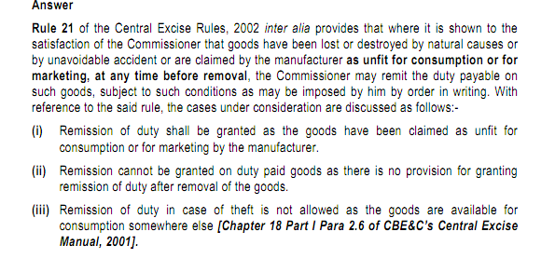

Q5. (A) (i)
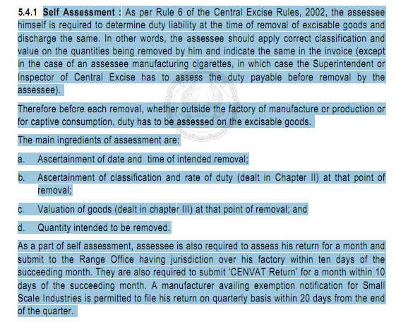
Q.5 (a) (ii) Compounded Levy scheme
Compounding of levies means the assessee being authorized to py a pre determined sum to the dept, at a fixed periodic intervals, instead of paying duty on a consignment-to-consignment basis. The amount of duty to be paid is predetermined by the dept on the basis of various parameters pertaining to production.
The advantage of compounding is the the assessee is freed from the procedural formalities being fulfilled by him for each consignment. The advantage to the dept is that it reduces the need to control various factors pertaining to production and removal. The option has been made available in case of manufacturers in unorganized sectors where accounting records are not adequate and there is no purpose for consumption and collection of duty payable on goods manufactured.
However, the system has been very selectively resorted to and apply only to a few items. Currently the scheme is applicable only to stainless steel patties/pattas and aluminium circles. The compounded levy scheme has recently extended to pan masala and gutka.

Q.5. (B) Procedure for filing of Appeal before Central Excise and service tax appellate tribunal
1. Any person aggrieved by any of the following orders may appeal to the Appellate Tribunal against such order —
(a) a decision or order passed by the [Commissioner of Central Excise as an adjudicating authority;
(b) an order passed by the [Commissioner (Appeals) under section 35A;
(c) an order passed by the Central Board of Excise and Customs constituted under the Central Boards of Revenue Act, 1963 (54 of 1963) (hereafter in this Chapter referred to as the Board) or the Appellate [Commissioner of Central Excise under section 35, as it stood immediately before the appointed day;
(d) an order passed by the Board or the [Commissioner of Central Excise , either before or after the appointed day, under section 35A, as it stood immediately before that day :
2. Every appeal under this section shall be filed within three months from the date on which the order sought to be appealed against is communicated to the Commissioner of Central Excise , or, as the case may be, the other party preferring the appeal.
3. On receipt of notice that an appeal has been preferred under this section, the party against whom the appeal has been preferred may, notwithstanding that he may not have appealed against such order or any part thereof, file, within forty-five days of the receipt of the notice, a memorandum of cross-objections verified in the prescribed manner against any part of the order appealed against
4. An appeal to the Appellate Tribunal shall be in the prescribed form and shall be verified in the prescribed manner and shall, irrespective of the date of demand of duty and interest or of levy of penalty in relation to which the appeal is made, be accompanied by a fee of, —
(a) where the amount of duty and interest demanded and penalty levied by any Central Excise Officer in the case to which the appeal relates is five lakh rupees or less, one thousand rupees;

(b) where the amount of duty and interest demanded and penalty levied by any Central Excise Officer in the case to which the appeal relates is more than five lakh rupees but not exceeding fifty lakh rupees, five thousand rupees;

(c) where the amount of duty and interest demanded and penalty levied by any Central Excise Officer in the case to which the appeal relates is more than fifty lakh rupees, ten thousand rupees
5.Both the parties in dispute will be heard together by a bench
6. The dept will be represented normally by departmental officers functioning as departmental representatives. The assessee can appear in person or through some representatives.

Q.6.(A)
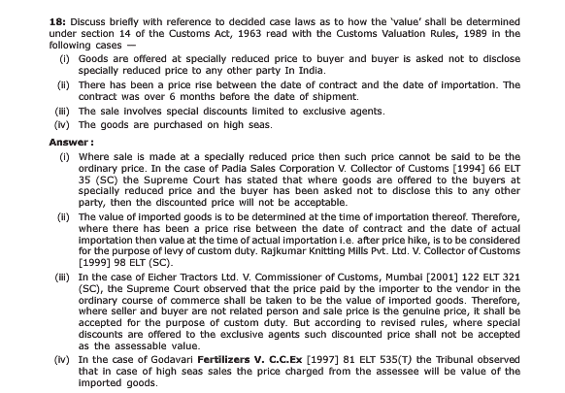

Q.6. (B) Transaction value of identical goods. — (
1)(a)Subject to the provisions of rule 3, the value of imported goods shall be the transaction value of identical goods sold for export to India and imported at or about the same time as the goods being valued;
(b) In applying this rule, the transaction value of identical goods in a sale at the same commercial level and in substantially the same quantity as the goods being valued shall be used to determine the value of imported goods.
(c) Where no sale referred to in clause (b) of sub-rule (1), is found, the transaction value of identical goods sold at a different commercial level or in different quantities or both, adjusted to take account of the difference attributable to commercial level or to the quantity or both, shall be used, provided that such adjustments shall be made on the basis of demonstrated evidence which clearly establishes the reasonableness and accuracy of the adjustments, whether such adjustment leads to an increase or decrease in the value.
(2) Where the costs and charges referred to in sub-rule (2) of rule 10 of these rules are included in the transaction value of identical goods, an adjustment shall be made, if there are significant differences in such costs and charges between the goods being valued and the identical goods in question arising from differences in distances and means of transport.
(3) In applying this rule, if more than one transaction value of identical goods is found, the lowest such value shall be used to determine the value of imported goods.

Q.6. (C) Duty on pilfered goods. –
If any imported goods are pilfered after the unloading thereof and before the proper officer has made an order for clearance for home consumption or deposit in a warehouse, the importer shall not be liable to pay the duty leviable on such goods except where such goods are restored to the importer after pilferage.
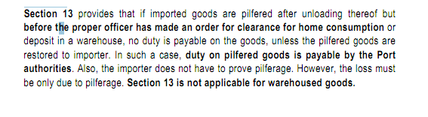

Part C
Q.7 (A)
(i) The application filled for advance ruling may be withdrawn within 30days from the date of application.
(ii) Uncontrolled transaction means a transaction between enterprises other then associated entp.
(iii) OECD stands for Organisation for economic cooperation and development
(iv) CFC stands for Controlled Foreign Corporations
(v) Financial Institutional Investors can invest in govt securities as well as private securities subject to guidelines prescribed by the RBI and Govt approval

Q.7(b) Transfer Pricing
Transfer pricing deals with the technique where parent companies sell goods and services to subsidiary entities at an inflated price to deliberately reduce profits and tax liability. The law requires that goods and services should be sold to subsidiary companies at arm's length price -- the price at which goods are traded between unconnected companies.

Ussualy there is a tendancy among MNCs to adjust their international transactions in such a way that maximum profit arises in that country where the rate of tax is lowest and minimum profit arises in that country where the rate of tax is highest. This creates the problem of transfer pricing. Thus there may be chances that MNC escape tax in those countries where the tax rate is more by adjusting their international transaction and declaring lesser profits in such country. This can be explained with an example:

Suppose a subsidiary company, resident in country A (which has a tax rate of, say, 30%) manufactures goods and transfers them to its parent company in country B (which has a tax rate of 20%) for trading. In order to increase the overall profits of the group company, it will seek to supply the goods at prices which are lower than the market price. So, in effect, the subsidiary company in country A will have lower profits and hence, a lower tax incidence whereas the parent company in country B is affected in the opposite manner higher profits due to low costs, but lower taxes because of the tax rate.

the Finance Act, 2001 introduced law of transfer pricing in India through sections 92A to 92F of the Indian Income tax Act, 1961 which guides computation of the transfer price and suggests detailed documentation procedures
In order to cover such tendencies of MNCs section 92A to 92F have been enacted and section 271AA, 271BA and 271G have been incorporated and section 271 has been amended providing for penal provisions in this regard.

Q7. (c) Under section 245R, certain restrictions have been imposed on the admissibility of an application, if the question concerned is pending before other authorities. According to it, the authority shall not allow an application where the question raised by the non-resident applicant (or a resident applicant having transaction with a non-resident) is already pending before any income-tax authority or appellate Tribunal or any court of law. Further, the authority shall not allow the application where the question raised in it:—
i. involves determination of fair market value of any property; or
ii. it relates to a transaction or issue which is designed prima facie for the avoidance of income-tax.
Q.7. (d) Permenant Establishment in Context of Double Taxation Avoidance Agreement
PE has not been defined in the IT Act. For the purpose of DTAA The term permanent establishment includes especially:
(a) a place of management;
(b) a branch;
(c) an office;
(d) a factory;
(e) a workshop;
(f) a mine, an oil or gas well, a quarry or any other place of extraction of natural resources, including an installation or structure used for the exploration or exploitation of natural resources; and
(g) a warehouse, in relation to a person providing storage facilities for others.

Some salient aspect concerning PE:-
- PE is defined with reference to place and a person.
- PE could be a fixed place, a construction site, service PE, agency PE etc.
- PE denotes non resident business preserves.
- An enterprise is liable to tax on its profits in a foreign country, if it conducts its subsidiary in that country through PE.

