FINANCIAL CRISIS @ 2008
FROM 4-09-2009 TO 28-09-2009

AT NIRC OFFICE JALANDHAR
SUBMITTED TO
2009
INFORMATION TECHNOLOGY PROJECT
CA-IPCC
BY SAHIL CHOPRA
jalandhar branch of nirc


INTRODUCATION : -These days the most talked about news is the current financial crisis that has engulfed the world economy. Every day the main headline of all newspapers is about our falling share markets, decearsing industrial growth and the overall negative mood of the economy. For many people an economic depression has already arrived whereas for some it is just round the corner. In my opinion the depression has already arrived and it has started showing its effect on India.
- Cause:- So what has caused this major economic upheaval in the world? What is the cause of falling share markets the world over and bankruptcy of major banks? In this article, I shall try to explain the reasons for recent economic depression for all those who find it difficult to understand the complex economics lingo and are looking for a simple explanation. property prices were soaring, the only aim of most lending institutions and mortgage firms was to give
- for an initial period the interest rates were low (known as adjustable rate mortgage (ARM). However, despite knowing that the interest rates would increase after an initial period, many sub-prime borrowers opted for them in the hope that as a result of soaring housing prices they would be able to quickly refinance at more favorable term.

US BIRH PLACE OF CRISIS :- US, a boom in the housing sector was driving the economy to a new level. As more and more people took home loans, the demands for property increased and fuelled the home prices further. As there was enough money to lend to potential borrowers, the loan agencies started to widen their loan disbursement reach and relaxed the loan conditions.
ORIGIN OF CRISIS:- In order to understand how US economy got flooded with dollars, we need to go back in time by a decade. In 1997-98, the tiger economies of Asia (a term used to refer the countries of South East Asia like Thailand, Malaysia, Indonesia etc) suffered a major economics crisis. Though it is not necessary to know the details of this crisis, a brief overview of that crisis will help us understand the current mess in world as it is all linked.
- During those years, several countries of South East Asia had developed worrying financial weaknesses which were the results of heavy investment in highly speculative real estate ventures, financed by borrowing either from poorly informed foreign sources or by credit from under regulated domestic financial institutions.
- RELATIONSHIP OF WRONG BANKING SYSTEM:- The crisis began with wrong banking practices. In those countries crony capitalism (where borrower had the connections with government) became too dominant. The minister’s nephew or the president’s son could open a bank and raise money both from the domestic populace and from foreign lenders, with everyone believing that their money was safe because official connections stood behind the institution. Government guarantees on bank deposits are standard practice throughout the world, but normally these guarantees come with strings attached. The owners of banks have to meet capital requirements (that is, put a lot of their own money at risk), restrict themselves to prudent investments, and so on. In Asian countries, however, too many people were granted privilege without responsibility, allowing them to play a game of “heads I win, tails somebody else loses.” And the loans financed highly speculative real estate ventures and wildly overambitious corporate expansions.
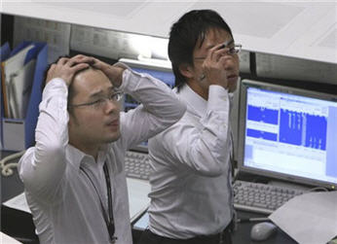
- This bubble was inflated still further by credulous foreign investors, who were all too eager to put money into faraway countries about which they knew nothing (except that they were thriving). It was also, for a while, self-sustaining: All those irresponsible loans created a boom in real estate and stock markets, which made the balance sheets of banks and their clients look much healthier than they were.
- However, this bubble had to burst sooner or later. At some point it was going to become clear that the high values Asian markets had placed on their assets weren’t realistic. Speculative bubbles are vulnerable to self-fulfilling pessimism: As soon as a significant number of investors begin to wonder whether the bubble would burst, it did.
- So what has caused this major economic upheaval in the world? What is the cause of falling share markets the world over and bankruptcy of major banks? In this article, I shall try to explain the reasons for recent economic depression for all those who find it difficult to understand the complex economics lingo and are looking for a simple explanation.
- The housing sector of Ametreasury bill rate was 4 percent, while the average inflation rate was 3 percent. That resulted in a real—that is, after-inflation—rate of 1 percent. Today, the treasury bill rate is roughly zero and inflation expectations appear anchored around 2 percent. That implies a real rate of around –2 percent—that is, 3 percentage points below its pre-crisis level. The Federal Reserve can leave the policy rate—the federal funds rate—at zero if it needs to, and, because inflation expectations are more likely to increase than to decrease, real rates are likely to remain negative. An old rule of thumb is that a 1 percentage point lower real rate that is expected to remain so for some time leads to a roughly 1 percent increase in aggregate demand. A decrease in the real rate of 3 percentage points would seem sufficient to offset the caution of consumers and firms and sustain the recovery.
- But it may not be. What matters for demand is the rate at which consumers and firms can borrow, not the policy rate itself. As was clear during this crisis, the rate at which consumers and firms borrow often is alot higher than the policy rate. Risk premiums on U.S. BBB-rated bonds, for example, are nearly 3 percentage points higher than before the crisis. This higher risk perception may well be an enduring legacy of the crisis. (The Great Depression led to a large increase in the risk premium on stocks, which lasted for the better part of four decades. But the Depression lasted a long time, and this crisis appears unlikely to have the same psychological impact.) Higher risk premiums, then, could undo, at least in part, lower policy rates. U.S. policymakers cannot count on low interest rates alone to deliver a sustained U.S. recovery.

Can Asia help?
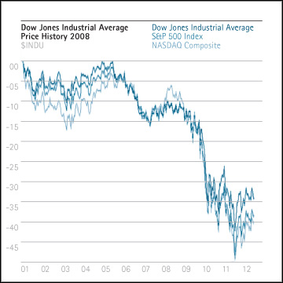
- If the U.S. recovery is to take place, if the fiscal stimulus must be phased out, and if private domestic demand is weak, then U.S. net exports must increase. In other words, the U.S. current account deficit must decrease. That means that the rest of the world, now in substantial surplus, must reduce that current account surplus. Where should this reduction come from?
- It is natural to look first at the countries with large current account surpluses. Among them, most prominently, are Asian countries. And most prominent among them is China. From the point of view of the United States, a decrease in China’s current account surplus would help increase demand and sustain the U.S. recovery. That would result in more imports from the United States, which would help sustain world recovery.
- CHINA AND EFFECT OF CRISIS ON IT :- Why might China be willing to go along? Because it may well be in its own interest: China’s growth has been based on an export-led growth model that relies on a high saving rate, leading to low internal demand, and a low exchange rate, leading to high external demand. The model has been highly successful, but is leading to the accumulation of extremely large reserves, and pressure is building to increase consumption. The high rate of saving reflects the lack of social insurance and the resulting high precautionary saving by households, limited access of households to credit, and governance issues in firms that lead them to retain too high a proportion of their earnings. Providing more social insurance, increasing household access to credit, and improving firms’ governance are all desirable on their own, and would lead to both lower saving and higher internal demand. If such an expansion of demand runs into supply-side constraints, this higher internal demand would have to be partly offset by lower external demand, meaning an appreciation of the Chinese renminbi (RMB) at least in real terms. Both higher Chinese import demand and a higher RMB would increase U.S. net exports.
- Other emerging market Asian countries also run large current account surpluses. Their motivations vary—some want to accumulate reserves as insurance, others chose an export-led growth strategy that incidentally affects the current account and reserve accumulation. Many of these countries could decrease saving, public or private (as the dramatic decline in household saving in Korea since the 1990s demonstrates), and allow their currency to appreciate. That would lead to a shift from external to internal demand and to a reduction in their current account surplus.
- Their incentives, however, are weaker than China’s. Having substantial reserves has proved very useful in the crisis. Swap lines from central banks, and multilateral credit lines—such as the “flexible credit line” created by the IMF during the crisis—could reduce the demand for reserves. But swap lines and credit lines might not be renewed, and so do not offer quite the same degree of safety as reserves. (Establishing arrangements to substantially reduce reserve accumulation would also both be highly desirable in the long run and help to sustain the recovery in the short and the medium run.) Thus, countries that have adopted an export-led growth model may reassess that policy and give more weight to internal demand, but any change is likely to be gradual.
- To get a sense of magnitudes, another rough computation is useful. The GDP of emerging Asia is roughly 50 percent of U.S. GDP (with the ratio projected to increase to 70 percent in 2014). So, if all their trade was with the United States, Asian countries would have to lower their current account position by 4 percent of GDP to improve the U.S. current account by, say, 2 percent of GDP (under the assumption of a 3 percent shortfall in the ratio of consumption to GDP, minus a 1 percent increase coming from lower real interest rates). Since emerging Asia’s trade is not all with the United States, the adjustment would likely have to be even larger. This raises the question of whether other countries can and should play a role.

What role for non-Asian countries?
- A number of other countries, including some advanced countries, also have current account surpluses. For example, Germany’s surplus for 2008 is half China’s (although it is shrinking fast); Japan’s surplus is one-third of China’s.
- Should Germany, for example, reduce its surplus? It cannot follow the same route as that suggested for China—that is, a currency appreciation accompanied by a decrease in saving. Because it is part of the euro area, Germany cannot engineer an appreciation on its own. And, on the demand side, it suffers largely from the same problem as the United States: it has limited room on the fiscal side, and it is not clear that it is either desirable or feasible to get German consumers to save less. Germany could, however, improve productivity in its nontradable sector, which would be in its interest. This would, in time, lead to a reallocation of demand toward nontradables and reduce its current account surplus. The same argument applies to Japan. But, because such structural reforms are politically difficult, and because their effects take place slowly, it is likely to be a slow process—too slow to provide substantial support to the recovery over the next few years. So, if rebalancing is to come soon, it probably has to come largely from Asia, through a decrease in saving and an appreciation of Asian currencies vis-à-vis the dollar.

What if rebalancing does not happen?
This tour of the world suggests three conclusions:
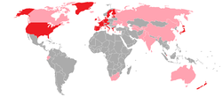
- First, the crisis is likely to have led to a decrease in potential output. One should not expect very high growth rates in the recovery.
- Second, sustained recovery in the United States and elsewhere eventually requires rebalancing from public to private spending.
- Third, sustained recovery is likely to require an increase in U.S. net exports and a corresponding decrease in the rest of the world, coming mainly from Asia.
- One can question all three conclusions:- On the supply side, the effect on potential output is highly uncertain. After all, despite the pessimistic historical evidence, some countries have emerged from banking crises without experiencing a visible impact on potential output (on the other hand, though, some countries have seen a long-lasting negative impact not only on the level of GDP, but also on its growth rate).
- On the demand side, the fiscal space in advanced countries may be larger than expected, allowing the United States to sustain longer-lasting deficits and a higher debt level than currently forecast without raising market concerns about debt sustainability. If this is the case, rebalancing private and public spending can be phased in more slowly if needed, allowing more time to achieve a rebalancing of world demand. Alternatively, private demand in the United States may be stronger: U.S. consumers could return to their old ways and save less. That would help the recovery and avoid the need for amajor adjustment of net exports, although it would re-create in the longer run some of the problems that caused the current crisis. Or it could be that the world decouples—that Asia, for example, is able to return to high growth, while recovery in advanced countries falters. But the crisis, and the strong export links that turned a U.S. shock into a world recession, suggests that decoupling, although possible, is unlikely.
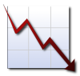
- If, however, one accepts the argument that both rebalancing acts are likely to be necessary for a sustained recovery, the next question is whether they will take place. It is clear that they may not, at least not on the scale needed. If, for example, Asia is unwilling to reduce its current account surplus and U.S. net exports do not substantially improve, weak U.S. private demand may lead to an anemic U.S. recovery. In that case, there would likely be strong political pressure to extend the fiscal stimulus until private demand has recovered.
- Were that to happen, one can imagine various scenarios: political pressure may be resisted, the fiscal stimulus could be phased out, and the U.S. recovery might falter. Or fiscal deficits might be maintained for too long, leading to issues of debt sustainability and worries about U.S. government bonds and the dollar, and causing large capital flows from the United States. Dollar depreciation may take place, but in a disorderly fashion, leading to another episode of instability and high uncertainty, which could itself derail the recovery.
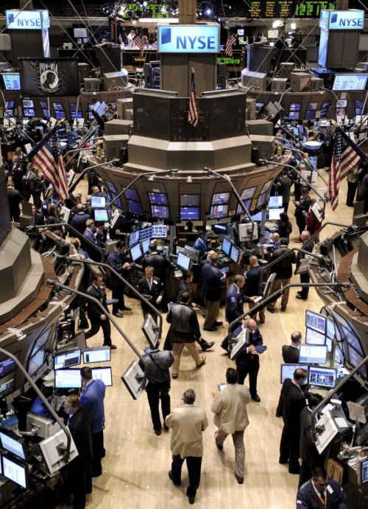
- Sustaining the nascent recovery is likely to require delicate rebalancing acts, both within and across countries. This would not be your first time to hear a story about a company which is to be closed down and the next step would be to retrench people as soon as possible, due to global economic crisis ! diamond industry is one of the affected ones. Only recently, I blogged about how Diamond industry holds crisis, please read here. Yes we are, in fact the original company we used to work here has already been started reducing people. In connection with this, I felt the significance of knowing the real situation of our economy by understanding the theory behind.
Why I started talking about "UNEMPLOYMENT". What is its connection to global recession? Unemployment is directly associated to recession. A decline in the economic activity records an immediate dip in the employment market. This is a proven fact that has been recorded in IT and financial sectors since centuries. Many companies today are firing employee due to cost deductions issues. Even the rate of hiring new employees is falling down drastically, eventually changing the complete picture and complexion of the job market.
It is believed that in August 2008 nearly about 84,000 jobs were lost accounting fro 6.1% unemployment rate. This seems to be the highest since the rate recorded in September 2003. Over the last sixty years, starting from 1948 to 2008, rate of unemployment have fluctuated from 2.5% to about 10.8%. Combining this to the period of economic recession brings out a severe downturn, leading to an unhealthy economy.
Economic recession is defined as a decline in the country’s gross domestic product growth for about two or more consecutive quarters in a particular year. As a part of a normal business life-cycle when an economy that grows over a period of time tends to slow down. An economy typically grows for 6 to 10 years and later is likely to go into a recession for about 6 months to 2 years. Thus, economic recession is a declining phase of the business life cycle when there decline in economic activities spread across the economy, lasting for more than a couple of months, normally visible in GDP, employment, real income, industrial production and wholesale or retail sales.
    - The global economy is teetering on the brink of recession. The downturn after four years of relatively fast growth is due to a number of factors: the global fallout from the financial crisis in the United States, the bursting of the housing bubbles in the US and in other large economies, soaring commodity prices, increasingly restrictive monetary policies in a number of countries, and stock market volatility.
- … the fallout from the collapse of the US mortgage market and the reversal of the housing boom in various important countries has turned out to be more profound and persistent than expected in 2007 and beginning of 2008. As more and more evidence is gathered A recession has many characteristics that can occur simultaneously and can include declines in real-time measures of overall economic activities. Recessions are the result of reduction in the demand and may also be associated with falling prices also known as deflation, or on the other hand it could also be due to increasing prices also known as inflation or a combination of increasing prices and stagnant economic growth.
A prolonged or severe recession is referred to as an economic depression. Although the difference between a recession and a depression is not clearly stated, it is often believed that a decline in Gross Domestic Product or GDP of more than 10% constitutes a depression.
- US markets have a great impact on the global economic growth. Therefore when there is a cue of probable recession in the US it apparently affects the Indian market as well as the global markets leading to a global economic slowdown. Thus weakening of the US economy is bad news, not only for Africa or Philippines or England, but also for the rest of the world.

Rich countries face their deepest recession since the 1930s. For poorer nations it could still be relatively mild
- MANY economists are now predicting the worst global recession since the 1930s. Such grim warnings discourage spending by households and businesses, depressing output even more. It is unfortunate, therefore, that there is so much confusion about what pundits mean when they talk about a “global recession”.
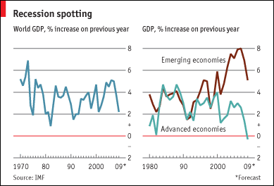
- America, Britain, the euro area and Japan are almost certainly already in recession according to the popular rule of thumb of two successive quarters of falling GDP. But is the R-word really justified for the world as a whole? In an updated World Economic Outlook, published on November 6th, the IMF predicted that world GDP growth would fall to 2.2% in 2009, based on purchasing-power parity (PPP) weights, from 5% in 2007 and 3.7% in 2008. In the past, the IMF has said that global growth of less than 3% implied a world recession, so its latest forecasts would push the world over the edge. Some forecasts by private-sector firms are even gloomier, with several now predicting global GDP growth of no more than 1.5% in 2009.
- Why does the IMF think that a world economy growing by less than 3% a year is in recession? To many people, growth of 2.9%, say, sounds pretty robust. Surely a drop in output is required? The trouble is that there is no agreed definition of a global recession. The popular benchmark used in developed economies—two successive quarters of decline—is not helpful when looking at the world as a whole, because many emerging economies do not report seasonally adjusted quarterly GDP figures. Also, downturns are rarely perfectly synchronised across countries, so even if most countries contract at some stage during a two-year period, global GDP growth may not turn negative. Indeed, global GDP has never fallen in any year since the 1930s Depression. Its worst years since then were 1982 and 1991, with growth of 0.9% and 1.5% respectively (see left-hand chart).
- World growth also needs to be adjusted for rising world population. The IMF suggests that a sufficient (although not necessary) condition for a global recession is any year in which world GDP per head declines. In each of the downturns in 1975, 1982 and 1991, growth in world GDP per head turned negative. By contrast, in 2001, despite much talk of “the mother of all recessions”, global GDP per head expanded by around 1%. The annual growth rate in world population has now slowed to 1.2%, so recent GDP forecasts would still allow average world income per head to rise.
- Nevertheless, some economists reckon that the IMF’s 3% benchmark for global recession may be too high. UBS, for instance, suggests a demarcation point of 2.5%. Even the IMF now seems less sure. At the original launch of the World Economic Outlook in October, Olivier Blanchard, the fund’s chief economist, said “it is not useful to use the word ‘recession’ when the world is growing at 3%”.
- When tracking such diverse economies, it does make much more sense to define a global recession not as an absolute fall in GDP, but as when growth falls significantly below its potential rate. This can cause anomalies, however. Using the IMF’s definition (ie, growth below 3%), the world economy has been in recession for no fewer than 11 out of the past 28 years. This sits oddly with the fact that America, the world’s biggest economy, has been in recession for only 38 months during that time, according to the National Bureau of Economic Research (the country’s official arbiter of recessions), which defines a recession as a decline in economic activity. It is confusing to have different definitions of recession in rich and poor economies.

Growing apart
- Before proclaiming global recession, it is also important to consider the extent to which a downturn has spread around the world. As stockmarkets and currencies have slumped in emerging economies and some governments have had to knock on the IMF’s door, it might appear as if these economies are being hit harder than rich countries. Even in China, growth seems to be slowing sharply, prompting the government to lift its quotas on bank lending at the start of this month. Yet most emerging economies are still widely expected to hold up much better than in previous global downturns.
- It is only really the developed world that faces severe recession (see right-hand chart). The IMF’s revised November figures now forecast that the advanced economies will shrink by 0.3% in 2009, which would be the first annual contraction since the war. The IMF has become markedly more bearish on emerging economies since October, revising its forecasts downward by an average of a percentage point. But emerging economies are still tipped to grow by around 5%. This is a sharp slowdown from recent growth of 7-8%, but still above their average growth rate over the past three decades and considerably higher than their typical growth in previous global downturns.
- These numbers could of course, be revised down still further. But if broadly correct, this could be a relatively mild downturn for emerging economies. Real income per head is still expected to increase next year in countries that account for well over half of the world’s population. Indeed, if the developed world as a whole suffers an absolute decline in 2009, next year is set to be the first year on record when emerging economies account for more than 100% of world growth. Three reasons why the US faces recession in 2008
- Presidential election years usually are not recessionary but next year will be an exception. Several economic factors are colliding in an almost perfect storm to markedly slow the general economy and the stock market.

The most important signal flashing recession is, of course, the subprime mortgage fiasco. After years of monetary inflation on the part of the Federal Reserve, individuals and families with poor credit were suckered into low-down-payment/low-interest adjustable mortgages that simply cannot be maintained or repaid under current conditions.
- Their incentive is to sell the property quickly before their equity evaporates or the financial institution repossesses it. Yet the massive oversupply of homes and condos for sale has pushed prices down at a record clip and made additional foreclosures even more likely. Next year, unfortunately, will be the Year of the Auction.
- The financial institutions have also been punished … well sort of. Various institutions including hedge funds that hold these poorly performing debt obligations have been forced (by accounting rules) to 'write down' the value of these assets, take huge paper losses in the bargain, and pull in their financial horns.
- Thus, any near-term recovery in housing must now fight a record supply availability, falling prices, higher insurance costs and restricted credit … a near-term impossibility in my view.
- Moreover, the slowdown in residential and commercial construction will send secondary ripple effects throughout the economy. Laid-off construction workers don't spend money. Construction and home furnishing suppliers sell less output and make fewer investments. Even local governments will be pinched by declining property-tax assessments and fewer developer fees. Things are likely to get worse before they get any better.

Sky-high crude oil is near-term recession risk
- The second major factor indicating a near-term recession is the sky-high price of crude oil and refined product. Pushed upward by world-wide speculative Middle East war fears and increases in demand (especially from China), increasing energy prices act as an inflationary 'tax' on domestic production and consumption throughout the market economy.
- Higher costs of production will lower profits; higher prices will reduce some consumption. The only good news here is that any substantial economic slowdown in 2008 will eventually moderate the price of oil and other commodity prices as well.

Dollar devaluation is real wild card
- The third factor in the current recession scenario — and the real wild card — is the continuing decline in the value of the dollar in international money markets caused by our Iraq blunder and the Federal Reserve–generated oversupply of dollars. Some economists would argue that a devalued dollar is good for US exports, and thus positive for the economy as a whole. I disagree for three reasons.
- First, the bulk of crude oil purchases takes place in dollars; a falling dollar translates into still higher crude oil prices. Second, the US dollar is the major reserve currency of the international monetary system and dollar-paying investments (such as US Treasury bills and bonds) are held in massive amounts by foreign banks and governments. Dollar devaluation makes these investments less attractive and any disinvestment in these areas would sharply drive bond prices down and increase interest rates.
- THIRD AND LAST REASON :-The third reason why dollar devaluation makes recession more likely is that it effectively prevents the Federal Reserve from pushing US interest rates much lower. Any additional Fed easing (inflation) would be seen as a signal of even further future dollar devaluation and even higher dollar prices for oil.
- Unfortunately, we will not be able to 'inflate' our way out of this recession this time. We will simply have to take our lumps and let market forces liquidate the bulk of the malinvestments caused by the unprecedented Greenspan money bubble. This liquidation process will not be pretty but it is necessary to restore a sustainable economic recovery in the years ahead
- Many commentators - and stock market traders - were heartened by comments of White House and Fed officials who saw some "green shoots of spring" in the US economy. The speed of the recession is decelerating, they say. The notion, never accurate, that the economy was in "free fall" has been discarded.
None of that should be surprising. Government officials are paid to accentuate the positive. Moreover, published White House and Fed economic forecasts have consistently predicted the economy would bottom out later this year. And forecasts of most private sector economists run along the same lines. Even I think the recession will end this fall.
- Where opinions differ, however, is what happens next. Will the business recovery be solid and self-sustaining? Or will it be fragile and vulnerable to a renewed set back? No consensus has jelled on the outlook for 2010 and beyond.
Washington is clearly in the optimistic camp. The White House budget is based on an assumption of 3.2% growth in real GDP for calendar year 2010. The non-partisan Congressional Budget Office predicts 2.9% growth. The Federal Reserve's latest published forecasts for 2010 show a wide dispersion among Fed officials but most are clustered in that same range.
Their optimism is based on three factors. They assume history will repeat. Deep recessions have always been followed by strong upswings, they say. They take for granted that the combination of aggressive monetary policy and powerful fiscal stimulus will generate strong increases in business activity. And they assume the financial markets will get back to normal soon.
My forecast is much less cheerful, a 2010 rate of GDP growth of only around 1 ½%. Fundamentally, I doubt that history will repeat, because this recession is unique. It has been caused by massive wealth destruction, not simply the normal forces of the business cycle. It is the culmination of many years of excesses in the credit markets that have literally brought the financial sector to brink of collapse. Americans indulged on cheap and easily available credit to spend much more on cars and houses than they could afford. They were betting that prices 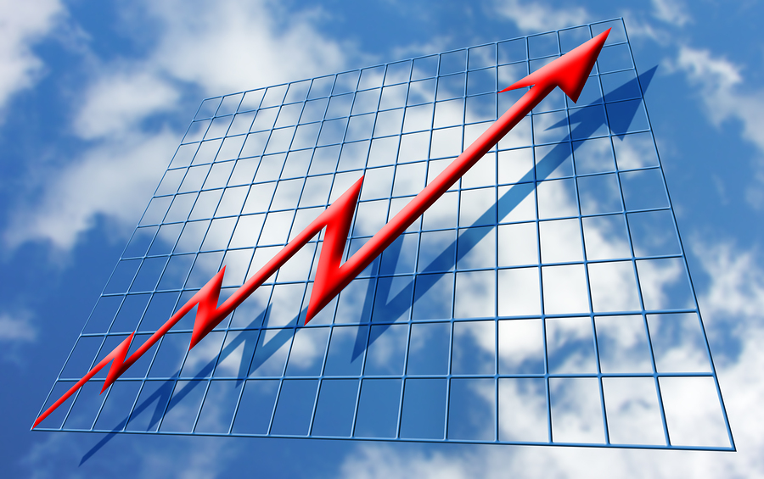would keep rising, especially home prices, and that would bail them out. As evidenced by rising mortgage defaults and foreclosures, they have learned a painful lesson.
US HOUSEHOLDS FACING WITH CRUEL REALITIES:- Now US households are confronted with a number of cruel realities. Their jobs are at risk because of severe dislocations in US industry. Whole industries are threatened by bankruptcy, notably motor vehicles. Wages and salaries are under tight control everywhere, as businesses struggle to lower costs. New hiring is severely restricted even in industries that are still reasonably healthy. Moreover, state and local tax revenues are down so sharply that school boards are unable pay teachers already on their payrolls, normally the most stable occupation in the economy.
But worst of all is what has happened to household wealth. It has plummeted because of falling home prices and the sharpest drop in equity prices since the 1930s. Back then, however, only a slim fraction of Americans owned stocks, essentially the wealthy. Nowadays, things are completely different. The majority of middle-class Americans depends on self-directed pensions, the familiar 401k accounts, to provide for their retirement, over and above the limited benefits received from Social Security. Those 401k accounts are now down 30%-40% from their peaks.
Consequently, the US consumer is in no position to become a dynamic force for economic recovery. If anything, millions will seek to increase savings to replace part of this lost wealth. They will not rush out to buy new homes, because they rightly fear further erosion in housing values. They will be content to keep their cars a little longer, rather than buy new ones. Even if some consumers are inclined to increase their spending, they will face continued credit restraint imposed by hobbled banks that have established far more restrictive lending standards.
This so-called negative wealth effect will influence business decisions, too. Firms will be more selective in approving capital expenditures and will retain tough control over costs. They will also face difficulty getting credit, particularly for commercial real estate development.
Finally, the global nature of the current recession is unprecedented. US exports have already been adversely affected, and foreign demand willremain suppressed for some time.
To me, it adds up to a weak recovery, at best. I suspect that the Fed's easy money policy will continue and that the Obama administration will prepare another fiscal stimulus package. These supportive policies are essential to avoid a "double dip" recession. But they will be insufficient to generate the traditional robust recovery that White House and Fed economists apparently believe will be underway a year from now.

