
3.EFFECTIVE COMMUNICATION
Objectives:
- To develop effective communication skills that enable the candidates to express, speak effectively, interpersonally and in large or small groups
- To develop awareness about the communication process
- To develop effective writing skills, enabling the candidates to write clear, concise, and audience-centered business documents
- To develop effective listening skills that would enable the candidates to comprehend instructions and become an active listener
- Therefore, effective communication not only helps managers discharge their duties but also builds a bridge between managers and the external environment of the organization.

Effective Communication

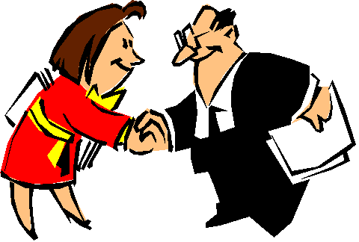Communication is not only conveying or sharing our ideas, thoughts or feelings, however it’s about having those ideas, thoughts, and feelings understood by the people we are talking with. So communication has to be effective which also involves feedback. As without feedback, there would be no way of knowing if meaning has been shared or if understanding has taken place.
The ability to speak clearly and concisely, and to convey information or articulate an opinion is essential for every job. Communication is reflection of our professionalism, our intellect, our preparedness, and our character. Communication is not an isolated series of only one skill. It involves several other skills. The ability to effectively communicate is a critical skills and it involves the following skills:
- Language skills
- Writing Skills
- Listening Skills
- Soft skills

Steps to ensure effective written communication
Plan
Like nearly any activity, written communication too requires a plan and a structure.
Certain things must be clearly ascertained like
- Sender: From whom is the communication starting?
- Receiver: Who is the end receiver/audience of the written Communication?
- Purpose: Why are we making the communication?
- What is the expected outcome: what do you expect the receiver to do?

Follow rule
The Structure of the content of the message must be Brief: Brevity and simplicity avoids any confusion in understanding the message. The content must be:
- Short Sentences
- Simple usable words
- Facts and Figures
- Suit it to the audience
- Request feedback

Write It
Once we have done the above, we could proceed to actually writing our communication on paper, bearing a few things in mind.
- Double spacing to improve readability, as used on this page
- Use of paragraph to make the communication more logical and understandable
- Neat, uniform handwriting, in case it is not typed or printed
- Avoid jargon, acronyms, technical terms unless essential
The purpose of communication is to create an impression or understanding in the mind of receiver of the message.

4.Types of Communication
The purpose of communication is to get the message across to others. This is a process that involves both the sender of the message and the receiver. By successfully getting your message across, you convey your thoughts and ideas effectively. These thoughts and the ideas can be conveyed either by speaking to the other person or by writing it or by explaining through signs and symbols. So, broadly speaking there are three types of communication
- Verbal
- Non-verbal
- Written
Verbal Communication- Communication done by way of speaking or by exchange of words is called verbal communication.
Non-verbal communication- Conveying ideas or thoughts through signs, symbols, gestures or facial expressions are called non-verbal communication.
Written Communication- Conveying facts, ideas or thoughts in writing is called written communication. For example: letters, articles, notices and e-mails etc.
Non Verbal communication
Non-verbal communication consists of all the messages other than words that are used in communication. These symbolic messages are transferred by means of body posture, body gestures, and facial expressions, which all together are called Body language or signs, symbols.
Body Language or Kinesics
Body language is the person’s expressions, behavior, AND BODY movement etc through which you can judge a person.
Body language consists of signs and symbols we send out by the small movements we make with our eyes, face and the way we sit, stand and move.

Example: gestures, postures, nodding, blinking of eyes, shrugging of shoulders etc.

A recent study tells us that non verbal signals play a large part of any communication between people. But exactly how much?
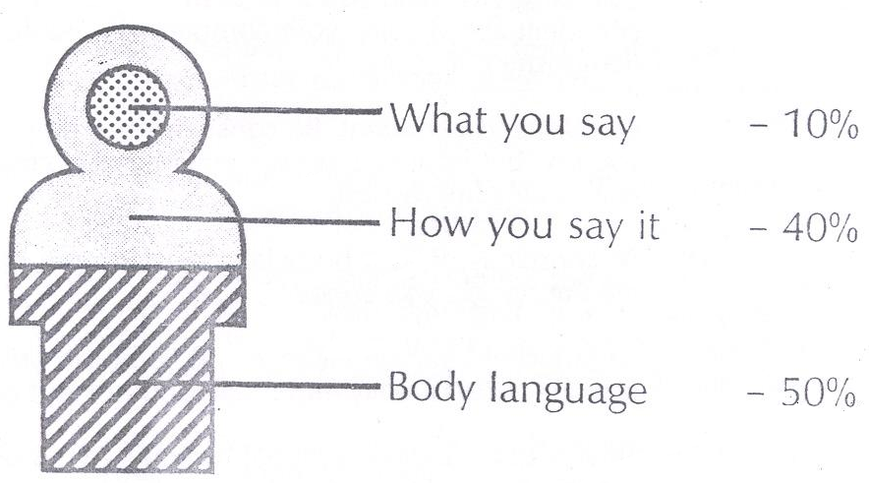
According to the 10-40-50 principle, 10 % of the impression or impact comes from what we actually say, 40% comes form the way how we say it and the major par i.e. 50% coming from our body language.
Examples of Body Language

NONVERBAL BEHAVIOR | INTERPRETATION
Brisk, erect walk | Confidence
Standing with hands on hips | Readiness, aggression
Sitting with legs crossed, foot kicking slightly | Boredom
Sitting, legs apart | Open, relaxed
Arms crossed on chest | Defensiveness
Touching, slightly rubbing nose | Rejection, doubt, lying
Rubbing the eye | Doubt, disbelief
Hands clasped behind back | Anger, frustration, apprehension
Locked ankles | Apprehension
Rubbing hands | Anticipation
Sitting with hands clasped behind head, legs crossed | Confidence, superiority
Open palm | Sincerity, openness, innocence
Tapping or drumming fingers | Impatience
Patting/fondling hair | Lack of self-confidence; insecurity
Tilted head | Interest
Stroking chin | Trying to make a decision
Looking down, face turned away | Disbelief
Biting nails | Insecurity, nervousness

5.Top Ten Body Language Tips
- Eye Contact
Eye contact is one of the most important aspects of dealing with others, especially people we've just met. Maintaining good eye contact shows respect and interest in what they have to say.

- Posture
Posture is the next thing to master, get your posture right and you'll automatically start feeling better, as it makes you feel good almost instantly. Next time you notice you're feeling a bit down, take a look at how your standing or sitting. Chances are you'll be slouched over with your shoulders drooping down and inward. This collapses the chest and inhibits good breathing, which in turn can help make you feel nervous or uncomfortable.

- Head position
Head position is a great one to play around with, with yourself and others. When you want to feel confident and self assured keep your head level both horizontally and vertically. You can also use this straight head position when you want to be authoritative and what you're saying to be taken seriously. Conversely, when you want to be friendly and in the listening, receptive mode, tilt your head just a little to one side or other.
- Arms
They give away the clues as to how open and receptive we are to everyone we meet and interact with, so keep your arms out to the side of your body or behind your back. In general terms the more outgoing you are as a person, the more you tend to use your arms with big movements. The quieter you are the less you move your arms away from your body. So, try to strike a natural balance and keep your arm movement’s midway. When you want to come across in the best possible light, crossing the arms is a no, no in front of others.
- Legs
Legs are the furthest point away from the brain; consequently they're the hardest bits of our bodies to consciously control. They tend move around a lot more than normal when we are nervous, stressed or being deceptive. So best to keep them as still as possible in most situations, especially at interviews or work meetings
- Body Angle
Angle of the body in relation to others gives an indication of our attitudes and feelings towards them. We angle toward people we find attractive, friendly and interesting and angle ourselves away from those we don't, it's that simple! Angles includes leaning in or away from people, as we often just tilt from the pelvis and lean sideways to someone to share a bit of conversation.
- Hand Gestures
Hand gestures are so numerous it's hard to give a brief guide but here goes. Palms slightly up and outward is seen as open and friendly. Palm down gestures are generally seen as dominant, emphasizing and possibly aggressive, especially when there is no movement or bending between the wrist and the forearm. This palm up, palm down is very important when it comes to handshaking and where appropriate we suggest you always offer a handshake upright and vertical, which should convey equality.
- Distance
Distance from others is crucial if you want to give off the right signals. Stand too close and you'll be marked as "Pushy" or "In your face". Stand or sit too far away and you'll be "Keeping your distance" or "Stand offish".
- Ears
Yes your ears play a vital role in communication with others, even though general terms most people can't move them much, if at all. However, you've got two ears and only one mouth, so try to use them in that order. If you listen twice as much as you talk you come across as a good communicator who knows how to strike up a balanced a conversation without being me, me, me or the wallflower.
- Mouth
Mouth movements can give away all sorts of clues. We purse our lips and sometimes twist them to the side when we're thinking. Another occasion we might use this movement is to hold back an angry comment we don't wish to reveal. Nevertheless, it will probably be spotted by other people and although they may not know the comment, they will get a feeling you were not to please. There are also different types of smiles and each gives off a corresponding feeling to its recipient
Paralanguage:
This term is used to describe a wide range of vocal characteristics like tone, pitch and speed etc.
- Pitch variation
- Speaking speed
- Pause
- Volume variation
- Non- fluencies
- Word stress
Artifactual communication : sometimes we react to people on the basis of their appearance like clothing , accessories, makeup,hairstyle etc.provides important non verbal cues about one’s age , social and economic status,educational level,personality etc.
Proxemics : it refers to space , is also called “space language” as the following four space zones indicate the type of communication and the relationship of the source and receiver.
Intimate – Physical contact to 18 inches
Personal- 18 inches to 4 feet
Social- 4 to 12 feet
Public – 12 feet to as far as we can see hear.
Hepatics or touch therapy: touching is another kind of communication sends important message, and express amount of depth of message.
Silence: silence is more important than words. it can effectively describe – respect, fear, lack of interest.

6.Written Communication
The ability to convey your message in writing using proper grammar is a basic requisite for nearly every job. Once you have control of grammar, you can work to enhance your style. However, written communication as compared to oral communication is at a disadvantage because of the absence of non-verbal gestures, voice variation and physical expressions. This is why the importance of clarity and accuracy of the content of our written message becomes all the more critical.
Written Communication can be in the form of:

1. Letters
2. E-mails
3. Notices, reports, memo
4. In-house Magazines

PROCESS OF COMMUNICATION
The process of communication consists of the following steps :
- Sender
The person who conveys the message is known as the sender or communicator. He may be a speaker a writer or an actor. He initiates the process of communication He is the source of communication.
- Message
It is the subject-matter of communication It may consist of facts, information ideas, opinions etc. It exists in the mind of the sender. A communication in writing, in speech, or by signals.
- Encoding
The sender translates the message into words symbols which he feels will make the receiver understand the message This is known as encoding of message
- Channel or Medium
The encoded message is transmitted through some medium which is know as the communication channel e..g speaking ,writing, movement of body parts etc. Messages are conveyed through channels, with verbal including face-to-face meetings, telephone and videoconferencing; and written including letters, emails, memos and reports.
- Receiver
The person who receives the message is called the receiver. The receiver may be a listener, reader or viewer..
- Decoding
It means interpretation of the message by the receiver.
- Feedback
The receiver sends his response to the sender to the message such response is known as feedback .When the feedback is received by the sender, the process of communication is complete. Transmission of feedback involves the same steps as in the case of the sender’s message .Therefore, communication becomes a circular process.
Circular process
Sender Message Encoding Medium Receiver
Noise
Feedback Decoding
Communication process can be illustrated with an example.
The managing director of a company sends a notice to the factory manager asking him to send a report of the performance of the previous month. The factory manager sends the required report. The managing director informs the factory manager that the report does not mention the costs incurred during the month. The factory manger sends another report stating the expenses.

8. Noise
Sometimes the process of communication is disturbed by noise. Noise in communication means the disruption or interference anywhere along the way. It can occur at any stage in the communication process. Some examples of noise are as follows:
- Use of ambiguous symbols resulting in faulty encoding
- A poor telephone connection
- An inattentive listener
- Attaching wrong meaning to message i.e. faulty decoding
- Gestures and postures which distort the message
- Prejudice causing poor understanding of message

7. COMMUNICATION IN AN ORG

