AS OF NOW RELIANCE INDUSTRIES LTD HAS ANNOUNCED IT’S QUARTER4 RESULTS WE SEE THE FOLLOWING POINTS:

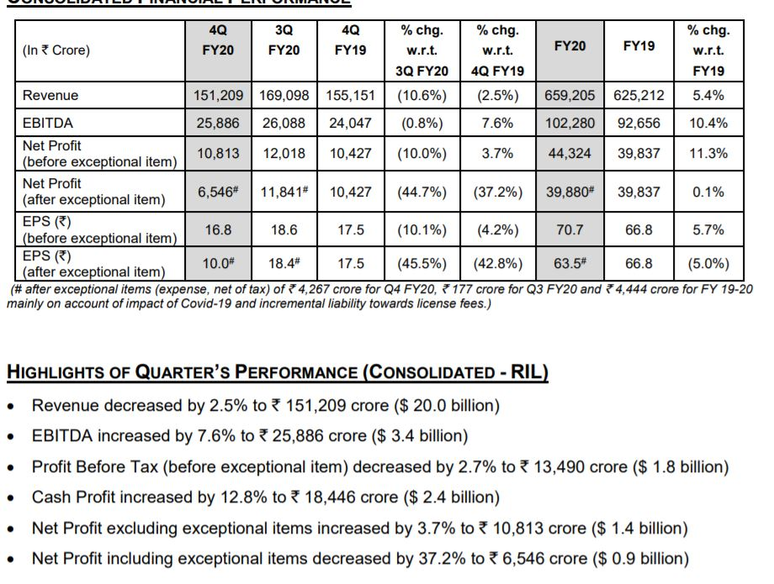
WE SEE THAT THE REVENUE IS DECREASED (IF COMPARED WITH QUARTER3 WITH QUARTER4) BECAUSE OF COVID-19 AND DUE TO DECLINE OF CRUDE OIL PRICES BY 73% WHICH IN RESULTS DECREASES RETURN BY OIL SEGEMENT BY 15-32%. BUT THEN HOW COMPANY MANAGES TO GET THE HIGHER “EBIDTA”& “INCREASE IN REVENUE AS COMPARED TO LAST YEAR” WHICH IS OUTLINED BY COMPANY IN THE FOLLOWING:
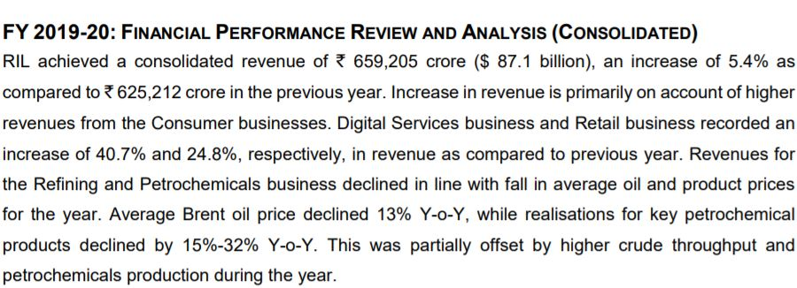

AS WE ARE TALKING ABOUT O2C SEGMENT OF RELIANCE INDUSTRIES, THEY ARE IN A DEAL WITH ARAMCO A SAUDI ARABIA BASED OIL COMPANY, ONE OF THE BIGGEST IN THE WORLD. THE DEAL AMOUNTING TO $15 BILLIONS FOR 20% STAKE WHICH MAKES O2C BUSINESS VALUE EQUALS TO $75 BILLIONS. TILL NOW RELIANCE SAYS THE FOLLOWING:
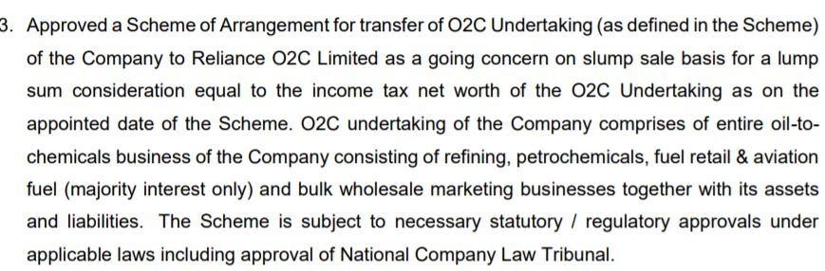
RELIANCE ALSO SAID THAT THE DUE DILIGENCE OF SUCH INVESTMENTS IS IN PROCESS.

BUT OUR QUESTION IS WHY RELIANCE GOT VALUE OF $75 BILLIONS AS IF WE COMPARE TO THE COMPARABLE COMPANY WHOSE REVENUE, RESULTS, ASSETS AND LIABILITES ARE NEARLLY EQUAL BUT WHY RELIANCE GETS SUCH HIGHER VALUATIONS. FOR THIS WE WILL LOOK INTO THE COMPARABLES OF TWO COMPANIES:

PARTICULARS | RELIANCE INDS LTD (2018-2019) | INDIAN OIL CORPORATION LTD (2018-2019)
REVENUE (O2C SEGMENT) | 5,54,815 CRORES | 6,08,922 CRORES
RESULTS | 50,662 CRORES | 26363.21 CRORES
ASSETS EMPLOYED | 3,86,197 CRORES | 2,59,946.47 CRORES
LIABILITES | 3,31,989 CRORES | 1,03,618 CRORES

AND ALSO IF WE LOOK INTO SO0ME FINANCIAL RATIOS INDIAN OIL IS MEANT TO GET LOWER VALUATIONS AS COMPARED TO REELIANCE INDUSTRIES LTD.
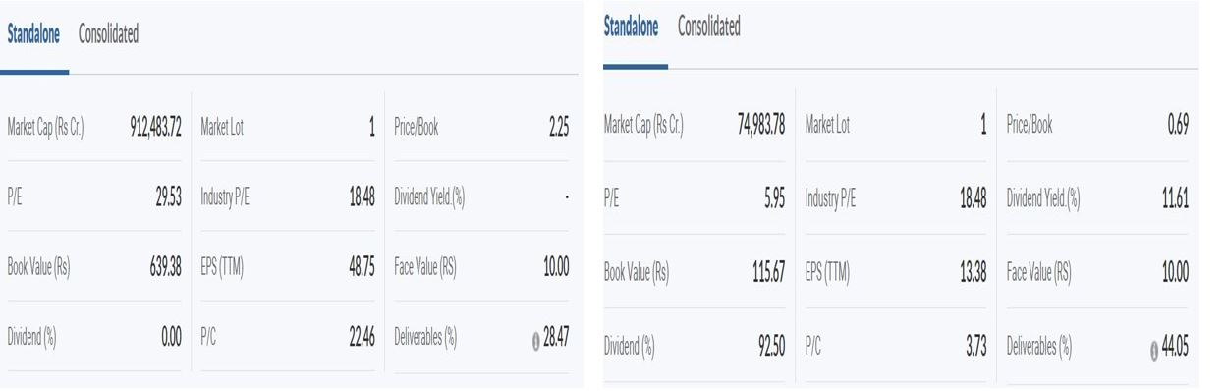
SO WHAT RELIANCE GIVES A BETTER EPS, A HIGHER P/E WHICH IS HIGHER THAN INDIUSTRY AVERAGE P/E, THIS IS BECAUSE OF THE BETTER GROWTH FOR INSTANCE THE RESULTS OF O2C SECTOR ARE GROWN BY 11% AS COMPARED TO THE INDIAN OIL CORPORTAION WHOSE RESULTS WAS DECREASED BY 20.83%. AND THE EXPECTATIONS OF INVESTORS WHICH ARE FULFILING BY RELIANCE NOT BY INDIAN OIL CORPORATION.
INDIAN OIL CORPORATION IS NOT ABLE TO MAINTAIN THE COST AT ITS LOW BUT RELIANCE MANAGES TO GET THE COST REDUCED TO THE POSSIBLE LEVEL WHICH MAKES EARNINGS AVAILABLE MORE (IN OUR CASE EPS) AND ABLE TO GET MORE RETURN FROM IT.

