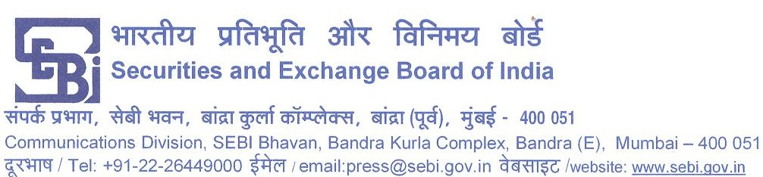

PR No.94/2011
Order in the matter of issuance of Optionally Fully Convertible Debentures (OFCDs) issued by Sahara India Real Estate Corporation Ltd. (SIRECL), now known as Sahara Commodity Services Corporation Ltd. and Sahara Housing Investment Corporation Ltd. (SHICL)
Whole Time Member, SEBI, has passed an Order dated June 23, 2011, in the captioned matter. The Order inter-alia contains following directions:
(i). SIRECL and SHICL, and its promoter, Mr. Subrata Roy Sahara, and the directors of the said companies, namely, Ms. Vandana Bhargava, Mr. Ravi Shankar Dubey and Mr. Ashok Roy Choudhary, jointly and severally, shall forthwith refund the money collected by the aforesaid companies through the RHP dated March 13, 2008 and October 6, 2009, issued respectively, to the subscribers of such Optionally Fully Convertible Debentures with interest of 15% per annum from the date of receipt of money till the date of such repayment.
(ii). Such repayment shall be effected only in cash through Demand Draft or Pay Order.
(iii). SIRECL and SHICL shall issue public notice, in all editions of two National Dailies (one English and one Hindi) with wide circulation, detailing the modalities for refund, including details on contact persons including names, addresses and contact details, within fifteen days of this Order coming into effect.
(iv). SIRECL and SHICL are restrained from accessing the securities market for raising funds, till the time the aforesaid payments are made to the satisfaction of the SEBI
(v).Mr. Subrata Roy Sahara, Ms. Vandana Bhargava, Mr. Ravi Shankar Dubey and Mr. AshokRoy Choudhary are restrained from associating themselves, with any listed public company and any public company which intends to raise money from the public, till such time the aforesaid payments are made to the satisfaction of SEBI.
After completing the aforesaid repayments, the two Companies shall file a certificate of such completion with SEBI from two independent peer reviewed Chartered Accountants who are in the panel of any public authority or public institution.
In case of failure of the parties to comply with the aforesaid directions, SEBI shall take appropriate action including launching of prosecution proceedings against them and other persons who are in default, in accordance with law.
It may be recalled that SEBI, in the interest of investors in and for the integrity of the securities market, had passed an ad interim order dated November 24, 2010 inter alia restraining SIRECL and SHICL including the persons named as promoters and directors of the said companies from mobilizing funds under the Red Herring Prospectus through these OFCDs, till further directions.
The Hon’ble Supreme Court of India vide its order dated May 12, 2011 has directed SEBI to '“expeditiously hear and decide this case so that this Court can pass suitable orders on re-opening. However, effect to the order of SEBI will not be given.” Therefore this Order will be given effect to only subject to the directions of the Hon’ble Supreme Court.
In respectful compliance with the Order dated May 12, 2011 of the Hon’ble Supreme Court of India, a copy of this Order shall be placed before the Registrar of the Hon’ble Supreme Court of India immediately.
The full text of the order is available on the website: www.sebi.gov.in
Mumbai
June 23, 2011

