Bonds Valuation
Bonds are long-term debt securities that are issued by corporations and government entities. Purchasers of bonds receive periodic interest payments, called coupon payments, until maturity at which time they receive the face value of the bond and the last coupon payment. Most bonds pay interest semiannually. The Bond Indenture or Loan Contract specifies the features of the bond issue. The following terms are used to describe bonds.

1 Par or Face Value
The par or face value of a bond is the amount of money that is paid to the bondholders at maturity. For most bonds the amount is $1000. It also generally represents the amount of money borrowed by the bond issuer.

2 Coupon Rate
The coupon rate, which is generally fixed, determines the periodic coupon or interest payments. It is expressed as a percentage of the bond's face value. It also represents the interest cost of the bond issue to the issuer.

3 Coupon Payments
The coupon payments represent the periodic interest payments from the bond issuer to the bondholder. The annual coupon payment is calculated be multiplying the coupon rate by the bond's face value. Since most bonds pay interest semiannually, generally one half of the annual coupon is paid to the bondholders every six months.

4 Maturity Date
The maturity date represents the date on which the bond matures, i.e., the date on which the face value is repaid. The last coupon payment is also paid on the maturity date.

5 Original Maturity
The time remaining until the maturity date when the bond was issued.

6 Remaining Maturity
The time currently remaining until the maturity date.

7 Call Date
For bonds which are callable, i.e., bonds which can be redeemed by the issuer prior to maturity, the call date represents the date at which the bond can be called.

8 Call Price
The amount of money the issuer has to pay to call a callable bond. When a bond first becomes callable, i.e., on the call date, the call price is often set to equal the face value plus one year's interest.

9 Required Return
The rate of return that investors currently require on a bond.

10 Yield to Maturity
The rate of return that an investor would earn if he bought the bond at its current market price and held it until maturity. Alternatively, it represents the discount rate which equates the discounted value of a bond's future cash flows to its current market price.

11 Yield to Call
The rate of return that an investor would earn if he bought a callable bond at its current market price and held it until the call date given that the bond was called on the call date.
The figure below illustrates the cash flows for a semiannual coupon bond with a face value of $1000, a 10% coupon rate, and 15 years remaining until maturity. (Note that the annual coupon is $100 which is calculated by multiplying the 10% coupon rate times the $1000 face value. Thus, the periodic coupon payments equal $50 every six months.)

12 Bond Cash Flows
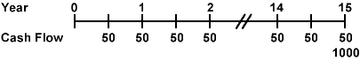
Because most bonds pay interest semiannually, the discussion of Bond Valuation presented here focuses on semiannual coupon bonds.

13 Bond Price
The price or value of a bond is determined by discounting the bond's expected cash flows to the present using the appropriate discount rate. This relationship is expressed for a semiannual coupon bond by the following formula:
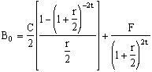
where
- B₀ = the bond value,
- C = the annual coupon payment,
- F = the face value of the bond,
- r = the required return on the bond, and
- t = the number of years remaining until maturity.
Bond Valuation Example
Find the price of a semiannual coupon bond with a face value of $1000, a 10% coupon rate, and 15 years remaining until maturity given that the required return is 12%.
Solution:
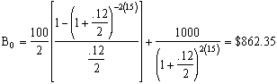

14 Par Bonds
A bond is considered to be a par bond when its price equals its face value. This will occur when the coupon rate equals the required return on the bond.

15 Premium Bonds
A bond is considered to be a premium bond when its price is greater than its face value. This will occur when the coupon rate is greater than the required return on the bond.

16 Discount Bonds
A bond is considered to be a discount bond when its price is less than its face value. This will occur when the coupon rate is less than the required return on the bond.

17 Yield to Maturity
The yield to maturity on a bond is the rate of return that an investor would earn if he bought the bond at its current market price and held it until maturity. It represents the discount rate which equates the discounted value of a bond's future cash flows to its current market price. This is illustrated by the following equation:
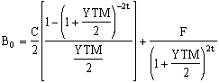
where
- B₀ = the bond price,
- C = the annual coupon payment,
- F = the face value of the bond,
- YTM = the yield to maturity on the bond, and
- t = the number of years remaining until maturity.
The yield to maturity usually cannot be solved for directly. It generally must be determined using trial and error or an iterative technique. Fortunately, financial calculators make the task of solving for the yield to maturity quite simple.
Yield to Maturity Example
Find the yield to maturity on a semiannual coupon bond with a face value of $1000, a 10% coupon rate, and 15 years remaining until maturity given that the bond price is $862.35.
Solution:
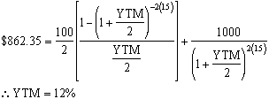

18 Yield to Call
Many bonds, especially those issued by corporations, are callable. This means that the issuer of the bond can redeem the bond prior to maturity by paying the call price, which is greater than the face value of the bond, to the bondholder. Often, callable bonds cannot be called until 5 or 10 years after they were issued. When this is the case, the bonds are said to be call protected. The date when the bonds can be called is refered to as the call date.
The yield to call is the rate of return that an investor would earn if he bought a callable bond at its current market price and held it until the call date given that the bond was called on the call date. It represents the discount rate which equates the discounted value of a bond's future cash flows to its current market price given that the bond is called on the call date. This is illustrated by the following equation:
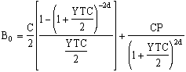
where
- B₀ = the bond price,
- C = the annual coupon payment,
- CP = the call price,
- YTC = the yield to call on the bond, and
- CD = the number of years remaining until the call date.
Like the yield to maturity, the yield to call usually cannot be solved for directly. It generally must be determined using trial and error or an iterative technique. Fortunately, financial calculators make the task of solving for the yield to maturity quite simple.
Yield to Call Example
Find the yield to call on a semiannual coupon bond with a face value of $1000, a 10% coupon rate, 15 years remaining until maturity given that the bond price is $1175 and it can be called 5 years from now at a call price of $1100.
Solution:
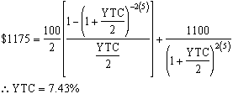

19 Bond Valuation Equations
Semiannual Coupon Bonds
Bond Price:
Yield to Maturity:
Yield to Call:
Annual Coupon Bonds
Bond Price: | 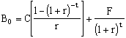
Yield to Maturity: | 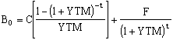
Yield to Call: | 