Option Valuation

1 Definitions
A call option is a contract giving its owner the right to buy a fixed amount of a specified underlying asset at a fixed price at any time or on or before a fixed date. For example, for an equity option, the underlying asset is the common stock. The fixed amount is 100 shares. The fixed price is called the exercise price or the strike price. The fixed date is called the expiration date. On the expiration date, the value of a call on a per share basis will be the larger of the stock price minus the exercise price or zero.
One can think of the buyer of the option paying a premium (price) for the option to buy a specified quantity at a specified price any time prior to the maturity of the option. Consider an example. Suppose you buy an option to buy 1 Treasury bond (coupon is 8%, maturity is 20 years) at a price of $76. The option can be exercised at any time between now and September 19th. The cost of the call is assumed to be $1.50. Let's tabulate the payoffs at expiration.
Call Option Payoff
T-bond Price  on Sept. 19 | Gross Payoff  on Option | Net Payoff  on Option
60 | 0.0 | -1.5
70 | 0.0 | -1.5
75 | 0.0 | -1.5
76 | 0.0 | -1.5
77 | 1.0 | -0.5
78 | 2.0 | 0.5
79 | 3.0 | 1.5
80 | 4.0 | 2.5
90 | 14.0 | 12.5
100 | 24.0 | 22.5
Consider the payoffs diagrammatically. Notice that the payoffs are one to one after the price of the underlying security rises above the exercise price. When the security price is less than the exercice price, the option is referred to as out of the money.
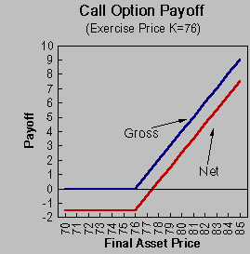
A put option is a contact giving its owner the right to sell a fixed amount of a specified underlying asset at a fixed price at any time on or before a fixed date. On the expiration date, the value of the put on a per share basis will be the larger of the exercise price minus the stock price or zero.
One can think of the buyer of the put option as paying a premium (price) for the option to sell a specified quantity at a specified price any time prior to the maturity of the option. Consider an example of a put on the same Treasury bond. The exercise price is $76. You can exercise the option any time between now and September 19. Suppose that the cost of the put is $2.00.
Put Option Payoff
T-bond Price  on Sept. 19 | Gross Payoff  on Option | Net Payoff  on Option
60 | 16.0 | 14.0
70 | 6.0 | 4.0
75 | 1.0 | -1.0
76 | 0.0 | -2.0
77 | 0.0 | -2.0
78 | 0.0 | -2.0
79 | 0.0 | -2.0
80 | 0.0 | -2.0
90 | 0.0 | -2.0
100 | 0.0 | -2.0
The payoff from a put can be illustrated. Notice that the payoffs are one to one when the price of the security is less than the exercise price.
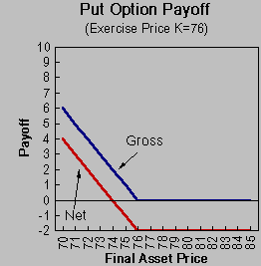
Writing or "shorting" options have the exact opposite payoffs as purchased options. The payoff table for the call option is:
Short Call Option Payoff
T-bond Price  on Sept. 19 | Gross Payoff  on Option | Net Payoff  on Option
60 | 0.0 | 1.5
70 | 0.0 | 1.5
75 | 0.0 | 1.5
76 | 0.0 | 1.5
77 | -1.0 | 0.5
78 | -2.0 | -0.5
79 | -3.0 | -1.5
80 | -4.0 | -2.5
90 | -14.0 | -12.5
100 | -24.0 | -22.5
Notice that the liability is potentially unlimited when you are writing options.
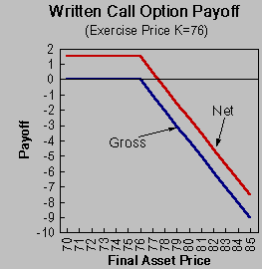
The put option can be similarly illustrated:
Short Put Option Payoff
T-bond Price  on Sept. 19 | Gross Payoff  on Option | Net Payoff  on Option
60 | -16.0 | -14.0
70 | -6.0 | -4.0
75 | -1.0 | 1.0
76 | 0.0 | 2.0
77 | 0.0 | 2.0
78 | 0.0 | 2.0
79 | 0.0 | 2.0
80 | 0.0 | 2.0
90 | 0.0 | 2.0
100 | 0.0 | 2.0
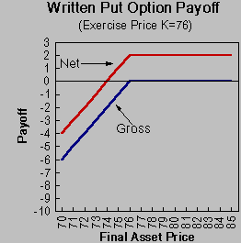
As with the written call, the upside is limited to the premium of the option (the initial price). The downside is limited to the minimum asset price - which is zero.

2 Determinants of Option Value

2.1 Current Stock Price
As the current stock price goes up, the higher the probability that the call will be in the money. As a result, the call price will increase. The effect will be in the opposite direction for a put. As the stock price goes up, there is a lower probability that the put will be in the money. So the put price will decrease.

2.2 Exercise Price
The higher the exercise price, the lower the probability that the call will be in the money. So for call options that have the same maturity, the call with the price that is closest (and greater than) the current price will have the highest value. The call prices will decrease as the exercise prices increase. For the put, the effect runs in the opposite direction. A higher exercise price means that there is higher probability that the put will be in the money. So the put price increases as the exercise price increases.

2.3 Volatility
Both the call and put will increase in price as the underlying asset becomes more volatile. The buyer of the option receives full benefit of favorable outcomes but avoids the unfavorable ones (option price value has zero value).

2.4 Interest Rates
The higher the interest rate, the lower the present value of the exercise price. As a result, the value of the call will increase. The opposite is true for puts. The decrease in the present value of the exercise price will adversely affect the price of the put option.

2.5 Cash Dividends
On ex-dividend dates, the stock price will fall by the amount of the dividend. So the higher the dividends, the lower the value of a call relative to the stock. This effect will work in the opposite direction for puts. As more dividends are paid out, the stock price will jump down on the ex-date which is exactly what you are looking for with a put. (There is also an issue of optimal exercise of the call and put option which will be addressed later.)

2.6 Time to Expiration
There are a number of effects involved here. Generally, both calls and puts will benefit from increased time to expiration. The reason is that there is more time for a big move in the stock price. But there are some effects that work in the opposite direction. As the time to expiration increase, the present value of the exercise price decreases. This will increase the value of the call and decrease the value of the put. Also, as the time to expiration increase, there is a greater amount of time for the stock price to be reduced by a cash dividend. This reduces the call value but increases the put value.

3 . Basic Principles of Option Valuation
Consider the following two rules:
(1) If one portfolio of securities gives a higher future payoff than another portfolio in every possible circumstance, then the first portfolio must have a higher current value than the second portfolio.
(2) If two portfolios of securities give the same future payoff in every possible circumstance, then they must have the same current value.
If (1) and (2) did not hold, then it would be possible for a professional trader to make an arbitrage profit by simultaneously selling the relatively overpriced portfolio and buying the relatively underpriced portfolio. We will use these rules to construct positions that offer the identical payoff as the option. If we can price the position with the same payoff as the option, then we have the price of the option.
Another point to note is that the modern valuation of exchange-traded options ignores margin requirements, transactions costs, and taxes because it focuses on market pricing relations that are enforced by the arbitrage activities of professional traders. The margin requirements and transactions costs of these traders are very low. Furthermore, taxes usually reduce the level of arbitrage profits but do not change the circumstances in which they occur.

