Basics of Technical Analysis
Stock Charts
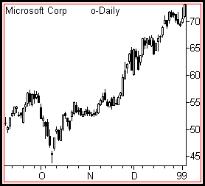
Stock charts gained popularity in the late 19th Century from the writings of Charles H. Dow in the Wall Street Journal. His comments, later known as "Dow Theory", alleged that markets move in all kinds of measurable trends and that these trends could be deciphered and predicted in the price movement seen on all charts.
FUNDAMENTAL ANALYSIS seeks to determine future stock price by understanding and measuring the objective "value" of an equity. The study of stock charts, known as TECHNICAL ANALYSIS, believes that the past action of the market itself will determine the future course of prices.
A stock chart is a simple two-axis (x-y) plotted graph of price and time. Each individual equity, market and index listed on a public exchange has a chart that illustrates this movement of price over time. Individual data plots for charts can be made using the CLOSING price for each day. The plots are connected together in a single line, creating the graph. Also, a combination of the OPENING, CLOSING, HIGH and/or LOW prices for that market session can be used for the data plots. This second type of data is called a PRICE BAR. Individual price bars are then overlaid onto the graph, creating a dense visual display of stock movement.
Stock charts can be created in many different time frames. Mutual fund holders use monthly charts in which each individual data plot consists of a single month of activity. Day traders use 1 minute and 5 minute stock charts to make quick buy and sell decisions. The most common type of stock chart is the daily plot, showing a single complete market session for each unit.
Stock charts can be drawn in two different ways. An ARITHMETIC chart has equal vertical distances between each unit of price. A LOGARITHMIC chart is a percentage growth chart. It has equal vertical distances between the same percentages of price growth. For example, a price movement from 10 to 20 is a 100% move. A move from 20 to 40 is also a 100% move. For this reason, the vertical distance from 10 to 20 and the vertical distance from 20 to 40 will be identical on a logarithmic chart.
Stock chart analysis can be applied equally to individual stocks and major indices. Analysts use their technical research on index charts to decide whether the current market is a BULL MARKET or a BEAR MARKET. On individual charts, investors and traders can learn the same thing about their favorite companies.

Trends
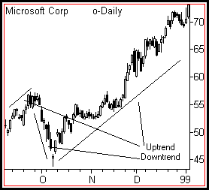
Use the stock chart to identify the current trend. A trend reflects the average rate of change in a stock's price over time. Trends exist in all time frames and all markets. Day traders can establish the trend of their stocks to within minutes. Long term investors watch trends that persist for many years.
Trends can be classified in three ways: UP, DOWN or RANGEBOUND.
In an uptrend, a stock rallies often with intermediate periods of consolidation or movement against the trend. In doing so, it draws a series of higher highs and higher lows on the stock chart. In an uptrend, there will be a POSITIVE rate of price change over time.
In a downtrend, a stock declines often with intermediate periods of consolidation or movement against the trend. In doing so, it draws a series of lower highs and lower lows on the stock chart. In a downtrend, there will be a NEGATIVE rate of price change over time.
Rangebound price swings back and forth for long periods between easily seen upper and lower limits. There is no apparent direction to the price movement on the stock chart and there will be LITTLE or NO rate of price change.
Trends tend to persist over time. A stock in an uptrend will continue to rise until some change in value or conditions occurs. Declining stocks will continue to fall until some change in value or conditions occurs. Chart readers try to locate TOPS and BOTTOMS, which are those points where a rally or a decline ends. Taking a position near a top or a bottom can be very profitable.
Trends can be measured using TRENDLINES. Very often a straight line can be drawn UNDER three or more pullbacks from rallies or OVER pullbacks from declines. When price bars then return to that trendline, they tend to find SUPPORT or RESISTANCE and bounce off the line in the opposite direction.
A famous quote about trends advises that "The trend is your friend". For traders and investors, this wisdom teaches that you will have more success taking stock positions in the direction of the prevailing trend than against it.

Volume
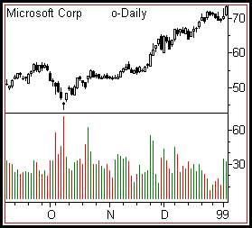
Volume measures the participation of the crowd. Stock charts display volume through individual HISTOGRAMS below the price pane. Often these will show green bars for up days and red bars for down days. Investors and traders can measure buying and selling interest by watching how many up or down days in a row occur and how their volume compares with days in which price moves in the opposite direction.
Stocks that are bought with greater interest than sold are said to be under ACCUMULATION. Stocks that are sold with great interest than bought are said to be under DISTRIBUTION. Accumulation and distribution often LEAD price movement. In other words, stocks under accumulation often will rise some time after the buying begins. Alternatively, stocks under distribution will often fall some time after selling begins.
It takes volume for a stock to rise but it can fall of its own weight. Rallies require the enthusiastic participation of the crowd. When a rally runs out of new participants, a stock can easily fall. Investors and traders use indicators such as ON BALANCE VOLUME to see whether participation is lagging (behind) or leading (ahead) the price action.
Stocks trade daily with an average volume that determines their LIQUIDITY. Liquid stocks are very easy for traders to buy and sell. Illiquid stocks require very high SPREADS (transaction costs) to buy or sell and often cannot be eliminated quickly from a portfolio. Stock chart analysis does not work well on illiquid stocks.
Breakouts accompanied by volume much higher than the average for that stock are healthy for the continuation of the price movement in that direction. But after long rallies or declines, stocks often have a day of very high volume known as a CLIMAX. During these days, the last of the buyers or sellers take positions. The stock then reverses as there are no longer enough participants to cause price to move in that direction.

Patterns and Indicators
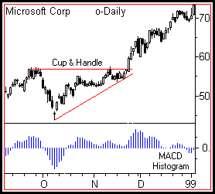
How can you organize the endless stream of stock chart data into a logical format that doesn't require rocket science to interpret? Charts allow investors and traders to look at past and present price action in order to make reasonable predictions and wise choices. It is a highly visual medium. This one fact separates it from the colder world of value-based analysis.
The stock chart activates both left-brain and right-brain functions of logic and creativity. So it's no surprise that over the last century two forms of analysis have developed that focus along these lines of critical examination.
The oldest form of interpreting charts is PATTERN ANALYSIS. This method gained popularity through both the writings of Charles Dow and Technical Analysis of Stock Trends, a classic book written on the subject just after World War II. The newer form of interpretation is INDICATOR ANALYSIS, a math-oriented examination in which the basic elements of price and volume are run through a series of calculations in order to predict where price will go next.
Pattern analysis gains its power from the tendency of charts to repeat the same bar formations over and over again. These patterns have been categorized over the years as having a bullish or bearish bias. Some well-known ones include HEAD and SHOULDERS, TRIANGLES, RECTANGLES, DOUBLE TOPS, DOUBLE BOTTOMS and FLAGS. Also, chart landscape features such as GAPS and TRENDLINES are said to have great significance on the future course of price action.
Indicator analysis uses math calculations to measure the relationship of current price to past price action. Almost all indicators can be categorized as TREND-FOLLOWING or OSCILLATORS. Popular trend-following indicators include MOVING AVERAGES, ON BALANCE VOLUME and MACD. Common oscillators include STOCHASTICS, RSI and RATE OF CHANGE. Trend-following indicators react much more slowly than oscillators. They look deeply into the rear view mirror to locate the future. Oscillators react very quickly to short-term changes in price, flipping back and forth between OVERBOUGHT and OVERSOLD levels.
Both patterns and indicators measure market psychology. The core of investors and traders that make up the market each day tend to act with a herd mentality as price rises and falls. This "crowd" tends to develop known characteristics that repeat themselves over and over again. Chart interpretation using these two important analysis tools uncovers growing stress within the crowd that should eventually translate into price change.

Moving Averages
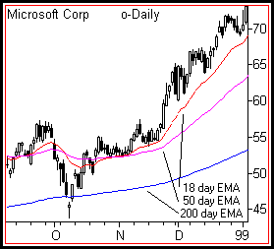
The most popular technical indicator for studying stock charts is the MOVING AVERAGE. This versatile tool has many important uses for investors and traders.
Take the sum of any number of previous CLOSE prices and then divide it by that same number. This creates an average price for that stock in that period of time. A moving average can be displayed by recomputing this result daily and plotting it in the same graphic pane as the price bars. Moving averages LAG price. In other words, if price starts to move sharply upward or downward, it will take some time for the moving average to "catch up".
Plotting moving averages in stock charts reveals how well current price is behaving as compared to the past. The power of the moving average line comes from its direct interaction with the price bars. Current price will always be above or below any moving average computation. When it is above, conditions are "bullish". When below, conditions are "bearish". Additionally, moving averages will slope upward or downward over time. This adds another visual dimension to a stock analysis.
Moving averages define STOCK TRENDS. They can be computed for any period of time. Investors and traders find them most helpful when they provide input about the SHORT-TERM, INTERMEDIATE and LONG-TERM trends. For this reason, using multiple moving averages that reflect these characteristics assist important decision making. Common moving average settings for daily stock charts are: 20 days for short-term, 50 days for intermediate and 200 days for long-term.
One of the most common buy or sell signals in all chart analysis is the MOVING AVERAGE CROSSOVER. These occur when two moving averages representing different trends criss-cross. For example, when a short-term average crosses BELOW a long-term one, a SELL signal is generated. Conversely, when a short-term crosses ABOVE the long-term, a BUY signal is generated.
Moving averages can be "speeded up" through the application of further math calculations. Common averages are known as SIMPLE or SMA. These tend to be very slow. By giving more weight to the current changes in price rather than those many bars ago, a faster EXPONENTIAL or EMA moving average can be created. Many technicians favor the EMA over the SMA. Fortunately all common stock chart programs, online and offline, do the difficult moving average calculations for you and plot price perfectly.

Support and Resistance
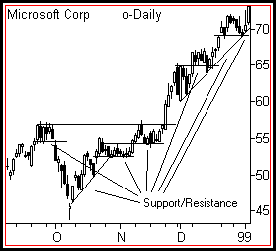
The concept of SUPPORT AND RESISTANCE is essential to understanding and interpreting stock charts. Just as a ball bounces when it hits the floor or drops after being thrown to the ceiling, support and resistance define natural boundaries for rising and falling prices.
Buyers and sellers are constantly in battle mode. Support defines that level where buyers are strong enough to keep price from falling further. Resistance defines that level where sellers are too strong to allow price to rise further. Support and resistance play different roles in uptrends and downtrends. In an uptrend, support is where a pullback from a rally should end. In a downtrend, resistance is where a pullback from a decline should end.
Support and resistance are created because price has memory. Those prices where significant buyers or sellers entered the market in the past will tend to generate a similar mix of participants when price again returns to that level.
When price pushes above resistance, it becomes a new support level. When price falls below support, that level becomes resistance. When a level of support or resistance is penetrated, price tends to thrust forward sharply as the crowd notices the BREAKOUT and jumps in to buy or sell. When a level is penetrated but does not attract a crowd of buyers or sellers, it often falls back below the old support or resistance. This failure is known as a FALSE BREAKOUT.
Support and resistance come in all varieties and strengths. They most often manifest as horizontal price levels. But trendlines at various angles represent support and resistance as well. The length of time that a support or resistance level exists determines the strength or weakness of that level. The strength or weakness determines how much buying or selling interest will be required to break the level. Also, the greater volume traded at any level, the stronger that level will be.
Support and resistance exist in all time frames and all markets. Levels in longer time frames are stronger than those in shorter time frames.

