TOP 5 SKILLS EVERY PROFESSIONAL NEEDS TO MASTER

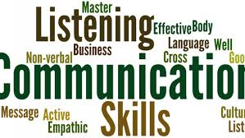
1. Communication Skills
One must communicate clearly, effectively and with confidence to be successful at workplace. It is essential to put forth your ideas in an engaging way to progress.

2.Networking Skills

Networking is essential to boost career. It is near impossible to achieve greater career success if you are alienated and work in a silo. It is equally important to build a strong professional network on social media in today's digital world.

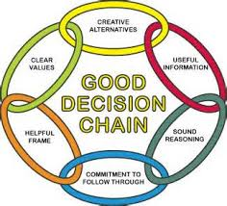
3.Decision Making Skills
One must know how to make decisions that will generate the desired outcome for business. At every step in your career you will be faced with complex situations, how you fare them will depend on your risk taking abilities and making powerful and successful decisions.

4.Leadership Skills

Building leadership skills is the key to success at work. If you want to move up in hierarchy you must focus on acquiring leadership qualities. Remember some people are born leaders; others can be created.

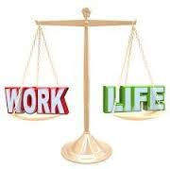
5.Skills to Balance Work-Life
It is important to know how to maintain a healthy work-life balance to perform your function with more confidence and zeal. While it is more for your personal well-being, it does help a great deal in building a successful and happy career.

THANK YOU

