E–Commerce Opportunity
(THE ECOMMERCE GOLD RUSH IN INDIA)

1) E-Commerce overview

COMMERCE
Commerce is a division of trade or production which deals with the exchange of goods and services from producer to final consumer.

E-COMMERCE
E-commerce is the purchasing , selling & exchanging goods and services over computer network or internet through which transactions or terms of sale are performed electronically.
Introduction to E-Commerce Industry in India
The E-Commerce industry is one of the most progressive sectors of the economy. The e-commerce market has changed the way business is transacted, whether in retail or business-to-business, locally or globally.
Despite being a developing country, India has shown a commendable increase in the e-commerce industry in the last couple of years, thereby hitting the market with a boom. Though the Indian online market is far behind the US and the UK, it has been growing at a fast page.
Today, the online shopping has become a trend in India and the reason behind the adoption of this technique lies in the attractive online websites, user friendly interface, bulky online stores with new fashion, easy payment methods (i.e. secure pay online via gateways like PayPal or cash-on-delivery), no bound on quantity & quality, one can choose the items based on size, color, price, etc.
Brief History of E-Commerce
- 1970s
  - E- commerce meant the facilitation of commercial transactions electronically, using technology such as Electronic Data Interchange (EDI) and Electronic Funds Transfer (EFT), allowing businesses to send commercial documents like purchase orders or invoices electronically.
- 1980s
  - The growth and acceptance of credit cards
  - Automated teller machines (ATM)
  - Telephone banking
  - Airline reservation system

- 1990s
  - The Internet commercialized and users flocked to participate in the form of dot-coms, or Internet start-ups
  - Innovative applications ranging from online direct sales to e-learning experiences
- 2000s
  - Many European and American business companies offered their services through the World Wide Web.
  - Since then, People began to associate a word “e-commerce”
The Key drivers of Indian E-commerce have been:
- Increasing broadband Internet and 3G penetration.
- Growing Living standards
- Availability of much wider product range
- Busy lifestyles and lack of time for offline shopping
- Increased usage of online categorized sites
- Evolution of the online marketplace model with websites like eBay, Flipkart, Snapdeal, etc.

The process of E-commerce
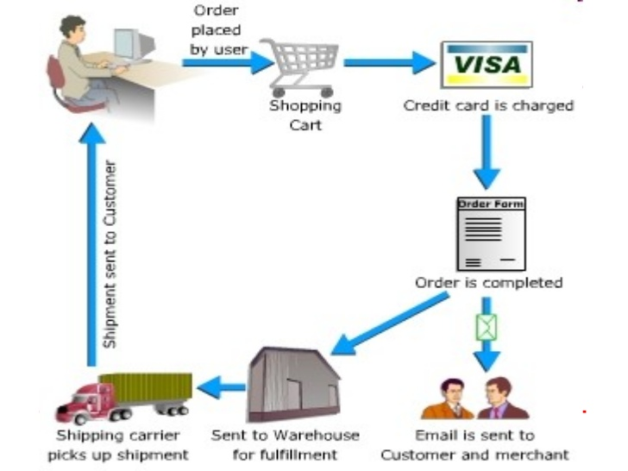
- A consumer uses Web browser to connect to the home page of a merchant's Web site on the Internet.
- The consumer browses the catalogue of products featured on the site and selects items to purchase. The selected items are placed in the electronic equivalent of a shopping cart.
- When the consumer is ready to complete the purchase of selected items, she provides a bill-to and ship-to address for purchase and delivery
- When the credit card number is validated and the order is completed at the Commerce Server site, the merchant's site displays a receipt confirming the customer's purchase.
- The Commerce Server site then forwards the order to a Processing Network for payment processing and fulfilment.

E Commerce Features
- Global Reach:- The technology reaches across national boundaries, around Earth
- Richness:- Supports video, audio, and text messages
- Interactivity :-The technology works through interaction with the user
- Information Density:- Vast increases in information density—the total amount and quality of information available to all market participants.

2) E-Commerce categories
Business-to-business (B2B):- B2B e-commerce is simply defined as ecommerce between companies. About 80% of e-commerce is of this type.
Examples: Intel selling microprocessor to Dell ,Heinz selling ketchup to Mc Donalds.

Business-to-Consumer (B2C) : Business-to-consumer e-commerce, or commerce between companies and consumers, involves customers gathering information; purchasing physical goods or receiving products over an electronic network.
Example: Dell selling me a laptop.

Business-to-government (B2G) : Business-to-government e-commerce or B2G is generally defined as commerce between companies and the public sector. It refers to the use of the Internet for public procurement, licensing procedures, and other government-related operations. Example: Business pay taxes, file reports, or sell goods and services to Govt. agencies.
Consumer-to-consumer (C2C): Consumer-to-consumer e-commerce or C2C is simply commerce between private individuals or consumers. Example: Mary buying an iPod from Tom on eBay,
Me selling a car to my neighbor.

Government to consumer (G2C): This Model is also a part of e-governance. The objective of this model is to provide good and effective services to each citizen. The Government provides the following facilities to the citizens through website. Information of all government departments, Different welfare schemes, Different application forms to be used by the citizens.
Government-to-business (G2B): Government-to-business (G2B) is a business model that refers to government providing services or information to business organization.
3) Pros & Cons of e-commerce & SWOT ANALYSIS of E –Commerce
a)Pros & Cons of e-commerce
Pros to organizations | Cons For organizations
- Global reach  - Cost reduction  - Supply chain improvements  - Extended hours: 24/7/365  - Customization  - Improved customer relations | - Elimination of face to face interaction  - Distribution (in-stock?)  - Competition (prices down=profit margin down)  - 24/7 (updating, responding, etc.)

Pros to consumers | Cons For Consumers
- More products and services  - Cheaper products and services  - Instant delivery  - Information availability  - Participation in auctions | - Unable to examine products personally  - New way for cyber-criminals to steal personal, financial info, and even your identity  - Product Overload  - Don’t always know what your getting  - Shipping delay (purchases and returns)  - Slower product verification and problem resolution  - Loss of emotional fulfillment
B)SWOT ANALYSIS of E –Commerce
Weakness
- No entry barriers
- Fierce competition
- Margins are thin
- Allied sector not very well developed
- Bargaining power of firms is less
- Overdependence on technology
- These co’s trade at high multiples
Strengths
- Less Capital Intensive
- Venture capital willing to fund, less debt burden of these co’s
- Different models of business is already tried and refined in the west

Threats
- Change in government rules, currently no specific rules for this space
- Fragmented too many players
- Threat of substitute / new entrants
- Scope for misuse of confidential information
- Threat of takeover is high
Opportunities
- Job creation
- Scope for overall infrastructure development
- Tier I – Tier II cities are untouched
- Head room for growth due to favorable demographics
- Growth directly related to spending power which is increasing

5) E-commerce Industry: Key players & Interesting facts , figures & Graphs.
A) Key players.
There are hundreds of other ecommerce websites in India but we have tried to assemble the game changers of the Industry. Lets have a look on the timeline of Giants emergence in the Industry.

- 2000: Indiatimes Shopping - Under prestigious Times Group, it operated as a marketplace model, like eBay, with sellers being allowed to sell directly on the website under their name and warranty. online shopping started here at a big level. A taste of online shopping was served here. Elegant and powerful till date.
- 2005: Ebay.in - This multi billion dollar company made its debut through Baazee.com and understood the potential of Indian online market.
- 2007: Infibeam.com - Launched in year 2007, it now collects a whooping revenue of 10 billion rupees. This online portal was first in its league. The best part is that its founder sold all his asset just to start this company with no external venture capital funding.
- 2007: Flipkart.com - Launched in year 2007, because of it, Amazon is now fighting its own employee built rival company. Flipkart.com is the dragon of online shopping in India.
- 2007: Myntra.com - It was launched in year 2007 now merged with Flipkart.com to fight Amazon.in, Myntra have a brilliant tap over the customers who love fashion & variety.
- 2007: Inkfruit.com - A 'hatke' site, launched in 2007 focused on trend and redefining style. It later merged with Zovi.com to compete harder with the fast growing competition in Indian Retail market.
- 2008: Homeshop18.com - Again a 2008 product Homeshop18 has grown from Television to laptop. This portal is a unique experience in itself. The deals are so lavishing that you cant take you eyes off them. It was launched 7 years ago at 24X7 T.V. channel selling products through Anchors. Later in 2011 it was launched as a website.
- 2010: Snapdeal.com - Five years ago with four square growth, started as a deal and coupon site, Snapdeal soon switched to became an ecommerce portal to harnessing the power of online retailing. And now it stands as a multimillion company regulating tides of online retailing.
- 2012: Jabong.com - It has been 3 years since its inception but the brilliant service and amazing understanding of customer needs have turned this online shopping portal into a nuclear of e-retailing in India. It majorly focus on Tier-II & Tier-III cities.
- 2013: Amazon.in - Came in 2003 and plunged a $2 billion investment to crush the competition and grow. This is in fact the spice of worlds largest online retailer fighting in India for its dominance.

B) Interesting facts , figures & Graphs
- Most online spend today is focused on travel. Estimates put online travel (rail, air, bus, hotel, and tours) at 71% of e-commerce spend, with B2B/B2C e-commerce at 5%. Within online travel, air travel is 50-60% of spend. Online purchasing for bus travel is small compared to air travel. Only 2% of online spend for travel is on bus tickets.
- Mobile shopping infrastructure is improving –smartphones, connectivity, mobile websites and apps
- People are becoming more comfortable in ordering higher priced items online35% of online GMV in 2016 will be influenced by women, Key factor in this growth is increasing supply of women specific categories e.g. jewellery, lingerie, motherhood products.
- 200M of Indians will come online in next 3 years, Majority of these will come online on smartphones E-Commerce companies are building their brands, thus gaining trust of users.
- Penetration rate in spend on bus travel is small relative to air travel. RedBus estimates that only 9% of spending on bus tickets is through online bookings, compared to 35% of air travel in India.
- Cash on Delivery still rules the mode of payment used by online shoppers, as it resulted in 45% of all payments in 2014. Debit Cards came at second position with 21% share, followed by 16% by Credit Cards; Internet Banking at 10%. Mobile wallets, which have seen a surge of activity in the last few months, resulted in 8% of all payments. Last year we had reported that 20% of all payments are being done on mobile devices. Hence, with 8% share of mobile wallets in the overall online payments, it means that the niche is also growing rapidly. Reportedly, there are 300 million Internet users in India right now, and by end of 2016, 500 million mark would be breached.

- Central & North-Eastern India appears to have low adoption of e-commerce
- Top 3 e-commerce states:- Delhi-NCR , Karnataka, Maharashtra
- Large states with very little ecommerce presence: Bihar, Uttrakhand , Chhattisgarh,
- Top 10 e-commerce cities:1. Delhi, 2. Bangalore ,3. Mumbai ,4. Pune ,5. Hyderabad ,6. Chennai,7. Kolkata,8. Ahmedabad ,9. Jaipur,10. Panaji.

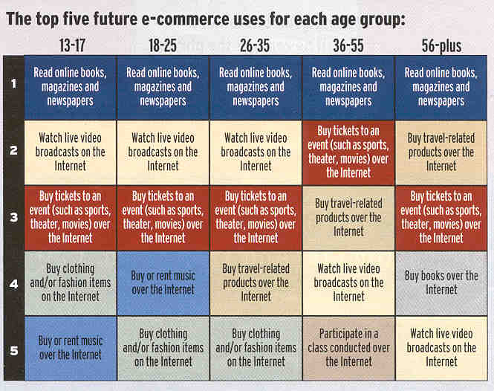

E-commerce Industry: challenges and issues
- Payment Gateway have high failure rate.
- Cash on delivery is the preferred payment mode.
- Logistics & Supply Chain.
- Cyber Crime.
- Indian Customers Return Much of Their Products They Buy Online
- Features Phones Rule The Roost

E-commerce Industry: Recent trends
- Smartphones are driving the E-Commerce industry.
- Classifieds and Online Service Market gain momentum.
- Online grocery stores are gaining popularity in India.
- More and more companies will be using the big data services to create personalized offers, an in-depth analysis of the collected data will help them make future decisions.
- Merger and Acquisitions are the increasing trend in the Indian E-Commerce. The great examples are Flipkart-Myntra and Ibibio-RedBus.

E-commerce Industry: Future outlook Continue....
- The Indian online industry is estimated to be a $90 billion industry by 2019.
- E-Commerce industry in India will drive the future growth from $13 billion to $90 billion in 2020 because of rising disposable incomes and increasing customer awareness, increasing number of Smartphone users and Internet users, the share of apparel category in the overall online revenues will grow exponentially.
- Indian e-commerce industry will spend $950-1,900 million by 2017-2020 on infrastructure, logistics and warehousing
- The industry is expected to spend an additional $500- 1,000 million during the same period on logistics functions, leading to a cumulative spend of $950-1,900 million till 2017-2020, it added
- 'Evolution of e-Commerce in India', estimates that over the next three to four years, there will be an addition of 7.5-15 million square feet of space in the form of fulfillment centers.
- This indicates - addition of 6-12% to the space available in form of organized warehousing in India and almost 25-50% of all the incremental addition of consumption driven warehousing space in the same period.
- The Ecommerce is having huge scope in the upcoming future as the number of Indian E commerce are also increasing day by day and the number of users are also increasing in India. This shows the changing pattern of the customers taste and preferences. It is also going to increase the employment in the country.
- According to the latest research by Forrester, a leading global research and advisory firm, the e-commerce market in India is set to grow the fastest within the Asia-Pacific Region at a CAGR of over 57% during 2012-16.
- A new report by the Boston Consulting Group says online retail in India could be a $84-billion industry by 2016 — more than 10 times its worth in 2010 — and will account for 4.5 per cent of total retail.
- The e-commerce platforms maximize its reach to the potential customers and provide them with a convenient, satisfying & secure shopping experience.
- The third party e wallets are now replacing the cash-on-delivery method such that people feel safe as well as both seller and buyer is mutually satisfied

The Key drivers of Indian E-commerce have been:
- Increasing broadband Internet and 3G penetration.
- Growing Living standards
- Availability of much wider product range
- Busy lifestyles and lack of time for offline shopping
- Increased usage of online categorized sites
- Evolution of the online marketplace model with websites like eBay, Flipkart, Snapdeal, etc.

5) What are the opportunities of E commerce
A) General Opportunities

1: Changing Ecommerce Landscape
Vertically Integrated Brands
- “I see the biggest opportunity in online commerce as design-oriented and/or custom products in specialty verticals.” – Jason Pressman, Shasta Ventures
- “We’re seeing more and more ‘Warby Parker-style’ vertically integrated businesses being created that bring products directly to consumers at really competitive prices.” – Mark Macdonald, Shopify
Online Retail Education
- “Many people are under the false assumption that it’s very hard, risky, and takes a lot of money.” – Billy Murphey, EcomLab
Location Independence
- “With fulfillment services like Shipwire and the ability to hire writers and customer service people on oDesk, it’s now possible more than ever to run an ecommerce business with a shoestring budget.” – Leighton Taylor, EcommercePulse.com
Aggregation of Niche Products
- “Aggregating many independent manufacturers under a single ecommerce brand. New product discovery is a compelling reason for your customers to return to check out your merchandise.” – Sina Djafari, Duoplane.com
Niche Retailers and Small Manufacturers
- “The web is changing traditional distribution channels.” – Dale Traxler, PracticalEcommerce.com

2: Customer Relationship Management
Customer Lifecycle Management
- “The big opportunities are in customer relationships — solving for customer lifetime value — both before and after the sale.” – Sam Mallikarjunan, HubSpot
- “The fastest growing companies are comparing the cost per acquired customer to the lifetime value of customers, rather than just looking at the immediate return from the customer’s initial purchase.” – Corey Pierson, Custora
Customer Loyalty
- “Build loyalty into the process. Know me and love me, if I’m your buyer.” – Chris Brogan
Customer Segmentation
- “Use remarketing lists for search ads, tailor your site experience based upon personas or distinct buying behaviors, and customize emails to consumer preferences.” – Carson Biederman, Mustang Group.

3: Conversion Rate Optimization
- “The biggest opportunities are with conversion rate optimization (CRO) and the entire customer experience.” – Peep Laja, ConversionXL
- “Most retailers are focusing on traffic generation, not conversion rate optimization, which is where most of the potential lies.” – Neil Patel, Quicksprout

4: Evolving Digital Landscape
Mobile Commerce
- “The biggest opportunity is optimizing for mobile.” – Linda Bustos, Elastic Path
- “I think huge opportunity will come from Apple opening up the API for their fingerprint scanners to allow you to purchase products from any website with a finger scan.” – Richard Lazazzera, A Better Lemonade Stand
- “Mobile commerce is the big opportunity.” – Deena Varshavskaya, Wanelo
Social Customer Acquisition
- “It’s never been easier to drive mass volumes of sales quickly and test markets. Get good at FB ads.” – Ezra Firestone, SmartMarketer.com
- “Nimble startups who can repeatedly and at scale build customer acquisition expertise in unsaturated channels can really differentiate from their competitors. ” – Jeremy Liew, Lightspeed Venture Partners
Combine Online and Offline
- “Our guideshops and physical catalog have been our largest recent growth drivers.” – Craig Elbert, Bonobos VP Marketing
- “There’s opportunity in combining the online with the offline, even as a showroom environment, or pop up shop, or other non-traditional retail environment.” – Miracle Wanzo, HipUndies

5: Improving Customer Experience
Personalization
- “Tailor each member’s experience to reflect that member’s preferences based on demographic information, purchasing behavior, waitlist data and click-through history.” – Alexandra Wilkis Wilson, Gilt
- “We may see categories that now customize to your taste/fit/need better in the future than in the past.” – Ed Han, TinyPrints
- “Gifting: It should be easier for the web to curate a limited set of choices for me that is unique to the receiver, within a given price range.” – Charlie O’Donnell, Brooklyn Bridge Ventures
- “I am personally interested in starting something in the mass customization space: e.g. only making customized products & selling it via e-commerce.” – JP Canada, ProTeethGuard.com
Smarter Merchandising
- “Smarter Merchandising is a big opportunity, but it is rare for anyone to write about it because it’s not new!” – Dave Chaffey, Smart Insights
Pricing & Bundling
- “The ability to dynamically price items is an enormous margin opportunity for online retailers.” – Eric Roth, Lazard Freres
Complex and Big Purchasing Decisions
- “Big ticket items are moving online. Technology can help qualify these complex purchase decisions.” – Janus Jagd, Cylindo

6: Inbound Marketing
Build a destination
- “Build a destination: bring the store to the consumer and allow others (publishers mostly) to use it. Leveraging this we are now the top revenue partner to big names like Priceline, Lenovo, and 1800Flowers.” – Charlie Kim, Next Jump
Content strategy
- “Smaller shops can focus their content on a very small niche and really show off their personality.” – Steve Chou, Bumblebee Linens
Podcasting
- “Being able to personally speak to people each week helps build a strong rapport and level of trust. ” – Andrew Youderian, EcommerceFuel.com
Branding
- “Your store has to offer more than products, it has to offer some sort of experience and story that customers want to be a part of or want their business to be a part of. ” – Taylor Pearson, The Portable Bar Company
Differentiation
- “For an ecommerce company to compete successfully, they must find a way to provide true differentiation from Amazon in order to overcome these advantages.” – Vince Jones, Bluestem Brands

B)Opportunities For CA

Tax Specialization: We know that chartered accountants are professionally trained tax professionals. The fact that taxation is one of the main areas which are start-up faces beyond the fundamental areas of finance and fundraising is one of the criteria why chartered accountants play a significant and crucial role to help smoothen the business operations.
Finance professional: Chartered Accountants are trained professionals who work in the finance field. For start-ups undoubtedly one of the most key areas still remains to be fundraising and managing their capital. It is a difficult job to ensure the important expenses are being met off at the same time the startup remains in a situation which is manageable in terms of financial profitability.
Secretarial matters:Chartered accountants along with other professionals like company secretaries are specialists in the matter of secretarial compliances. As start-up generally are in the form of a registered company ensuring the compliances of companies act 2013 is of high relevance
The concept of virtual CFO:Most of us understand the concept of virtual CFO. For those who do not understand I would like to discuss here. Now, why is this relevant for us. The relevancy is because the start-ups are generally coming from people who are not of finance background. They might be engineers or doctors or any other professionals with a brilliant idea and the passion to convert this idea into a successful start-up.
Compliance check up: In this modus of operation instead of choosing a full-time or part-time compliance officer one can appoint a chartered accountant to do the compliance audit of the organization and identify key areas of non compliances which should be addressed and immediately worked upon.
Intellectual capital :This service will measure the intellectual capital by reference to agreed upon criteria for measurement and then provide for assurance on the measurement.
Performance measurement :Investors and Managers demand is more comprehensive information base than just financial statements. They need a balanced scorecard.
Electronic Commerce :The growth of electronic commerce is inhibited by lack of confidence in systems. We see a series of potential projects -consumer to business, business to business, internet service providers and other services.
Risk assessment : Managers and Investors are concerned about whether entities have identified the full scope of this risk and evaluates whether adequate precautions are taken to mitigate these risk. Our service is to ensure entities, identification of business risk is comprehensive and evaluates whether the entity has an appropriate system in place to effectively manage this risk.
Other Areas:-
- Business Structurisation
- Advisory
- Support in Integrating with Other Portals viz Flipkart, Snapdeal etc and to conduct necessary vat amendments are required by most of these well established players
- Highlight risk areas and suggesting potential mitigation strategies
- Risk Minimization
- Representations to Venture Capitalists
- Internal Audits
- Statutory Audits
- Certification
- Others

6) Summary and Conclusion
- The Internet has lead to the birth and evolution E-commerce. E-commerce has now become a key component of many organizations in the daily running of their business.
- As the Internet and in turn E-commerce has developed, and continues to evolve and grow, it is vital that any organization, in any particular industry, must base its strategic planning around such a rapidly growing medium.
- It’s a boom for small and medium enterprises (SMEs) after joining ecommerce trend as these have started providing thousands of job opportunities. Thereby, unemployment will no more be the biggest challenge before Indian government. Ecommerce industry can proudly cite that it is contributing its fair share to GDP.
- By 2020, the e-commerce sector is anticipated to cross $ 80 billion. The sales sector will also enjoy boom due to its cost-effective trait. Online business transactions will reap revenues up to 51 percent more.
- The SMEs are in commanding position to create 1.3 million jobs every year. It would be a boost to the career-seekers who can plan their bright future after joining this industry.

THANK YOU

