February 3, 2009
Press Release
MOU with CPA Australia recognizing each others qualification
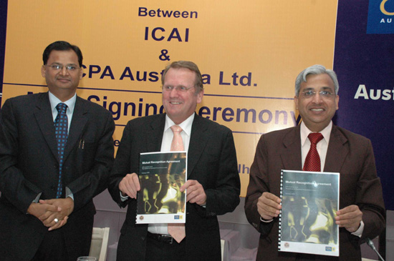
The Institute of Chartered Accountants of India (ICAI) and CPA Australia Ltd, the two largest Chartered Accountancy bodies in the world have decided together by working out a Mutual Recognition Agreement (MRA), which was signed today, to recognize the qualification, training of each other and admit the members in good standing by prescribing a bridging mechanism.
“The instant MRA with CPA Australia by ICAI is a step forward in increased mobility to professionals at either end and would herald a new dimension for businesses globally” said President, ICAI, Ved Jain. Adding further Mr Ved Jain stated “ It also puts the two Accountancy Profession from India and Australia on global radar to play the leadership role in addressing new challenges before profession.”
“A landmark agreement between CPA Australia and ICAI highlights the increasingly global nature of the accounting profession”, said President, CPA Australia, Alex Malley.
As per the Mutual Recognition Agreement reached, members of ICAI who are graduates will be eligible for CPA Australia membership on passing one paper on Business Strategy and Leadership. On the other hand, members of CPA Australia will be eligible for ICAI membership subject to passing two papers on Corporate & Allied Laws and Taxation and two more papers on Advanced Auditing & Professional Ethics and Financial Reporting, if they have not already passed them as a part of the CPA Australia programme.
The papers in respect of bridging mechanism as above would be administered locally by the two institutes. Mutual Recognition Agreement is likely to herald an increased mobility of the professionals in either country.
The MRA will open professional opportunities to our members in Australia and this will bring the two countries, India and Australia, closer.
CPA Australia is one of the Worlds largest accounting bodies, representing 122, 000 finance, accounting and business professionals in Australia, Asia and Europe with 12 overseas divisions and branches.
The Institute of Chartered Accountants of India (ICAI) is a statutory body established under the Chartered Accountants Act, 1949 for the regulation of the profession of Chartered Accountants in India. During its nearly six decades of existence, ICAI has achieved recognition as a premier accounting body not only in the country but also globally, for its contribution in the fields of education, professional development, maintenance of high accounting, auditing and ethical standards. ICAI now is the second largest accounting body in the world.
This MRA comes closer on the heels of an arrangement entered by ICAI with the Institute of Chartered Accountants of England and Wales in November 2008.

