8
_{TAX CONNECT}

325th Issue: 21st November 2021-27th November 2021
12017

Knowledge Partner:



TAX CONNECT

Mumbai : A/1001, Cirrus Bldg, Cosmos Paradise; Pokhran Road No. 1, Thane (West), Maharashtra – 400606
Bangalore: A-414,Carlton Towers,19th Main; Road Hal Old Airport Rd, Domlur, Bengaluru, Karnataka-560008
New Delhi: B-139, 2nd Floor, Transport Nagar, Noida-201301 (U.P)
Kolkata : 1, Old Court House Corner, “Tobacco House” 1st Floor, R.No.-13 (North), Kolkata-700001
: Room No 119; 1st Floor; Diamond Arcade; 1/72, Cal Jessore Road; Kolkata – 700055

Dubai : AziziFeirouz, 803, 8th Floor, AL Furjan, Opposite Discovery Pavillion, Dubai, UAE

Contact: +919874466163; +91 9830661254
Website: www.taxconnect.co.in
Email: info@taxconnect.co.in



Friends,
In some cases where, though the service recipient is located outside India and place of supply of the service is in India as per IGST Act 2017, the payment is received by the service provider located in India not in foreign exchange, but through other modes approved by RBI. In such cases, the supplier will not be fulfilling the condition specified in S. No. 4 of the Circular No. 156/12/2021 dated 21st June 2021, and accordingly, will be required to have dynamic QR code on the invoice.
The issue of dynamic QR code on the invoices in such cases should be available if the payment is received through any RBI approved mode of payment, and not necessarily in foreign exchange has been clarified by the CBIC. The relaxation from dynamic QR code on the invoices in such cases should be available if the payment is received through any RBI approved mode of payment, and not necessarily in foreign exchange.
The clarification has been issued by the CBIC considering various references received from trade and industry seeking further clarification on applicability of Dynamic Quick Response (QR) Code on B2C invoices for compliance of notification 14/2020-Central Tax, dated 21st March, 2020 as amended. In order to ensure uniformity in the implementation of the provisions of the law across the field formations, CBIC has clarified the matter as under:
It is observed that from the present wording of S. No. 4 of Circular No. 156/12/2021 dated 21stJune 2021, doubt arises whether the relaxation from the requirement of dynamic QR code on the invoices would be available to such supplier, who receives payments from the recipient located outside India through RBI approved modes of payment, but not in foreign exchange.
It is mentioned that the intention of clarification as per S. No. 4 in the said circular was not to deny relaxation in those cases, where the payment is received by the supplier as per any RBI approved mode, other than foreign exchange.
Accordingly, to clarify the matter further, the Entry at S. No. 4 of the Circular No. 156/12/2021-GST dated 21st June, 2021 is substituted as below:
" In cases, where receiver of services is located outside India, and payment is being received by the supplier of services, through RBI approved modes of payment, but as per provisions of the IGST Act 2017, the place of supply of such services is in India, then such supply of services is not considered as export of services as per the IGST Act 2017 whether in such cases, the Dynamic QR Code is required on the invoice issued, for such supply of services, to such recipient located outside India? No.
Wherever an invoice is issued to a recipient located outside India, for supply of services, for which the place of supply is in India, as per the provisions of IGST Act 2017, and the payment is received by the supplier, in convertible foreign exchange or in Indian Rupees wherever permitted by the RBI, such invoice may be issued without having a Dynamic QR Code, as such dynamic QR code cannot be used by the recipient located outside India for making payment to the supplier."
Truly Yours
Editor:
Vivek Jalan
Partner - Tax Connect Advisory Services LLP
Co-Editors:
Rohit Sharma
Senior Manager – Tax Connect Advisory Services LLP
Rajanikant Choudhury
Manager - Tax Connect Advisory Services LLP
S.NO. | TOPICS | PAGE NO.
1] | TAX CALENDER | 4
2] | INCOME TAX | 5
CASE LAW | THE PRINCIPAL COMMISSIONER OF INCOME TAX, KOCHI-1 VERSUS M/S LAKSHADWEEP DEVELOPMENT CORPORATION LTD
3] | GST | 6
CIRCULAR | CLARIFICATION ON CERTAIN REFUND RELATED ISSUES
4] | FEMA | 7
DISCUSSION | Procedure for transfer of shares to Non-Resident- (FC-TRS)
5] | CUSTOMS | 8
NOTIFICATION | Rate of exchange of foreign currency equivalent to Indian rupees
6] | DGFT | 9
Trade Notice | AMENDMENT IN RELATION TO NON-PREFERENTIAL CERTIFICATE OF ORIGIN
7] | GST PLEADING AND PRACTICE: WITH SECTION-WISE GST CASES & GST NOTICES AND THEIR REPLIES | 10
8] | IN STANDS - AN INTEGRATED APPROACH TO GST E-INVOICING, E-WAYBILL & E-RETURN FILING | 11
9] | IN STANDS –SECTION WISE COMPENDIUM ON GST | 12
10] | IN STANDS – UNION BUDGET 2021 | 13
11] | LET’S DISCUSS FURTHER | 14

Due date | Form/Return/Challan | Reporting Period | Description
25th November 2021 | CMP-08 | JULY 2021-OCTOBER 2021 | GST Challan Payment for taxpayer, with aggregate turnover of less than INR 5 Crores during preceding year, who has opted for quarterly filing of returns.

CASE LAW
THE PRINCIPAL COMMISSIONER OF INCOME TAX, KOCHI-1 VERSUS M/S LAKSHADWEEP DEVELOPMENT CORPORATION LTD
BRIEF: Exemption u/s 10(26B) - Claim for exemption was rejected by firstly by noting that the assessee is not a Corporation constituted/established under an Act of the Centre, State or Provincial Act, but a Company formed under the Companies Act AND assessee never claimed the status under Section 10(26B) of the Act in any of the previous assessment years - Whether the Tribunal is right in granting exemption to the assessee under Section 10(26B)
OUR COMMENTS:- The incorporation of assessee under the Companies Act gives the assessee the status of a body corporate and the objects, indisputably, of the assessee are promoting the interests of the members of the Scheduled Castes or the Scheduled Tribes or backward classes or of any two or all of them of Lakshadweep Union Territory. The argument of learned Senior Counsel that Corporation established by Provincial Act does not fit into the literal or plain reading of Section 10(26B). The argument that the Corporation is established by the Centre/State by an enactment is unavailable from the expression used in Section 10(26B) of the Act.
This Court is construing Section 10(26B), both by keeping in mind the golden rule of construction and also Noscitur a Sociis, and the inescapable conclusion is that the assessee though incorporated under the Companies Act falls within the ambit of exemption envisaged by Section 10(26B) and is entitled to benefit of exemption.
Centre/State Governments, as the case may be, bring into existence what is known as Government Companies. All these companies are not immediately entitled to be bracketed within the ambit of Section 10(26B) because the existence of that Company is relatable to the primary aim of promoting the interests of the members of the Scheduled Castes or the Scheduled Tribes or backward classes or of any two or all of them. The assessee is a body viz., incorporated under the Companies Act and formed to achieve or promote the interests of the members of the Scheduled Castes or the Scheduled Tribes or backward classes or of any two or all of them, receives full financial assistance from the Government, hence is entitled to exemption. We are in agreement with the reasoning and the conclusion recorded by the Tribunal and for the above reasons as well, substantial question no.1 is answered in favour of the assessee and against the Revenue.

CIRCULAR
CLARIFICATION ON CERTAIN REFUND RELATED ISSUES
OUR COMMENTS: CBDT vide Circular number 166/22/2021-GST dated 17th November 2021, issued clarification in the matter of certain issues relating to refund as under:
Issue | Clarification
Whether the provisions of subsection (1) of section 54 of the CGST Act regarding time period, within which an application for refund can be filed, would be applicable in cases of refund of excess balance in electronic cash ledger. | No, the provisions of sub-section (1) of section 54 of the CGST Act regarding time period, within which an application for refund can be filed, would not be applicable in cases of refund of excess balance in electronic cash ledger.
Whether certification/ declaration under Rule 89(2)(l) or 89(2)(m) of CGST Rules, 2017 is required to be furnished along with the application for refund of excess balance in electronic cash ledger | No, furnishing of certification/ declaration under Rule 89(2)(l) or 89(2)(m) of the CGST Rules, 2017 for not passing the incidence of tax to any other person is not required in cases of refund of excess balance in electronic cash ledger as unjust enrichment clause is not applicable in such cases.
Whether refund of TDS/TCS deposited in electronic cash ledger under the provisions of section 51 /52 of the CGST Act can be refunded as excess balance in cash ledger | The amount deducted/collected as TDS/TCS by TDS/ TCS deductors under the provisions of section 51 /52 of the CGST Act, as the case may be, and credited to electronic cash ledger of the registered person, is equivalent to cash deposited in electronic cash ledger. It is not mandatory for the registered person to utilise the TDS/TCS amount credited to his electronic cash ledger only for the purpose for discharging tax liability. The registered person is at full liberty to discharge his tax liability in respect of the supplies made by him during a tax period, either through debit in electronic credit ledger or through debit in electronic cash ledger, as per his choice and availability of balance in the said ledgers. Any amount, which remains unutilized in electronic cash ledger, after discharge of tax dues and other dues payable under CGST Act and rules made thereunder, can be refunded to the registered person as excess balance in electronic cash ledger in accordance with the proviso to sub-section (1) of section 54, read with sub-section (6) of section 49 of CGST Act.
Whether relevant date for the refund of tax paid on supplies regarded as deemed export by recipient is to be determined as per clause (b) of Explanation (2) under section 54 of CGST Act and if so, whether the date of return filed by the supplier or date of return filed by the recipient will be relevant for the purpose of determining relevant date for such refunds | Clause (b) of Explanation (2) under Section 54 of CGST Act reads as under: “(b) in the case of supply of goods regarded as deemed exports where a refund of tax paid is available in respect of the goods, the date on which the return relating to such deemed exports is furnished;” On perusal of the above, it is clear that clause (b) of Explanation (2) under section 54 of the CGST Act is applicable for determining relevant date in respect of refund of amount of tax paid on the supply of goods regarded as deemed exports, irrespective of the fact whether the refund claim is filed by the supplier or by the recipient. Further, as the tax on the supply of goods, regarded as deemed export, would be paid by the supplier in his return, therefore, the relevant date for purpose of filing of refund claim for refund of tax paid on such supplies would be the date of filing of return, related to such supplies, by the supplier
DISCUSSION
Procedure for transfer of shares to Non-Resident- (FC-TRS)
OUR COMMENTS: Concept of FCTRS :
1. The Form FC-TRS shall be file within 60 days from the date of receipt/date of payment of the amount of consideration.
2. There will be no official fee for filing of form FC-TRS, if the form is filed within 60 days .
3. Form shall be filed by the transferor/transferee whosoever is resident in India.
4. The transferor/transferee filing the form shall first register itself with RBI-Firms portal before filing it.
5. The consent letter of both buyer and seller is mandatory to be attached with form FC-TRS.
6. Valuation of shares to be transferred must be as per FDI norms.
7. Sectoral Limits applicable on the company must be taken care of before transferring shares.
8. Share purchase Agreement shall be executed
Registration on RBI-FIRMS Portal
Following 2 registrations are required on RBI FIRMS portal before you can file the form:
- The applicant reporting the transaction should get Entity user registration by visiting https://firms.rbi.org.in
- After getting the Entity user registration, the entity required to get the business user registration as well.
For this, one need to visit on https://firms.rbi.org.in/firms/ and select Registration Form for Business User and fill the necessary details and attach the authorization letter.
Please note that this registration can also be availed by an individual in the case where a resident individual is required to report.
Transfer of securities
The following steps are to be followed for successful registration of transfer of securities from Resident to Non-Resident:
1. On receipt of consideration from non-resident, obtain FIRC (Foreign Inward Remittance certificate) and KYC (Know your customer) of person residing outside India from AD Category-I bank.
2. Submit Security transfer deed/SH-4 and other documents required with the company.
3. Company shall register the transfer in accordance with Companies Act 2013.
4. File FC-TRS along with the attachments on FIRMS RBI Portal by logging in with Id password created for Business User Registration.
5. RBI shall approve FC-TRS if it is filed without any discrepancies.

NOTIFICATION
Rate of exchange of foreign currency equivalent to Indian rupees
OUR COMMENTS: The Central Board of Indirect Taxes & Customs, hereby makes the following amendments vide notification 91/2021-CUSTOMS (N.T.) dated 15th November 2021, in the notification No. 36/2001-Customs (N.T.), dated the 3rd August, 2001, published in the Gazette of India, Extraordinary, Part-II, Section-3, Sub-section (ii), vide number S. O. 748(E), dated the 3rd August, 2001, namely:-
In the said notification, for TABLE-1, TABLE-2, and TABLE-3 the following Tables shall be substituted, namely: -
SCHEDULE-I
Sl. No. | Chapter/ heading/ sub-heading/tariff item | Description of goods | Tariff value  (US $Per Metric Tonne)
(1) | (2) | (3) | (4)
1 | 1511 10 00 | Crude Palm Oil | 1268
2 | 1511 90 10 | RBD Palm Oil | 1288
3 | 1511 90 90 | Others – Palm Oil | 1278
4 | 1511 10 00 | Crude Palmolein | 1295
5 | 1511 90 20 | RBD Palmolein | 1298
6 | 1511 90 90 | Others – Palmolein | 1297
7 | 1507 10 00 | Crude Soya bean Oil | 1421
8 | 7404 00 22 | Brass Scrap (all grades) | 5678

Table 2
1. | 71 or 98 | Gold, in any form, in respect of which the benefit of entries at serial number 356 of the Notification No. 50/2017-Customs dated 30.06.2017 is availed | 599 per 10 grams
2. | 71 or 98 | Silver, in any form, in respect of which the benefit of entries at serial number 357 of the Notification No. 50/2017-Customs dated 30.06.2017 is availed | 805 per kilogram
3. | 71 | i. Silver, in any form, other than medallions and silver coins having silver content not below 99.9% or semi-manufactured forms of silver falling under sub-heading 7106 92;ii. Medallions and silver coins having silver content not below 99.9% or semi-manufactured forms of silver falling under sub-heading 7106 92, other than imports of such goods through post, courier or baggage. | 805 per kilogram
4. | 71 | i. Gold bars, other than tola bars, bearing manufacturer’s or refiner’s engraved serial number and weight expressed in metric units;ii. Gold coins having gold content not below 99.5% and gold findings, other than imports of such goods through post, courier or baggage. | 599 per 10 grams

Table 3

(1) | (2) | (3) | (4)
1 | 080280 | Areca nuts | 5252(i.e., no change)”

[For further details please refer the Notification]

NOTIFICATION
Amendment in RELATION TO Non-Preferential Certificate of Origin
OUR COMMENTS: In continuation to the earlier Trade Notice 42/2020-2021 dated 19.02.2021, 48/2020-2021 dated 25.03.2021, 10/2021-2022 dated 19.07.2021, 19/2021-2022 dated 01.10.2021 and 21/2021-22 dated 18.10.2021, it is informed vide notification number 41/2015-2020 dated 8th November 2021, that the electronic platform for Certificate of Origin (CoO) (URL: https://coo.dgft.gov.in) has been expanded to facilitate electronic filing and issuance for Non-Preferential Certificates of Origin. The objective of this platform is to provide an electronic, contact-less single window for the CoO related processes.

2. In this reference, it is informed that the transition period for mandatory filing of applications for Non-Preferential Certificate of Origin through the e-CoO Platform has been extended till 31st January 2022. The existing systems for submitting and processing non-preferential CoO applications in manual/paper mode is being allowed for the stated time period and the online system is not being made mandatory.

3. All Agencies as notified under Appendix-2E are required to ensure their onboarding process is completed at the earliest and no later than 31st January 2022. Reference Trade Notice 21/2021-22 dated 18.10.2021, it
is submitted that all Agencies notified under Appendix-2E, are required to ensure that the onboarding exercise is completed latest by 31st January 2022 failing which the agencies shall be de-notified from Appendix 2E
4. All Exporters concerned are requested to ensure that they are duly registered onto the said platform at the earliest. Any technical/procedural issues may be brought to the attention of the CoO Helpdesk within the time prescribed. For guidance on registration and application submission process, the Help Manual & FAQs may be accessed on the landing page at https://coo.dgft.gov.in .

For any further assistance you may utilize any of the following channels — • Raise a service request ticket through the DGFT Helpdesk service • Send an email to DGFT CoO Helpdesk at coo-dgft@gov.in • Call the toll-free DGFT Helpdesk numbers.

[For further details please refer the Trade Notice]

:IN STANDS

GST PLEADING AND PRACTICE: With Section-wise GST Cases & GST Notices and their Replies
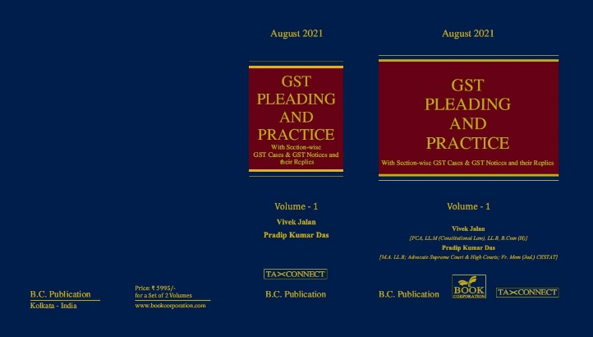

ABOUT THE BOOK: This publication includes:
1. GST Notices and their Replies
2. Orders and Appeals under GST
3. Text of provisions under IGST Act 2017 & CGST Act 2017
4. CGST & IGST Section-wise Synopsis of Case Laws and Notification/Circulars Gist
5. CGST & IGST Section-wise Synopsis of “Question of Law” answered under GST
6. Completely Updated Synopsis of Case Laws under GST by Supreme Court, High Court, AAARs & AARs

Authors:
Vivek Jalan
[FCA, LL.M (Constitutional Law), LL.B, B.Com(H)]

Pradip Kumar Das
[M.A. LL.B; Advocate Supreme Court & High Courts; Fr. Mem (Jud.) CESTAT]

Published by: In Association With:
BOOK CORPORATION TAX CONNECT ACADEMY
4, R. N. Mukherjee Road 1, Old Court House Corner
Kolkata 700001 Kolkata 700001
Phones: (033) 64547999 Phones: (033) 40016761
Cell : 9830010297, 9331018333 Cell : 9874466163, 9830661254
Order by email:bookcorporation@gmail.com Order by email: info@taxconnect.co.in Website :www.bookcorporation.com Website: : www.taxconnect.co.in

:IN STANDS

AN INTEGRATED APPROACH TO GST E-INVOICING, E-WAYBILL & E-RETURN FILING
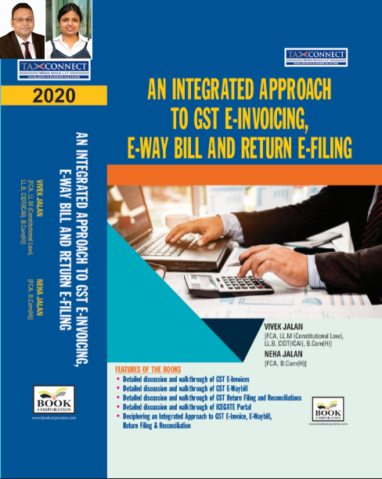
ABOUT THE BOOK: This publication includes:
- Detailed discussion and walkthrough of GST E-Invoices.
- Detailed discussion and walkthrough of GST E-Waybill.
- Detailed discussion and walkthrough of GST Return Filing and Reconciliations.
- Detailed discussion and walkthrough of ICEGATE Portal.
- Deciphering an Integrated Approach to GST E-Invoice, E-Waybill, Return Filing & Reconciliation

Authors:
Vivek Jalan
[FCA, L.LM (Constitutional Law), L.LB, CIDT(ICAI), B.Com(H)]

Neha Jalan
[FCA, B.Com(H)]

Published by: In Association With:
BOOK CORPORATION TAX CONNECT ACADEMY
4, R. N. Mukherjee Road 1, Old Court House Corner
Kolkata 700001 Kolkata 700001
Phones: (033) 64547999 Phones: (033) 40016761
Cell : 9830010297, 9331018333 Cell : 9874466163, 9830661254
Order by email:bookcorporation@gmail.com Order by email: info@taxconnect.co.in Website :www.bookcorporation.com Website : www.taxconnect.co.in

:IN STANDS

Section wise Compendium on GST
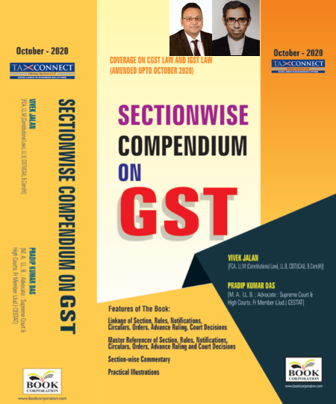
ABOUT THE BOOK: This publication includes:
1. Linkage of Section, Rules, Notifications, Circulars, Orders, Advance Ruling, Court Decisions
2. Master Referencer of Section, Rules, Notifications, Circulars, Orders, Advance Ruling and Court Decisions
3. Section-wise Commentary
4. Practical Illustrations

Authors:
Vivek Jalan
[FCA, L.LM (Constitutional Law), L.LB, CIDT(ICAI), B.Com(H)]

Pradip Kumar Das
[M.A. LL.B; Advocate Supreme Court & High Courts; Fr. Mem (Jud.) CESTAT]

Published by: In Association With:
BOOK CORPORATION TAX CONNECT ACADEMY
4, R. N. Mukherjee Road 1, Old Court House Corner
Kolkata 700001 Kolkata 700001
Phones: (033) 64547999 Phones: (033) 40016761
Cell : 9830010297, 9331018333 Cell : 9874466163, 9830661254
Order by email:bookcorporation@gmail.com Order by email: info@taxconnect.co.in Website :www.bookcorporation.com Website : www.taxconnect.co.in

:IN STANDS

UNION BUDGET 2021
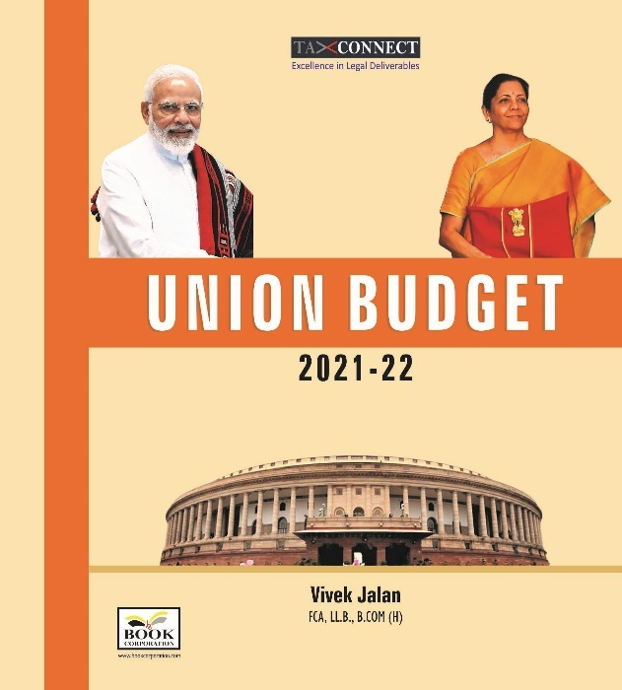
ABOUT THE BOOK: This publication includes:
1.Commentary on Budget
2.Finance Minister’s Budget Speech
3.Budget at a Glance
4.Memorandum
a. Direct Tax
b. Customs
c. Excise
d. GST
5. Finance Bill
6. Notes on Clauses

Authors:
Vivek Jalan
[FCA, L.LM (Constitutional Law), L.LB, CIDT(ICAI), B.Com(H)]

Published by: In Association With:
BOOK CORPORATION TAX CONNECT ACADEMY
4, R. N. Mukherjee Road 1, Old Court House Corner
Kolkata 700001 Kolkata 700001
Phones: (033) 64547999 Phones: (033) 40016761
Cell : 9830010297, 9331018333 Cell : 9874466163, 9830661254
Order by email:bookcorporation@gmail.com Order by email: info@taxconnect.co.in Website :www.bookcorporation.com Website : www.taxconnect.co.in

LET’S DISCUSS FURTHER!

OUR OFFICES:




DUBAI
Azizi Feirouz, 803, 8th Floor, AL Furjan, Opposite Discovery Pavillion, Dubai, UAE
Contact Person: Rohit Sharma
Email: rohit.sharma@taxconnect.co.in

KOLKATA
R No 119; 1st Floor; Diamond Arcade; 1/72, Cal Jessore Road; Kolkata – 700055
Contact Person: Priyanka Chowdhury
Email: priyanka.chowdhury@taxconnect.co.in

KOLKATA
1, Old Court House Corner, “Tobacco House”, 1st Floor, Room No. 13 (N), Kolkata-700001
Contact Person: Priyanka Chowdhury
Email: priyanka.chowdhury@taxconnect.co.in

MUMBAI
Building No.9, Flat- 403, LodhaEternis, 11th Road, MIDC, Andheri(E)-400093
Contact Person: Rajanikant Choudhury
Email: rajnikant.choudhary@taxconnect.co.in
DELHI
B-139, 2nd Floor, Transport Nagar, Noida-201301 (U.P)
Contact Person: Poonam Khemka
Email: poonam.khemka@taxconnectdelhi.co.in

BANGALORE
A-414,Carlton Towers, 19th Main; Road Hal Old Airport Rd, Domlur, Bengaluru, Karnataka-560008
Contact Person: Manmit Sinha
Email: manmit.sinha@taxconnectdelhi.co.in

Disclaimer:
This e-bulletin is for private circulation only. Views expressed herein are of the editorial team and are based on the information, explanation and documents available on Government portal platforms. Tax Connect or any of its employees do not accept any liability whatsoever direct or indirect that may arise from the use of the information contained herein. No matter contained herein may be reproduced without prior consent of Tax Connect. While this e-article has been prepared on the basis of published/other publicly available information considered reliable, we do not accept any liability for the accuracy of its contents.
Tax Connect 2021. All rights reserved.

