CASE: COMPENSATION RECEIVED BY A PARTNER FROM THE OTHER EXISTING PARTNERS FOR REDUCTION OF PROFIT SHARING RATIO WILL NOT AMOUNT TO CAPITAL GAIN TAX.

CASE OF
M/S ANIK INDUSTRIES LTD
V/S
DCIT
“IN ITAT MUMBAI BENCH”

1) M/S ANIK INDUSTRIES ENGAGED IN THE BUSINESS OF MANUFACTURING AND MILK PRODUCTS ALSO IN WIND GENERATION, MINING AND TRADING. INCOME OF ASST. YEAR 2010-2011 WAS ASSESSED UNDER SECTION 143(3) BY ASSESSING OFFICER OF 1419.55 LACS AGAINST WHICH ASSESSEE FILED INCOME OF 1019.10 LACS.

2) ADDITION OF 400 LACS WHICH WAS RECEIVED BY ASSESSEE FOR SURRENDER OF SHARE IN A PARTNERSHIP FIRM WAS BROUGHT TO TAX BY AO UNDER CAPITAL GAINS.

3) ASSESSEE WAS PARTNER IN M/S MAHAKOSH PROPERTY DEVELOPERS WITH A PROFIT SHARING RATIO OF 30%. DURING THE YEAR ASSESSEE REECEIVED 400 LACS ON ACCOUNT OF SURRENDER OF 5% SHARE FROM THE OLD PARTNERS WHO GET THE SHARE OF RIGHT EQUALLY WHICH GET ITS PROFIT SHARING RATIO TO 25%. ASSESSEE RELIED ON THE DECISION OF HON’BLE MADRAS HIGH COURT IN A.K.SHARFUDDIN V. CIT (1960 39 ITR 333) (IN WHICH HIGH COURT SAID THAT THE AMOUNT RECEIVED FOR RELINQUISHMENT OF RIGHT IN PARTNERSHIP IS A CAPITAL RECEIPT AND NO TRANSFER UNDER SECTION 45(4).

4) AO WAS OF OPINION THAT ONE OF THE METHOD TO PAY OFF THE GOODWILL IN CASE OF RECONSTITUTION OF FIRM AN INCOMING PARTNER PAYS OFF THE GOODWILL TO OLD PARTNER ITSELF WITHOUT INVOLVING THE FIRM. AO REFERED THE DECISION OF AHMEDABAD TRIBUNAL IN SAMIR SURYAKANT SHETH V. ACIT AND SUCH AMOUNT IS BROUGHT TO TAX BY UNDER SECTION 45(1):

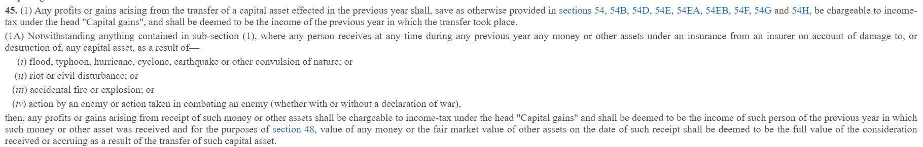

5) THIS CASE WAS REFERED TO LD. CIT (A). CIT (A) HOLD THE DECISION OF AO BY STATING THIS:
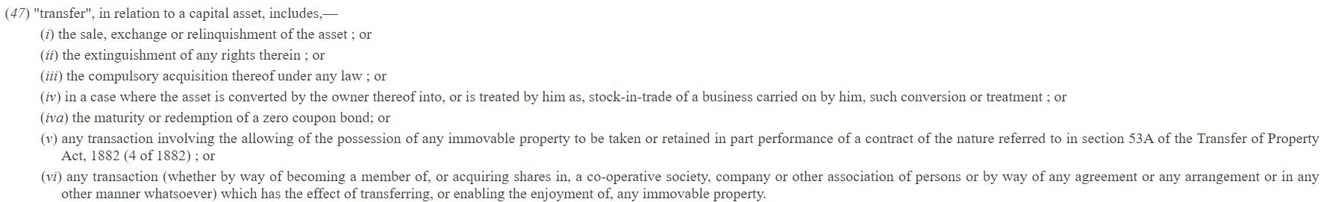
THE ASSESSING OFFICER BROUGHT TO TAX RS 4 CRORE AS CAPITAL GAIN U/S 45(1) OF THE ACT HOLDING THAT THE SUM OF RS 4 CRORE WAS RECEIVED BY THE APPELLANT COMPANY ON ACCOUNT OF RELINQUISHMENT OF ITS RIGHT IN THE SHARES TO THE EXTENT OF 5%.THE APPELLANT COMPANY DURING THE COURSE OF APPEAL PROCEEDINGS CONTENDED THAT SUCH RECEIPT IS NEITHER REVENUE RECEIPT NOR TAXABLE UNDER THE HEAD CAPITAL GAINS. THE SUBMISSIONS OF THE APPELLANT ARE NOT ACCEPTABLE. SECTION 2(47) OF THE ACT DEFINES THE TERM "TRANSFER". RELINQUISHMENT OF THE ASSET AND THE EXTINGUISHMENT OF ANY RIGHTS THEREIN ARE INCLUDED AS 'TRANSFER' UNDER THE PROVISIONS OF SECTION 2(47) OF THE ACT.

6) AGGREIVED ASSESEE FURTHER MOVES TO THE ITAT.ITAT SAYS FIRSTLY APPLICATION OF SECTION 45(4) IS NOT APPLICABLE OF WHICH SUCH CONTENTION IS GIVEN BY ASSESSEE IN PARA 3. SECTION 45(4) IS APPLICABLE ONLY WHEN THERE’S DISTRIBUTION OF CAPITAL ASSETS BY FIRM TO ITS PARTNERS AT THE TIME OF DISSOLUTION OF FIRM. DURING THE YEAR SUCH PARTNER HAS OPENING BALANCE OF 2321.60 LACS IN HIS CURRENT ACCOUNT. AN AMOUNT OF 400 LACS WAS DEBITED TO THE CURRENT ACCOUNT BY CREDITING THE AMOUNT OF 80 LACS EQUALLY FROM THE FIVE PARTNERS. A NEW PARTNERSHIP DEED WAS FORMED AS ON 31/03/2010 WHICH MEANS THAT BUSINESS OF SUCH FIRM IS CONTINUING AND SUCH PARTNER IS ALREADY ENGAGED IN THE BUSINESS WITH LESS PROFIT SHARING RATIO.
SO THIS MEANS THAT THE FIRM IS CONTINUING OTS BUSINESS AND THEREFORE NO CASE OF RETIREMENT AND APPLICABILITY OF SECTION 45 (4). BUT THE QUESTION IS WHETHER SECTION 45(1) WILL BE APPLICABLE OR NOT WHICH I DEFINED EARLIER.

7) WE FIND THAT THE ANSWER TO AFORESAID QUESTION LIES IN THE DECISION OF HON'BLE KARNATAKA HIGH COURT IN CIT V. P.N.PANJAWANI WHICH IS AS BELOW:

The Assessing Authority relying on the judgment of the Apex Court in the case of Malbar Fisheries Co., (supra) has proceeded on the assumption that the partnership firm has no legal existence. The partnership property will vest in all the partners and in that sense, every partner has an interest in the property of the partnership. The partnership firm under the Indian Partnership Act, 1932 is not a distinct legal entity
But at the same time, the firm as such has no will of its own although, it is an assessable entity under the provisions of the Act. Therefore, he was of the view that when the existing three partners having a share of 1/3rd each in the assets of the firm have relinquished their 50% share i.e., from 1/3rd to 16.67% in favour of the four new partners on account of which each of the three partners were able to gain a sum of Rs. 1, 16, 66,666/- each. By the said relinquishment of their share by 50% it has resulted in a capital gain accrued even though the firm continued after its reconstitution.
Section 14 of the Indian Partnership Act, 1932 deals with the property of the firm, which reads as under: -
14. The property of the firm - Subject to contract between the partners, the property of the firm includes all property and rights and interests in property originally brought into the stock of the firm, or acquired, by purchase or otherwise, by or for the firm, or for the purposes and in the course of the business of the firm, and includes also the goodwill of the business.
Unless the contrary intention appears, property and rights and interest in property acquired with money belonging to the firm are deemed to have been acquired for the firm.
It is in this background if we look at the background of this case, the landed property was not owned by the erstwhile partners. It was owned by the partnership firm. May be the erstwhile partners had l/3rd share each in all the partnership assets including this assets. On reconstitution of the firm, four more partners were inducted, who contributed Rs.2.50 crores as their capital contribution. Thus, the inducted partners also became partners in the firm and the firm continue to assets own, including this, landed property. The erstwhile partners withdrew the money brought in by the incoming partners as drawings, they did not retire from the partnership firm. They continued to be the partners of the firm. However, their share got reduced. In other words, 50% of their share held before reconstitution became the share of the incoming partners. As the property was not owned by this erstwhile partners, it cannot be said they transferred 50% in favour of incoming partners and any amount represents the consideration received for such transfer and as such it is liable for payment of capital gains under Section 45 (1) of the Act. It is because they did not transfer the capital assets. Insofar as arguments with regard to the reconstitution, their share got reduced and the amount which was withdrawn and partnership represents inducted partners along with erstwhile partners
In the instant case, as the assessee was not the owner of this capital asset, the question of relinquishing their interest in that asset or extinguishment of their right in their asset would not arise. The assets belong to the firm. The incoming partners paid money to the firm by way of their capital contribution. The firm as such has not relinquished its interest in favour of the incoming partners. On the contrary, by inducting them, they are also entitled to interest in the said assets
CONLUSION: IN SIMPLE WORDS, PARTNERSHIP ACT 1932 DOESN’T TERM PARTNERSHIP AS “SEPARATE LEGAL ENTITY”. BUT IN INCOME TAX ACT, 1961 FIRM IS A SEPARATE LEGAL ENTITY. ALL THE ASSETS OF FIRM ARE DEEMED TO BE OWNED BY FIRM. AND ANY RIGHTS ON SUCH ASSETS WHICH ARE OWNED BY PARTNERS WOULD NOT AMOUNT TO CAPITAL GAIN UNDER SECTION 45 (1) BECAUSE SUCH CAN’T BE SAID TO A TRANSFER UNDER SECTION 2 (47) IN WHICH RELINQUISHMENT AND EXTINGUISHMENT OF RIGHT IN SUCH ASSETS ARE GIVEN. AND ALSO OF THE FACT THAT FIRM OWNS 100% SHARE OF THE ASSETS AND SUCH SHARE HAS NOT BEEN TRANSFERRED BY THE FIRM TO ANYONE. THE RIGHT OF THIS ASSETS WHICH WILL BE USED TO EARN PROFITS, REPAY DEBTS AND OTHER LIABILITES AT THE TIME OF DISSOLUTION ARE IN 100% CONTROL OF FIRM AND “ HENCE SUCH CONSIDERATION OF 400 LACS WOULDN’T BE TAXAXBLE IN THE HANDS OF M/S ANIK INDUSTRIES LTD.

