- Procedure to File Online Challan Correction Through CompuTds:
Now that you have paid tax deducted to the account of Central Government, what if there is any inadvertent mistake while making payment such as choosing wrong assessment year, choosing a wrong major head code, entering the wrong amount, wrong PAN / TAN etc and challan is already generated? Such errors lead to no tax credit situation for the deductee. The tax department does understand that such clerical errors are unavoidable and has provided for a mechanism to correct such errors. Let us understand the procedure to correct errors in TDS challan.
- Step 1 : Login in the Software
- Firstly, click on “CompuOffice Online” for login into software.
- When we click on Icon it displays login page. Then, enter login credentials for further process.
- Then, select “TDS” tab which is shown after login into “CompuOffice Online”.
(CompuOffice Online > Login Page > TDS)
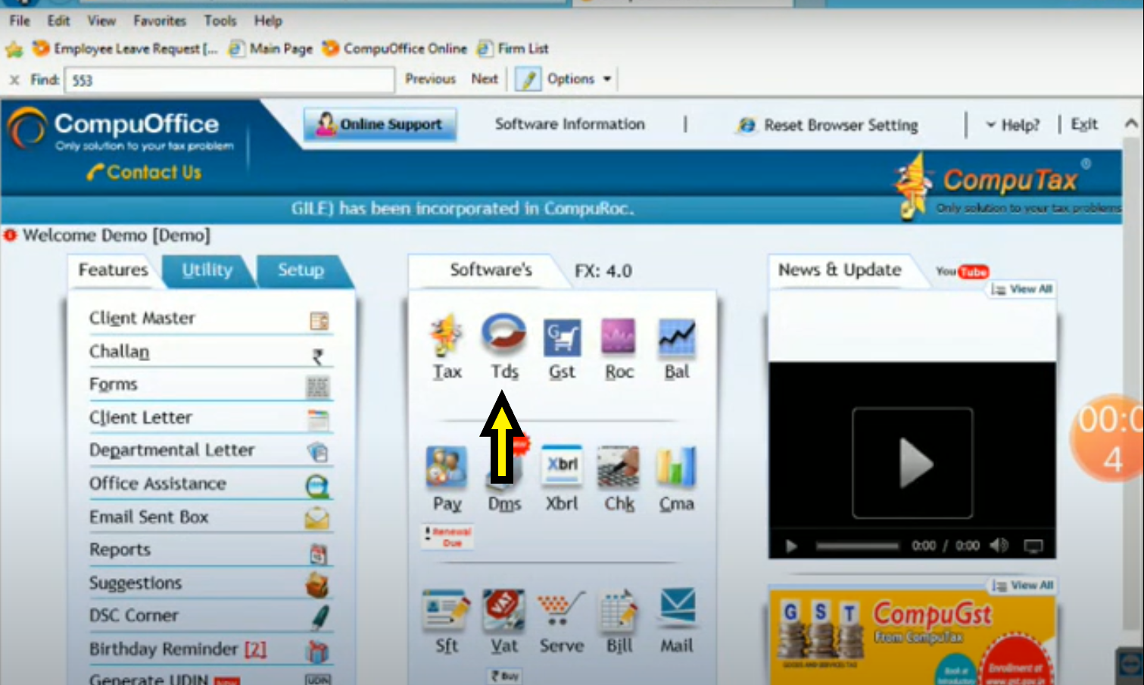
- After selecting “TDS” tab it displays screen which shows list of clients for selecting appropriate client name.
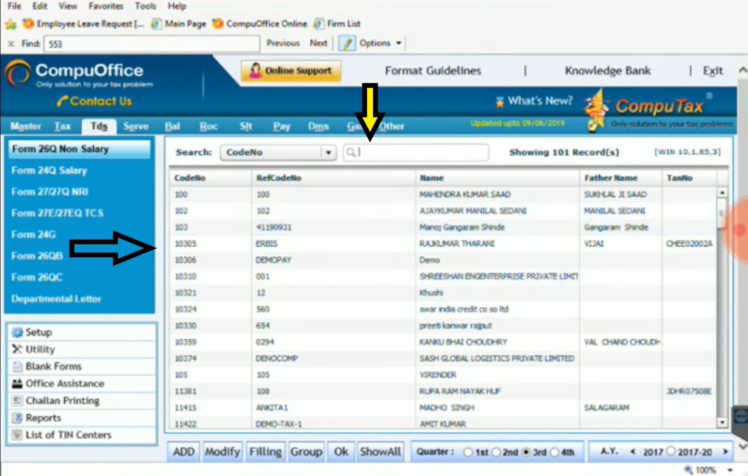

- Step 2: Process For Creating Revised Return
- If you want to create revised return in the CompuTds Software you must enter the “Return Filing Entry” from acknowledgement which is received at the time of submitting original return. Without return filing entry you cannot revised return or submit online challan correction request.
- After selecting party from data, Firstly Click on the “Create Revised Return” tab for further process.
(Login > TDS > Select Party > Create Revised Return)
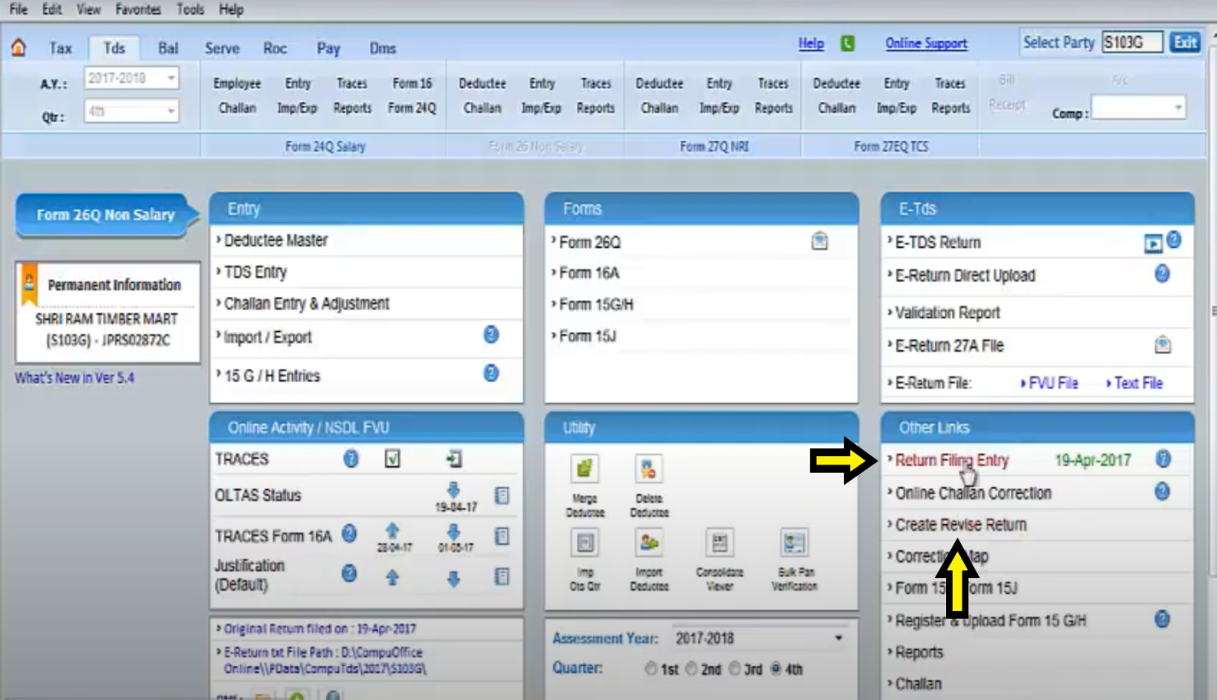

- After click on the “Create Revise Return” tab screen displays like below image and it open a tabs for editing or adding challan for online correction.
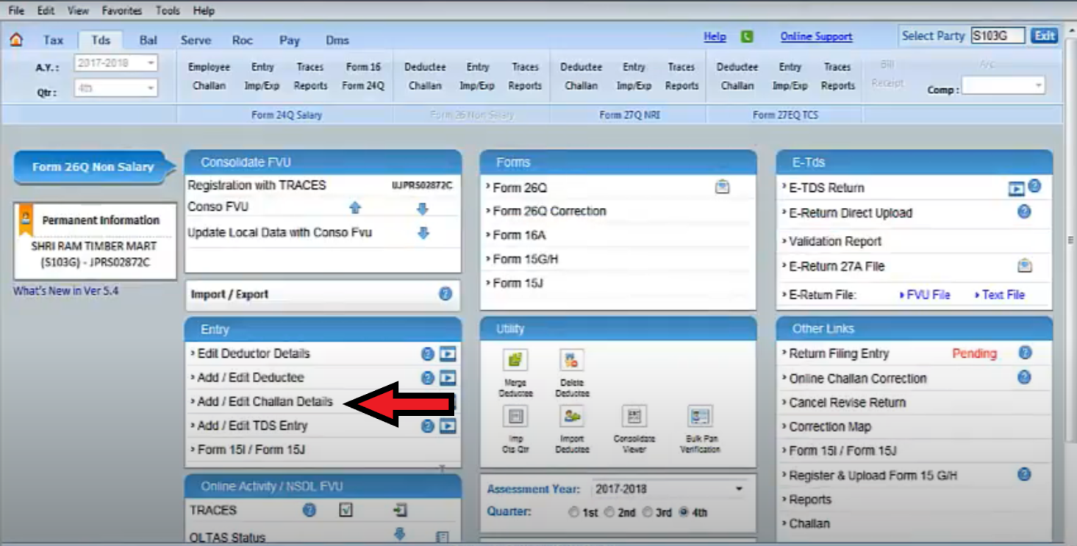

- Step 3: Add/ Edit Challan Details
- When tab opens for add/ edit challan details we further process for add or edit challan details which is already in the original return.
- After click on the “Add/ Edit Challan Details” tab we see already entered challan. We displays screen like below image.
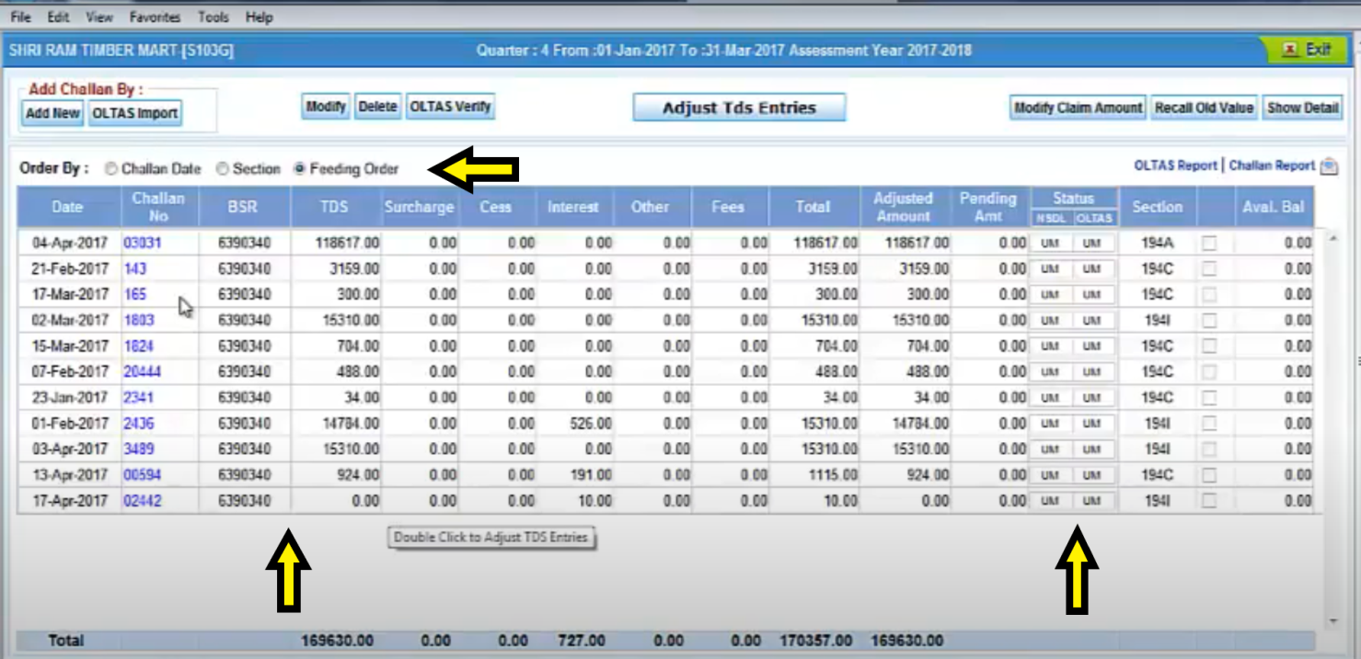
- In this tab we can add challan which is not entered in original return or also we can edit challan which already in the original return.
- After changing challan details added challan or edited challan has been highlighted by colours. (Screen displays as below image)
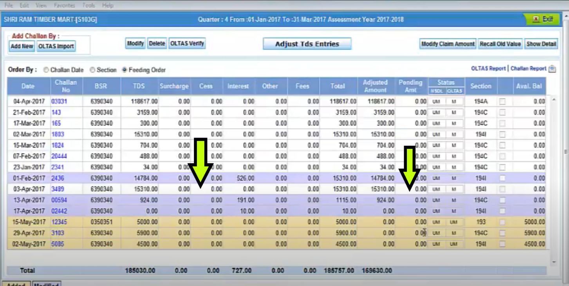
- Then, we display a message for online challan correction which is added or edited challan in the software.
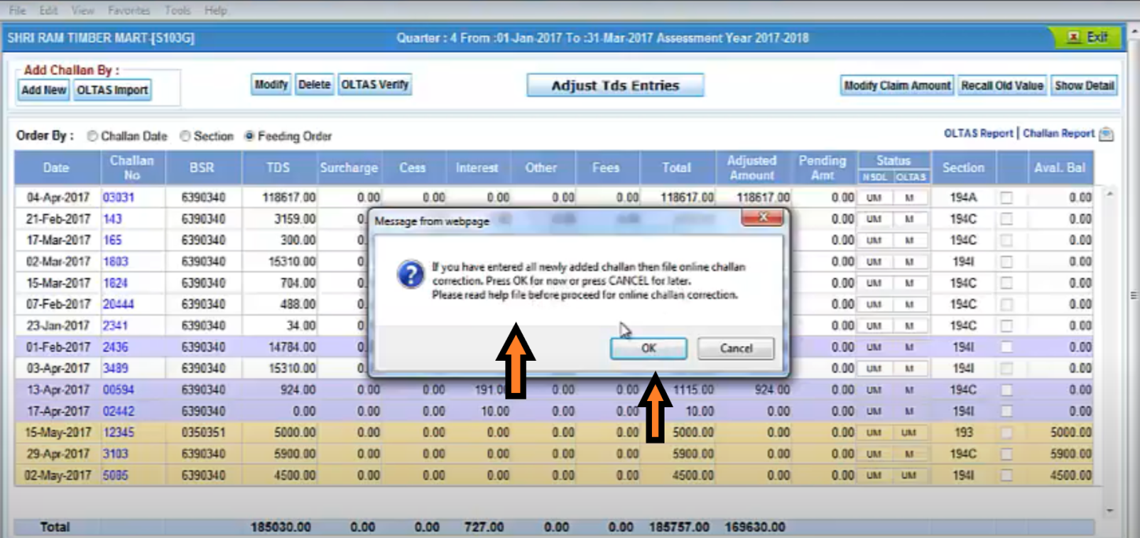

- Step 4: Online Challan Correction
- When we click on “Online Challan Correction” tab we transfer on the screen of selecting the appropriate option of adding the challan or modify the challan and then we further process for correction at traces site.
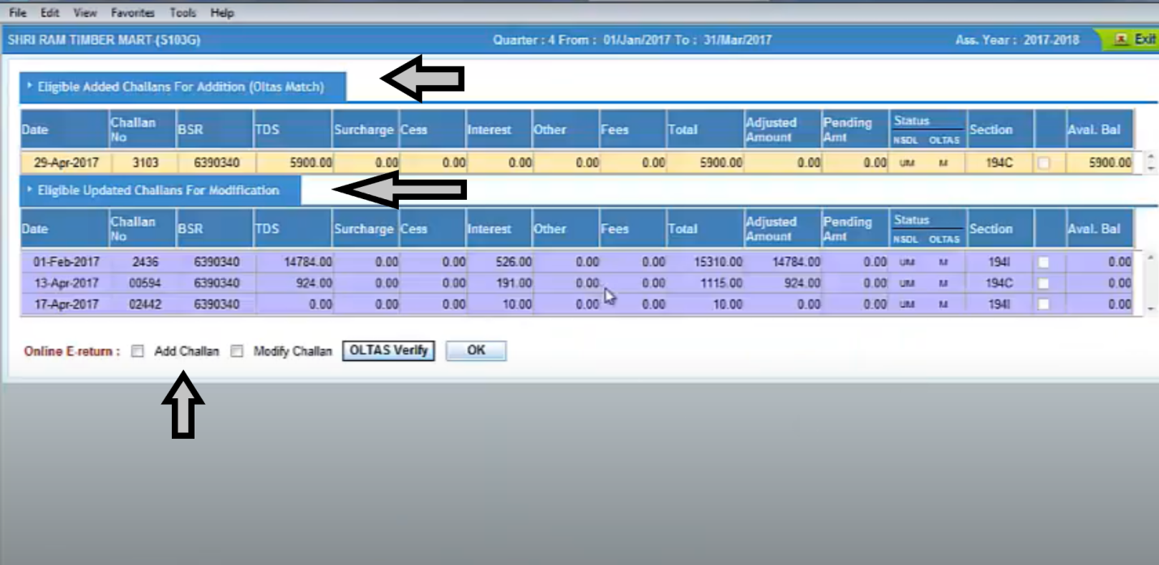
- We can tick on “Add Challan” or /and “Modify Challan” and Press on “Ok” tab for further process on the traces.
- We can also verify challan at OLTAS for that click on the “OLTAS Verify” icon.
- After click on the “Ok” icon software automatically go to traces site and then start process on the traces site.
- When traces additional which we want to add are available with traces it shows message and then we click on “Ok” for process further.
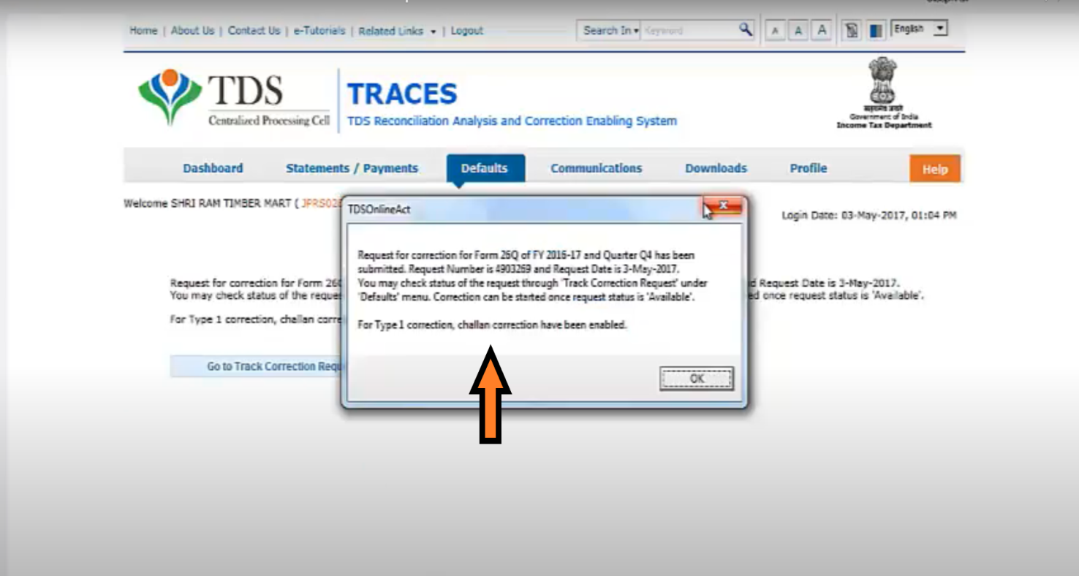

- After clicking on the “Ok” we traces started to request for online challan correction. (When traces process the request screen displays like below image)
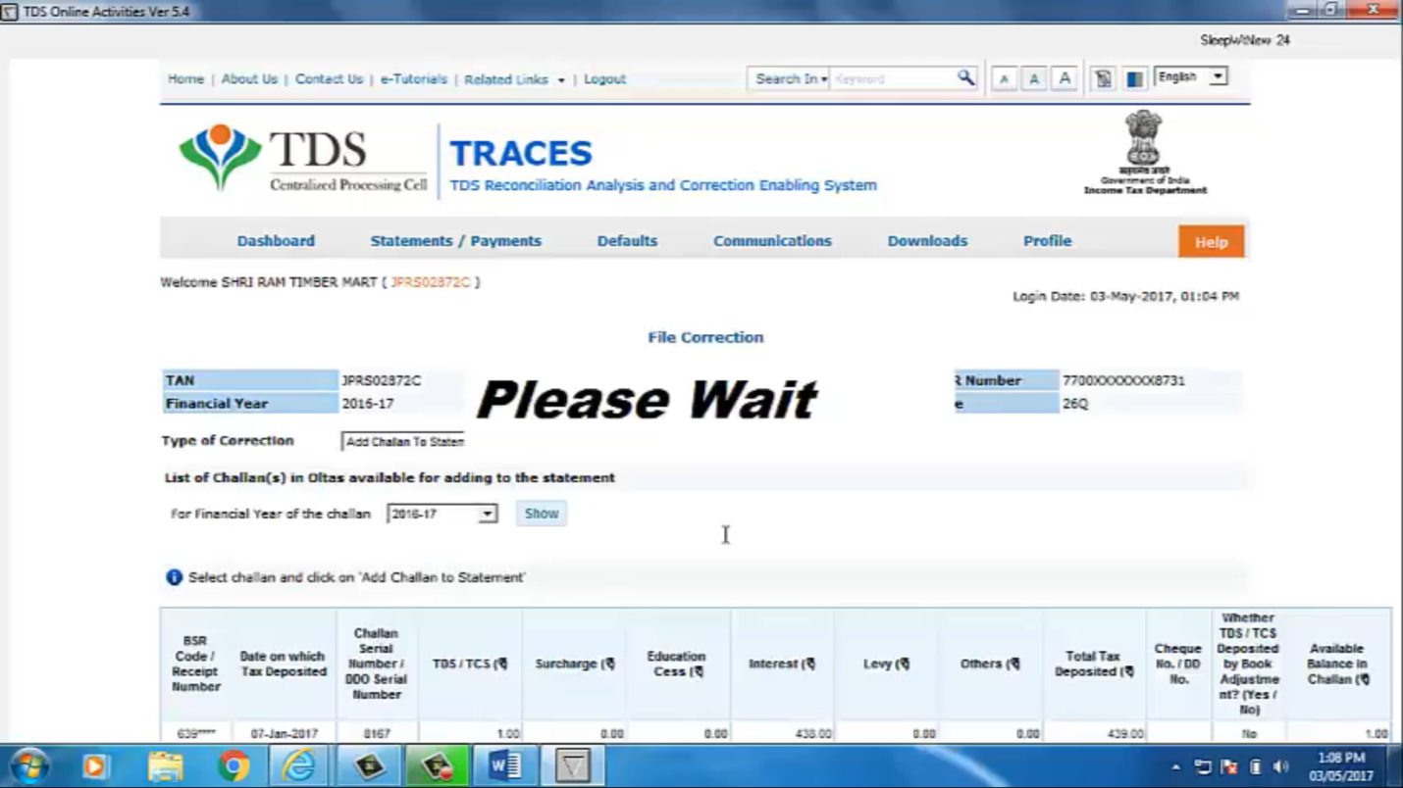
- Then, at final stage traces shows the message for final submission of request of challan correction. When we press “Yes” icon request for challan correction has been submitted finally.
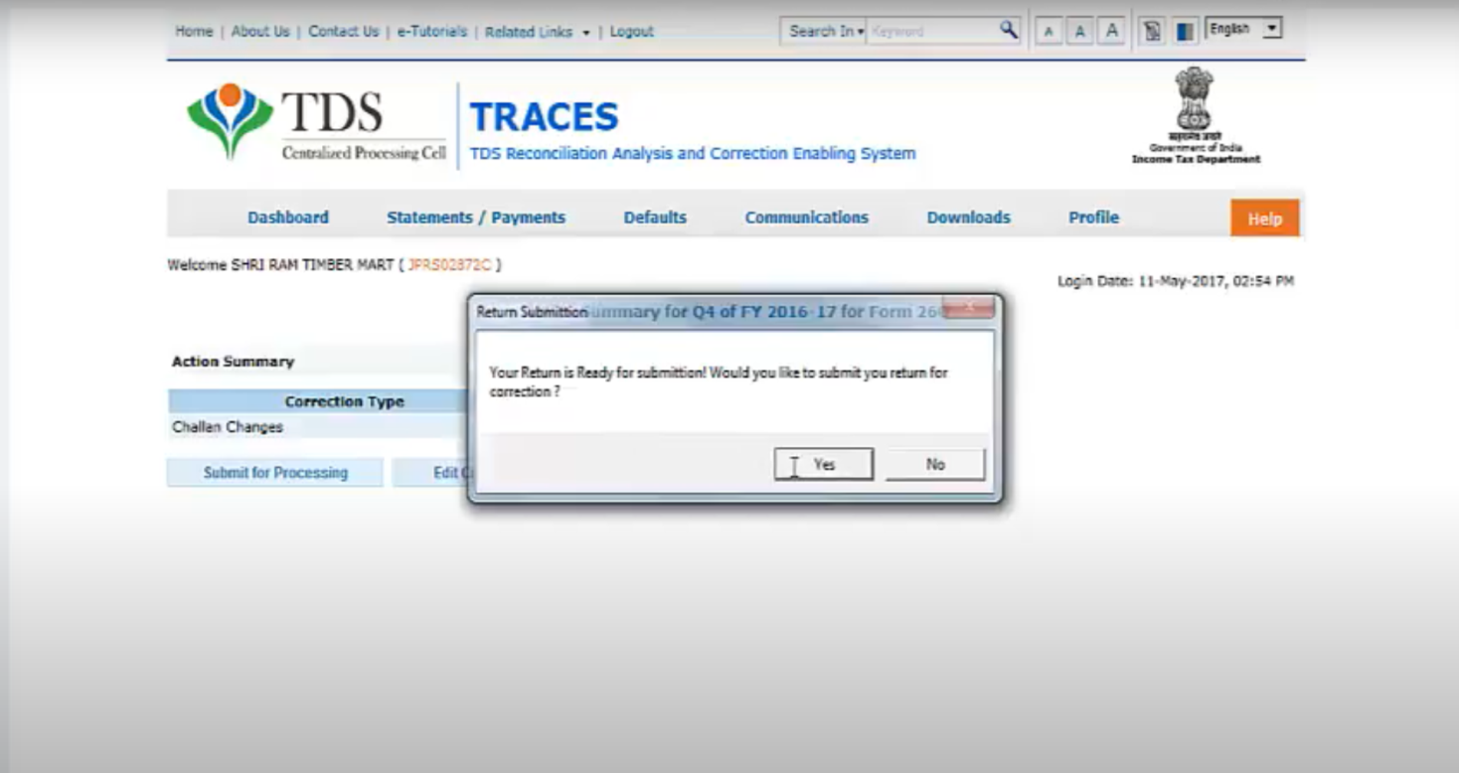
- After final submission of challan correction request return filing entry in CompuTds will be date of challan correction.
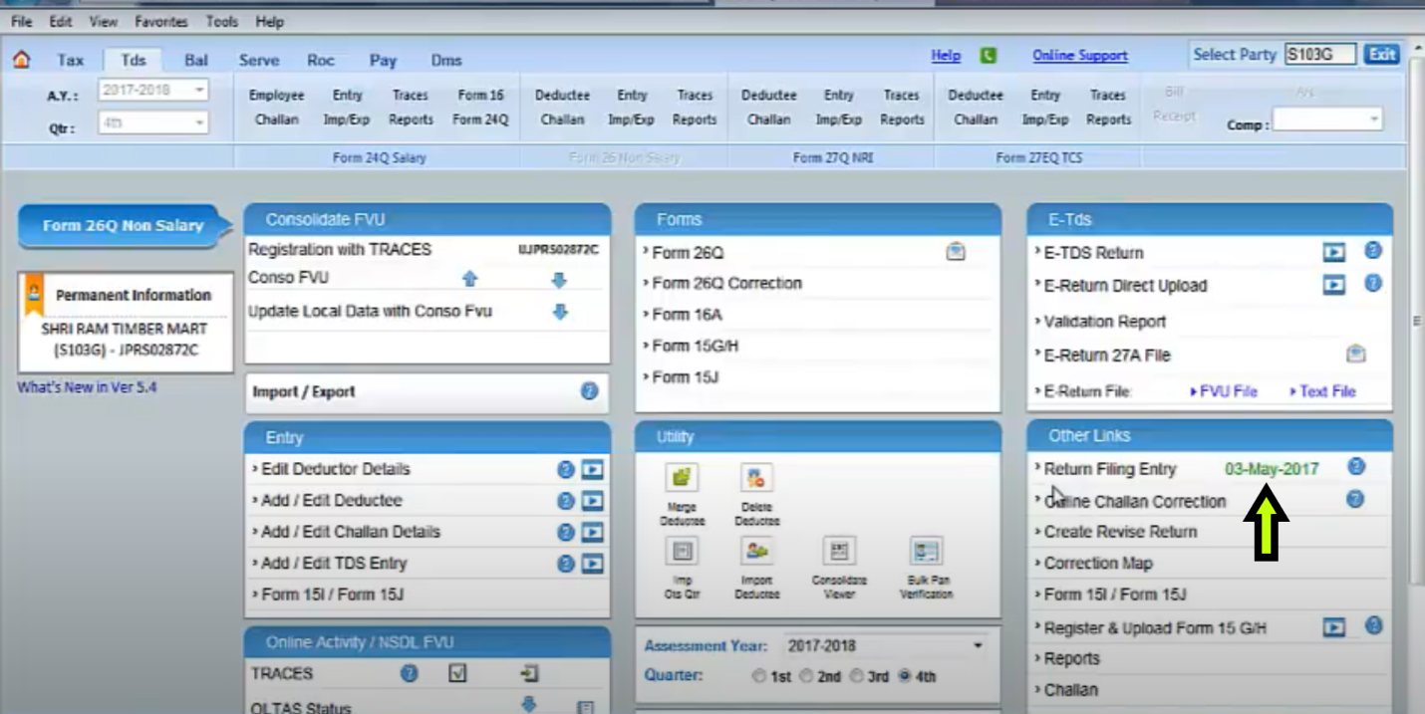
For challan correction traces will takes 2-3 days and it will be reflected on the traces site.
We can check status of challan correction request through CompuTds or also check status directly from traces site.
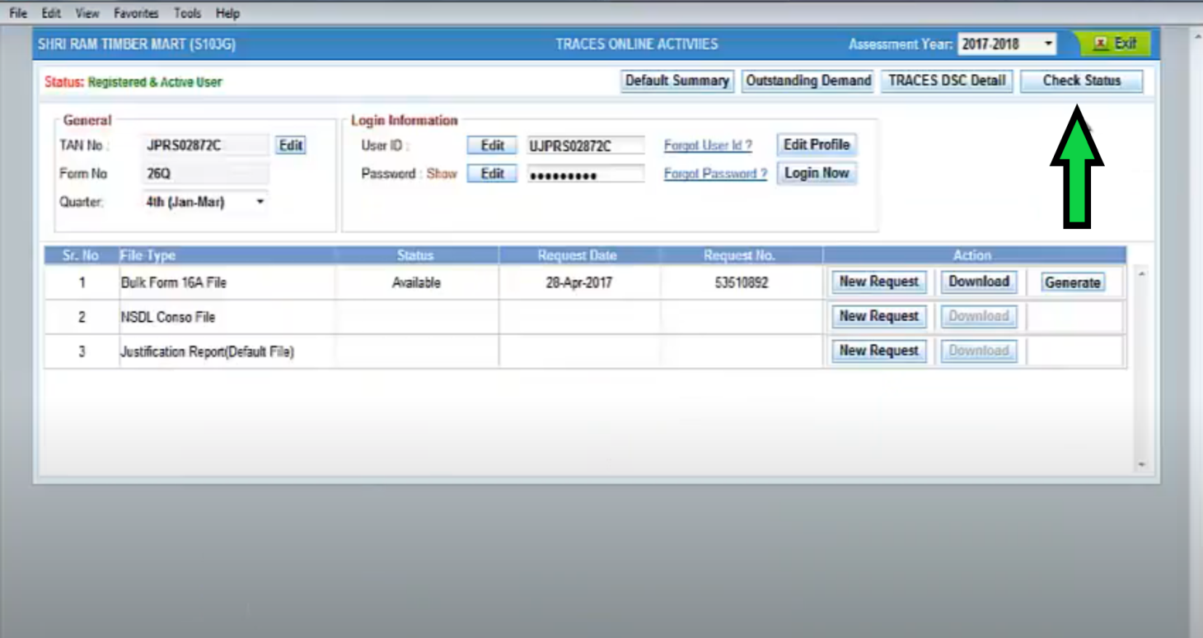

Thank You

CA Aniket V Kothawade
Contact: 8087967277
Nashik

