- Procedure to File TDS Return through CompuTds Software:

- Introduction About TDS Return:
- Tax Deducted at Source or TDS is a source of collecting tax by Government of India at the time when a transaction takes place. Here, the tax is required to be deducted at the time money is credited to the payee’s account or at the time of payment, whichever is earlier.
- In case of payment of salary or life insurance policy, tax is deducted at the time of payment. The deductor then deposits this TDS amount to the Income Tax (I-T) department. Through TDS, some portion of your tax is automatically paid to the I-T department. Thus, TDS is considered as a method of reducing tax evasion.
- Tax is deducted usually over a range of 1% to 10%.

- Due Dates for Payment of TDS:
Amount paid/credited |  | Due date of TDS deposit
Government Office | Without Challan |  | Same Day
Government Office | With Challan |  | 7th of next month
Government Office | On perquisites opt to be deposited by employer |  | 7th of next month
Others | In month of March |  | 30th April
Others | In other months |  | 7th of next month

- What is TDS Return?
- Apart from depositing the tax, the deductor should also file a TDS return.
- TDS return is a quarterly statement to be given to the I-T department. It is compulsory for deductors to submit a TDS return on time. The details required to file TDS returns are:
- PAN of the deductor and the deductee
- Amount of tax paid to the government
- TDS challan information
- Others, if any

- TDS Return Filing
- Due dates of TDS Return FY 2018-19 :
Quarter | Quarter Period | TDS Return Due Date
1st Quarter | 1st April to 30th June | 31st August 2018
2nd Quarter | 1st July to 30th September | 31st October 2018
3rd Quarter | 1st October to 31st December | 31st January 2019
4th Quarter | 1st January to 31st March | 31st May 2019

- TDS Return Forms
Particulars | Form No.
TDS on Salary | Form 24Q
TDS where deductee is a non-resident, foreign company | Form 27Q
TDS on payment for transfer of immovable property | Form 26QB
TDS in any other case | Form 26Q

- Penalty for delay in filing TDS Return
According to Section234E, if an assessee fails to file his/her TDS Return before the due date, a penalty of Rs 200 per day shall be paid by the assessee until the time the default continues. However, the total penalty should not exceed the TDS amount.

- Guide to Step by Step filing of TDS Return through CompuTds: (For Form 26- Non Salary)
- Step 1: Preliminary Process
- Firstly, click on the icon of the “CompuOffice Online”.
- After that Login with valid credentials like User ID and Password.
- Then Select “TDS” tab from various tabs which is seen after login process.
(CompuOffice Online > Login Page > USER ID & Password > TDS)
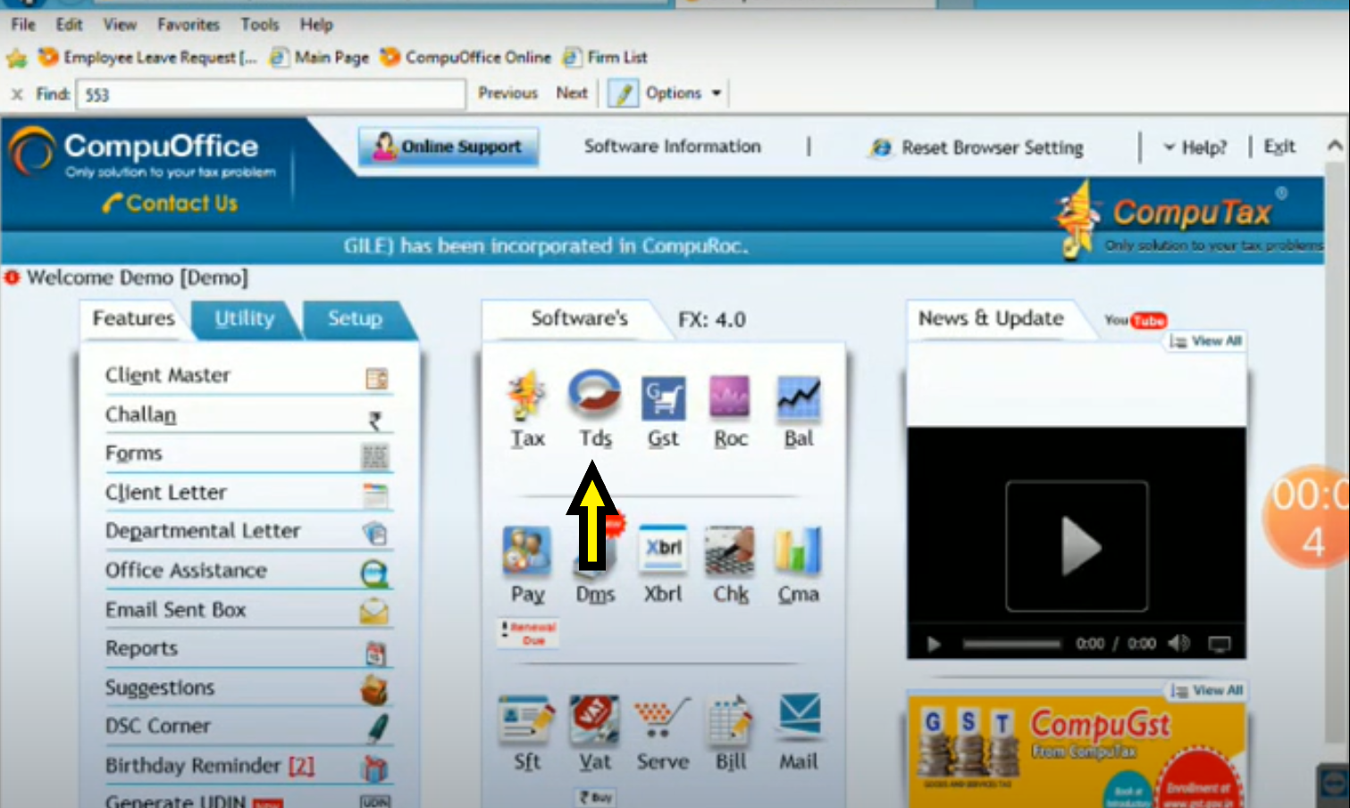

- This displays the page for selecting the client name that is required to file TDS Return through this software.
- Go to Drop box and search client name by typing name or search by using code number.
(Use Below image in case of any queries regarding this)
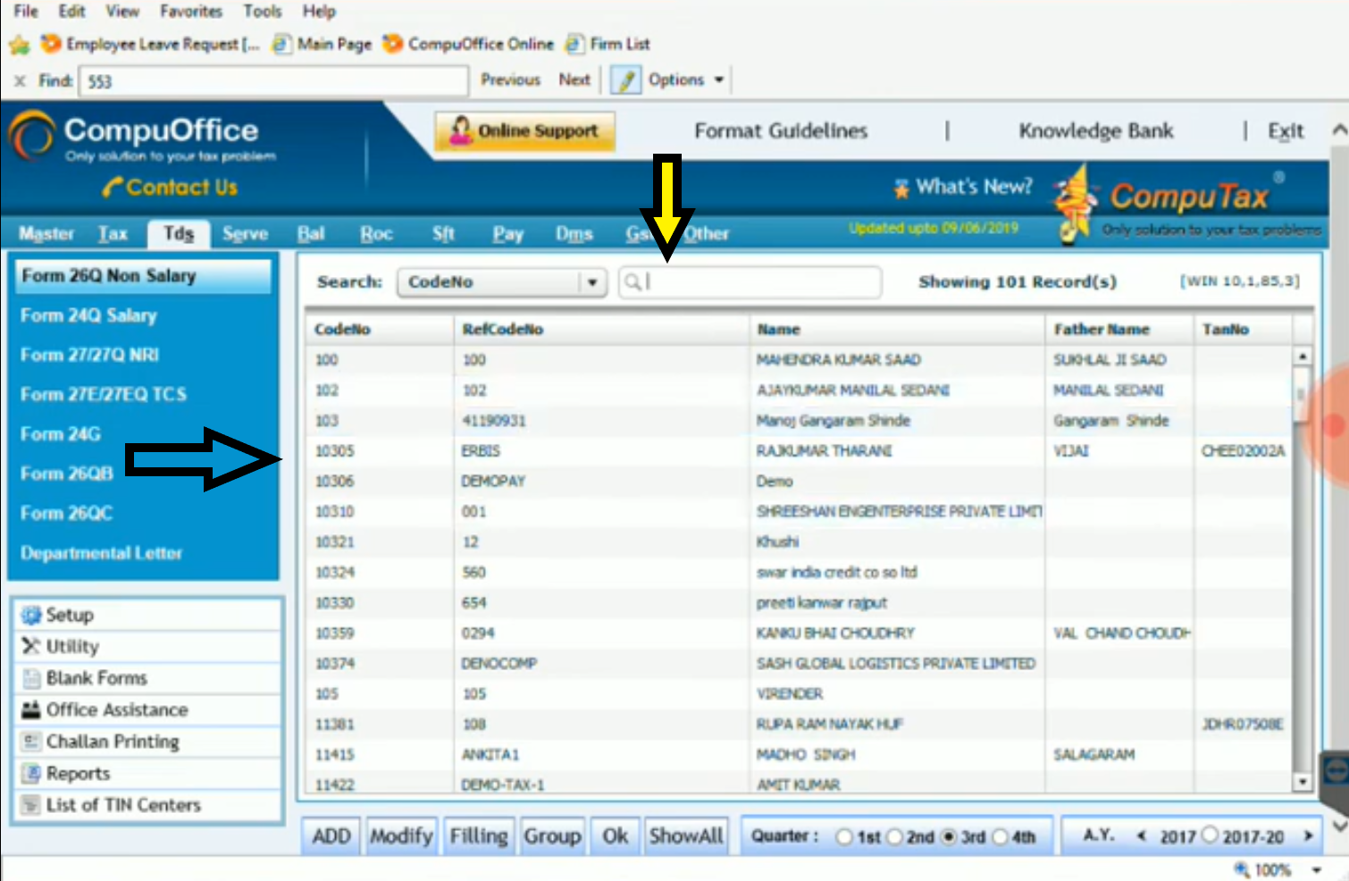

- Step 2: Selection of Year
- After selecting the appropriate client firstly select the relevant “Assessment Year” and relevant “Quarter” for which TDS return is required to be file.
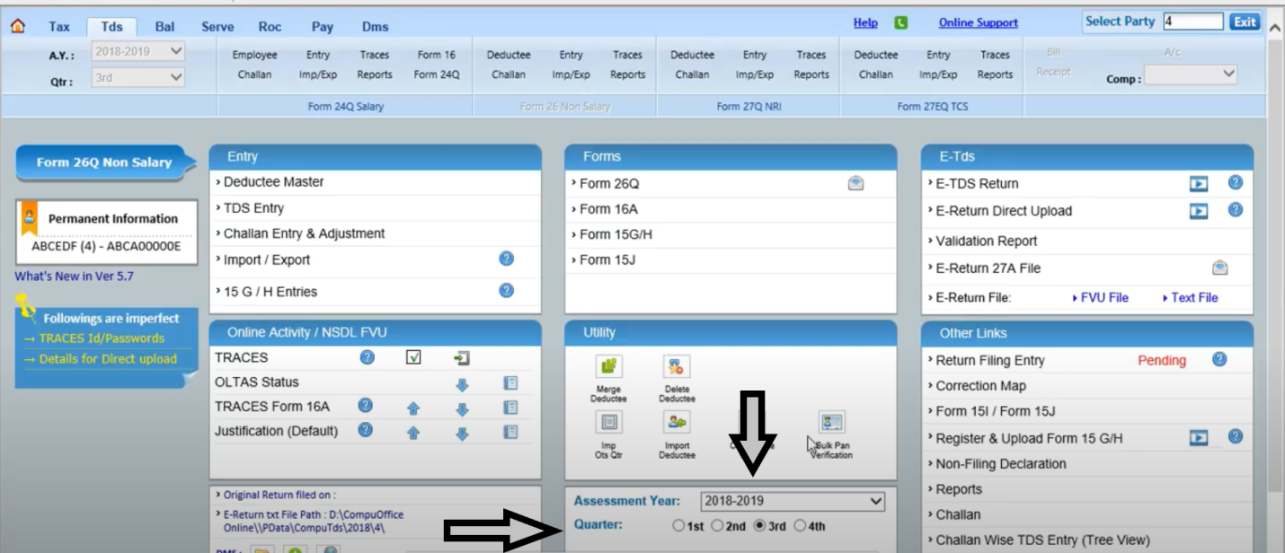
- Also select the appropriate Form for preparing return in the software. (Form 24Q-For Salary/Form 26-For Non-salary).
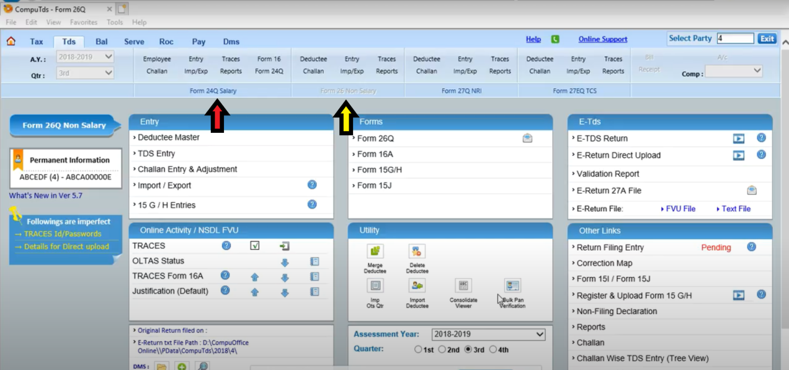
- Step 3: Filing Deductee Information
- On ‘Entry’ box, click on the ‘Deductee Master’ button for processing further. Under this tab contains a Deductee details like Name, PAN No., Status of deductee etc.
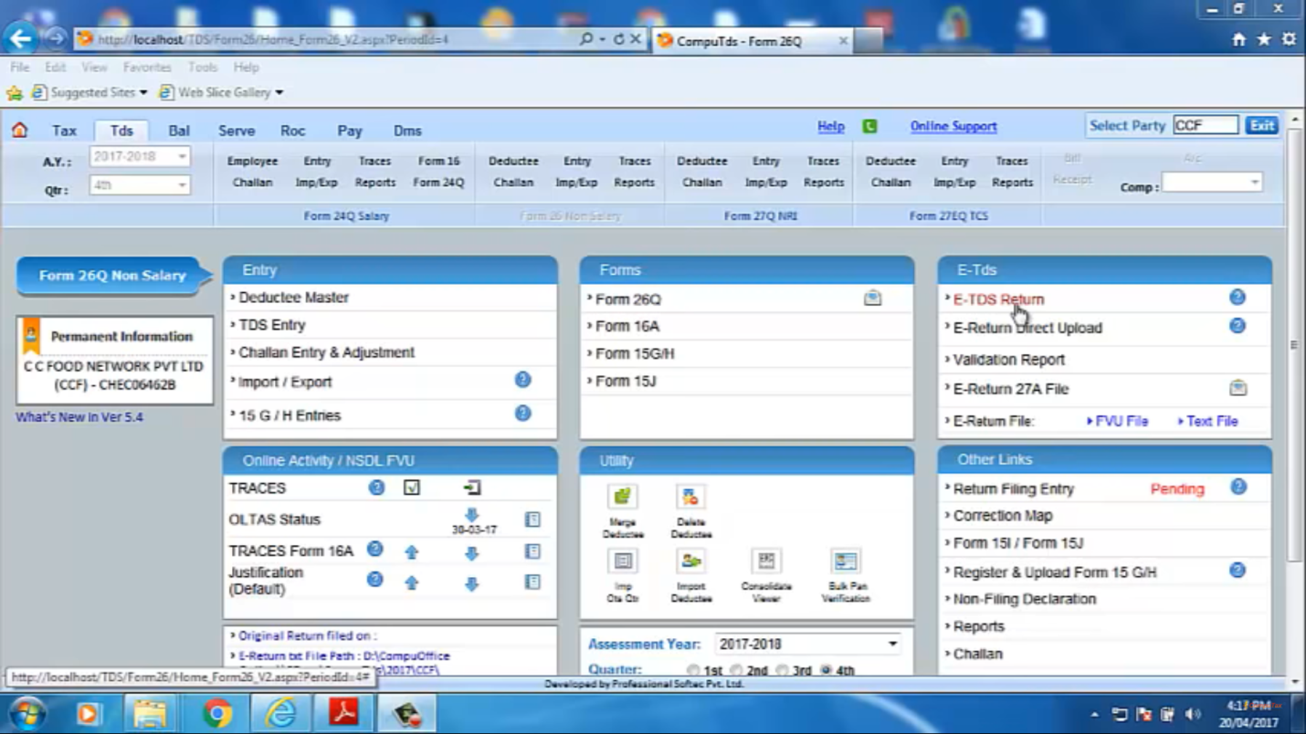
- In this “Deductee Master” tab we can “Add New Deductee” or “Modify Deductee Information”. Also we can only change a PAN of current deductee.
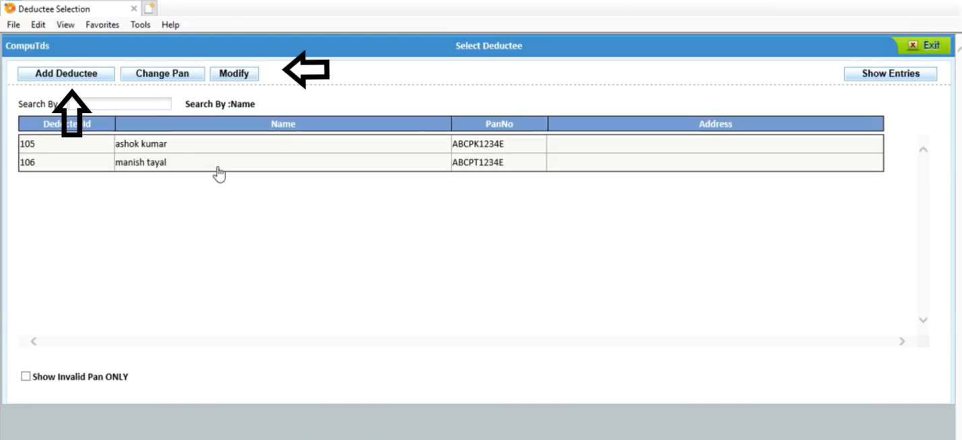
- For Adding the new deductee firstly click on the “ADD NEW” tab and fill the all information relating to deductee like Name, Status, Address, and PAN Number (PAN number is most important in this TDS case).
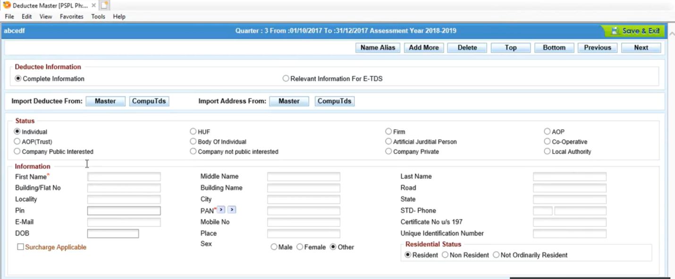
- Step 4: Challan Entry Procedure
- In this Process, Firstly click on the “CHALLAN ENTRY AND ADUJUSTMENT” Tab.
Login in CompuOffice > TDS > Challan Entry & Adjustment
- After entering into Challan entry tab we see various options like Add New challan, Modify Challan, OLTAS Verification of relevant challan etc.
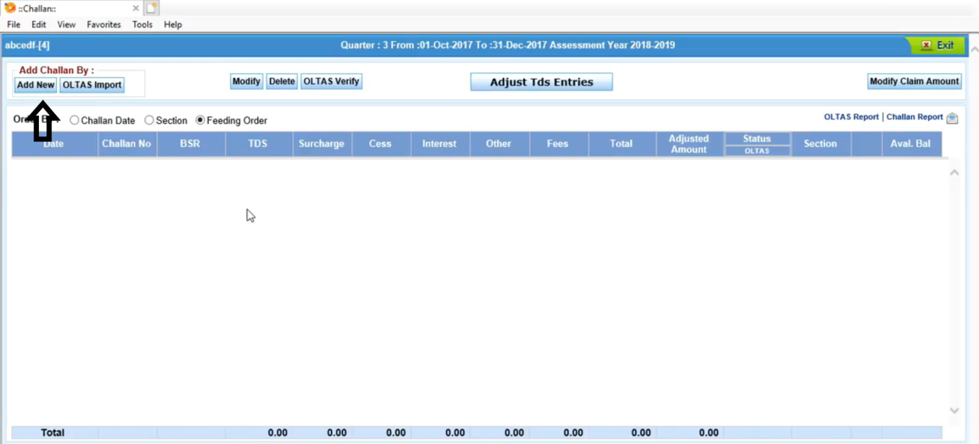
- When we click on “Add New” tab we display below screen for filling the relevant challan information which includes choosing appropriate section, amount of challan, challan date, challan no., BSR code etc.
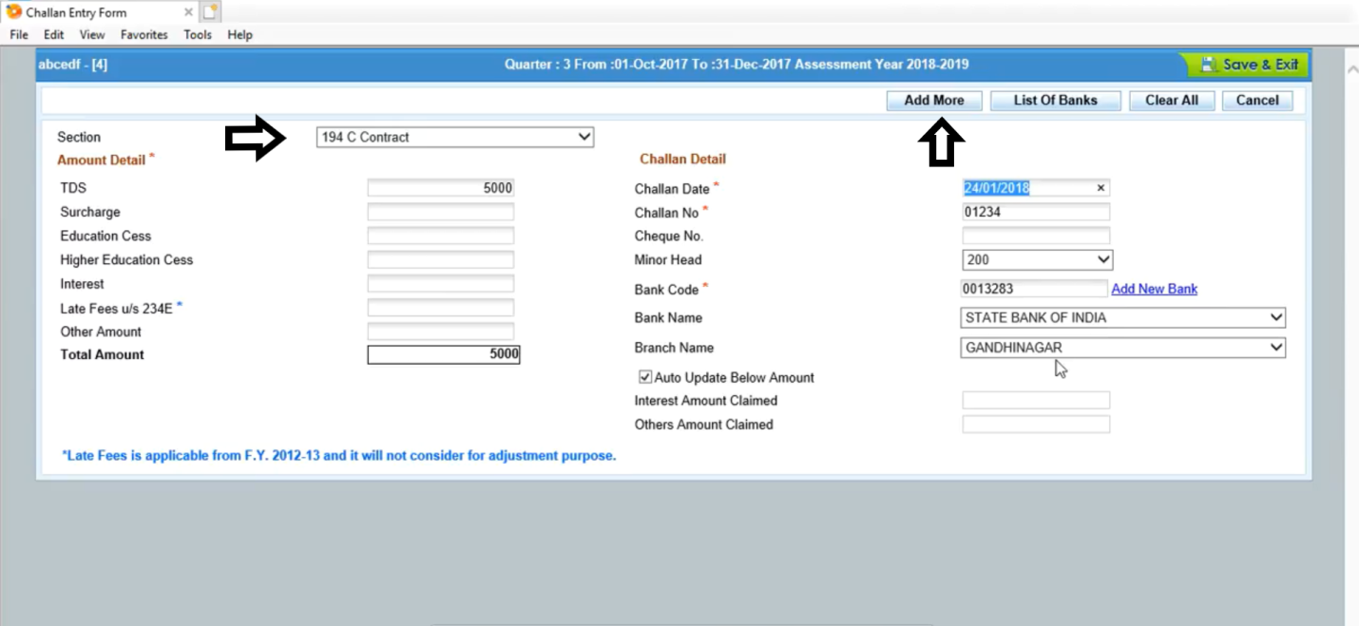
- Before proceed further verify the challan through “OLTAS Verify” tab.

- Step 5: TDS ENTRY
- After successful challan entry and adjustment proceed further for “TDS Entry”. When we return again to home page click on “TDS Entry” tab.
(CompuOffice Online > TDS > Select Deductor > TDS Entry)
- Then this tab displays options for selection of New entry, Section Selection, Modify Entries etc.
- This includes:
- For TDS entry in form 26 (non-salary) select relevant sections as per requirements of the deductor.
- Then we add new TDS entry through “Add New” tab which displays screen for filling TDS entry information.
- We can also Modify or delete entries through this tab.
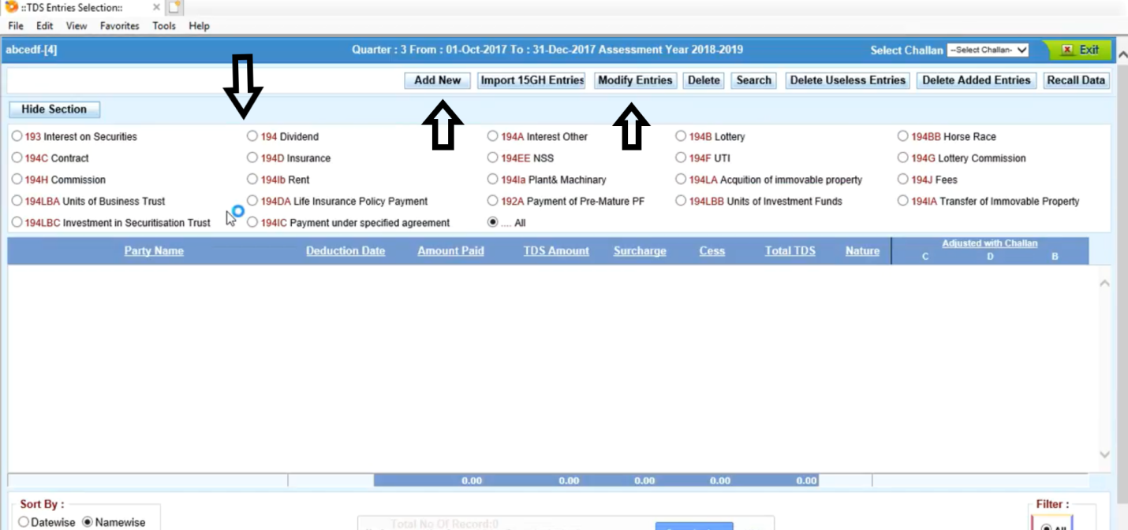

- Step 6: Add New TDS entry in the CompuTds
- For adding new entry click on “Add New” tab and after clicking on same tab we displays a tab for selection of deductee.
Select section > Add New > Select deductee.
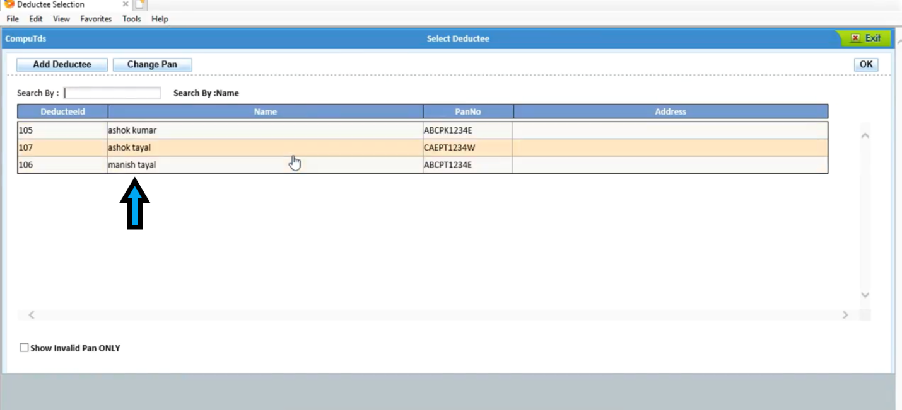
- TDS Entries Insertion:
- In TDS entries insertion tab displays screen which contains all information regarding the payments and tax deducted on same payments.
- Firstly enter the credit/payment date then deduction date (sometimes it was same or sometime it was different than credit/payment date).
- Then, Enter amount on which TDS has to be deducted (i.e. amount paid to the deductee.)
- After entering amount in “Paid/Credited” column enter tax rate in “Tax” column (Sometimes software automatically takes tax rate as per status of deductee)
- When we enter tax rate in “Tax” column software automatically calculate the tax amount as per tax rate.
- Then, we select the appropriate challan for TDS amount enters by us.
(Below image includes all the procedure which is mention in above Para)
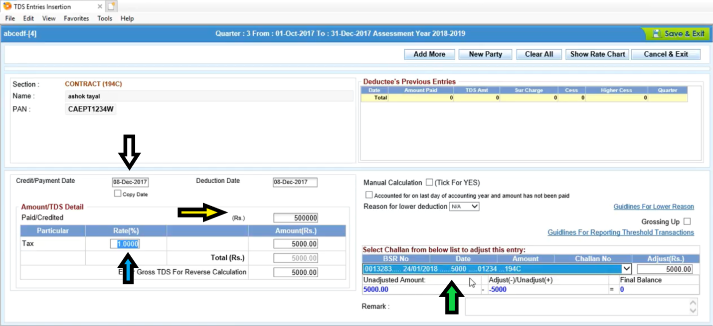

- We can enter various entries for various sections one by one and then proceed further for E-TDS Return procedure. Repeat the above procedure for all entries with various deductee names & with various sections of TDS.
(After Entering the TDS entry screen will be seen like below image)
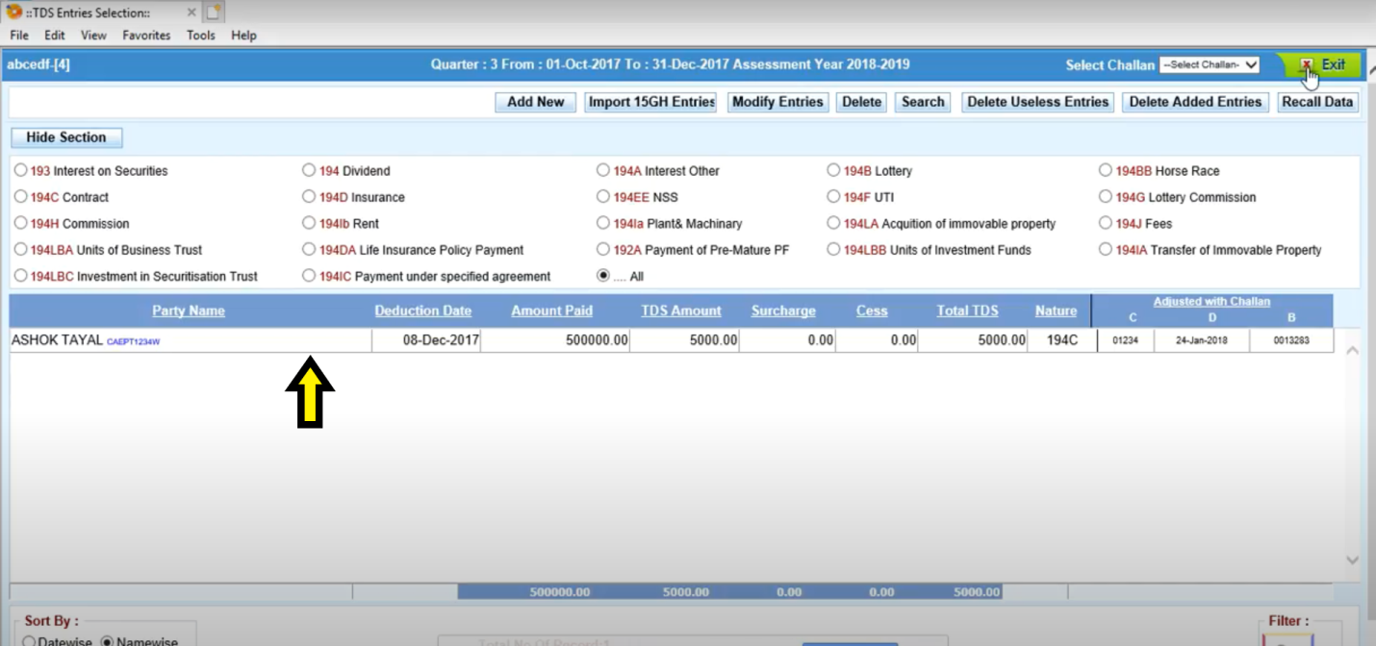
- Step 7: Final Procedure
- After entering all information regarding TDS entries and Challan entries we proceed further for uploading TDS return on portal by clicking on “E-TDS Return” Tab.
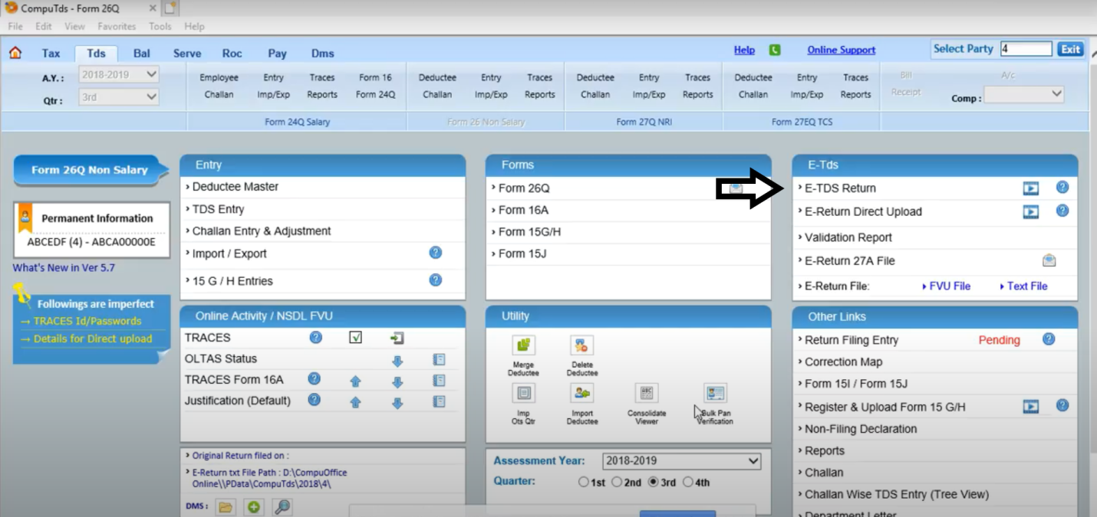
- When we enter on “E-TDS Return” tab software started to generate E-Return. Before generating E-Return software verify all TDS entries and deductee information at Traces. Software itself go to online portal for verify information.
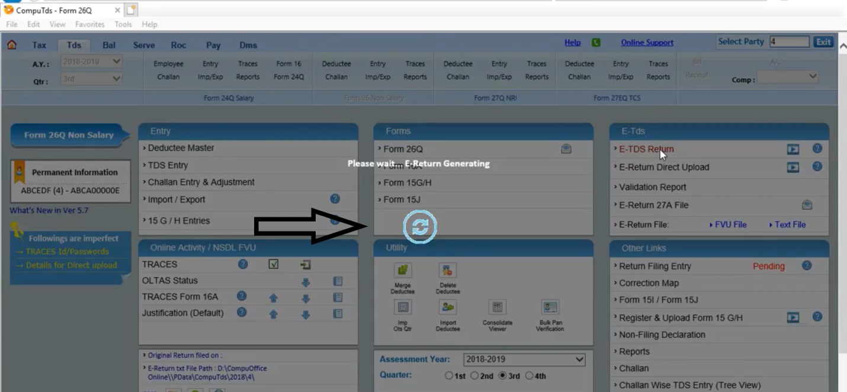
- After verification of all information we click on “Continue” button which is shown at the end of all procedure.
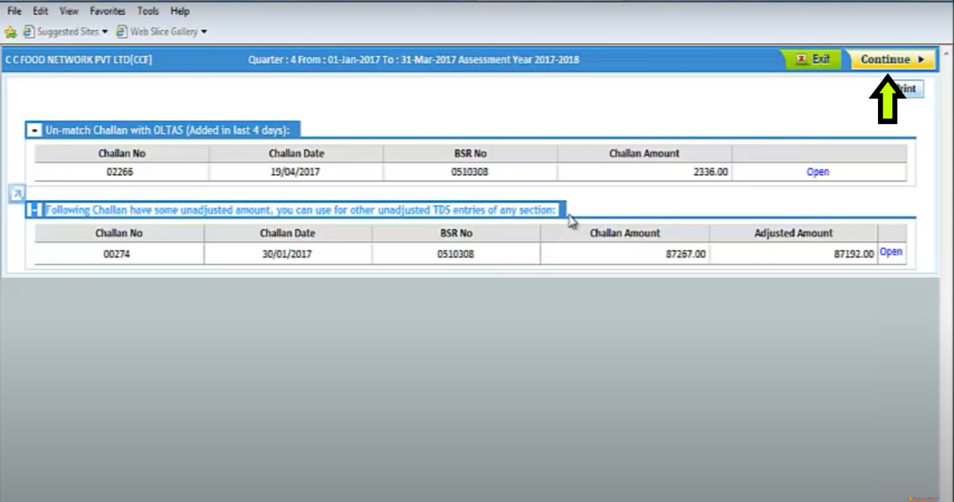

- When we click on “Continue” button it generates “Form 27A” in PDF format and “FUV” file in text format.
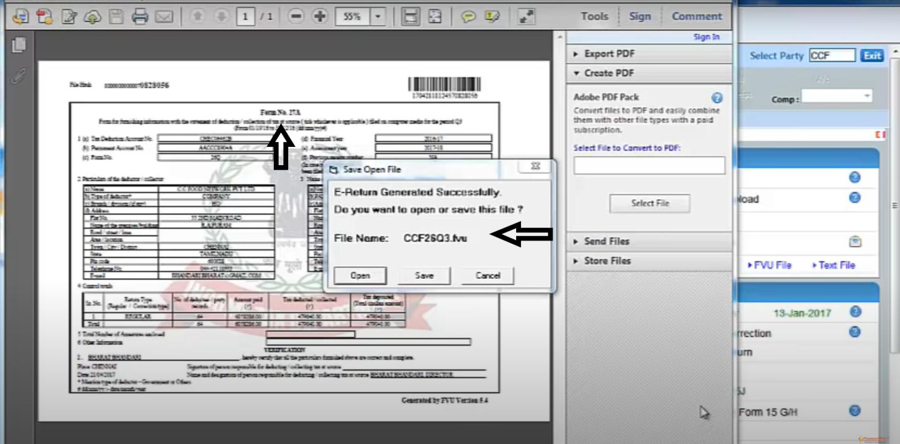
- We save both the files at appropriate location.
- Both files will be uploaded by Authorized Person of NSDL who is taking agency regarding this TDS return.
After all this procedure your TDS return has been submitted when generating acknowledgement for the same.

THANK YOU

CA Aniket v kothawade
Contact no: 8087967277
Nashik

