You should ensure that TDS certificates (Form 16/16A) issued to you are downloaded only from TRACES.
- TDS certificates should be downloaded only from TRACES
You should ensure that TDS certificates (Form 16/16A) issued to you are downloaded only from TRACES (TDS Reconciliation Analysis and Correction Enabling System of the Income tax department). Certificates downloaded from TRACES are in a specific format. A form downloaded from TRACES would bear a 7 character alphabet unique certificate number and it will also have a TDS- CPS logo on the left side and a national emble on the right side at the top. This certificate would provide the details of the income paid to you and also the tax deducted from that income by the payer and whether the same has been deposited by him with the government. See below for a sample of how a valid TDS certificate in Form 16 or Form 16A should look.

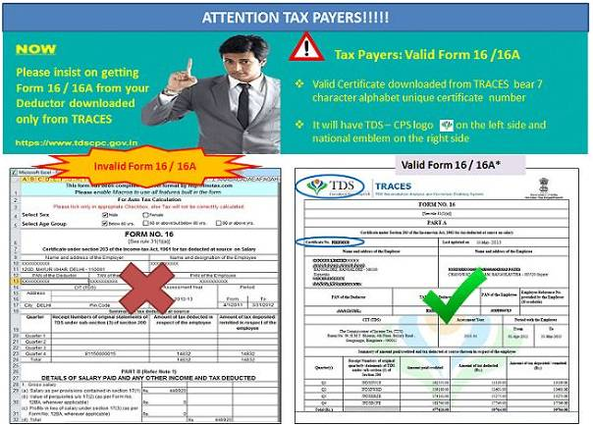

- Digital signature should be verified.
In case of digitally signed certificates check that the signature is verified i.e. has a check mark across it. An unverified signature will bear a question mark over the signature instead of the check mark.
- Must check details on the TDS certificate
Your name, PAN, Deductor's TAN, amount paid to you, TDS amount should be correctly reflected on the TDS certificate.

- What is Form26AS and how to get it
An annual tax credit statement is generated by the income tax department for a person subjected to TDS (deductee) in Form 26AS. The statement provides details such as name of the deductee, PAN of deductee, details of deductor, the TDS amount, the amount of TDS deposited with the Government by the deductor etc.
The user can download the statement from the income tax e-filing website. The downloaded statement is password protected and the password to open the file is the Date of birth of the user which he would have entered when registering with the income tax e-filing site.
This statement is linked to your PAN and contains details of all your TDS -by employers as well as others (e.g. banks etc).
The link to download Form 26AS from TRACES can be found after logging into your account on the income tax e-filing site.
https://incometaxindiaefiling.gov.in/e%20Filing/UserLogin/LoginHome.html?nextPage=taxCred
It can also be downloaded via your net banking account provided that your bank provides the e-filing login facility. The list of banks providing this facility is available at: http://contents.tdscpc.gov.in/en/netbanking.html

5. Cross check the TDS certificate figures with Form 26AS
You can verify whether your TDS -as shown in the TDS certificate received from the deductor --has actually been received by the government or not by comparing with the Form 26AS. It is the duty of a taxpayer to verify whether the deductor has deducted tax on each transaction on which it was supposed to be deducted. He must also check that the TDS mentioned in form 16/16A is reflecting in Form 26AS. In case the TDS shown in your TDS certificate is not reflecting in your Form 26AS it would imply that although the deductor has deducted the tax on your behalf but the TDS has not been deposited / has not reached the income tax department. In case of any discrepancy between the TDS certificates and Form 26AS inform your deductor and ask for the reasons for this discrepancy and get it corrected. A possible reason behind the mismatch can be because your PAN has been incorrectly entered in the records of the deductor. In case the deductor has not deducted the tax on your behalf, then it is your responsibility to remind the deductor to deduct tax on your behalf and deposit the same with government.
Your form 26AS will also reflect any advance/regular/ self assessment tax that you pay.
Following details would also be available in your Form 26AS in case applicable:
Details of tax deducted on your behalf by deductors
Details of tax collected on your behalf by collectors
Details of tax deducted on sale of Immovable Property
Refund received during the financial year by you
Details of your transactions in Mutual Fund, Shares and Bonds, etc. (as reported by AIR filer)
TDS Defaults related to processing of Statements
A person deducting tax on account of buying an immovable property needs to submit TDS certificate to the seller in Form 16B. Link to download Form 16B (Tutorial) http://contents.tdscpc.gov.in/en/download-from16b-etutorial.html
- Why you need TDS certificates when Form 26AS provides all information
One can gather all information related to TDS in Form 26AS which is sufficient to file one's return. This might make you doubt the importance of TDS certificates but the rationale behind introducing Form 26AS is to enable the taxpayer to cross check the details mentioned in his/her TDS certificates with those mentioned in Form 26AS and create transparency. TDS certificates are important because because these certificates and the Form 26AS are a cross check for each other-in case there is a mismatch you can try to get the relevant document corrected. Without the TDS certificate you would not get to know if there was a mismatch.
Further, if your return sails through the IT department's e-processing system without a hitch then your TDS certificates may not be required to be shown/submitted but in case your return gets picked up for scrutiny then you are likely to need your TDS certificates to show to the IT department. Also, in case a TDS is not reflecting in the Form 26AS then again you would need the certificate to prove that tax was actually deducted.
"In case of salaried persons, Form 26AS in itself is not sufficient to file the return since it does not show the breakup of your income and details of deductions claimed under section 80C to 80U which are available in Form 16" Kapur adds.
- Why you must provide PAN to the deductor
It is the duty of the assessee/deductee to provide his PAN to the deductor or else the deductor will deduct his tax at a higher rate (generally 20%). Also, if PAN is not provided the TDS will not reflect in your Form 26AS which is linked to your PAN. This is because the deductor will not know which PAN to assign the TDS to while uploading data in the income tax site.

