
Ab kya karu? C.A. sahib kaha ho aap?

INTRODUCTION
Rectification application maybe filed u/s 154 of the Income Tax Act by the taxpayer in case of any mistake apparent from the record. An Income Tax authority may:

a) amend any order passed by it under the provision of this Act

b) amend any intimation or deemed intimation under sub-section (1) of Section 143.

Subject to the other provisions of this section, the authority concerned,
a) may make an amendment under sub-section (1) of its own motion,

b) shall make such amendment for rectifying any such mistake which has been brought to its notice by the assessee.



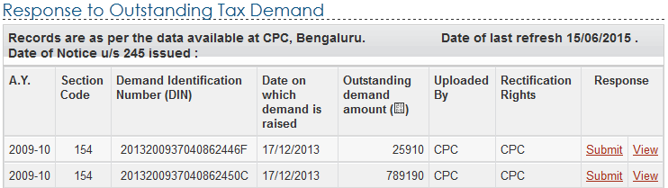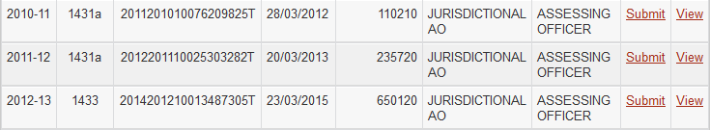

(Note: Please check who has the rectification rights for the order uploaded by CPC or AO accordingly prepare the papers and submit to the concern department for the speedy disposal of tax Arrears)

Pre-Requisites

- The Income Tax Return for the Assessment Year should have been processed in CPC, Bangalore.
- An Intimation under Section 143(1) OR an order under Section 154 passed by CPC, Bangalore for the e-Filed Income Tax return should be available with the taxpayer.
- For Electronic returns filed and processed at CPC, only online rectifications will be considered.
- If the refund arising out of return processed at CPC is adjusted against the demand of other Assessment Years and then the assessee is challenging the demand itself, in that case i) Rectification application has to be filed for the demand year, if the demand was raised by CPC then online application has to be filed ii) for the demand raised by the Field Assessing Officer, the application has to be filed before him.
- No rectification has to be filed for giving credit to taxes paid after raising the demand.
- To file your Rectification, you should be a registered user in e-Filing application
(Note: There are some times the same intimation is further processed even after receiving the Rectification order u/s 154, this intimation has to be taken on a serious note and online rectification has to be processed. If the CPC has passed the order u/s 154 and if you are still aggrieved the order, rectification request can be given to respective AO of the assessee)


Process

Below listed are the steps to file Rectification:

Step 1 - LOGIN to e-Filing application and GO TO --> My Account --> Rectification request.

Step 2 - Select the Assessment Year for which Rectification is to be e-Filed, enter Latest Communication Reference Number (as mentioned in the CPC Order)

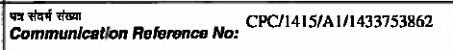
Step 3 - Click 'Submit'.

Step 4 - Select the 'Rectification Request type'
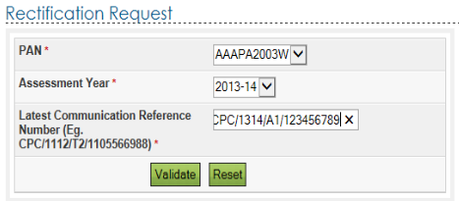

Taxpayer Correcting Data for Tax Credit mismatch only − On selecting this option, three check boxes, TCS, TDS, IT, are displayed. You may select the check-box for which data needs to be corrected. You can add a maximum of 10 entries for each of the selections. No upload of an Income Tax Return (XML) is required.
Taxpayer should ensure that the TAN number is valid and as per the Form 16A issued by Deductor.
PAN number of Deductor should NOT be mentioned in place of TAN.
In many cases Deductors may have given TDS certificate with certain TAN but submitted TDS return to Department under different TAN. This may happen where many group concerns operate in a flexible manner. This should be verified by cross-checking against the 26AS statement for the taxpayer which is available through NSDL or at the e-filing website. Any error by Deductor should be immediately pointed out and correction ensured

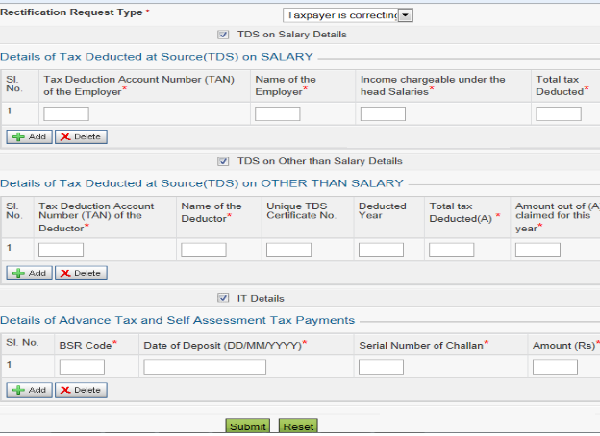
(Note: All entries of TDS , TCS and advance tax has to be updated even if credit for the same has been given. If there are more than entries than we cannot rectify through this option)

Taxpayer is correcting the Data in Rectification' − Select the reason for seeking rectification, Schedules being changed, Donation and Capital gain details (if applicable), upload XML and Digital Signature Certificate (DSC), if available and applicable. You can select a maximum of 4 reasons.

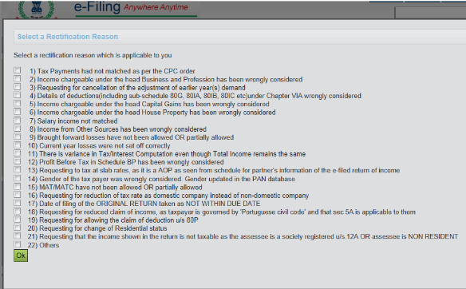
- Tax Payments had not matched as per the CPC order
BSR code, Challan number and date of deposit may have been incorrect since any mismatch may lead to rejection of tax payment. Date of deposit of challan cannot be beyond or after date of filing of return.
Taxpayer should NOT report tax payments made by Deductors as given in Form 16 or Form 16A as their own payment under Schedule IT. This is meant ONLY to enter tax payments DIRECTLY made by taxpayer himself.
- Income Chargeable under the head Business and Profession has been wrongly considered
There are many reasons for variation in Income From Business:
While entering Totals (for ex Total Duties and Taxes etc), breakup is not given.
Value entered in Sl no 42 (Depreciation) (where Books of Accounts are maintained) should match the value in Sch BP: Sl no 11 (Depreciation debited to P&L Account)
Profit Before Tax (and not Profit After Tax) should be entered in item 1of Sch BP.
Depreciation allowable under IT Act u/s 32(1) (ii) must be as per Sch DEP. When Schedule Profit and Loss is filled with a claim for depreciation but depreciation amount is either not added back at item A11 in Schedule BP or details of depreciation in plant and machinery and other assets are not filled by the assessee in Schedule DPM, DOA and Schedule DEP, this may lead to disallowance of depreciation.
Schedule DPM, DOA and DEP should NOT be left blank if Depreciation is being claimed. Entering total value of Depreciation in Sl A12 in Schedule BP WITHOUT entering DPM, DOA, DEP will lead to disallowance of Depreciation.
Where block ceases to exist, enter correct value in Cap.Gains / Loss u/s 50. Under NO OTHER CIRCUMSTANCE should item 16 be filled. Negative value, if entered in Sl 16, implies that block ceased to exist and then no Depreciation will be allowed for that block.
Where P&L account is filled and includes Deemed income u/s 44AD, 44AE 44AF etc, ensure that relevant figures in A4 and A33 in Sch BP are correctly filled
Total of Deemed Income (IF NON ZERO) under Sections 44AD , 44AE, 44AF, 44B, 44BB, 44BBA, 44BBB, 44D, 44DA, Chapter XII-G and First Sch of IT Act as per Sl no 33 of Sch BP) should not be hence lower than Sl no 4 of Sch BP.
In case nature of business does not include Tea/Coffee/Rubber, the net profit or loss from business or profession after applying Rule 7A,7B, 7C in A37 should be entered as the same value as arrived in Sl no 36 of Sch BP.
Where Schedule OI is filled with details of disallowances or amounts which are to be added back to income due to the provisions like 36, 37, 40, 40A, 43B, assessee must fill in the details in Schedule BP in arriving at the income from Business and Profession. This is because at the time of processing these disallowances are taken from Schedule OI and applied to relevant items in Sch BP. This will result in increase of Income under Business due to these disallowances.

Schedule CYLA,10A, 10AA,ESR
- Requesting for cancellation of the adjustment of earlier year(s) demand
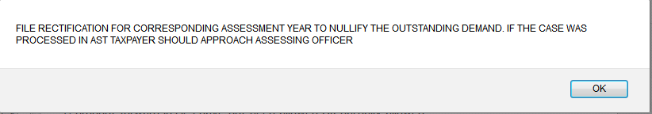
- Details of deductions (including sub-schedule 80G, 80IA, 80IB, 80IC etc) under Chapter VIA wrongly considered
While filling in Deductions in Chapter VI – A, taxpayer must ensure to fill up the breakup showing all individual Section-wise deductions such as 80 C etc, and then mention the Total Deduction claimed. At the time of processing, it is not clear under what section is the deduction claimed if details are not given. Since each deduction has different limits and eligibility, it is not possible to allow deduction only from the total.
Details u/s 80G in Sch 80G (where the Schedule is available in the return- ITR 4, 5 and 6) along with correct totals may not have been entered, before claiming the total in Chapter VI-A. Similarly, other schedules such as 80IA/IB etc must also be filled in where relevant schedules are in the ITR , before claiming Deductions in Chapter VI-A. Mentioning only the final total values in Chapter VI A Schedule or the total Deduction is not sufficient.

Schedule VIA, Filling Status, Schedule 80G, Schedule 80IA, 80IB, 80IC

- Income chargeable under the head Capital Gains has been wrongly considered
Start from full value of consideration in Capital Gain schedule. DO NOT ENTER ONLY FINAL VALUES. Enter the correct breakup to arrive at STCG and LTCG values. Do not leave blank any intermediate figures such as Full Value of Consideration etc.
Ensure that the value entered in Sch CG under LTCG Proviso (option under proviso to S.112(1) is exercised) is also correctly entered in Sch SI under LTCG proviso (Section 22). All Capital gain tax calculations are as per special rates given in Schedule SI. In case this is not correctly entered then the calculation may differ. In most cases taxpayers have entered capital gains in CG schedule at 20% tax rate, but in Schedule SI entered in code corresponding to 10% rate by mistake. In such cases tax may be calculated at both these tax rates.
Verify that correct quarterly breakups for LTCG and STCG are provided in Sch CG and the total of the quarterly breakups match with the respective values in Sch SI (taxable Income after adjusting Min Chargeable to Tax) after set off of all losses.
Ensure that the value entered in Sch CG under STCG 111A is also correctly entered in Sch SI under STCG 111A (Section 1A) Enter correct breakup of STCG 111A and other than 111A in Sch CG.
Schedule CG, Schedule 80IA, 80IB, 80IC, Schedule SI, Schedule DCG

- Income chargeable under the head House Property has been wrongly considered
In the House property Schedule the Interest paid value is not entered. Instead only the loss figure is mentioned in the final total. The totals are re-calculated while processing the return from the basic values provided. If the break up values are not provided then the total will be calculated as zero.
The other possibility is that even if the House Property Schedule was correctly filled, the taxpayer has not claimed the loss in Schedule CYLA. Therefore, even if loss is correctly shown in Sch HP, the adjustment of this loss is not automatic. It has to be entered in the first row against Salary Income as shown to indicate that this loss is adjusted against salary income.
Schedule HP, Schedule CYLA

- Salary income not matched
In Salary Schedule higher figure is reported under Gross salary which should be excluding Exempt income (such as transport allowance etc). Taxpayer may have mentioned Transport allowance in Exempt Income and may have deducted the same to arrive at a lower net figure in the final calculation. However, the Exempt income is to be mentioned only for reporting purposes and should not be used in any calculation.

Schedule SAL, Schedule CYLA

- Income from Other Sources has been wrongly considered
Schedule OS, Schedule CYLA

- Brought forward losses have not been allowed OR partially allowed
Before claiming adjustments in Sch BFLA, ensure that Schedule CFL is not left empty. The correct breakup of the losses claimed for setoff must be filled in Sch CFL which alone will be considered for Schedule BFLA. Direct entries in Schedule BFLA without any entry in Schedule CFL will not be entertained, thus leading to demand due to disallowance of claim for adjustment of brought forward loss.
Unabsorbed depreciation loss MUST be included in CFL against appropriate year or in case it relates to prior to AY 2002-03 period then it MUST be entered in the row relating to AY 2002-03. ONLY if the unabsorbed Depreciation is entered in CFL, then it will be allowed in Sch BFLA calculation.
In Sch BFLA, enter all adjustments correctly. Do not leave blank as system will not allow adjustments of brought forward loss unless claimed in Sch BFLA
Filling Status, Schedule BFLA, Schedule CYL

- Current year losses were not set off correctly
Schedule CYLA, Schedule SAL, Schedule HP, Schedule BP, Schedule CG, Schedule OS.

- There is variance in Tax Interest Computation even though Total Income remains the same
Personal Information, Filing Status

- Profit Before Tax in Schedule BP has been wrongly considered
Schedule P&L, Schedule BP

- Requesting to tax at slab rates, as it is a AOP as seen from schedule for partners information of the e-filed return of income.

- Gender of the tax payer was wrongly considered. Gender updated in the PAN database
Taxpayer may have entered Gender as Male or entered date of birth incorrectly.
Alternatively, taxpayer may have entered these details correctly but the details are different in PAN database, in which case the data in PAN database has to be corrected by taxpayer by giving proof and details.
Personal Information

- MAT/MATC have not been allowed OR partially allowed
Schedule MAT MUST be filled by all taxpayers filing ITR 6 irrespective of whether the book profit calculations result in application of provisions of MAT. Taxpayer may not have calculated MAT.
Schedule MAT, Schedule MATC

- Requesting for reduction of tax rate as domestic company instead of non-domestic company
For taxpayers filing ITR 6, the correct selection while opting for item under General Information relating to ‘If a Domestic Company’ must be made. Domestic companies MUST NOT select "N" here – which implies that taxpayer is stating that company is a Foreign Company. When ‘N’ is selected the tax rate applicable to Foreign Companies will be applied, leading to higher taxation.
Personal Information, Filing Status

- Date of filing of the ORIGINAL RETURN taken as NOT WITHIN DUE DATE

- Requesting for reduced claim of income, as taxpayer is governed by portuguese civil code and that sec 5A is applicable to them
Schedule P&L, Schedule BP, Schedule CG, Schedule OS, Schedule HP

- Requesting for allowing the claim of deduction u/s.80P
For assessee filing return ITR 5, Status (such as Cooperative Society, Firm, etc) in the General Information Portion may not have been selected correctly. Incorrect status selection can lead to taxation at higher rate or disallowance on specific deductions like 80P, etc.
Personal Information, Schedule VIA

- Requesting for change of Residential status
Filling Status

- Requesting that the income shown in the return is not taxable as the assessee is a society registered u/s.12A OR assessee is NON RESIDENT
Personal Information, Filling Status

- Others
Reasons for Rectification

(Note:- Multiple rectification reasons can be selected from the list of 22 .)
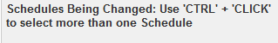

No further Data Correction required. Reprocess the case' − On selecting this option, three check-boxes, Tax Credit mismatch, Gender mismatch, Tax/ Interest mismatch are displayed. You may select the check-box for which re-processing is required. No upload of an Income Tax Return is required.
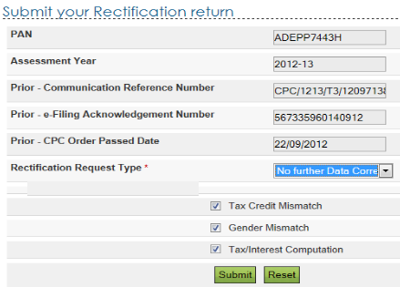

Step 5 Click the Submit button

(Note: For those assessee whose accounts where getting audited in that Assessment year than DSC would be required before clicking submit)

Step 6
On successful submission, an Acknowledgment number is generated and sent for processing to CPC, Bangalore.

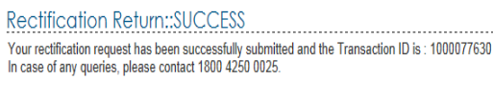

Common Errors in Rectification-

Important Notes before e-Filing Rectification-
You must file using the latest CPC Order for the selected Assessment Year. For eg: If an order has been passed by CPC on 27th September, 2013 and another order has been passed on 15th December, 2013, the assessee can e-File ONLY using the latest i.e. 15th December, 2013 order.
You can file another Rectification for the same Assessment Year ONLY if the previous Rectification request is processed.
The CPC order details can be used ONLY once to file a Rectification. Any subsequent Rectification should be filed using new/latest CPC order details. However, the same CPC Order details can be re-used if the e-Filed Rectification has been withdrawn by the assessee ( Note: Time for withdrawal is 7 days from date of e-Filing the Rectification)
The rectification request can be withdrawn within 7 days if submitted by mistake or the request needs to be amended. LOGIN and GO TO 'My Account' --> 'Rectification status' to withdraw the Rectification.

Tips to the user on filling the Income Tax Return-

The complete Income Tax Return should be e-Filed and NOT just the schedules/ fields that need change/correction. However, there should NOT be any revision in Income or new claims of deduction/ exemption made in the Rectification request, as this would lead to rejection or delay in processing by CPC. Please note that this facility is only provided by Income Tax Department for correcting mistakes. In case you wish to make changes in Income or make new claims, a Revised Income Tax Return should be filed as per the Income Tax Act, 1961.

Common mistakes while filing Rectification-

It is noticed that Communication Reference Number mentioned in the CPC Order (u/s 143(1) or 154) is entered wrongly. It must be mentioned exactly as it appears on the CPC order.
Right Assessment Year should be selected.
The complete Income Tax Return should be e-Filed and NOT just the schedules/ fields that need change/correction.
In case of change in 'Income', a rectification should NOT be filed. A revised Income Tax Return should be filed in this case, of course, subject to the time limit as per the Income Tax Act, 1961.
In case of change in 'Bank Account details' OR 'Address Details', a Rectification should NOT be filed. You can LOGIN and GO TO My Account --> Refund Re-issue request and raise a request for change in the Bank Account/Address details (in case of refund failure).

Note: The Bank Account details and Address details as in the original Income Tax Return (processed) will be considered for any refund/demand notice, and not the bank account/address details mentioned in the Rectified Income Tax Return.

Defective Return 139 (9) of the Income Tax Act 1961.
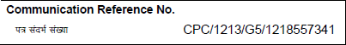

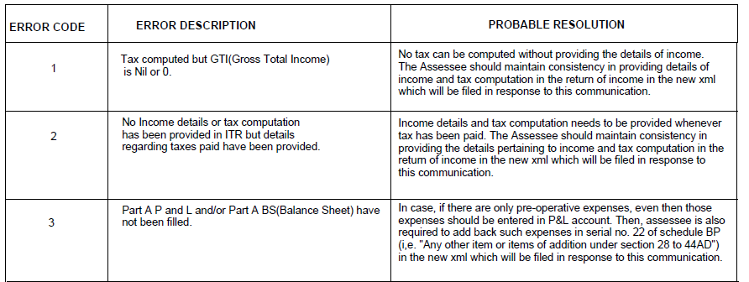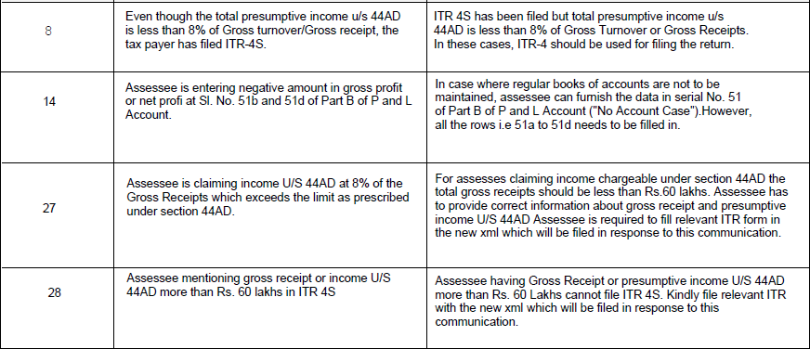
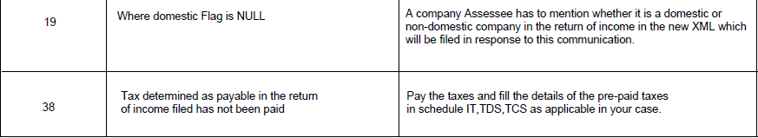

Procedure for Response to Arrear Demand by Taxpayer AND Verification and Correction of Demand by AO’s

Actions to be performed by Tax Payer’s :-
(i) Login to e-Filing website with User ID, Password, Date of Birth /Date of Incorporation and Captcha.

(ii) Go to E -file menu and click on "Response to Outstanding Tax Demand

(iii) Following details would be displayed.
- Assessment Year
- Section Code
- Demand identification Number (DIN)
- Date on which demand is raised
- Outstanding demand amount
- Uploaded By
- Rectification Rights
- Response- Submit and View

(iv) Taxpayer must click on "Submit" link under Response column for the respective
AY in order to submit the response. Taxpayer has to select one of the options
from the radio button.
- Demand is correct
- Demand is partially correct
- Disagree with demand

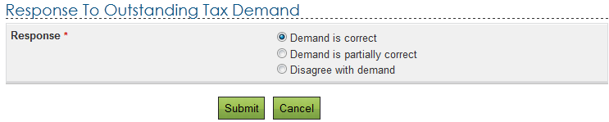

(v) If taxpayer selects "Demand is correct", then a pop up is displayed as "If you confirm "Demand is correct' then you cannot 'Disagree with the demand'. Click on
"Submit". A success message is displayed.
- If any refund is due, the outstanding demand along with interest will be adjusted against the refund due.
- In any other case taxpayer has to immediately pay the demand.

(vi) If taxpayer selects "Demand is partially correct", then "Amount which is correct”
and "Amount which is incorrect" has to entered.

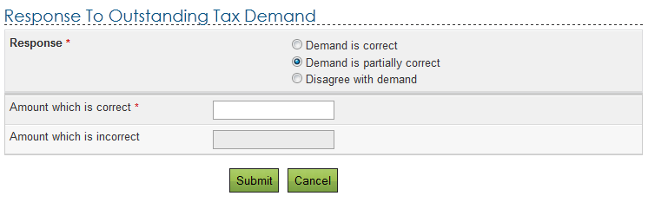
(vii) If taxpayer selects 'amount which is incorrect' then he should mandatorily fill one
or more reasons for stating so as listed below:
