VARIOUS INVESTMENTS OPTIONS AVAILABLE TO INDIVIDUALS AND TAX BENEFITS AVAILABLE UNDER EACH OF THEM - Financial Year 2013-14
- INVESMENT OPTIONS AVAILABLE UNDER SECTION 80C

- PPF (Public Provident Fund)
Among all the assured returns small saving schemes, Public Provident Fund is one of the best.

Features of PPF are:-
- Interest earned is tax-free. Rate of Interest is about 8% p.a.
- Minimum amount of contribution is Rs 500 and maximum is Rs 1,50,000/-.
- Though the PPF account matures in 15 years, you can extend it in blocks of five years each.
- Contributions to PPF accounts of the spouse and children are also eligible for tax deduction.
- Past trends of PPF rate of interests is:-
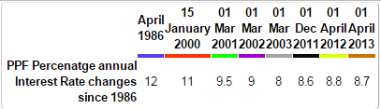

- National saving certificates( NSC)
It is a saving bond , primarily used for small saving and income tax saving investment in India, part of the Postal savings system of Indian Postal Service (India Post).

Features of NSC are:-
- Lock in period is 5 years or 10 years.
- Can be purchased from a post office by an adult in his own name or in the name of a minor, a minor, a trust two adults jointly.
- Rate of interest is about 8 % compounded half-yearly, i.e., the effective annual rate of interest is 8.16 %
- Interest accrued every year is liable to tax but the interest is also deemed to be reinvested and thus eligible for section 80C deduction.

- Lic
Features of lic
1. Any amount that you pay towards life insurance premium for yourself, your spouse or children can also be included in Section 80C deduction.
2. Please note that life insurance premium paid by you for your parents (father / mother / both) or your in-laws is not eligible for deduction under section 80C.
3. For more than one insurance policy, premiums are eligible for deductions. It is not necessary to have the insurance policy from Life Insurance Corporation (LIC).
4. Returns varies from year to year and scheme to scheme.

- Home Loan Principal Repayment
The Equated Monthly Instalment (EMI) that you pay every month to repay your home loan consists of two components – Principal and Interest.
The principal component of the EMI qualifies for deduction under Sec 80C. Even the interest component can save you significant income tax.
Features of Home loan Principal repayment
- Tax benefit is available only after the construction is complete.
- Stamp Duty and Registration Charges for a home: The amount you pay as stamp duty when you buy a house, and the amount you pay for the registration of the documents of the house can be claimed as deduction under section 80C in the year of purchase of the house.

- Senior Citizen Savings Scheme 2004 (SCSS)
A recent addition to section 80C list, Senior Citizen Savings Scheme (SCSS) is the most lucrative scheme among all the small savings schemes but is meant only for senior citizens.
Features of SCSS
1. Rate of interest is about 9.20% per annum payable quarterly. Interest income is chargeable to tax.
2. The account may be opened by an individual,
- Who has attained age of 60 years or above on the date of opening of the account.
- Who has attained the age 55 years or more but less than 60 years and has retired under a Voluntary Retirement Scheme or a Special Voluntary Retirement Scheme on the date of opening of the account within three months from the date of retirement.
- No age limit for the retired personnel of Defence services provided they fulfill other specified conditions

- Infrastructure Bonds or Infra Bonds
These are issued by infrastructure companies, and not the government. The amount that you invest in these bonds can also be included in Sec 80C deductions.

- NABARD rural bonds
There are two types of Bonds issued by NABARD (National Bank for Agriculture and Rural Development): NABARD Rural Bonds and Bhavishya Nirman Bonds (BNB). Out of these two, only NABARD Rural Bonds qualify under section 80C.

- Unit linked Insurance Plan( ULIP)
ULIPs cover Life insurance with benefits of equity investments. They have attracted the attention of investors and tax-savers not only because they help us save tax but they also perform well to give decent returns in the long-term.

- Tuition fees

Features of Tuition fees
- Deduction is available on payment basis.
- Allowed max for 2 children. Also the deduction is available separately to both husband and wife for 2 children each.
- Deduction is not allowed for tuition for spouse or self.

- ELSS funds
Features of ELSS
- They have the shortest lock-in period of three years among all the tax-saving options under Section 80C
- Being equity funds, these schemes can generate good returns for investors over the long term.
- The minimum investment in ELSS funds is very low. You can put in as little as Rs 500 in an ELSS scheme.
- Unlike a Ulip, pension plan or an insurance policy, there is no compulsion to continue investments in subsequent years.

- 5-year Bank Fixed Deposit

These are special 5 year FD by banks which are eligible for deduction u/s 80C. Lock in period is 5 years.

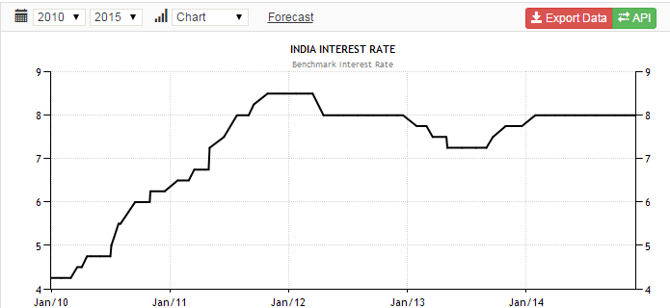

Prepared by
CA Priyanka Taluka

Email:- priyankataluka9@gmail.com

