How to submit Response to Outstanding Tax Demand
Introduction- Once the e-Filed returns are processed and outstanding tax demand available in e-Filing portal, assessee is facilitated to submit the response against outstanding tax demand raised by CPC/AST.

Process
The detailed process to submit the Response to Outstanding Tax Demand is as below
1. Logon on to incometaxindiaefiling.gov.in with your User ID, Password and Date of Birth/Incorporation.
2. Go to e-File > Response to Outstanding Tax Demand
3. Enter PAN and Captcha code and click on Submit button.

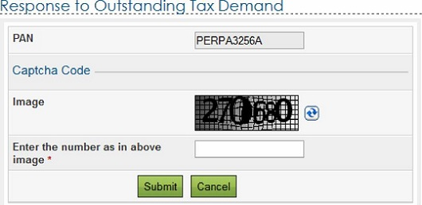

4. On successful validation if there is any Outstanding Tax Demand, the “Response to Outstanding Tax Demand” available with the following details

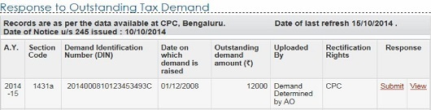

5. Assessee must click on ‘Submit link under Response column for the respective AY in order to submit the response. Assessee has to select one of the options from the radio button.
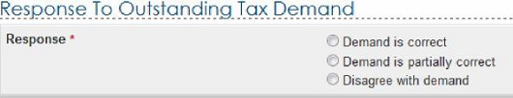
6. If assessee selects “Demand is correct”, then a pop up is displayed as “If you confirm “Demand is correct’ then you cannot ‘Disagree with the demand’. Click on Submit. A success message is displayed and no further action is required.
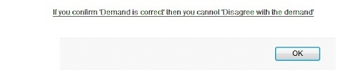

7. If assessee selects “Demand is partially correct´, then two amount fields will be available.

♠ Amount which is correct- Enter the amount which is incorrect.
If the amount entered here is equal to the demand amount, then one pop is displayed “Since the amount entered is equal to outstanding demand amount, please select the option “Demand is correct”
Note: If amount entered is equal to Outstanding demand amount than user shall not be allowed to submit with this option.

♠ Amount which is incorrect: Amount is auto filled which is the difference between the outstanding amount and Amount which is correct.

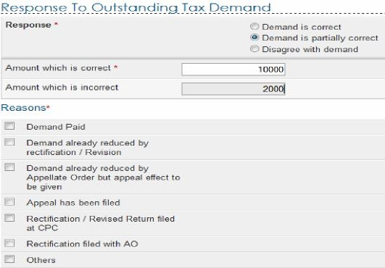

8. If amount entered is not equal to outstanding demand amount than user should mandatorily fill one or more reasons listed below-
♠ Demand Paid –
- Demand paid and challan has CIN
- Demand paid and challan has no CIN
♠ Demand already reduced by rectification/revision
♠ Demand already reduced by Appellate Order but appeal effect to be given
♠ Appeal has been filed
- Stay petition filed with
- Stay granted by
- Instalment granted by
♠ Rectification / Revised Return filed at CPC
♠ Rectification filed with AO
♠ Others
♠ Based on the reason selected, the assessee needs to provide additional information as per the below table.

Reason Selected | Additional Details Required
Demand paid and challan  has CIN | BSR Code
Demand paid and challan  has CIN | Date of payment
Demand paid and challan  has CIN | Serial Number
Demand paid and challan  has CIN | Amount
Demand paid and challan  has CIN | Remarks
Demand paid and challan  has no CIN | Date of payment
Demand paid and challan  has no CIN | Amount
Demand paid and challan  has no CIN | Remarks
Demand paid and challan  has no CIN | Upload Copy of Challan
Demand already reduced by rectification / Revision | Date of Order
Demand already reduced by rectification / Revision | Demand after rectification/ revision
Demand already reduced by rectification / Revision | Details of AO
Demand already reduced by rectification / Revision | Upload Rectification / Giving appeal  effect order passed by AO
Demand already reduced  by Appellate Order but  appeal effect to be given | Date of Order
 | Order passed by
 | Reference Number of Order
 | Demand after Appeal effect
Appeal has been filed: Stay petition has been filed | Date of filing of appeal
Appeal has been filed: Stay petition has been filed | Stay petition filed with
Appeal has been filed: Stay has been granted | Date of filing of appeal
Appeal has been filed: Stay has been granted | Stay granted by
Appeal has been filed: Stay has been granted | Upload copy of Stay
Appeal has been filed:  Instalment has been  granted | Date of filing of appeal
Appeal has been filed:  Instalment has been  granted | Instalment granted by
Appeal has been filed:  Instalment has been  granted | Upload copy of stay/installment order
Rectification / Revised  Return filed at CPC | Filing Type
Rectification / Revised  Return filed at CPC | e-Filed Acknowledgement No.
Rectification / Revised  Return filed at CPC | Remarks
Rectification / Revised  Return filed at CPC | Upload Challan Copy
Rectification / Revised  Return filed at CPC | Upload TDS Certificate
Rectification / Revised  Return filed at CPC | Upload Letter requesting rectification  copy
Rectification / Revised  Return filed at CPC | Upload Indemnity Bond
Rectification filed with AO | Date of application
Rectification filed with AO | Remarks
Others | Others

Note: Total Attachments size should be up to 50 MB.

9. If assessee selects “Disagree with the Demand” “, then assessee must furnish the details for disagreement along with reasons. Reasons are same as provided under “Demand is partially correct”.

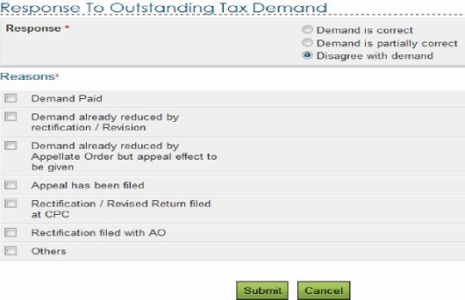
Fill the necessary details and click on “Submit” button.
10. After assesse submits the response the success screen must be displayed along with the Transaction ID.
The success message is as follows:
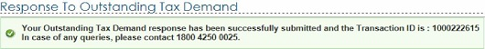

11. Assessee can click on ‘View’ link under Response column to view the response submitted. The following details are displayed:
- No.
- Transaction ID – A hyper link
- Date of Response
- Response Type

Click on
Transaction ID to know the details of response submitted.

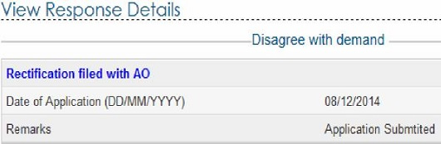

Note:
- Demand position gets updated every day
- Interest demand u/s 220(2) is linked to the principal demand of the same assessment This indicates that principal demand is already adjusted/ paid and interest demand is the only outstanding value. Hence does not require any confirmation.
- If demand is shown to be uploaded by AO in the above table, rectification right is with Assessing Officer, please contact your jurisdictional Assessing Officer for the same.
- For the demand against which there is “No Submit response option” available such demand is already confirmed by the Assessing Officer. Kindly contact your Jurisdictional Assessing officer.

