Reasons for Income Tax Refund Failure & Resolution

In this Article we have discussed 28 Reason for Failure or non issuance of Income Tax Refund and Solutions for the same.

1. Expired Cheque
Your refund cheque has been expired. You are requested to apply for refund reissue to claim your refund. The refund reissue can be applied through online by following the procedure given above.

2. Incorrect A/C No
The account number provided by you was incorrect. You are requested to apply for refund reissue by providing the correct account number to claim your refund. The refund reissue can be applied through online by following the procedure given above.

3. House Locked
The refund cheque dispatched was returned since the house was locked. You are requested to apply for refund reissue to claim your refund. The refund reissue can be applied through online by following the procedure given above.

4. Party Shifted
The refund cheque dispatched was returned as the concerned party was not available at the address provided. You are requested to apply for refund reissue to claim your refund by updating the new address. The refund reissue can be applied through online by following the procedure given above.

5. No such Address
The refund cheque dispatched was returned as the address provided was incorrect. You are requested to apply for refund reissue to claim your refund by updating the new address. The refund reissue can be applied through online by following the procedure given above.

6. No such person
The refund cheque dispatched was returned as the concerned person was not available at the address provided. You are requested to apply for refund reissue to claim your refund. The refund reissue can be applied through online by following the procedure given above.

7. Incorrect MICR code/unavailable
The MICR code provided by you was incorrect or not provided. You are requested to apply for refund reissue by providing the correct MICR code to claim your refund. The refund reissue can be applied through online by following the procedure given above.

8. Account has been closed
The account number provided by you was closed. You are requested to apply for refund reissue to claim your refund with new account number. The refund reissue can be applied through online by following the procedure given above.

9. Account Description incorrect
The account description provided by you was incorrect. You are requested to apply for refund reissue to claim your refund with correct account description or with new account number. The refund reissue can be applied through online by following the procedure given above.

10. Address given for dispatch is a foreign address:
It is found from our records that you have requested the refund cheque to be dispatched to a foreign address (as mentioned in your return of income). Hence, you are requested to provide a valid Indian address. The refund reissue can be applied through online by following the procedure given at following post- How to Request re-issue of Income tax Refund? Please contact SBI Call center 18004259760 for help further.

11. Mandatory fields missing: (Account Number/Account Name/Account Type/Address 1/City/State/Pin code)
Mandatory fields like Account Number, Account Name, Account Type, Address line 1, City, Pin code were not provided by you. You are requested to apply for refund reissue to claim your refund by providing the above mentioned mandatory details. The refund reissue can be applied through online by following the procedure given above.

12. Incorrect A/C Number Length
The account number provided by you was incorrect. You are requested to apply for refund reissue by providing the correct account number to claim your refund. The refund reissue can be applied through online by following the procedure given above.

13. Invalid A/C Number
The account number provided by you was invalid. You are requested to apply for refund reissue by providing the correct account number to claim your refund. The refund reissue can be applied through online by following the procedure given above.

14. Invalid A/C Number: Between two special characters there should be at least one alphabet/number
The account number provided by you was invalid. You are requested to apply for refund reissue by providing the correct account number to claim your refund. The refund reissue can be applied through online by following the procedure given above.

15. Invalid A/C Number: First Character in A/C No should be an alphabet/number only
The account number provided by you was invalid. You are requested to apply for refund reissue by providing the correct account number to claim your refund. The refund reissue can be applied through online by following the procedure given above.

16. Invalid A/C Number: Last Character in A/C Number should be a number
The account number provided by you was invalid. You are requested to apply for refund reissue by providing the correct account number to claim your refund. The refund reissue can be applied through online by following the procedure given above.
17. Invalid A/C Number: Numeric string between alphabets or special characters cannot be all zeros
The account number provided by you was invalid. You are requested to apply for refund reissue by providing the correct account number to claim your refund. The refund reissue can be applied through online by following the procedure given above.

18. Invalid character in A/C Number
The account number provided by you was invalid. You are requested to apply for refund reissue by providing the correct account number to claim your refund. The refund reissue can be applied through online by following the procedure given above.

19. Address not valid: Invalid characters or too long address
The address provided by you was too long. You are requested to apply for refund reissue by providing the correct address to claim your refund. The refund reissue can be applied through online by following the procedure given above.

20. Invalid character in Account Name or Name too short
The account name provided by you had invalid character or name too short. You are requested to apply for refund reissue by providing the correct account name to claim your refund. The refund reissue can be applied through online by following the procedure given above.

21. No numeric digit in Account Number
The account number provided by you was invalid. You are requested to apply for refund reissue by providing the correct account number to claim your refund. The refund reissue can be applied through online by following procedure given above.

22. Invalid IFSC code
The IFSC code provided by you was invalid. You are requested to apply for refund reissue by providing the correct account number to claim your refund. The refund reissue can be applied through online by following above.

23. Name mismatch with Bank account holder
The account number provided by you had a name mismatch. You are requested to apply for refund reissue by providing the correct account number or name to claim your refund. The refund reissue can be applied through online by following

24. Death of person and account is on hold.
In case of death of an assessee, legal heir can do the following steps:
- Need to approach to CPC with request and wait for CPC communication in this regard.
- On receiving the communication, kindly contact your jurisdictional AO along with relevant proof.
- After verification, if the Jurisdictional AO approves the legal heir claim, refund will be routed to your bank account.

25. Account is under attachment by court/IT.
Contact SBI Call center 18004259760 for help.

26. Account holder KYC is pending.
Contact SBI Call center 18004259760 for help.

27. Account details given are other than Current Account or Saving Bank Account.
Contact SBI Call center 18004259760 for help.

28. Minor assessee has attained majority and fresh documentation is pending.
Contact SBI Call center 18004259760 for help.

How to Request re-issue of Income tax Refund?
Income Tax Refund cheque issued by CPC Bangalore Returned undelivered or not been credited due to wrong account info, expired cheque etc?

Now days Assessee who file their Income tax Return online gets their refund cheque issued by CPC Bangalore. Refunds are issued by two modes:-

1. By crediting the refund amount in Assessee’s bank account if the Assessee has correctly mentioned his bank details in Income tax Return Filed by him.

2. By sending Income Tax Refund Cheque if Assessee failed to submit or correctly mention his bank account details in Income tax Return filed by him.

In case of Physical cheques there may be chances that after filing of Income tax Return Assessee has moved to new address and his Income tax Refund cheque issued by CPC Bangalore returned back for non-delivery. There may also be a chance that although address is not changed but Assessee could not receive the refund order as no one was there on the day when cheque was delivered or Refund cheque returned undelivered by the postal department as the house was locked.

Further in case Assessee has applied for ECS but has entered wrong account details or account of which details been entered is closed and ECS to such account been failed.

In such cases one question arises what Assessee should do to request reissue of Refund cheque or how to request Credit of that account in his bank account and how to intimate the change in address?

Procedure to apply for refund – reissue for refund related to AY 2009-10 and succeeding years

- Logon on to https://incometaxindiaefiling.gov.in/ with your user ID and Password.
- Go to MY Account →Refund Reissue Request
- Screen below appears, you need to enter the necessary details and click on submit button.

REFUND REISSUE SCREEN

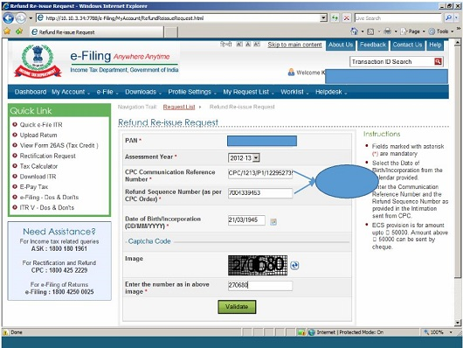

4. Please refer to the pictorial representation shown below; indicating the CPC reference number and refund sequence number as can be seen in the Order u/s 143(1)/154, Income Tax Act, 1961.
Intimation Pictorial Representation:
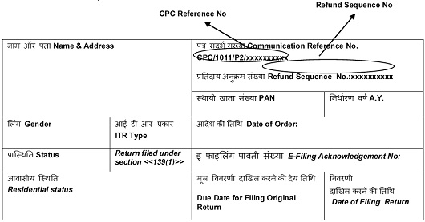

5. Assessee has two options to apply Refund Reissue- ECS or Paper.

6. ECS Mode: Select mode of Refund reissue, Bank Account Details – Can be changed, if required, category and click submit.

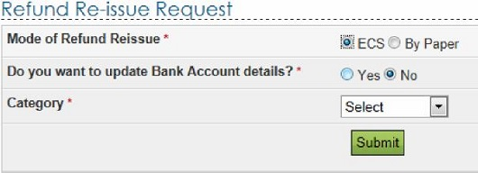

7. Paper Mode: If assessee applies refund reissue through Paper mode. This option envisages the assessee to get refund through cheque to the address selected by the assessee.
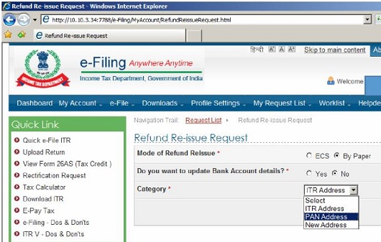

8. Refund Reissue related to AY 2008-09 to be applied through response letter to CPC.

- Paper return which were processed at CPC, refund reissue can be applied only through sending response directly to CPC.

• please note that from AY 2013-14 onwards, Assessee need enter IFSC code instead of MICR code for
• Find below the table with reasons for refund failure at CPC and the resolution thereof.

Procedure to apply for refund – reissue for refund related to A.Y. 2008-09

Assessee needs to download the address/bank-details modification form (Response Sheet) from the website of Income Tax department, fill the same and after that he needs to send the same by ORDINARY or SPEED POST along with cancelled cheque and other supporting documents to:
“Income Tax Department – CPC, Post Bag No – 1, Electronic City Post Office, Bangalore – 560100, Karnataka”

To Download the need to take Response Sheet Assessee Following steps:-
1. Visit https://incometaxindiaefiling.gov.in/portal/index.do
2. Enter login details.
3. after login go to sub menu ‘Response Sheet for Refund Failure Status’ under the main menu ‘My Account’ (Please note I have not found the link in Menu which was there earlier)
4. Download the response sheet.
It is to be noted if there is any change in address of the Assessee needs to get the same updated with PAN master database by filing Form No. 49Afor correction in PAN Data.

