HOW TO FIX TDS RPU ERROR IN WINDOW 7 32 BIT
1ST STEP
Copy these three file
SPR32X30.ocx
TABCTL32.ocx
Comdlg32.ocx

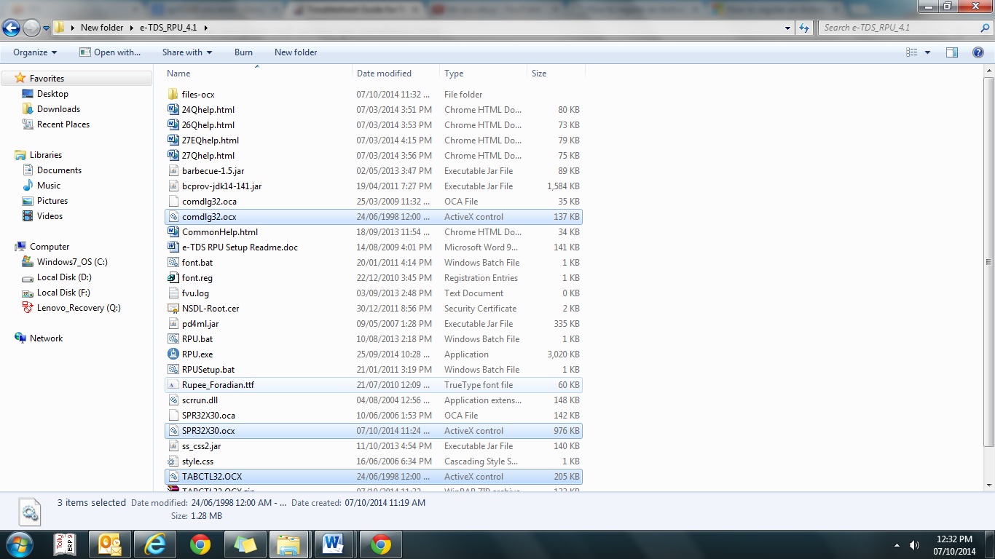
And paste in C:\Windows\System32
My computer c drive windows system32 and paste

2nd step
Open cmd.exe as administrator
Click on start type cmd right click on cmd.exe and run as administrator if asking for yes/no than press yes

3rd step
In command prompt u will see

C:\Windows\system32>
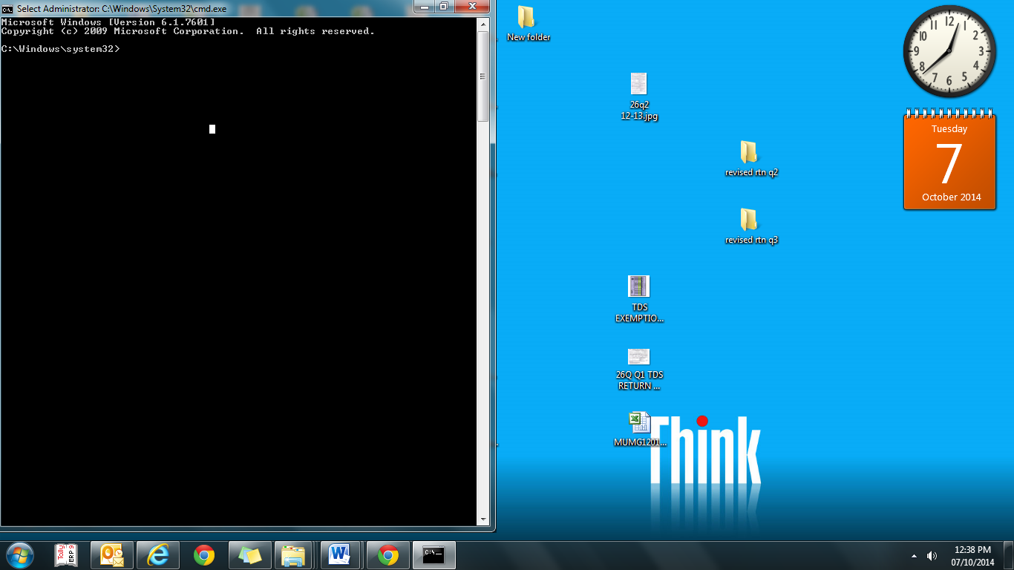
Here you have to type or paste this 3 command one by one and press enter
Regsvr32 /s c:\windows\system32\ SPR32X30.ocx
enter
Regsvr32 /s c:\windows\system32\ TABCTL32.ocx
enter
Regsvr32 /s c:\windows\system32\ Comdlg32.ocx
Enter

Than close cmd window and now run rpu setup.bat, now u can run rpu.exe

