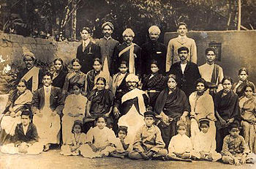

Hindu joint family
A Hindu Joint Family or or Hindu Undivided Family is an extended family arrangement prevalent among Hindus of the Indian subcontinent, consisting of many generations living under the same roof. All the male members are blood relatives and all the women are either mothers, wives, unmarried daughters, or widowed relatives, all bound by the common [sapinda] relationship. The joint family status being the result of birth, possession of joint cord that knits the members of the family together is not property but the relationship. The family is headed by a patriarch, usually the oldest male called "[Karta]", who makes decisions on economic and social matters on behalf of the entire family. The patriarch's wife generally exerts control over the kitchen, child rearing and minor religious practices. All money goes to the common pool and all property is held jointly.
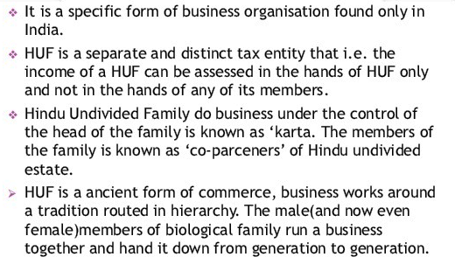
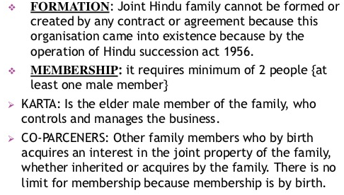

Schools
There are several schools of Hindu Law, such as Mitakshra, the Dayabhaga, the Marumakkathayam, the Santayana etc. Broadly, Mitakshra and Dayabhaga systems of laws are very common. Family ties are given more importance than marital ties. The arrangement provides a kind of social security in a familial atmosphere.
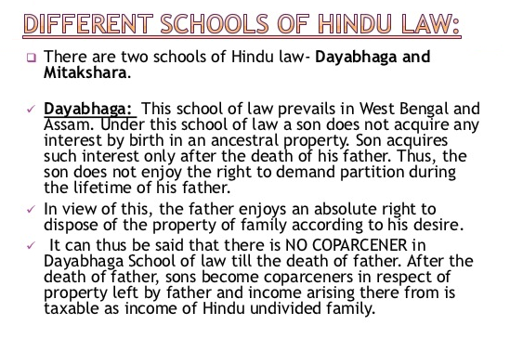

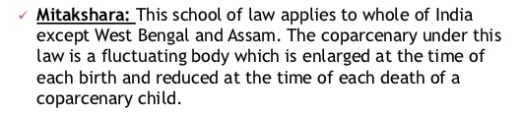

Key aspects
Key aspects of a joint family are:
- Head of the family (Kartha) takes all decision regarding financial and economical aspects of family.
- All members live under one roof.
- Share the same kitchen.
- Three generations living together (though often two or more brothers live together, or father and son live together or all the descendants of male live together).
- A common place of worship.
- All decisions are made by the male head of the family- patrilineal, patriarchal.
- No division of property until the death of the Karta (head of family or older male person).
- Income earned by the HUF and expenses incurred by the HUF are of the whole family and not of any specific individual. All Incomes are also taxed in the hands of the HUF and not any specific individual.







Relationships
In joint families in north and central India, between a bride or sister-in-law and her younger brother-in-law a joking or teasing relationship is common, while the relationship towards an older brother-in-law is that of respectfulness.
In a traditional Joint Hindu family, there is a subservient relationship between the wives of the brothers; that is to say, the Patriarch's wife is addressed as Badi Bhabhi, meaning eldest brother's wife. She is traditionally considered the mistress of the house, and is in charge of running the household affairs and overseeing the servants (if any). The subsequent younger brothers' wives typically seek her advice and permission in regards to any matters/decisions regarding the household and rearing of the children. In popular culture, Hindi dramas typically display these relationships as contentious, as the 'Badi Bhabhi' usually abuses her position of power.





