STEPS FOR ISSUE OF FORM 16B BY BUYER-TDS ON SALE OF PROPERTY
1.Go to www.tin-nsdl.com and pay the TDS wide challan No. 26 QB.
2.Once you have paid the tds ,the buyer need to issue Form-16B to the seller
3.For downloading the form 16B,follow the further steps:
a.Go to TRACES website i.e. www.tdscpc.gov.in
b.Register as a TAX PAYER.The buyer need to register as a tax payer with his PAN number.The following screen appears.

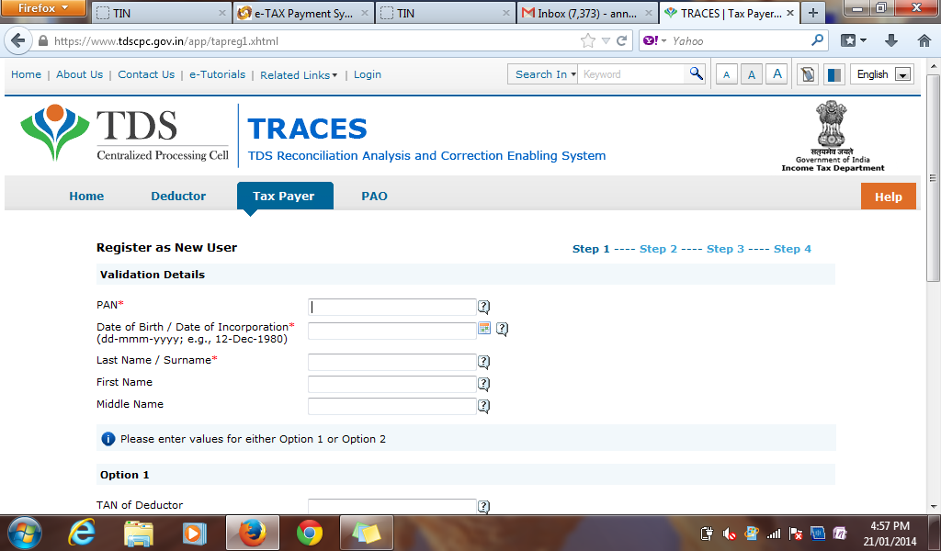

c.An activication code shall be sent on the mobile number and the email id provided during the registration.Activate your account by entering the codes provided.
d.Once you log-on to your account as a tax –payer.In the downloads section,place a request for form16B,you will be asked to provide acknowledgement number and the buyers pan Number.Fill in the details as required and you shall download form-16B.
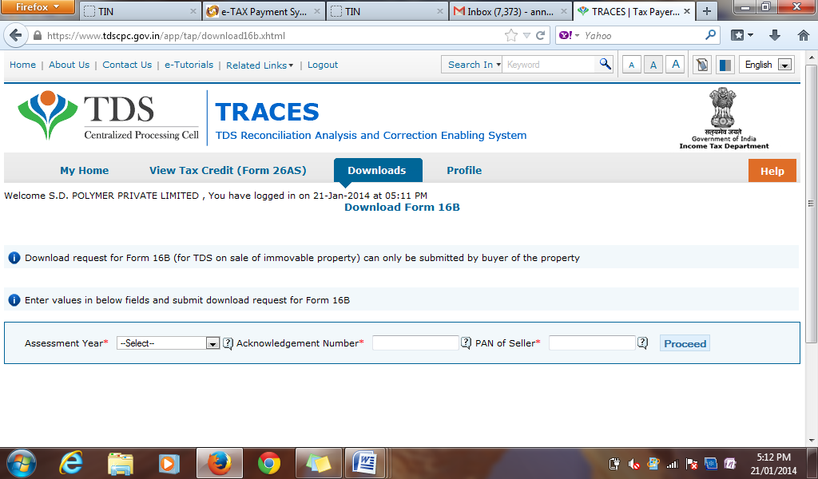
Hope this file helps you all.

