How to reset Income tax India e-filing portal password!!--you don’t need password at all to file your income tax return Ganesh babu K says
Dear friends,
There is an unresolved question with so many Assesses,
How to reset forgotten income tax India E-filing password?
As department stopped sending reset password links to alternate mail id’s , it became a headache to so many clients how to file return of income now!!!!!
Friends in this article I would like to share with all of you how to reset income tax India e-filing portal password by filing return without any password.


- HOW TO FILE INCOME TAX RETURN WITH OUT PASSWORD OF INCOME TAX E-FILING PORTAL.
***[ once you filed your income tax return with this procedure you can reset password with ITR-V acknowledgement number & bank account number used in income tax return]

- Yes, it is correct; it is possible to file Income tax return without password. Even I was
Shocked how it is possible to file income tax return without password but I have done it personally and confirmed that yes it is possible.

- Go to Tax cloud India website to file returns without password. Please find this link to go to tax cloud India website http://taxcloudindia.com/.

Below is the screen shot of website,

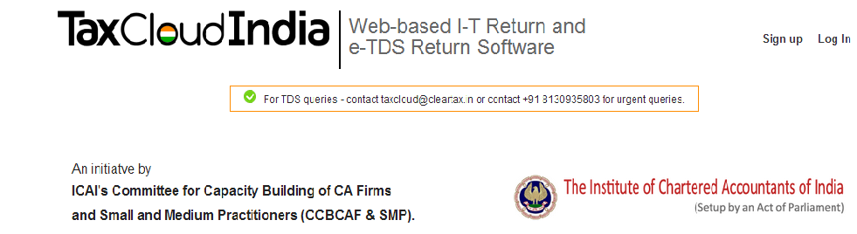

- Really I was surprised how Income tax dept. allows filing returns without any passwords; however it helps to us, here we don’t need Assesse password to file income tax return.[I don’t think this is fair to give access to file returns without password, income tax dept. may restrict the same in future in my opinion]
- Register in taxcloudIndia.com ,then only you can file return,>>>>>Click here
- To view Guide to file income tax return with Tax Cloud India website>>>>Click here
- Generally once you registered and started browsing tax cloud India website you can understand how to file ITR by going to link given in point 5.
- So with above introduction you can file your Income tax return online and can generate ITR-V without any password for income tax India e-filing password.
- So dear friends take this website help and file your returns which were kept pending because of unavailability of password and also reset your password immediately with ITR-V generated.
- We cannot say how long this website allow to file return with password so hurry up and file all pending returns, and reset your passwords.
- For other important guidance on how to go ahead in Tax cloud India website>>>Click here

- HOW TO RESET PASSWORD WITH ITRV AND BANK ACCOUNT NUMBER.

- Assesse having previous year e-filed Income tax return acknowledgement number (ITR-V) and bank account number quoted in ITR can reset password with the help of these details.
- Assesse who is not having previous year ITR details can file current year income tax return without any password as explained in STEP 1 and can reset your income tax India e-filing password with the help of ITR-V GENERATED AND BANK ACCOUNT NUMBER USED in filing ITR as in STEP1.
- Procedure to Reset password with ITR-V acknowledgement number and bank account number,
(i) Go to https://incometaxindiaefiling.gov.in/e-Filing/UserLogin/LoginHome.html
(ii)Click on “Forgot password”.
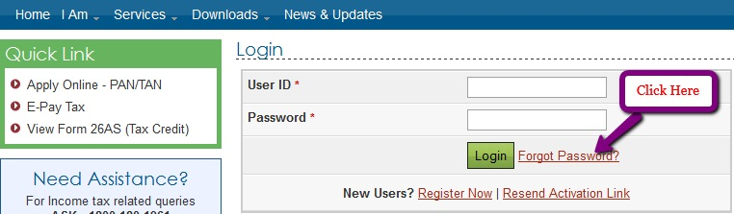

(iii)Enter PAN number as USER id and Captcha code then click on Continue.
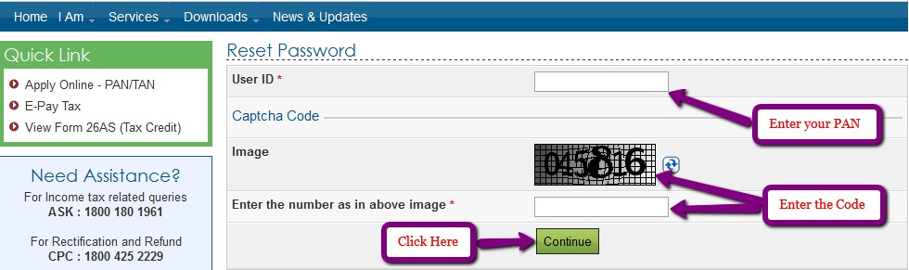

(iv) After above step you will find the below screen where you will find 3 option to choose any of them. Select one of them which you are comfortable with its respective data requirement. You can select 3rd option to reset password with ITR-V and bank account number
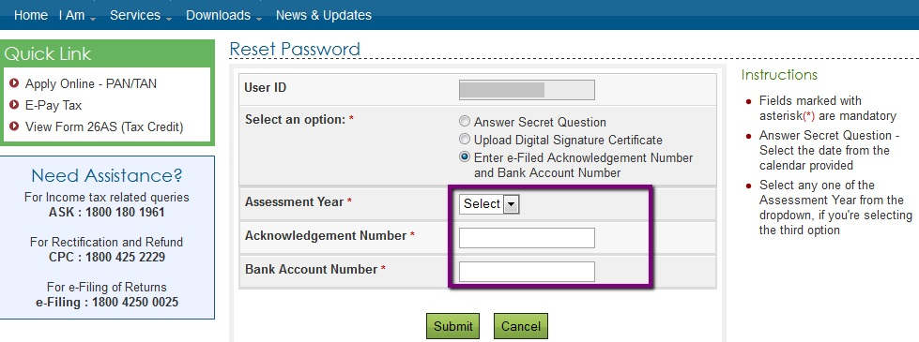

(v)Once you provided data as required in above screenshot and click on submit button you will find new screen where you can enter new password and confirm the password by entering again then click on submit.

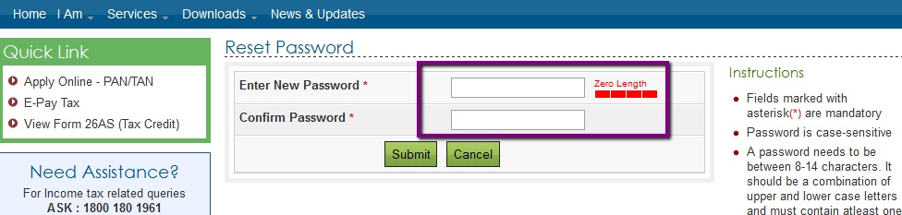

With this you can complete the resetting your e-filing password and use it for filing your income tax returns.

Thanks to Tax Cloud India

- RESET PASSWORD THROUGH SENDING MAIL ID:-
If password for e-filing portal was created from your mail id you can reset the password by sending a mail to validate@incometaxindia.gov.in , with the below required details requesting to reset password.
(i)PAN number
(ii)PAN holder name
(iii)Date of birth/Date of Incorporation
(iv)Father’s name
(v)Address as per PAN records (Form16,16A will contain Address as per PAN records)

You will receive reply from income tax department to your registered mail id, and then you can reset the password with new password.

Hope this article will helps you in resetting income tax India e-filing password.

No Person in this World has Ever been Rewarded for What He has 'RECEIVED',
He is Always "Honoured" for what He has 'GIVEN' to Others !!
Knowledge is power!!Keep sharing..

Thanks & Regards


