I. Objectives and legal aspects of RGESS
1. What is RGESS
Rajiv Gandhi Equity Savings Scheme (RGESS), is a tax saving scheme announced in the Union Budget 2012-13 (para 35). The scheme is designed exclusively for the first time retail individual investors in securities market, whose gross total income for the year is less than or equal to Rs. 10 lakh. The investor would get under Section 80CCG of the Income Tax Act, a 50% deduction of the amount so invested, upto a maximum investment of Rs. 50,000, from his/her taxable income for that year.2. What is the objective of the Scheme?As announced in the Union Budget 201 2-13, the objective of the Scheme is to encourage the flow of savings and to improve the depth of domestic capital markets. This would help in promoting an ‘equity culture’ in India. The Scheme aims at widening the retail investor base in the Indian securities markets and also furthers the goal of financial stability and financial inclusion.
3. What is the legal provision for RGESS?
A new section 80CCG under the Income tax Act, 1961 on ‘Deduction in respect of investment under an equity savings scheme’ was introduced, vide Finance Act 2012, to give tax benefits to ‘New Retail Investors’ who invest up to Rs.50,000 in ‘Eligible Securities’ and whose gross total annual income is less than or equal to Rs.10 Lakhs.
The details of the RGESS Scheme were notified on 23 November 2012 (Section No. 2777(E);Notification No. 51) and vide subsequent corrigendum dated 5 December 2012 (Section No. 2835(E); Notification No. 53) by Department of Revenue. The operational guidelines were issued bySEBI on 6 December 2012.
4. Would first time investors not lose money in the equity market? Would it be too dangerous for them to invest in it?
The investors in the RGESS run the risk of losing money in the equity market, like any other investor in the securities market. The Scheme does not provide any guarantee of assured returns. Therefore, investors under RGESS are advised to do due diligence before making any investments in the equity market. However, while designing the Scheme, safeguards like, restricting the investments to select large cap stocks, lock-in period with enough flexibility to take benefits of the positive market movements etc. have been provided to protect the interests of the first time investors.
To give the benefit of diversification and consequent risk minimization, investments into Exchange Traded Funds (ETFs) or Mutual funds, set up as per the criteria laid down in the scheme, are also allowed under the Scheme.
5. We already have an Equity Linked Savings Scheme (ELSS)? Why do we need RGESS?
ELSS and RGESS are entirely different schemes: They pertain to different asset classes with ELSS offering passive investment avenues. ELSS is meant for indirect participation in the stock market, whereas RGESS aims at encouraging direct participation in the stock market. The operational differences are given below:

Operational differences
ELSS | RGESS
Investments are in mutual funds | Investments are to be made directly in listed equity or into a combination of equity including mutual funds, ETFs
100% deduction (upto Rs. 1,00,000) is allowed under ELSS | Only 50% deduction (upto max. of Rs. 25,000) is allowed under RGESS.
The ELSS benefit is coming under Section 80C of the IT Act which has an aggregate limit of Rs. 1,00,000 for all such eligible instruments like LIC policy, PPF etc | RGESS deduction is available under Section 80CCG. This is a separate investment limit exclusively for RGESS, over and above the Section 80C Limit
Lock-in period of 3 years | Lock-in period of 3-years. However, trading allowed after one-year, subject to conditions.
Since investments are in mutual funds, it is perceived to be less risky | Since investments are in equity / risk / ownership capital, risk is perceived to be higher

6. What are the benefits / highlights of RGESS compared to other tax saving schemes?
The following are the benefits of RGESS:
- The allowed tax deduction u/s 80CCG will be over and above the Rs. 1 Lakh limit permitted under Section 80C of the Income Tax (IT) Act, making it thus attractive for the middle class investors.
- Further, the Dividend income is also tax free.
- Investor is free to trade / churn the portfolio after the lock-in period in each of the years following the first year of investment, subject to certain conditions.
- Gains arising out of higher market valuation of RGESS eligible securities can be realized after a year viz: fixed lock-in period. Provisions exist to protect the investor from general declines in the market to a certain extent. This is in contrast to all other tax saving instruments.
- You can meet emergencies through pledging or even by selling off some stocks after the fixed lock-in period.
- For investments upto Rs.50,000 in your sole RGESS demat account, if you opt for Basic Service Demat Account, annual maintenance charges for the demat account is zero and for investments upto Rs. 2 lakh, it is stipulated at Rs 100.
- The investments can be made in installments during the first financial year in which tax deduction is claimed.
II. Coverage of the Scheme: Investors and Investments allowed under RGESS
7. Who all will be covered under the Scheme? Who is a new investor?
The Scheme is open for all New Retail Investors who have gross total income less than or equal to Rs. 10 lakh. A new retail investor is one:
- who is a resident individual (the benefit cannot be availed by corporate entities / trusts etc)
- who has not opened a Demat account and has also not done any trading in the derivative segment till RGESS account opening date.
- those who have opened the Demat account and have not made any transactions in equity and /or in the derivative segment till designating such account as RGESS.
In case of joint accounts, only the first account holder will be considered as the existing retail investor. All those existing account holders other than the first demat account holder (eg. second / third account holders or other joint holders) or nominees of the existing account holders will be considered as new retail investors for the purpose of opening of a fresh RGESS account, if otherwise eligible.
In case the demat account is opened as a first holder, but there are no transactions in the equity or derivate segment, still the first account holder is eligible.
The new retail investor will have to submit a declaration, as in Form ‘A’, to the Depository Participant (DP) at the time of account opening or designating his existing demat account for taking the benefits under RGESS.
Eligible securities, which are brought thereafter into such an account, will be automatically subject to lock-in upto a value of Rs. 50,000, unless the investor specifies otherwise through the Form ‘B’ specified in this regard.
8. I am a non-resident Indian; Am I eligible for RGESS?
No.
9. I am already having units of mutual fund and / or Exchange Traded Funds; Am I eligible for the RGESS?
Yes. Prior investments in mutual funds and Exchange Traded Funds do not make an investor ineligible for the Scheme. However, you need to invest afresh in RGESS eligible mutual fund /ETF schemes and hold them in a demat account to avail of the benefits under RGESS.
10. I possess some physical shares; Am I eligible under RGESS?
Yes. You will be considered as a new retail investor, if otherwise eligible. However, you need to make fresh investments to avail of the benefits under RGESS. You will not be eligible to claim benefits of RGESS on dematerialisation of such shares.11. What are the investment options available under the Scheme? What are the “eligible securities” under RGESS?
The investment options under the scheme will be limited to the following categories of equities?*:
Listed equity shares
a. The top 100 stocks at NSE and BSE i.e., CNX-100 / BSE -100 (This does not mean that one has to trade through NSE or BSE only. If the securities constituting BSE 100 or CNX 100 are listed and traded in any new stock exchange that may come up on a later day, the same will be eligible for RGESS.)
b. Stocks of public sector enterprises which are categorized by the Government as Maharatna, Navaratna and Miniratna
c. Combinations of stocks in (a) and /or (b) which are listed and traded on a stock exchange and settled through a depository system (eg. Exchange Traded Funds (ETFs)or Mutual Fund (MF) schemes with RGESS eligible securities as mentioned in (a) and / or (b) as underlying, provided they are listed and traded on a stock exchange and settled through a depository mechanism)
d. Follow-on Public Offers (FPOs) of (a) and (b)
e. New Fund Offers (NFOs) of (c) above
Unlisted equity shares
f. Initial Public Offers (IPOs) of PSUs, which are scheduled to get listed in the relevant financial year and where the government holding is at least 51% and whose annual turnover is not less than Rs. 4000 cr for each of the immediate past three years.
(*Investment criteria as applicable at the time of investment)
12. Where can I get information about these eligible stocks?The consolidated and updated list of eligible securities from time to time is published on the websites of exchanges / Depositories / AM FI.
For detailed information see at the relevant pages of the websites of SEBI NSE BSE, NSDL, CDSL and AMFI.
As regards eligible IPOs, companies would be publishing this information in their offer documents / public advertisements.
13. Why RGESS Investments are limited to top 100 stocks?
The Scheme is designed for new investors who are venturing in the equity markets for the first time. The choice of investments have been restricted to the stocks included in BSE 100 or CNX 100 and to selected PSU stocks as they generally have shown relatively lower volatility, higher liquidity, and there is adequate reporting and analysis available in the market. The range of 100 stocks also provides enough scope for diversification of investments.
14. When I made the investment, the particular stock was in BSE 100; thereafter it was removed from the BSE 100 list by the exchange; Is my investment still eligible for RGESS when I file my returns?
A stock has to be in BSE 100 or CNX 100 only at the time at which the investments are made. This means that even if the stock moves out of CNX 100 / BSE 100, the investor would be deemed to be compliant for RGESS. However, his rights are limited to just selling those stocks off from RGESS portfolio. If he repurchases / make additions to the existing stock, then the additional stock will not be counted as a part of the RGESS portfolio.
15. I applied for the IPO in the month of March; However, the company got listed in the stock exchange only in April i.e, in the next financial year. Is my investment eligible?
No, only if it is scheduled to be listed in the same financial year the investment is eligible.
16. What is the maximum amount that I can invest in securities market? Can I bring the same in installments?
There is no maximum prescribed limit for your investments in securities market. However, RGESS benefits will be available only for investments in eligible securities upto Rs. 50,000. This investment can be made in installments. However, the benefits can be availed only for the investments made in the first financial year in which the benefit is claimed under Section 80CCG. Hence, if you are making investments in installments, make sure that you are making all your installments in a single financial year (which should be the year in which you open / designate your account for RGESS) as subsequent investments will not be counted towards RGESS.
17. Can I split my investment under RGESS over two financial years and claim deduction?
No. Only the investment during the first financial year can be booked as investment under RGESS to claim deduction.
18. Why the Scheme limit the benefits of the Scheme only to the first year?
The Scheme, as such, is designed for only the first time new investors. Since they can be ‘new’ only in the first year of entering the market, the benefits of the Scheme is limited to only one year for a particular beneficiary, i.e., the tax benefit can be availed of only to the extent of investments made in a single financial year in which the investor makes the first RGESS eligible investment after opting for the RGESS account.
The limitation of one year also arises from clause 2 of Section 80CCG as given below, which was inserted vide, Finance Act, 2012 in the Income Tax Act, 1961
80CCG (2) Where an assessee has claimed and allowed a deduction under this section for any assessment year in respect of any amount, he shall not be allowed any deduction under this section for any subsequent assessment year.
However, considering the financial constraints of the small retail investors, the flexibility to invest in installments in the first financial year is provided in the Scheme.
19. How much tax deduction will I be eligible for under RGESS?
You will be eligible to get tax deduction u/s 80CCG on 50% of the amount invested. Let us say, you invest Rs.50,000 under RGESS, the amount eligible for tax deduction will be Rs.25,000 from your taxable income. Let us say, you invest Rs.40,000 under RGESS, the amount eligible for tax deduction will be Rs.20,000 from your taxable income. This deduction is over and above Rs. 1 lakh limit specified under Section 80C.
In other words, for those who are in the 10% income tax bracket, savings from tax liability for investments upto Rs. 50, 000 under RGESS is Rs. 2500 (plus cess as applicable) and for those who are in the 20% income tax bracket, savings from tax liability is Rs. 5000/-(plus cess as applicable).
20. I have already claimed tax benefit under Section 80C. Can I avail of RGESS?
Yes you can. The tax deduction for RGESS is u/s 80CCG and it is over and above the Rs. 1 lakh limit specified under Section 80C. Further, it is not mandatory for citizens to exhaust the limit of Rs 1 lakh specified under Section 80C to make investments under Section 80CCG for RGESS.
21. Can I invest more than Rs.50,000 and claim tax benefit under RGESS?
You may invest any amount in a demat account designated under RGESS, but the benefit under the Scheme can be claimed only on investment up to Rs. 50,000. However, you have the freedom to select the stocks to be kept under lock-in for upto Rs. 50,000 for claiming benefits under RGESS. It may be noted that the depository would be automatically locking-in all the eligible securities which comes into an RGESS designated demat account during the first financial year upto a value of Rs. 50000. Hence, ensure that you intimate the depository participant through Form B within one month from the date of transaction, about those investments which you do not want to keep as part of RGESS investment in the first year, such that you have the right to sell / pledge those securities at any time. Once an application is made through Form B, that particular security cannot be brought back under RGESS while claiming for tax benefit in the first year. In subsequent years of flexible lock-in period, if that stock is still an eligible security under RGESS provisions, then the same will be counted towards valuation of RGESS portfolio irrespective of its status as an “eligible security” during the first year.22. I have purchased shares of Company ‘A’ which is an eligible security under RGESS for Rs 70,000; How can I free the investments beyond Rs. 50,000/-?
If you have purchased shares under RGESS for Rs. 70,000/-, the depositories will place shares amounting to only Rs. 50,000/- under fixed lock-in. Shares amounting Rs. 20,000 will not be under lock-in. However, if you are selective about the stocks to be kept under lock-in, then intimate the depository as mentioned in Q. No. 21
23. When should I submit Form B? Is there a time limit?You need to submit Form B to the depository participant, if you wish to keep any securities outside RGESS’s terms and conditions. This needs to be submitted within one month from the date of purchase / allotment of that security.
As per the Notification, Depositories are required to submit the report to Income Tax Department regarding RGESS beneficiaries within a period of thirty days from the end of the relevant financial year i.e. by 30th April. Hence, to avoid wrong reporting by Depositories on your investments to Income Tax Department, you are advised to submit declaration in Form B to the depository participants for the credits received during the month of March at the earliest and preferably by April 15th.
24.Can I claim tax deduction in respect of the amount invested in eligible securities which are specified in Form B?No.
III. Participating in the Scheme: Procedural and Operational issues
25. How to make RGESS eligible investments?Open a new demat account with any DP and designate it under RGESS or designate your existing demat account under RGESS through Form A. If you want to avail of Basic Service Demat Account facility, you may inform your DP to designate your account accordingly.
You may approach any SEBI registered stock broker for opening a trading account for making investment in any eligible stocks in the stock market or for applying for eligible IPOs.
In case you are investing in mutual funds through any distributor, you need to simply provide your demat account details like Demat Account Number and DP ID for receiving credit of the mutual fund units into the demat account.
For investing in any IPO/NFO of the eligible securities, you can subscribe for the same and provide your demat account details like Demat Account Number and DP ID for receiving credit of the eligible securities into the demat account.
26. What will be the mode of holding eligible securities?
The mode of holding eligible securities under RGESS will be in a ‘Demat account’. You cannot hold securities in physical form to enjoy the benefits of RGESS.
27. Should I need to get my mutual fund / ETF units also in demat form?
Yes. For getting your mutual fund units in demat form, make a request with your Asset Management Company or RTA. For more details please see the instructions ! guidance of CDSL and NSDL.
28. Is there any need for the investor to open a dedicated demat account for availing of RGESS benefits? Can I hold other securities i.e., other than eligible securities in my demat account designated for RGESS?
There is no need to open a separate dedicated account for availing of the RGESS benefits. The demat account through which RGESS benefits are being availed of can be used to keep shares! securities other than RGESScompliant securities. Investments in shares other than RGESS-compliant securities shall not be subject to the conditions of RGESS, nor shall be counted for extending the tax benefits under RGESS.
29. Is credit received in my demat account through off market trade or through dematerialisation eligible for claiming benefits under RGESS?
No. However, in the years of flexible lock-in (i.e., after the first year) all RGESS eligible securities would be counted towards checking for compliance of the investor with the Scheme, irrespective of whether it was acquired off market or came in through dematerialization.
30. How to open RGESS demat account with a Depository Participant (DP)?
You may approach any registered DP to open a demat account under RGESS.
You are required to fulfill the Know your client (KYC) norms prescribed by SEBI by submitting proof of identity, proof of address, etc. and provide PAN to the DP with whom you wish to open a demat account along with a declaration in prescribed format (i.e., ‘Form A’) for availing RGESS benefits.
31. How to open a trading account?
You can contact a broker (trading member) or a sub broker registered with SEBI for carrying out your transactions pertaining to the capital market. See the list of registered brokers ! sub brokers on the SEBI website.
32. What are the documents I need to bring for opening a demat / trading account?
You have to submit the following with the prescribed account opening form. In case you want to open account jointly with other person(s), following should be submitted for all the account holders.
Self-attested copy of PAN card and copies of passport size photograph is mandatory for all. Copies of all the documents submitted by the applicant should be self-attested and accompanied by originals for verification. In case the original of any document is not produced for verification, then the copies should be properly attested by entities authorized for attesting the documents.
i Proof of Identity (POI)
- Passport
- Voter ID Card
- Driving license
- PAN card with photograph
- Aadhar (Unique ID) letter
- Identity card/document with applicant’s Photo, issued by a) Central/State Government and its Departments, b) Statutory/Regulatory Authorities, c) Public Sector Undertakings, d) Scheduled Commercial Banks, e) Public Financial Institutions, f) Colleges affiliated to Universities (this can be treated as valid only till the time the applicant is a student), g) Professional Bodies such as ICAI, ICWAI, ICSI, Bar Council etc., to their Members; and h) Credit cards/Debit cards issued by Banks.
ii Proof of Address (POA)
- Ration card
- Passport
- Voter ID Card
- Driving license
- Bank passbook
- Verified copies of utility bills like Electricity bills, gas bills (not more than two months old)/ Residence Telephone bills (not more than two months old)/ Registered lease or sale agreement of residence / Flat maintenance bill / insurance copy
- Bank account statement / pass book
- Self-declaration by High Court & Supreme Court judges, giving the new address in respect of their own accounts.
- Proof of address issued by any of the following: Bank Managers of Scheduled Commercial Banks/ Scheduled Co-Operative Bank/Multinational Foreign Banks/ Gazetted Officer/Notary public/ Elected representatives to the Legislative Assembly/Parliament/Documents issued by any Govt. or Statutory Authority.
- Identity card/document with address, issued by a) Central/State Government and its Departments, b) Statutory/Regulatory Authorities, c) Public Sector Undertakings, d) Scheduled Commercial Banks, e) Public Financial Institutions, f) Colleges affiliated to universities (this can be treated as valid only till the time the applicant is a student); and g) Professional Bodies such as ICAI, ICWAI, Bar Council etc., to their Members.
List of people authorized to attest the documents: Notary Public, Gazetted Officer, Manager of a Scheduled Commercial/ Co-operative Bank or Multinational Foreign Banks (Name, Designation & Seal should be affixed on the copy).
You must remember to take original documents to your DP / trading member for verification. Your DP / trading member will carry-out “in-person verification” of account holder(s) at the time of opening your account. You should remember to obtain a copy of the agreement and schedule of charges for your future reference.
Your DP / trading member may ask an additional proof of identity/address.
33. I belong to PAN exempt category (resident of Sikkim) Can I open an RGESS account without PAN?
For availing benefits under RGESS, PAN is made mandatory even if you belong to PAN exempt category.
34. Should I ask for internet access to my trading and demat accounts?
Yes, it is preferable. This would facilitate you to keep a real time track of your account and the value of securities held therein.
35. Can I designate an existing demat account under RGESS?
Yes, provided you are eligible as a ‘new retail investor’ under RGESS. To designate your existing demat account under RGESS you need to submit a declaration in prescribed format (i.e., ‘Form A’) to your DP.
36. Where will I get Form A’ Form “B” etc?
You can get ‘Form A’ and Form ‘B’ from your DP or download it from the website directly. Click here to download.
37. Can I designate or open more than one demat account for RGESS?
No. You can have only one demat account under RGESS, across depositories (i.e., NSDL / CDSL).
38. Is there a low cost demat account for RGESS?
With a view to achieve wider financial inclusion, encourage holding of demat accounts and to reduce the cost of maintaining securities in demat accounts for retail individual investors, it has been decided on 27 August 2012 that all depository participants (DPs) shall make available a “Basic Services Demat Account” (BSDA) with limited services to all the individuals who have or propose to have only one demat account, where they are the sole or first holder, with value of securities held in that demat account not exceeding Rupees 2 lakhs at any point of time. For such demat accounts no Annual Maintenance Charges (AMC) will be levied by DPs, if the value of holding is upto Rs. 50,000. For the value of holding from Rs 50,001 to Rs 200,000, AMC is stipulated to not exceed Rs 100. The first time investors can make use of BSDA and reduce their cost of operations in the equity market by designating their RGESS account also as a BSDA account.
The comparative charges of opening demat accounts with various Depository Participants may be seen from the respective websites of Depositories – NSDL and CDSL.
39. What are the do’s and don’ts while operating in securities market?
Please see the SEBI guidelines in this regard. Please see the websites of Exchanges – BSE and NSE for safety advices. See the investor guides of NSDL and CDSL too.
SEBI maintains an updated, comprehensive website for education of investors (www.investor.sebi.gov.in). Please go through the materials given in there, before making investments in securities market.
40. How can I register my complaints with respect to my transactions in securities market?
In the event of any complaint you should first approach the concerned company! intermediary against whom you have a complaint ! grievance. SEBI has directed all the stock exchanges, registered brokers, sub-brokers, depositories, mutual funds and listed companies to make a provision for a special email ID of the grievance redressal division! compliance officer for the purpose of registering complaints by the investors.
If the complaint is not resolved at the level of company ! intermediary you may approach the concerned depository ! Exchange.
Depositories and Stock Exchanges have set up investor grievance redressal cells for fast redressal of investor complaints relating to securities markets. Exchanges have set up an Investor Protection Fund (IPF) to meet the claims of investors against defaulter brokers; The Exchanges and depositories also assist in arbitration process between brokers! depository participants and investors.
Please see the websites of Exchanges – BSE and NSE – and Depositories – NSDL & CDSL -regarding the details of investor grievance redressal mechanisms.
If the complaint is not resolved at the level of exchanges ! depositories, you may escalate the complaint to the market regulator, SEBI. SEBI also directly takes up complaints related to issue and transfer of securities and nonpayment of dividend with listed companies. In addition, SEBI also takes up complaints against the various intermediaries registered with it like mutual funds, stock brokers and related issues. SEBI has also set up a mechanism for redressal of investor grievances arising from the issue process.
SEBI commenced a new web based centralized grievance redress system called as SCORES(SEBI Complaints Redress System) on June 8, 2011. In the new system, all the activities starting from lodging of a complaint till its closure by SEBI are online in an automated environment and the status of every complaint can be viewed online in the above website at any time. An investor, who is not familiar with SCORES or does not have access to SCORES, can also lodge complaints in physical form. Such complaints are scanned and uploaded in SCORES for processing. In view of above, all grievances received will be in electronic mode with facility for online updation of Action Taken Reports by the users.
Investors can write! call! mail their query to asksebi@sebi.gov.in and their queries are replied.
The toll free helpline service numbers 1800 22 7575 / 1800 266 7575 are available to investors from all over India and is in 14 languages viz. English, Hindi, Marathi, Gujarati, Tamil, Bengali, Malayalam, Telugu, Urdu, Oriya, Punjabi, Kannada, Assamese and Kashmiri. The toll free helpline service is available on all days from 9:30 a.m to 5:30 p.m (excluding declared holidays). Further, SEBI has opened local offices at Bangalore, Bhubaneshwar, Chandigarh, Guwahati, Hyderabad, Indore, Jaipur, Kochi, Lucknow and Patna to provide the service to the investors in these localities.
You can also approach Capital Market Division, Department of Economic Affairs, Ministry of Finance for resolving your grievances ! submitting your suggestions.
IV. Implementation of Lock-in conditions and Valuation of securities under RGESS
41. What will be the basis for valuation of initial investment made under RGESS for availing tax benefit?
Valuation of initial investments i.e., upto Rs.50,000, for availing tax benefits under RGESS will be based on the cost of acquisition of eligible securities. This means that it excludes brokerage charges, Securities Transaction Tax, stamp duty, service tax and all taxes which are appearing in the contract note issued by the stock broker. The cost of acquisition (or the price at which the specified quantity was purchased) is taken by the depositories directly from the stock exchange on which the transaction has been done. You may verify the entries made by the depositories as “initial investment under RGESS” using the information given in the contract note provided to you by your broker.
42. What is the holding period for investments made under RGESS?
Investment holding period under RGESS is three years which includes ‘Fixed Lock-in’ of one year and ‘Flexible lock-in’ of two years.
Example:
Let us say, you have purchased eligible securities worth Rs. 50,000 on December 31, 2012 in a RGESS designated demat account. The eligible securities will be in ‘Fixed lock-in’ till December 30, 2013 and for flexible lock-in till December 30, 2015.
In case you intend to sell investment made under RGESS within three years, it can be done only after completion of ‘Fixed Lock-in’period, subject to certain conditions. The lock-in time lines in case of investments made at once and in installments are illustrated in the below mentioned graph.
RGESS lock-in period if investments are brought in at once
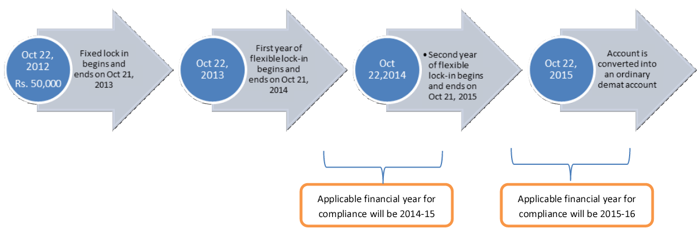

RGESS lock-in period if investments are brought in as installments
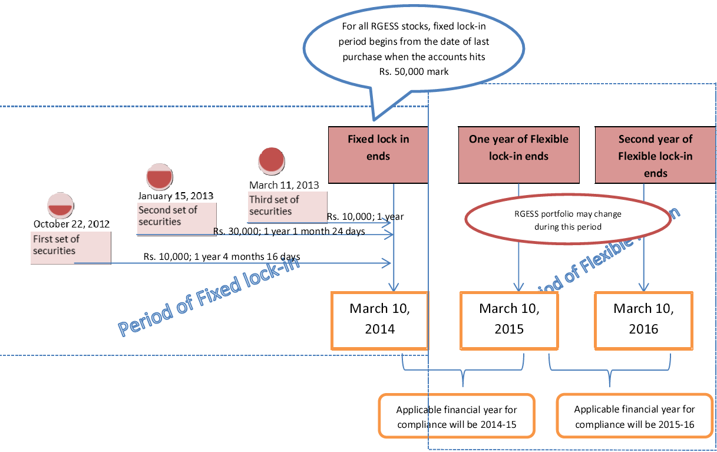
43. What is Fixed Lock-in’ period?‘
Fixed Lock-in’ period shall commence from the date of purchase of first set of eligible securities in the relevant financial year and end one year from the date of purchase of the last set of eligible securities (in the same financial year). Investor is not allowed to sell / pledge securities during this period.Example:If you have purchased first set of eligible securities worth Rs. 20,000 on December 25, 2012 and next set of eligible securities worth Rs. 20,000 on December 31, 2012 in a RGESS designated demat account, then the ‘Fixed lock-in’ period for both set of eligible securities will start from December 25, 2012 and will end on December 30, 2013.
44. When the lock-in period does start? From the date of purchase or from date of credit of securities in the demat account?
As there can be a time gap between the date of purchase and date of credit, the fixed lock-in period will commence from the date of ‘credit’ of such securities in the demat account during the relevant financial year and end one year from the date of ‘credit’ of last set of eligible securities in the same financial year on which deduction is claimed under the Scheme.
45. If the fixed lock-in is counted only from the last day of receipt of securities under RGESS won’t that result in lock-in for more than three years?Yes, if the investment is made in installments, the lock-in period for the first installment would be more than one year. Since the investor is given the flexibility (of no lock-in) for around 90 days in each of the flexible lock-in period, this extra lock-in period in the first year for certain securities is taken care of.
46. Can I sell / pledge eligible securities declared for RGESS during ‘Fixed Lock-in’ period?
No. You are not allowed to sell, pledge or hypothecate eligible securities during ‘Fixed Lock-in’ period.
47. What is Flexible Lock-in’ period?
The period of two years beginning immediately after the end of the fixed lock-in period shall be called the ‘Flexible Lock-in’ period.
48. Can I trade / sell during flexible lock-in period?
During ‘Flexible lock-in’ period, you can trade (sell/buy) the eligible securities and remain eligible to claim tax benefit under RGESS, provided that, the RGESS demat account is compliant for a cumulative period of a minimum of two hundred and seventy days during each of the two years of the flexible lock-in period. This means that you get almost a quarter of the year to churn your portfolio.
49. How the valuation of securities is done during the flexible lock-in period?
For checking compliance with the Scheme after any sale is done from the RGESS portfolio during the flexible lock-in period, the following balances of securities will be considered at the closing priceas on the previous day of the date of ‘trading’ (which is what get reflected as the value of the portfolio in the demat account of the investor on any day during trading hours; This is done to facilitate the decision making by investors). The date of trading is obtained by the depositories directly from the stock exchanges.The balances of securities which were under fixed lock-in in the first financial year, irrespective of its status as an ‘eligible security’ as on the date of valuation (This means that even if the security had gone out of the CNX 100 or BSE 100 list, if it was a part of the fixed lock-in and still retained in the account it would be considered towards the valuation of RGESS portfolio).
- The balances of securities which are appearing in the list of eligible securities as on the date of valuation, even though not forming part of the securities which were held under fixed lock in. These securities could have been bought by the investor during fixed lock-in period or subsequently.
- In case of a corporate action on eligible securities under fixed lock-in whereby additional credit of securities is received through Bonus/Rights, the same will be considered as an eligible investment for fixed lock-in as well as during flexible lock-in.

50. Is there a difference in the valuation of RGESS eligible securities as compared to the general valuation principle adopted by Depositories?
Yes. Valuation of initial investments for claiming tax benefits under RGESS is mentioned in Q. No. 41. The valuation criterion for the securities during the flexible lock-in period is mentioned in Q. No. 49.
Depositories generally value the securities in a demat account based on the closing price of the securities at the exchanges (for CDSL closing price at BSE is taken; for NSDL closing price at NSE is taken) for that day. The same is updated after the close of market hours every day. Since RGESS valuation is done at the actual price of acquisition for the initial investment and at previous day’s closing price during flexible lock-in period, it is different from the general valuation done by depositories for other securities.
However, for RGESS beneficiaries, depositories will show separately the value of initial investment under RGESS and the value of his! her RGESS portfolio on a day to day basis.
51. How the three year lock-in condition is implemented?
The total lock-in period for investments under the Scheme would be three years including a fixed lock-in period of one year, commencing from the date of last purchase of securities under RGESS.
After the first year, investors would be allowed to trade, in furtherance of the goal of promoting an equity culture and also as a provision to protect them from adverse market movements or stock specific risks, as also to give them avenues to realize profits.
Investors would, however, be required to maintain their level of investment during these two years at the amount for which they have claimed income tax benefit or at the value of the portfolio before initiating a sale transaction, whichever is less, for at least 270 days in a year. This process is clarified below:
a. The RGESS account will be deemed to be compliant unless such a trade (sale) is done that brings the value of the RGESS portfolio, on the date of sale, below the amount for which benefits have been claimed under RGESS, when valued at the closing price of the stocks ! units on the preceding day of trading. This means that as long as the market valuation of all the RGESS eligible securities in your account is above the amount for which benefits have been claimed, you can sell off securities above such level, without necessitating you to further purchase any RGESS eligible securities. Further, even if the market valuation of all RGESS eligible securities in your account is below the amount for which benefits have been claimed, if you have not sold off any security, you will still be deemed compliant with the Scheme; The clock ticks in only if a ‘sale’ is done from the RGESS eligible securities. This gives protection from general market declines.
b. In case of any sale during the flexible lock-in period by which the value of the RGESS portfolio goes below the amount for which tax benefits have been claimed, then the account would be deemed to be RGESS compliant only from the day on which the value of the RGESS portfolio becomes at least equivalent to the amount for which tax benefits have been claimed or the value of the RGESS portfolio before such sale, whichever is less. This may happen in any of the following manner, in part or full:
i. Due to market movements, the value of the remaining RGESS portfolio becomes not less than the amount for which RGESS benefits have been claimed or the value of RGESS portfolio before the sale of such securities, whichever is less.
ii. The investor deposits some RGESS compliant securities so that after depositing these securities, the value of the RGESS portfolio becomes not less than the amount for which RGESS benefits have been claimed or the value of RGESS portfolio in that account before sale of such securities, whichever is less.
iii. The investor purchases RGESS compliant securities in the account for a value not less than the value of the securities sold off; The maximum amount that an investor needs to bring back is what he sold off if the market movement does not benefit him.
If the account has become compliant once, then it will be deemed to have complied for the rest of the time period until the next transaction happens that takes the value of portfolio below the tax claimed amount.
The various scenarios are clarified as below:
The investor need to bother about purchasing back eligible securities, only if the investor sells those eligible securities which were under fixed lock-in (irrespective of their status as eligible securities as on the date of sale) or those securities which were not under fixed lock-in but were considered for valuation of investment of eligible securities during flexible lock-in period as mentioned in Q.No. 49 above.
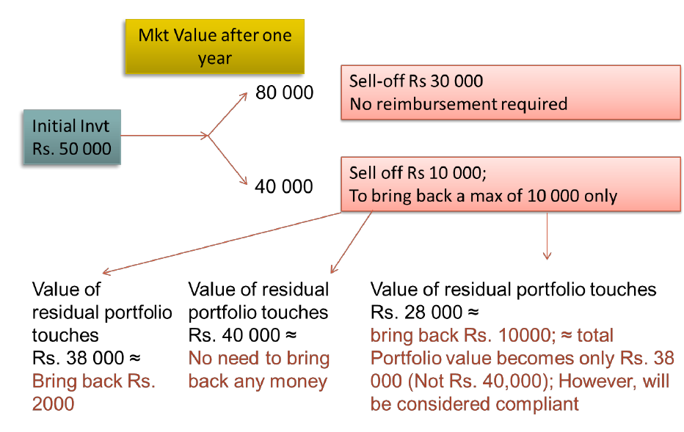

Example If an investor had claimed deduction on RGESS investment of value Rs. 50,000 of 400 shares of company A and had also bought additional 200 shares of company A (this additional purchase might have been done either in fixed lock-in period or in flexible lock-in period) then:- (a) for any sale upto 200 shares of company A in the flexible lock-in period, it would be deemed that the investor had sold off the additional 200 shares of Company A and not from the original set of 400 shares kept under fixed lock-in; this means that the investor need not have to be concerned about bringing back those shares. (b) Instead, if such an investor sells 300 shares of company A, he will be tracked for recouping the amount (if the residual value of the portfolio was below the investment claimed under RGESS) and value of 600 shares of Company A will be considered as the value of investment portfolio under the Scheme before sale.
If the value of RGESS portfolio falls due to fall in the market value of eligible securities in the flexible lock-in period and the investor sells the eligible securities as mentioned in above, the demat account shall be compliant from the day on which the value of investment portfolio becomes equal to investment claimed as eligible for deduction under Section 80CCG or the value of investment portfolio before such sale, whichever is less, even though there was no purchase of eligible securities after such sale.
52. What will happen if I do not trade (sell/buy) eligible securities during ‘Flexible Lock-in’ period?
In case, you do not trade (sell/buy) the eligible securities during the ‘Flexible Lock-in’ period, your RGESS demat account will remain complaint irrespective of the value of investment portfolio held under RGESS.
53. What will happen to my demat account at the end of flexible lock-in period?
Your demat account designated for RGESS will be converted into a regular or ordinary demat account at the end of the flexible lock-in period and the securities contained therein will be freely transferable.
V. Monitoring and Penalties
54. Do I have to value RGESS eligible securities for the purposes of compliance with the provisions of the Scheme?
No. The day to day valuation of securities in your RGESS portfolio and your compliance with the Scheme for 270 days etc will be monitored by the Depositories / Depository Participant (DP) and information about the same can be obtained from the DP. However, you may verify the entries / valuation of securities made into your demat account and in case of any discrepancy immediately take it up with your DP.
55. How do I claim for tax deduction?
You would receive a copy of the new retail investor certificate and the annual account statement provided by your DP to the Income Tax department. You are required to indicate these details in the Income Tax returns filed by you.
56. Who will give me new retail investor certificate and annual account statement?The new retail investor certificate will be issued to you by the concerned DP after verification of your credentials across the other depositories and Exchanges. The certificate will be issued to you within one month from the date of opening the demat account. However efforts are made to reduce this time.
You can either ask your DP to give you the new retail investor certificate or can download it from the web facility offered to you by your DP (efforts in this direction are underway).
The annual account statement will also be provided to you by your depository participants indicating your compliance with the scheme.
57. What is the penalty if I violate the conditions of RGESS?If the assessee, in any previous year (including the two years of flexible lock-in), fails to comply with any condition specified under RGESS, the deduction originally allowed shall be deemed to be the income of the assessee of such previous year and shall be liable to tax for the assessment year relevant to such previous year.
Example
If the assessee fails to meet any of the conditions during the second year of RGESS (i.e., first year of flexible lock-in), then he is required to pay tax on the entire investment (not just for the shortfall) claimed as deduction under Section 80CCG (RGESS) in the income for that year and pay tax accordingly.
58. What will be the effect of different types of corporate actions like split, consolidation, bonus, rights, etc. on RGESS eligible investment during flexible lock in period?
If there is any change in the RGESS investment due to corporate actions where investors do not have any choice (involuntary) e.g. split / demerger etc., there will not be any effect on compliance status of the account during flexible lock in. In case of bonus, etc., the additional shares allotted would be considered as RGESS securities to the extent allowed by the ratio of the existing RGESS securities in the account. The resulting securities would lie in the same category of lock-in (Fixed / Flexible) as the original securities.
If there is any change in the RGESS investment due to corporate actions where investors have the option to exercise their choice and results in debit of securities during flexible lock in, the same will be considered as a sale transaction. SEBI has notified the corporate actions allowed under RGESS, depending on the availability of choice to the investor. See SEBI operational guidelines for allowable corporate actions under RGESS.
59. How the Scheme is monitored?
PAN has been made mandatory for opening demat accounts. RGESS monitoring is primarily based on the PAN details. Each clients’ unique client code (UCC) assigned by the broker to the client, is linked to the Permanent Account Number (PAN) of that client and hence, depositories can easily verify who is a new investor based on information available with depositories and exchanges. New retail investor certificate will be issued by depositories through the concerned DP after internal and cross verification from the other depository and from stock exchanges as to whether the beneficiary has already traded in equity / derivatives. Depositories also provide valuation of RGESS portfolio through the concerned DP and verify the conformity to stipulated conditions during flexible lock-in period. Income details of the PAN holders availing the RGESS Scheme are verifiable by IT Dept from their electronic database. Further, the details of RGESS beneficiaries will be handed over to the IT Department by the concerned depositories by the end of the financial year.

THANK YOU

