Residential Staus

The Income Tax Act, 1961 governs the taxation of income in India. Income tax is charged on total income
for a given financial year. The financial year runs from 1 April to 31 March of the following year.
Residential status
The residential status of an individual for income-tax purposes depends on the physical stay of the individual
in India. Based on the period of stay in India in a given financial year, an individual may be classified as:
- Resident
- Not ordinarily resident (NOR)
- Non-resident (NR).
Tests of residence under the act
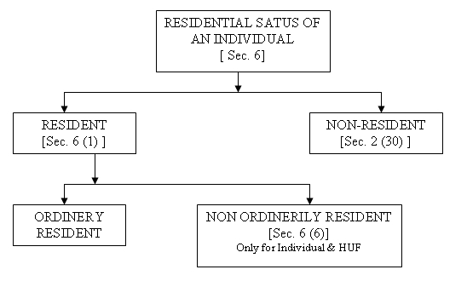
A. An individual is a resident in India if he stays in India for:
- At least 182 days during a financial year
- At least 60 days during a financial year and 365 days or more during the 4 years preceding that fiscal year.
Exceptions to the above:
- The 60-day period mentioned above will be substituted for 182 days in case of the following persons:-
- A citizen of India who leaves the country as a crew member of an Indian ship or for the purposes of employment outside India
- A Citizen of India or PIO who visits India in any previous year.
B. An individual is an NOR in India if:
- He is an NR in India in 9 of 10 financial years preceding the relevant fiscal year
- His stay in the 7 years preceding the relevant financial year is in the aggregate 729 days or less.
C. An individual is an NR in India if:
- He does not satisfy any of the two conditions mentioned in A above.
NRI
An NRI is defined as a citizen of India or a PIO who is not a resident.
PIO
A person shall be deemed to be of Indian origin if he or either of his parents or grandparents were born in
undivided India.

