The tax filing date for the financial year 2011-12 is July 31, 2012. Returns can be filed after July 31, 2012 but before the relevant assessment year (March 31, 2013), however it is advisable to file the tax returns by the due date.
The timelines for filing up of tax returns are as follow:
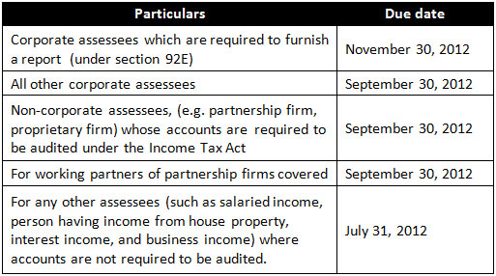
All taxes should be filed by the due date. Any failure in filing the taxes will attract an interest rate of 1 percent per month. The interest rate will increase for default in the payment of advance tax.
Advantages of filing the taxes before due date
If the return is filed after the due date, then losses under the section “Profits and Gains of Business or Profession” (other than depreciation loss) cannot be carried forward. Though, the payer can still save the losses against the income (other than income under the head salary) under other heads of the same year. The same procedure also applies for short and long term capital loss from sale of shares.
Therefore, if an individual files a tax by the due date of July 31, 2012, the short and long term capital loss from sale of shares can be carried forward and set off against capital gains or business profits, which could arise in the next eight years.
Tax return revision
Returns which are filed after the due date cannot be revised and considered as belated returns. As per the rules, belated tax filing is permitted within one year from the end of the evaluation year or completion of assessment, whichever is previous. However, the payer will have to decline the right to carry forward the losses or revise the return. For all those cases, a candidate can file a return with the due date and then revise it with actual details, subject to certain conditions.

