Know Your PAN
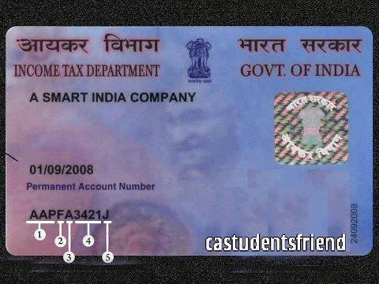
PAN is a 10 digit alpha numeric number, where the first 5 characters are letters, the next 4 numbers and the last one a letter again.
These 10 characters can be divided in five parts as can be seen below. The meaning of each number has been explained further.
...
1. First three characters are alphabetic series running from AAA to ZZZ
2. Fourth character of PAN represents the status of the PAN holder.
• C — Company
• P — Person
• H — HUF(Hindu Undivided Family)
• F — Firm
• A — Association of Persons (AOP)
• T — AOP (Trust)
• B — Body of Individuals (BOI)
• L — Local Authority
• J — Artificial Juridical Person
• G — Government
3. Fifth character represents first character of the PAN holder’s last name/surname.
4. Next four characters are sequential number running from 0001 to 9999.
5. Last character in the PAN is an alphabetic check digit.
Nowadays, the DOI (Date of Issue) of PAN card is mentioned at the right (vertical) hand side of the photo on the PAN card.

