- Go to www.tin-nsdl.com
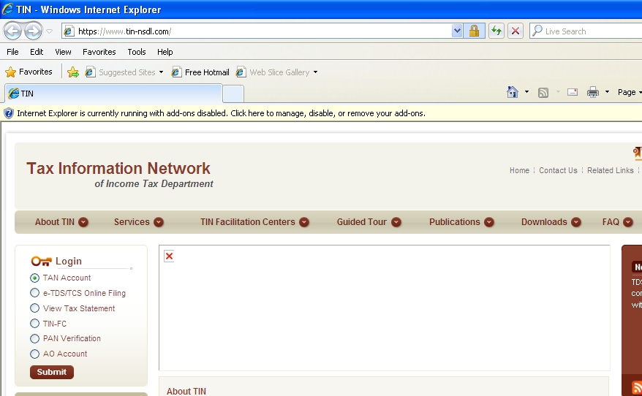

Click TAN Account for login and click submit
- Enter User ID, Password and TAN and click submit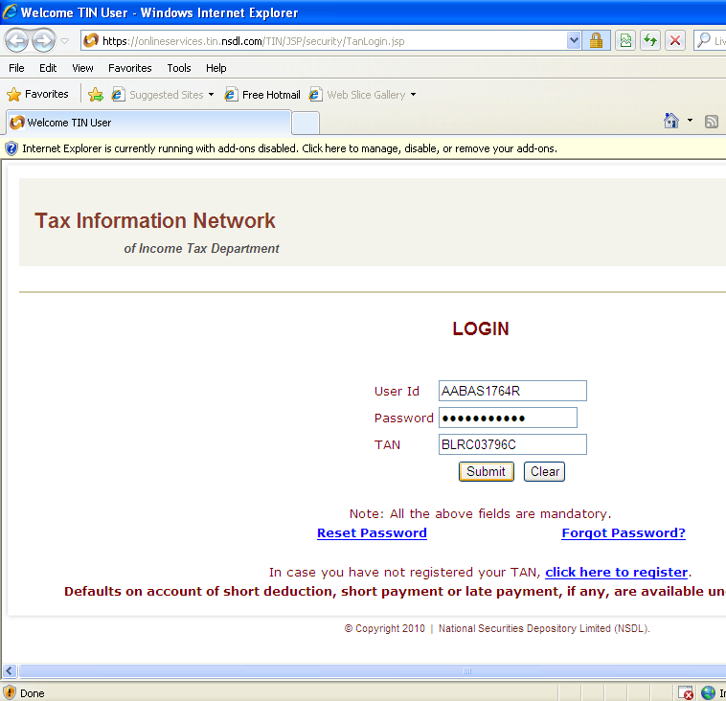

If you have not registered your TAN, first register it by clicking on ‘Click here to register’ It will ask various details like TAN, PAN, Name, Address, Type of entity, responsible person, etc. You will also be asked to provide details of one e-TDS return filed, like PRN No. (Acknowledgement No.), date of filing, no of challans, no, of deductions, etc. You can give details of any return filed (not necessarily of that year or of salary/non-salary). REMEMBER TO GIVE CORRECT MOBILE NO. AS YOU WILL RECEIVE A VERIFICATION CODE VIA SMS FOR ACTIVATING YOUR ACCOUNT. After confirming the details, you will get a confirmation page of registration. THIS IS A VERY IMPORTANT PAGE AS IT CONTAINS YOUR TAN REGISTRATION NO. SAVE IT AND TAKE A PRINT. After registering you will get a mail through which you can activate your TAN account. It will also ask for verification code, which you will receive through sms on the mobile number provided at the time of registration. After activating your account, in 24 hours another mail would be received by you with a pdf file attachment. After this your account is ready to use.

- If you want to change the details like name of responsible person, mobile no. etc. move the cursor to ‘Update Profile’ and in the scroll down click on ‘Update Profile’.
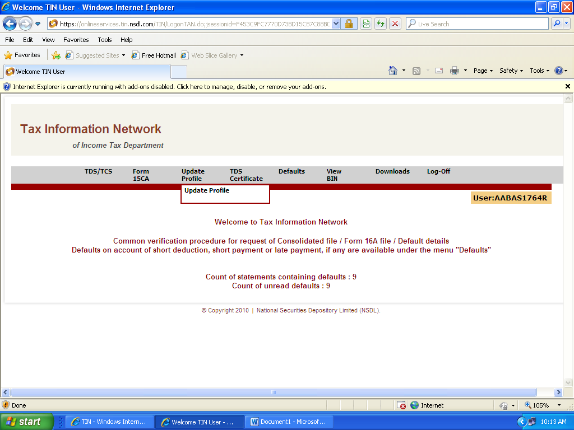

- Do the desired changes and click submit

- The following window will appear
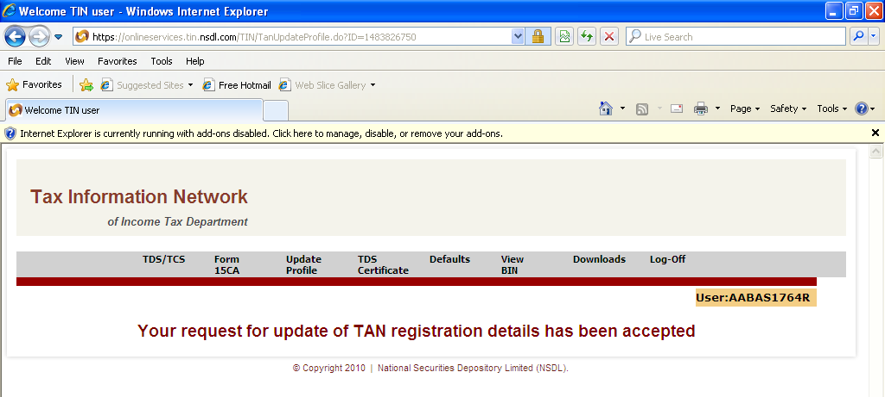

- For TDS/TCS statement (required for revising e-TDS return), go to ‘TDS/TCS’ and click on ‘Request consolidated TDS/TCS Statement’
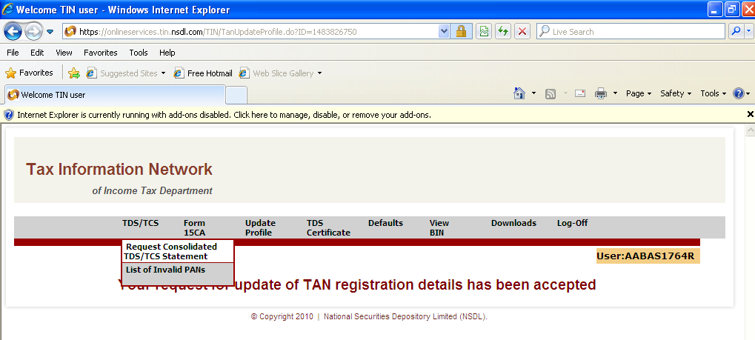
Provide ‘Token No. (Provisional Receipt No.)of the quarter and Financial year required and click submit.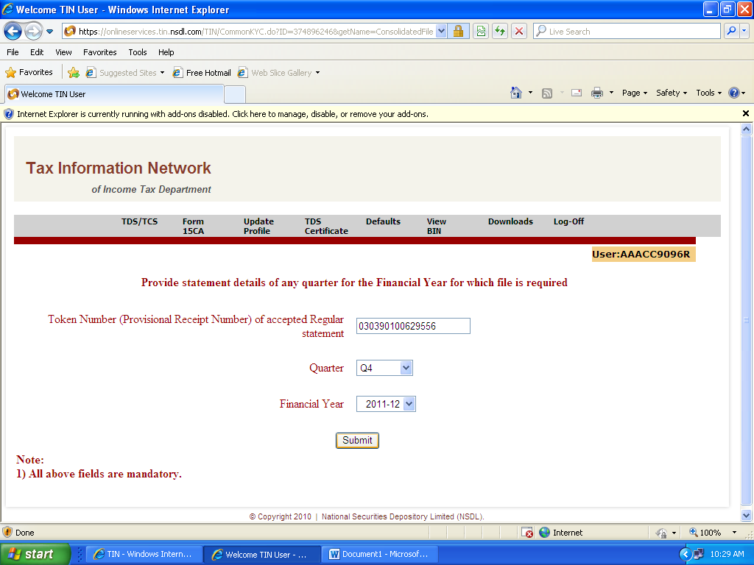
Provide one challan detail and three deduction details in respect of the particular quarter and click submit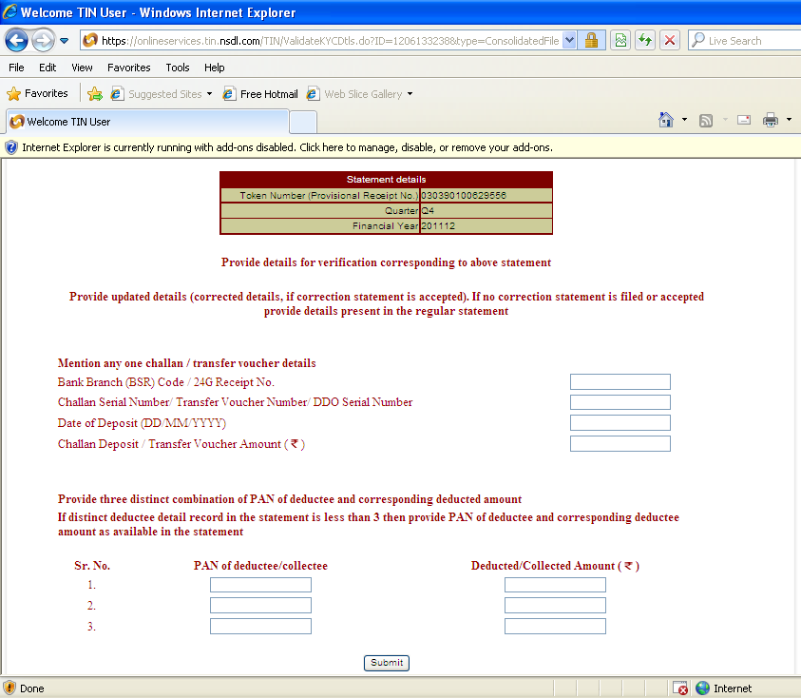
(The challan need not be linked to the deductions. Any one challan and any three deductions of the quarter would suffice. In the deduction details provide PAN and TDS deducted in respect of the PAN)
For downloading the TDS/TCS statement, go to ‘Downloads’ and click on ‘View Status/ Download- All’
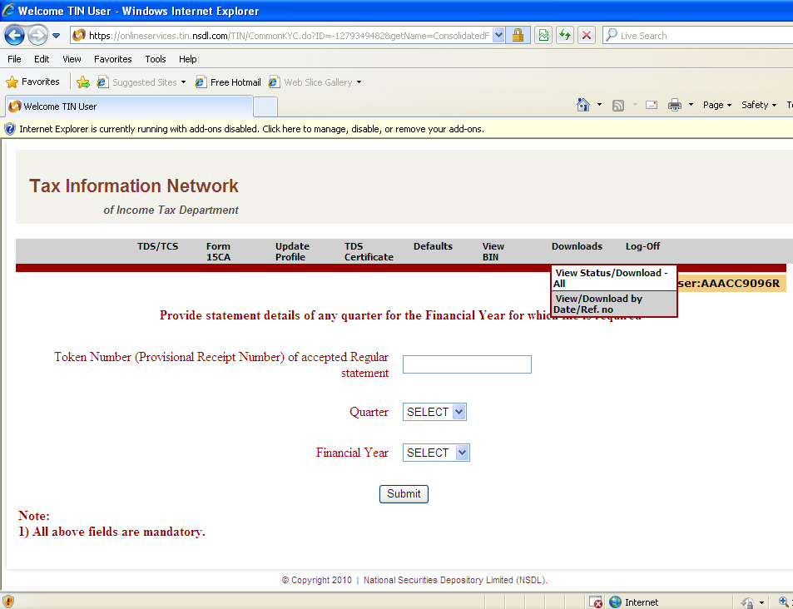
The following window will appear, where all the downloads will be available in chronological order: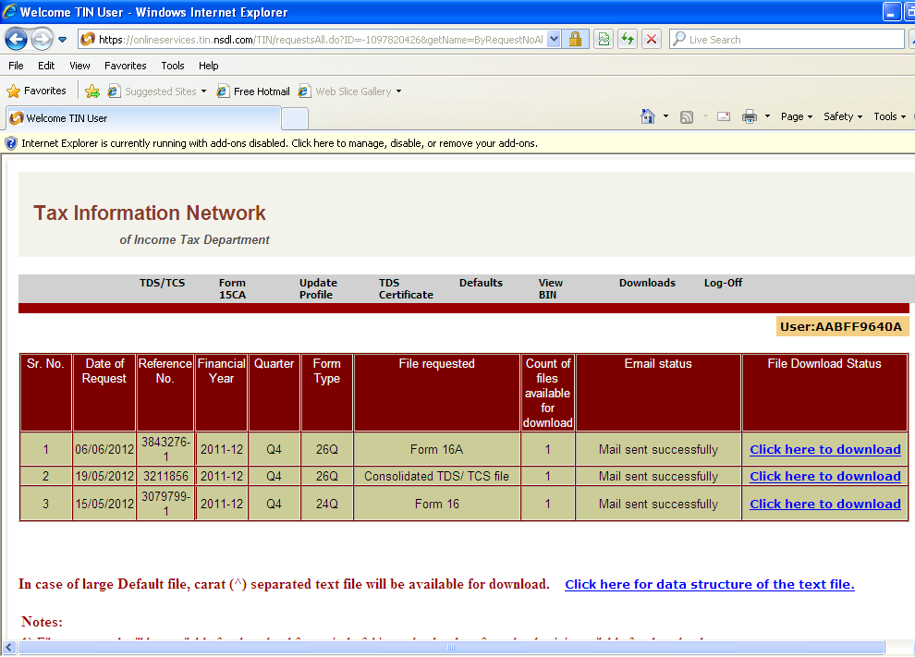
Click on ‘Click here to download’ in respect of the file required and save the file.

- To download and view Defaults:
On the home page, the number of defaults generated and number of unread defaults will be displayed. To download, click on ‘Defaults’
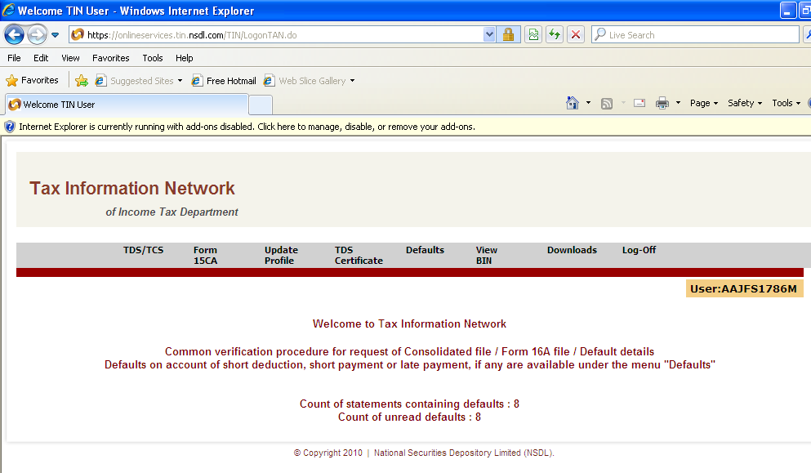

In the following window, click ‘Click here to verify and download the details’ in respect of the particular default required. Provide one challan detail and three deduction details and click on submit. The default file will be available to download in the ‘Downloads’ option.
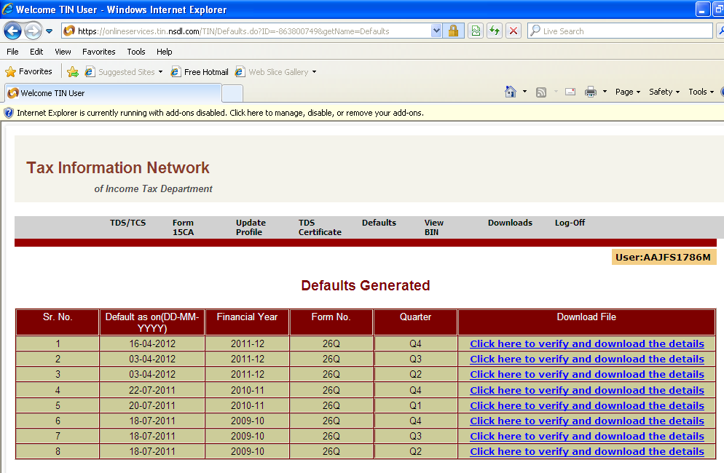
- To download Form 16/ Form 16A:
Go to ‘TDS Certificate’ and click on ‘Request Form 16A’ or Request Form 16” as per the requirement.
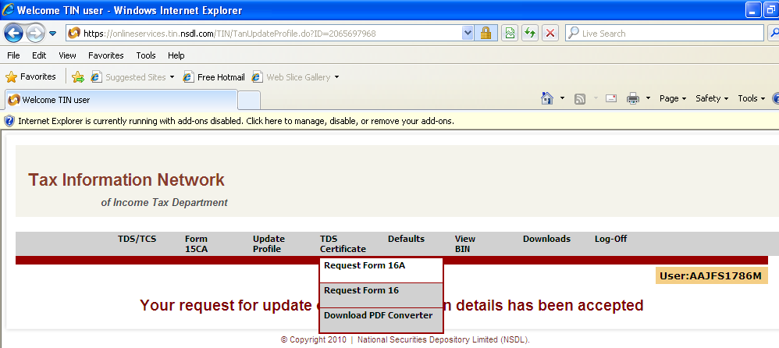
Provide Token No. (Provisional Receipt No.)of the quarter and Financial year required and click submit. Provide one challan detail and three deduction details and click submit. In the next window, option is given as to whether Form 16A/ Form 16 is required for all the PANs or selected PANs (upto 10 PAN). Choose as per requirement and click submit. The Forms would be available in the ‘Downloads’ option.

- All the three files (TDS/TCS statement, Default and Form 16A/Form 16) would be in the form of zip files. To extract these files, the following passwords are to be provided:
1.TDS/TCS Statement and Defaults: Token No. (Provisional Receipt No.)of the quarter and Financial year
2. Form 16A/ Form 16: TAN Registration No.

- To covert Form 16A/ Form 16 to pdf format:
After downloading the zip file and extracting the file using the password, a text file would be available (For all the Forms only one text file will be available. Ex: if there are 16 Form 16A in a quarter, only one text file would be available). To convert this file into separate pdf files:
- Go to ‘TDS certificate’ and click on ‘Download PDF Coverter’
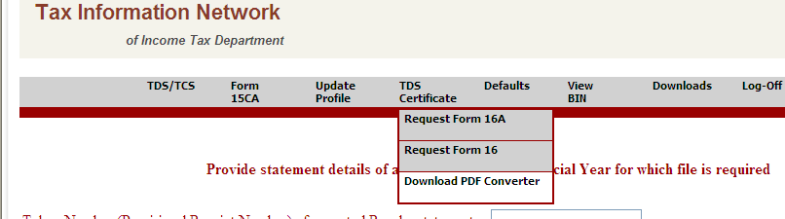
- Click on ‘Click here to download PDF Conerter utility
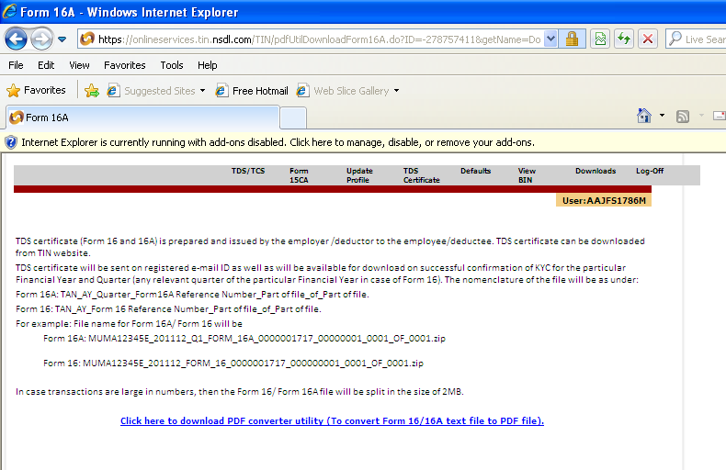
Agree to the conditions and click on ‘click here to download’.
Save the pdf converter on desktop. This converter is to be downloaded only once and to be used for all the forms.
- Click on the converter utility and browse the folder in which the text file is saved and click unzip.
- In the folder, where the text file is saved a new folder named ‘PDF converter utility’ will appear. In the folder click on the Executable Jar file named ‘PDF Converter Utility’.
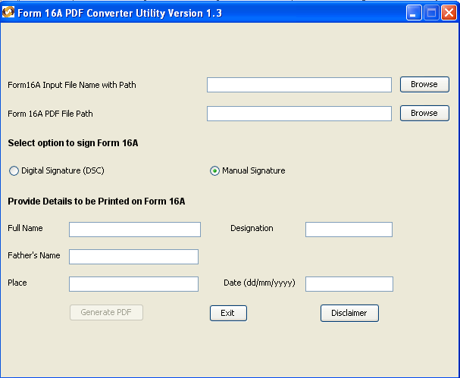
Provide the following:
Form 16A input file – browse the text file
Form 16A PDF file path – brose the path where PDF Forms are to be saved
Full name of the parson who would be signing the Forms, designation, Father’s name, Place and Date
Click on Generate PDF. The PDF files will be available in a separate folder in the path provided.

