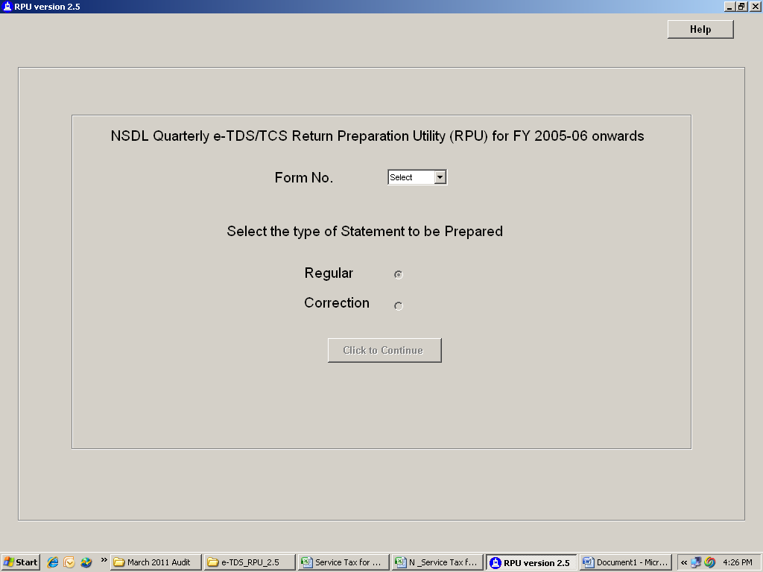
For correction of TDS return Click Import of TDS /TCS Consolidated statement as available on Tin-nsdl.com. The following screen appears
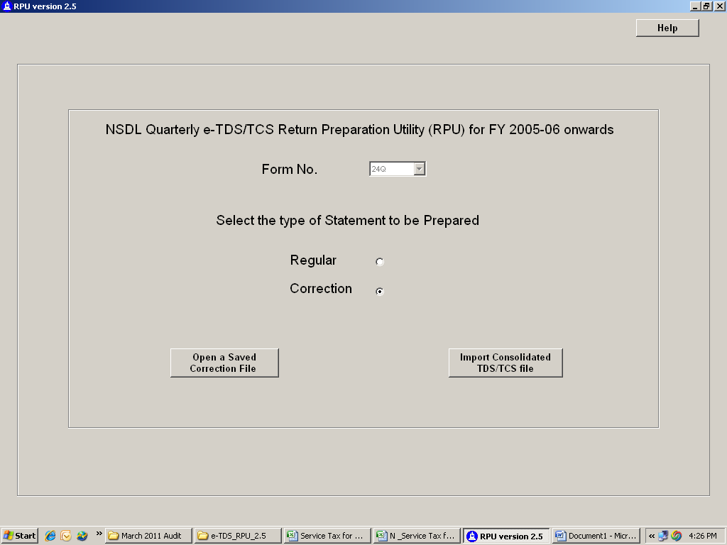
Extension of TDS /TCS consolidated statement is .tds
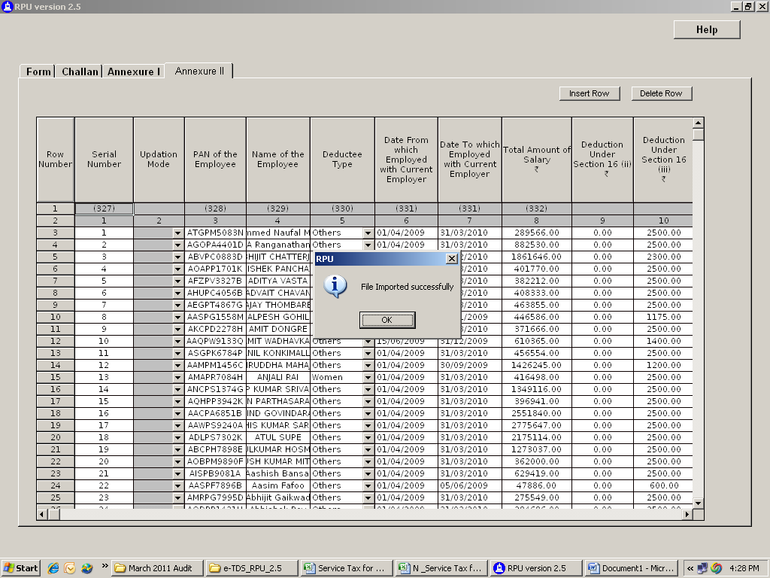
On import it shows confirmation of successful import click on ok the following screen appears
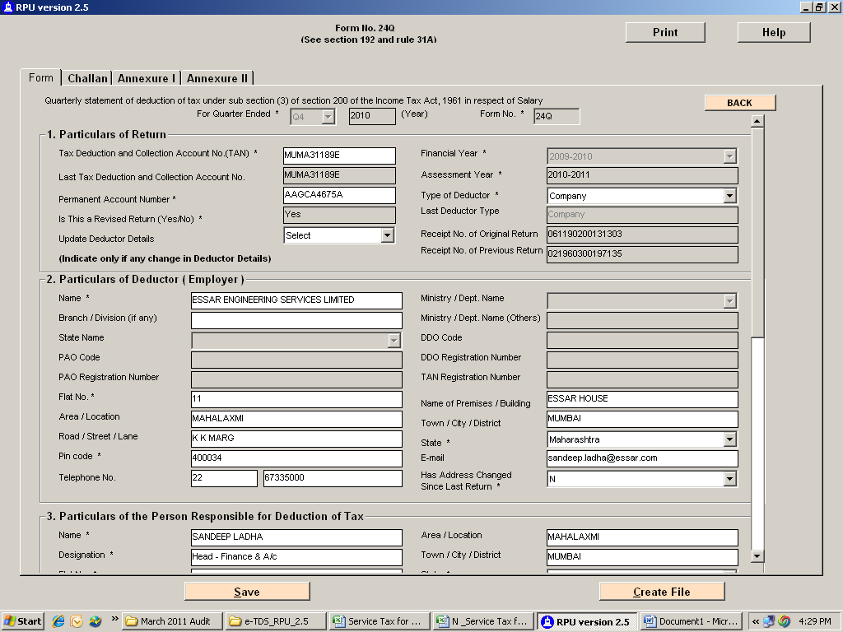

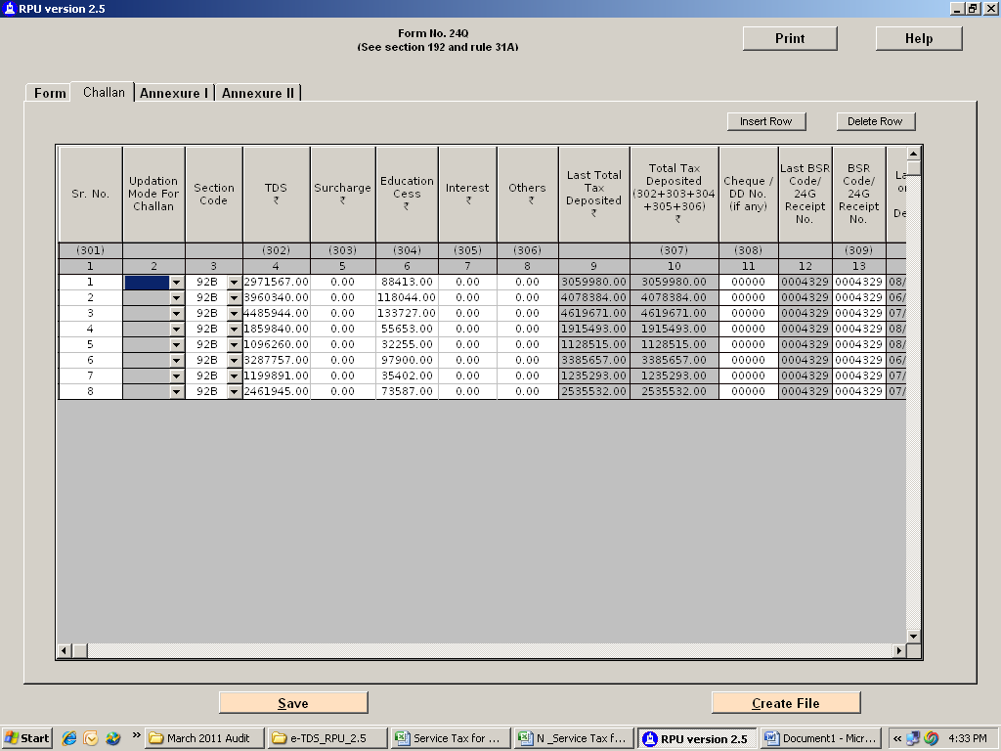
For updation in deductor details select the update button as circled in the above screenshot.

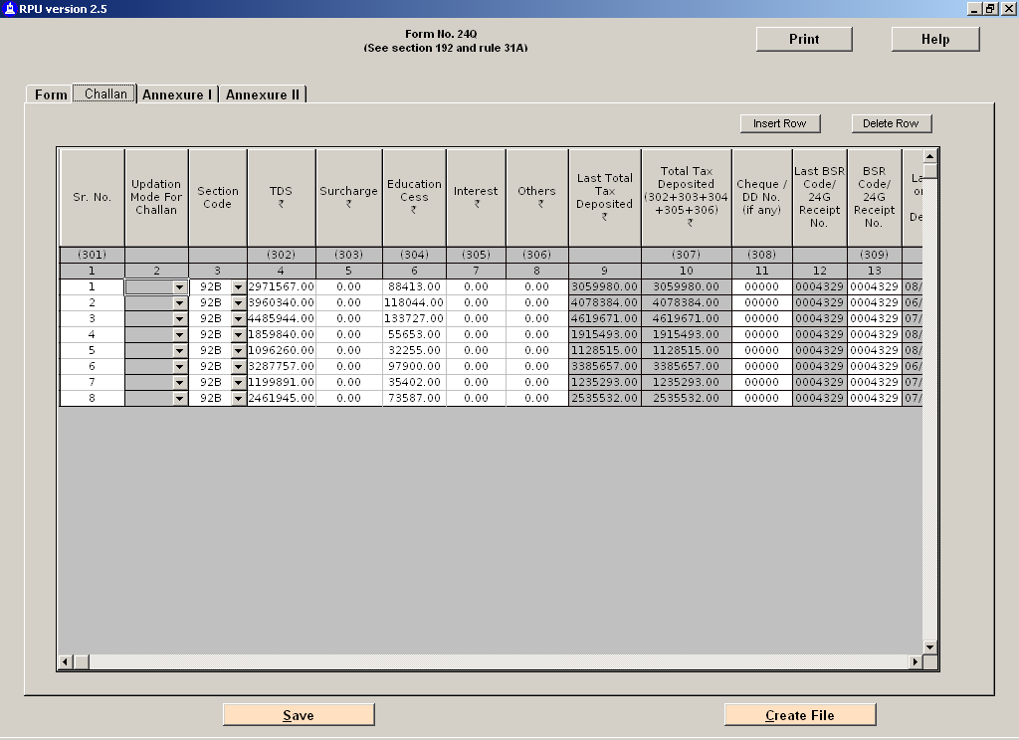
To update an existing challan select update in column no.2 i.e. updation mode for existing challan.
To add another challan insert row & add challan details. After inserting row following screen appears
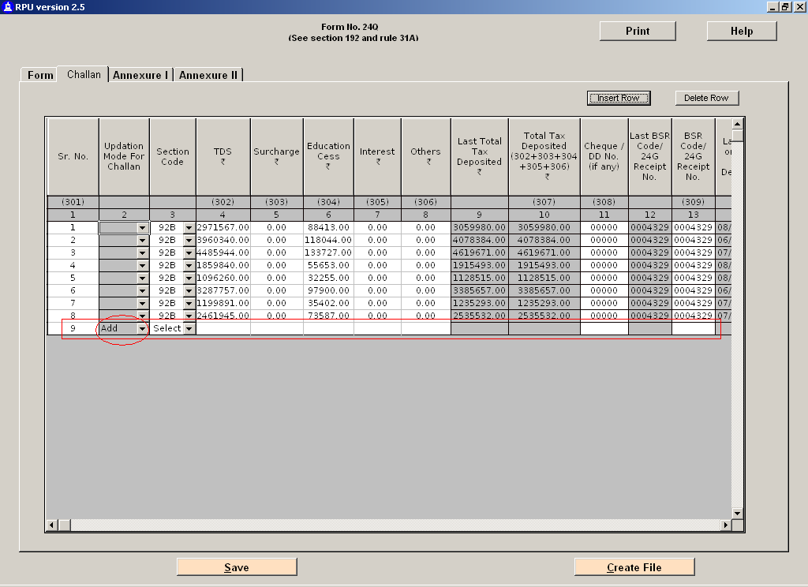 points to be considered for filling the details of the additional challan. :
- If additional challan solely for interest payment, tds, sc and ec column to contain “0”
- For payment other than by cheque, wherein chq no is not applicable, chq no in coloum no 11 to be written as “00000”
- Payment by book entry means settling the account by a non – cash transaction eg barter thn yes else no in column no 18

The above screenshot is for the challan section of the annexure chart.
:
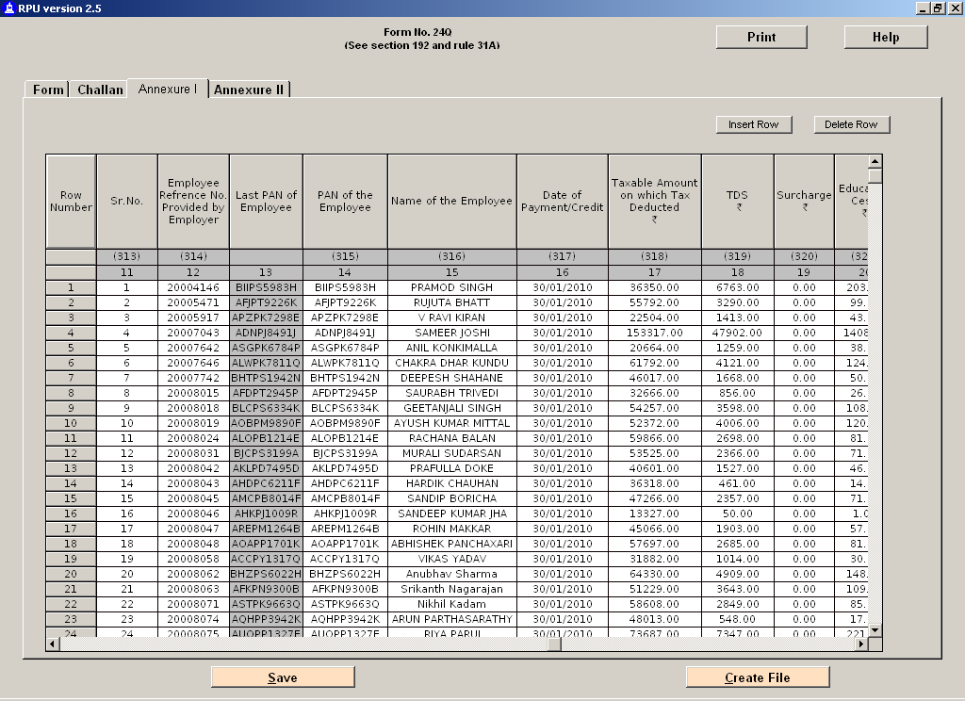
This screenshot is the deductee detail part of the annexure chart.

Following are the considerations for the above two screenshots in the annexure chart :
- For changes in the annexure chart, select the appropriate update in column no 2.
- Sr no in column no 13 would be challan not wise. Example : if there are 100 deductees whos amount was paid via challan no 1, the serial no would go upto 100 but as soon as the 2nd challan is started, the count refreshes and it begins from 1 again for challan 2.
- Column 17 is the salary paid for the period on which tax is deducted.
- Rest columns as mentioned in the column head.

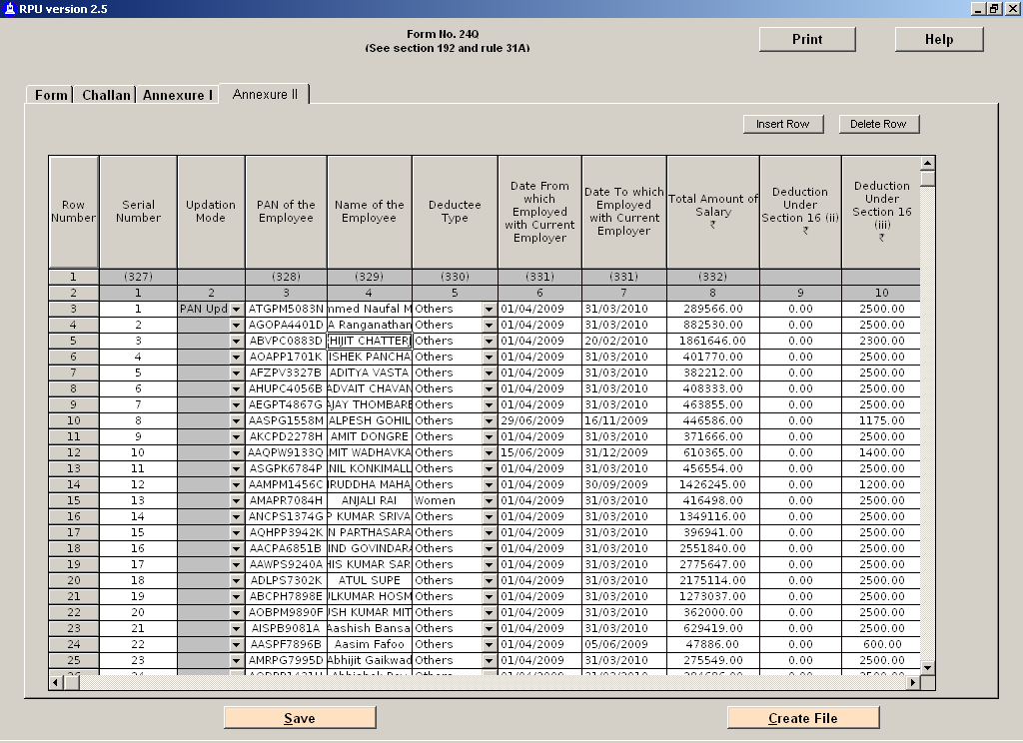
The last chart of annexure 2 is mere updation of the employees / deductees. If there are any changes in the employee or deductee then to be updated else to be untouched.

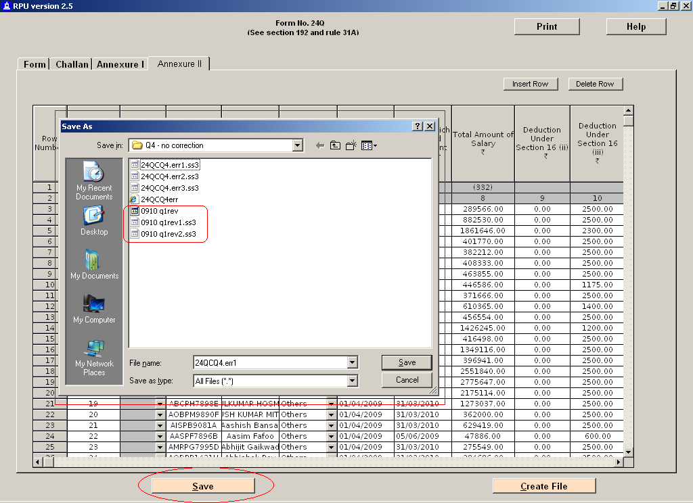
If at anytime you wish to save an intermediary file for further or later use, u can save the file by selecting the save button as circled in the and save in an appropriate path in the path box.
On saving 3 files as shown in the inner most circle would be created out of which 2 files would be hidden. To re-open the file at any latter stage, select the file which is not hidden.

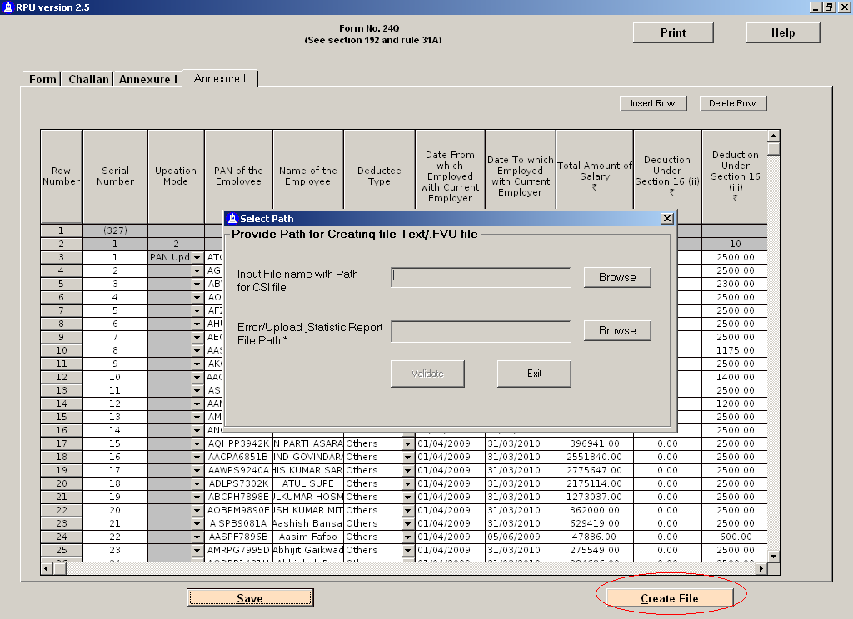
Finally when all the required updations and the additions are compiled with, click on create file button circled in the above screenshot.
A dialogue box as above appears in hitting the create button.
In the 2nd line of the dialogue box, put the path where the validated files are to be placed.
After putting the path, click validate.

Now there are 2 probabilities:
- There were no errors found during validation.
In such a situation, the 4 files generated would be as under
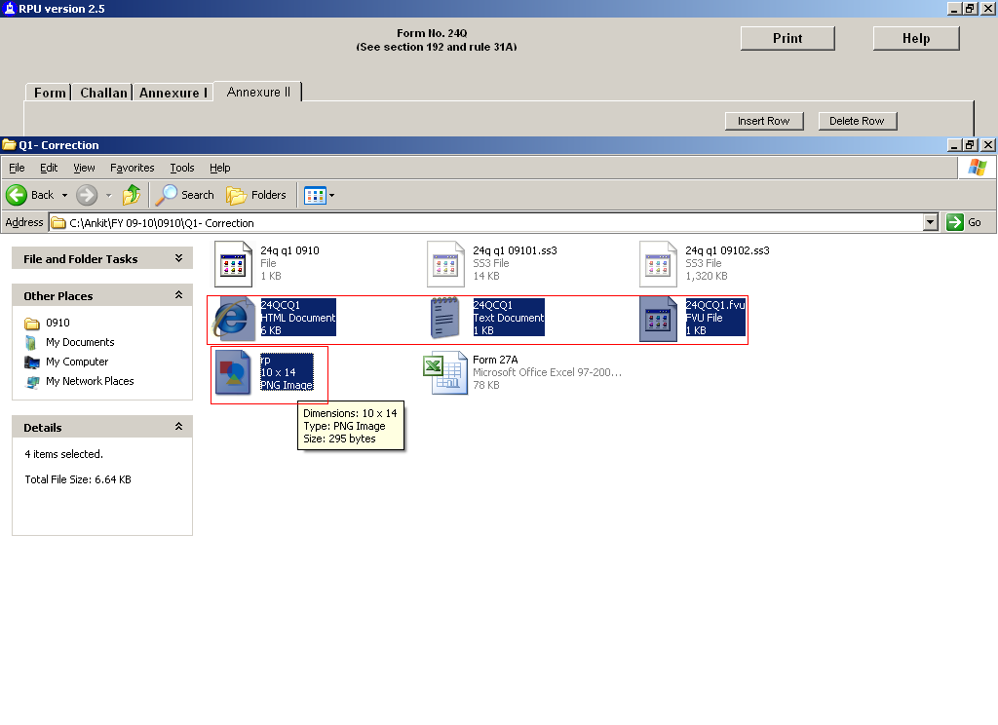
- There were some validation errors.
In this situation, the following files will be generated
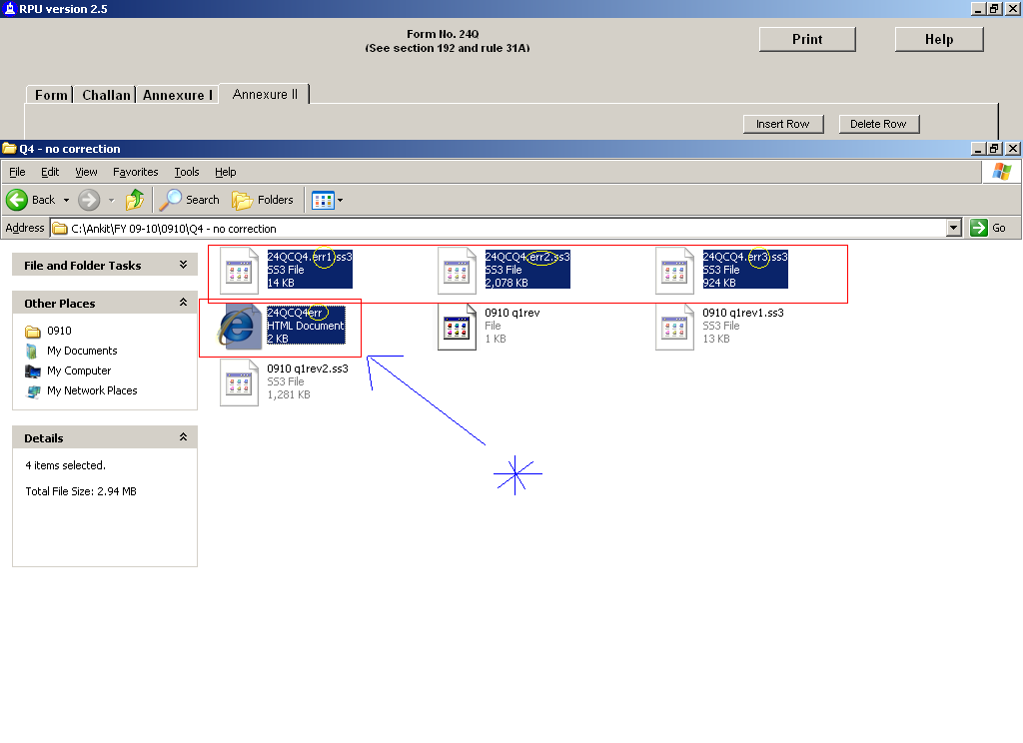
These are error files and even the names contain the letter “err” which stands for error as marked with a yellow circle.

The file marked with asterisk is an html version of error file which will show all the errors with respective line nos. as depicted under

You have to rectify the errors mentioned in the error file and try creating the file again as above.
And this procedure ends until there are no validation errors mentioned in the point 1 above.

After the validation is complete, copy the 4 files generated in point 1 to a cd and send to nsdl along with form 27A correction statement.

