FYI, following are the major reasons of generating the Default List (which our clients are getting through mails):-
- Quoting the Wrong PAN of deductee while submitting the e-tds return (original/regular): If invalid PAN mentioned in the e-tds return , their system will calculate TDS at higher rate (i.e. @ 20%).
- Late payment of TDS : It will calculate the Interest on late payment.
- If we mention wrong TDS rate in the deductee details. For ex : (94I)Invoice amount is 10,000/- and the rate applied is 16.995%. You would have correctly deducted 1699.5o. However, if you mention 17% as tds rate in the deductee details. System will calculate the tds @ 17%. Ie Rs.1700/-.
- Wrong Deductee type : like Company or Non-Company (Individual).

___________________________________________________________

STEPS FOR REMOVING THE DEFAULTS
First you need to register TAN Online.
Procedure for TAN registration:-Click on the tab Online TAN registration in NSDL website. Please enter the required details such as TAN, PAN, Co address, e-mail id, contact number, desired user ID & Password etc., and submit the same. On submission, system will generate TAN registration number. Please keep this number in your records. This may require in future for any other request from NSDL.
TAN registration will take 24 hours for activation of USER ID. Activation details will be sent to registered email ID.

Upon receipt of activation details, please follow the following steps.
Step1: Login to TAN account by providing USER ID and Password.
Step 2: After the Login, you will come to the main screen as shown below. Click on the Defaults Tab.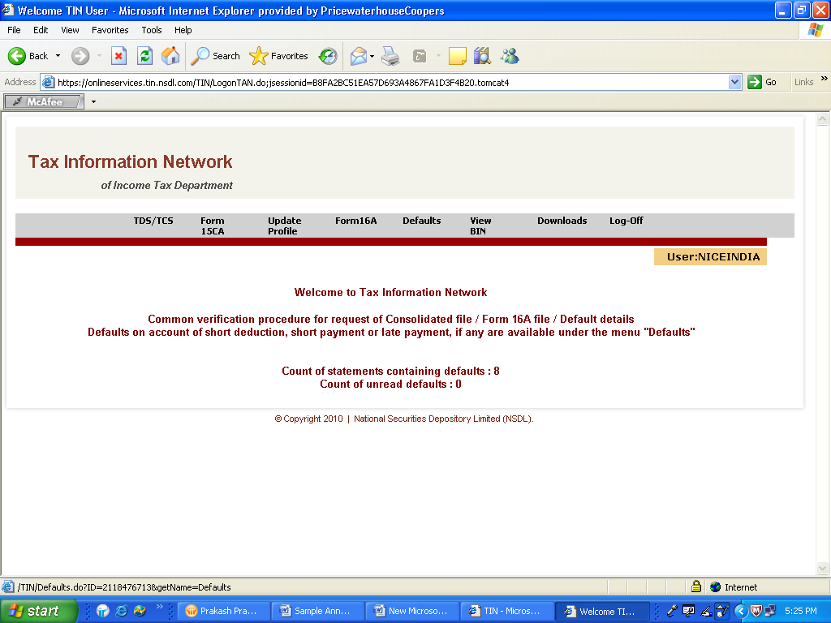

Step 3: Download all the default files on to your system.
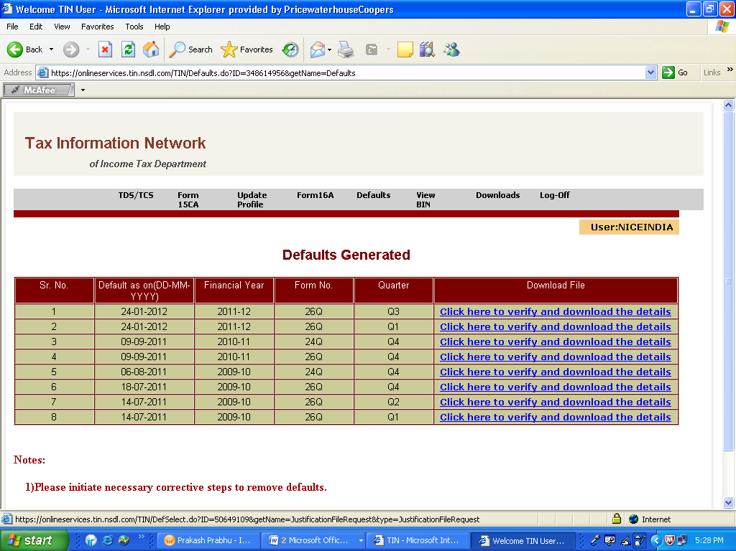
Step 4: While downloading the default details it will ask for provisional receipts and other details as shown below
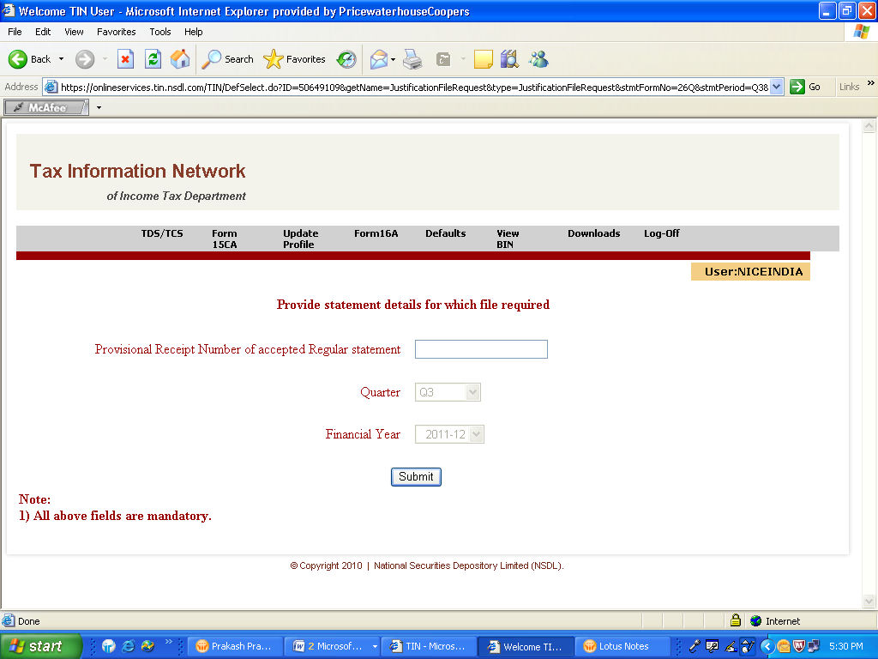
Step 5: Please fill in the records, exactly the same given in the template while preparing the original return. After filling the details click on the submit Tab.
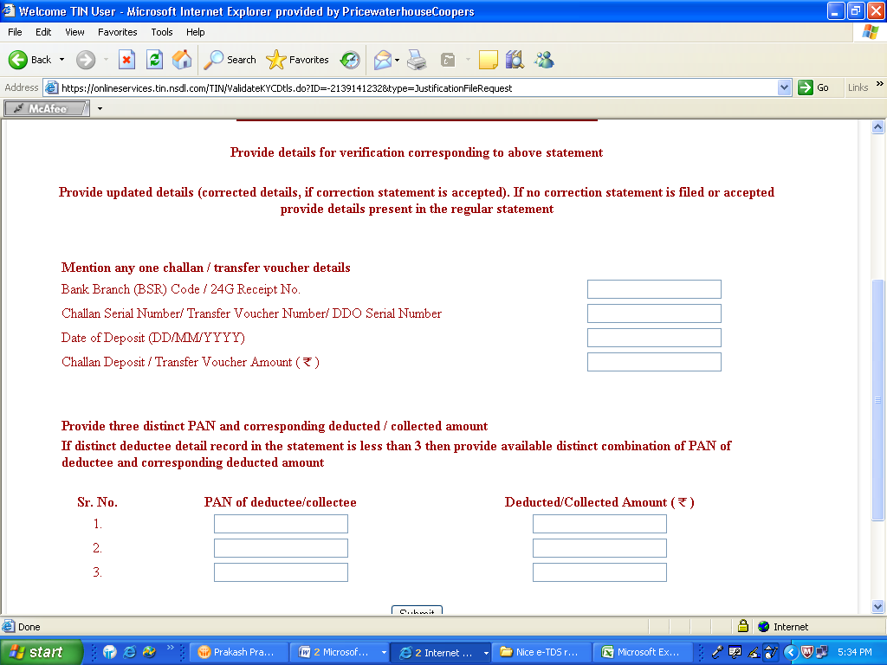
Step 6: Tick on the Consolidated TDS / TCS file which will download both default list and FVU file which is required for correction.
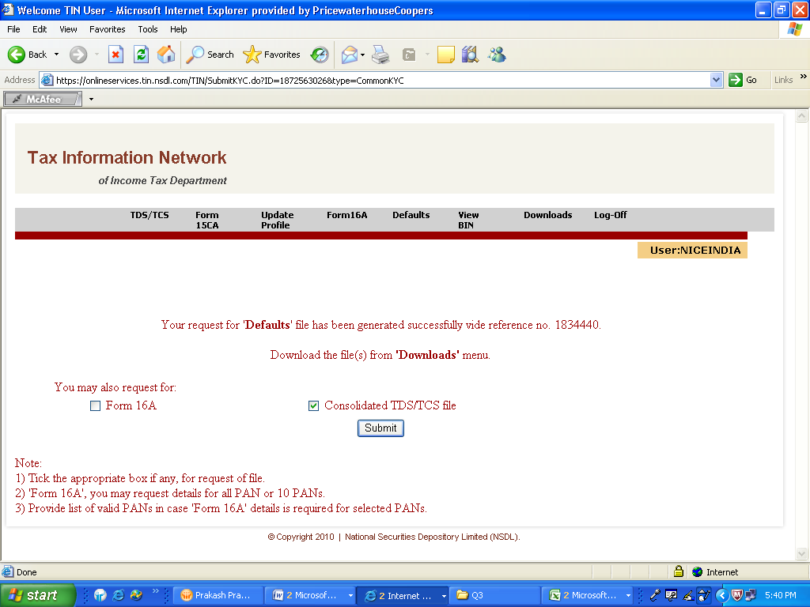

Step 7: Click on the Download Tab for downloading the Default file . However, FVU file can be downloaded only after 24 hours.
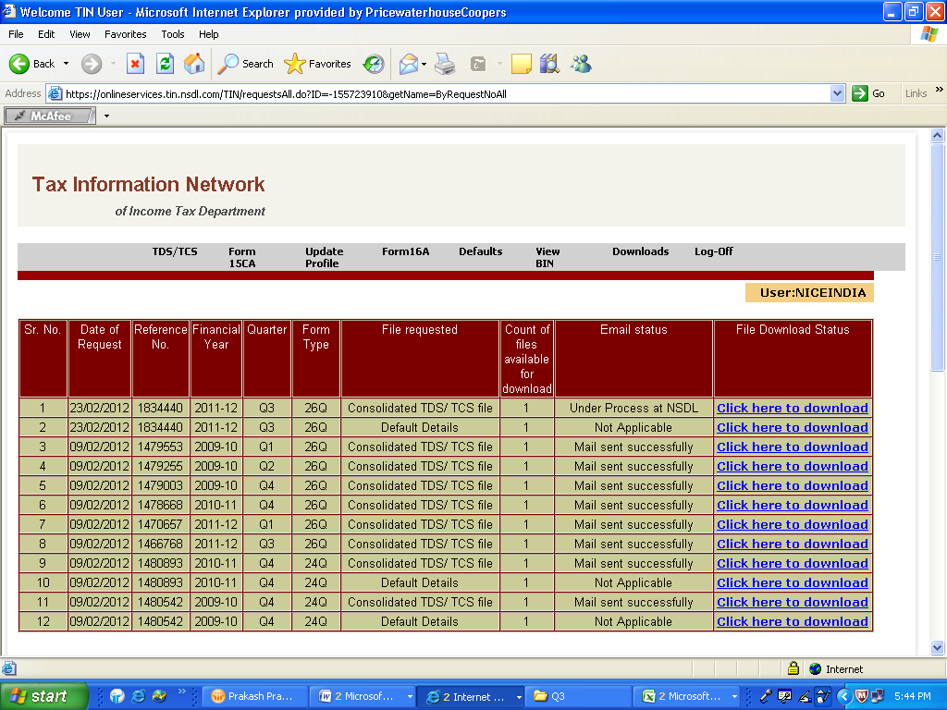

Step 8: Analyze the default file as mentioned in the first page and accordingly you need to revise the return by using the above downloaded FVU file.

