CA. Sameer Kashikar

Process to be followed for removing defaults generated in TDS returns filed earlier.

Click on following link which will take you to the screen shown below
URL - https://onlineservices.tin.nsdl.com/TIN/JSP/security/TanLogin.jsp

Input user id, password and TAN

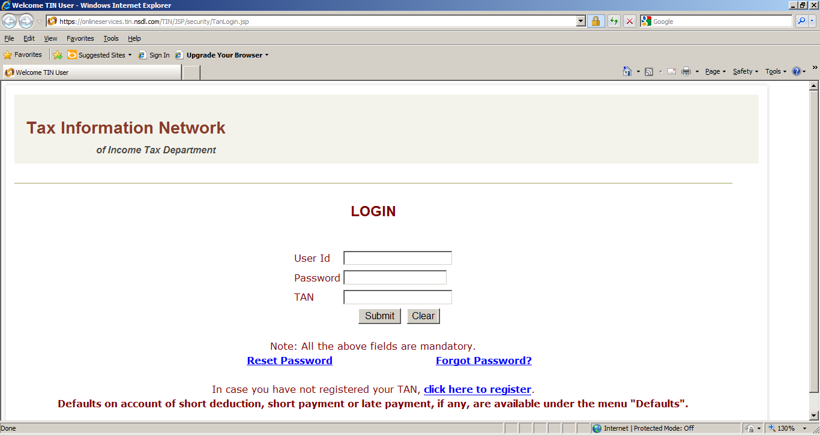

Click on the “Defaults”
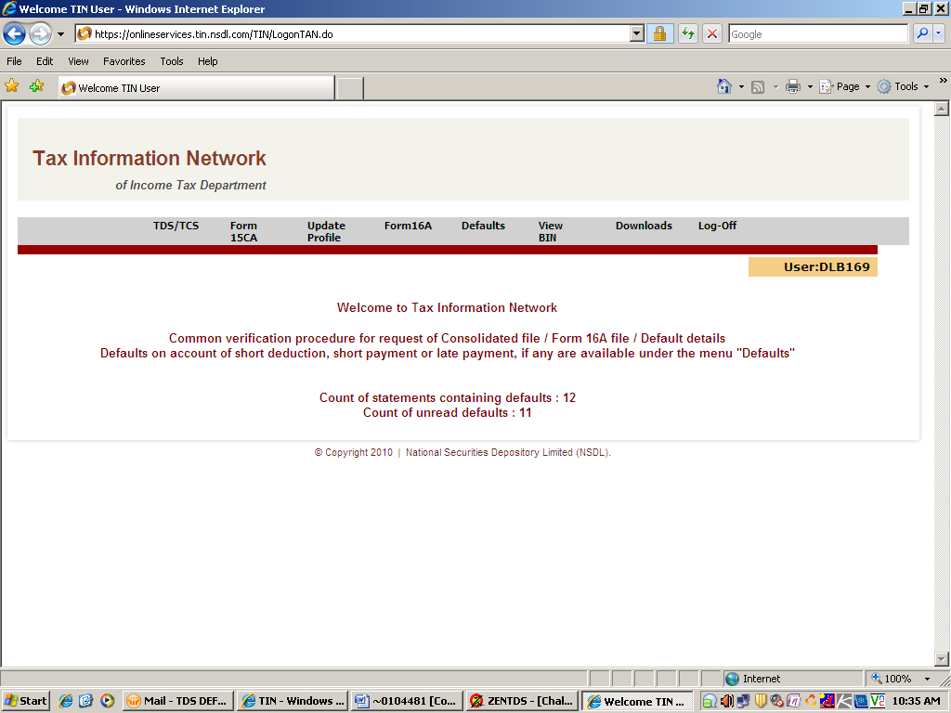

Enter Provisional receipt number of regular statement (i.e.: of 1st Original return filed) corresponding to the quarter and year for which default is generated and click on submit.

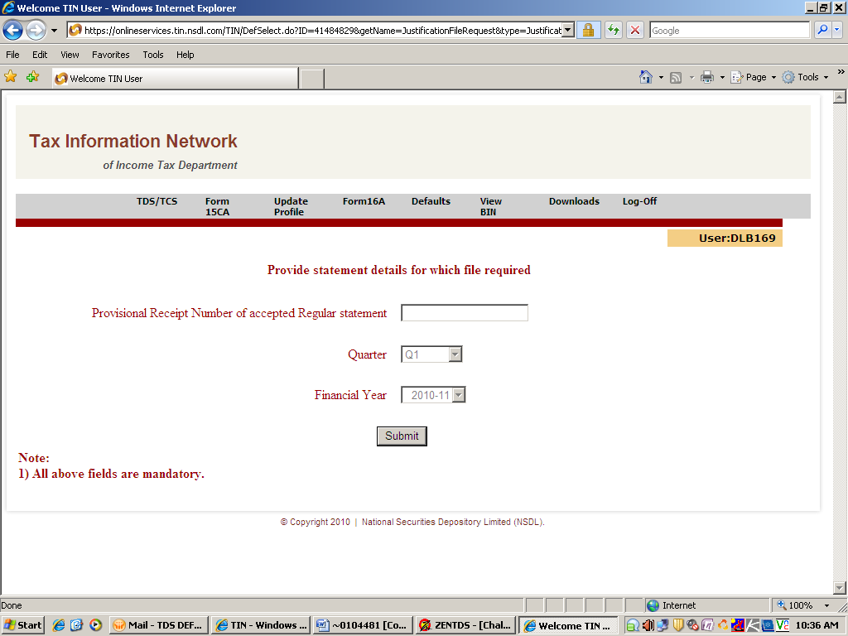

After clicking on Submit following screen will appear, asking additional details regarding the return filed

You have to provide details of any one challan (All such details are printed on challn itself) and PAN number & TDS amount of any three deductees corresponding to the challan details entered in first part.

Then click on “submit”
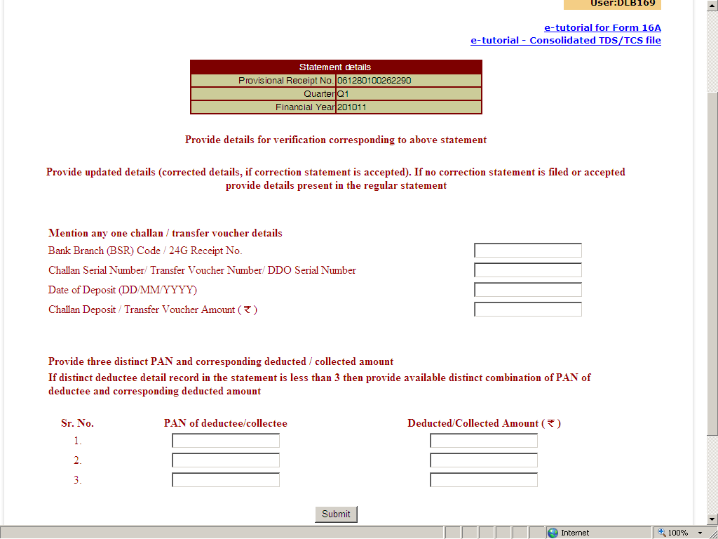

You will receive reference number of generated default file
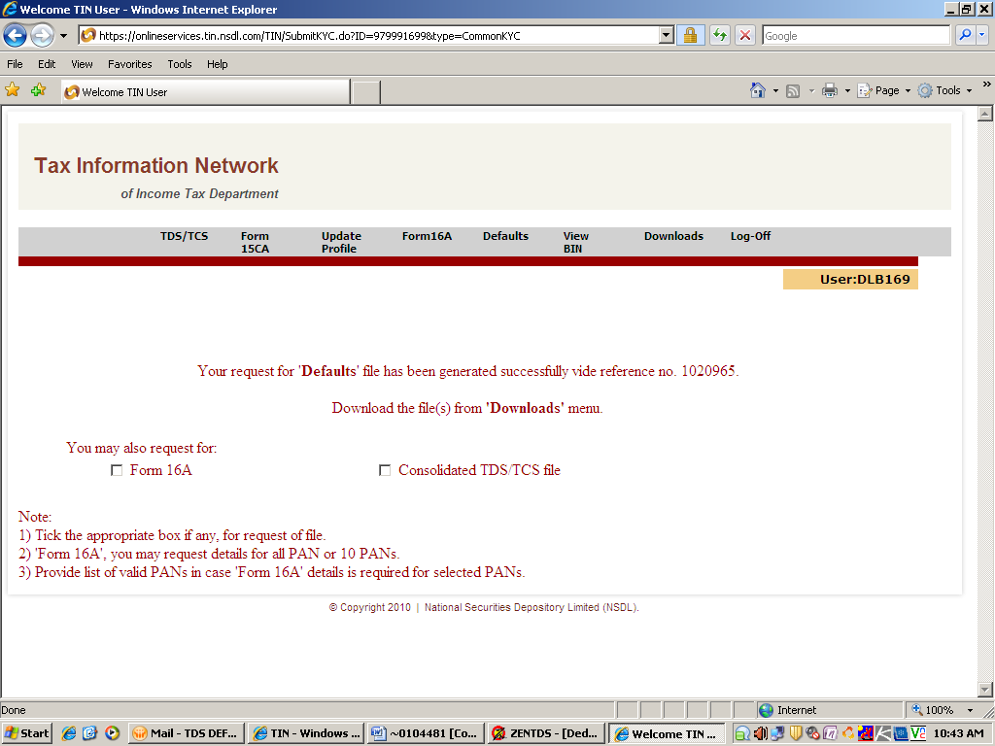

Then click on “Download View/ Downlaod by Date/Ref. no.”
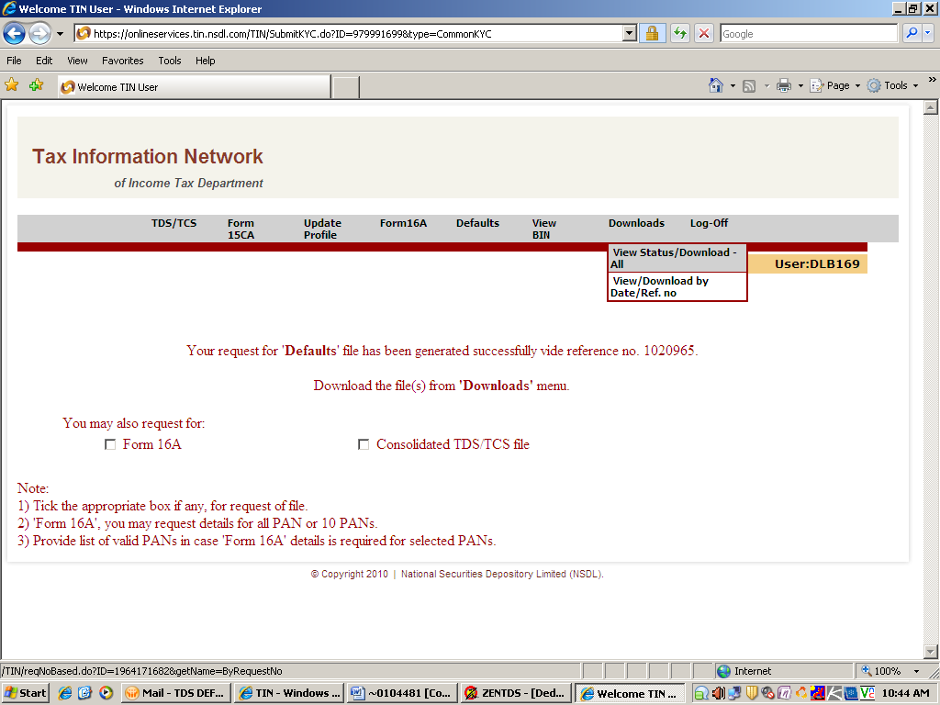

Enter the reference number generated and date
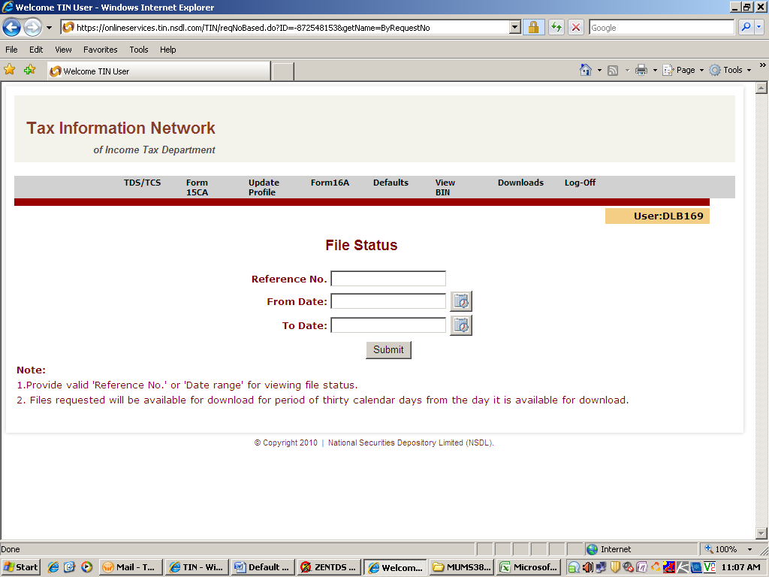

Click on “Click here to download”
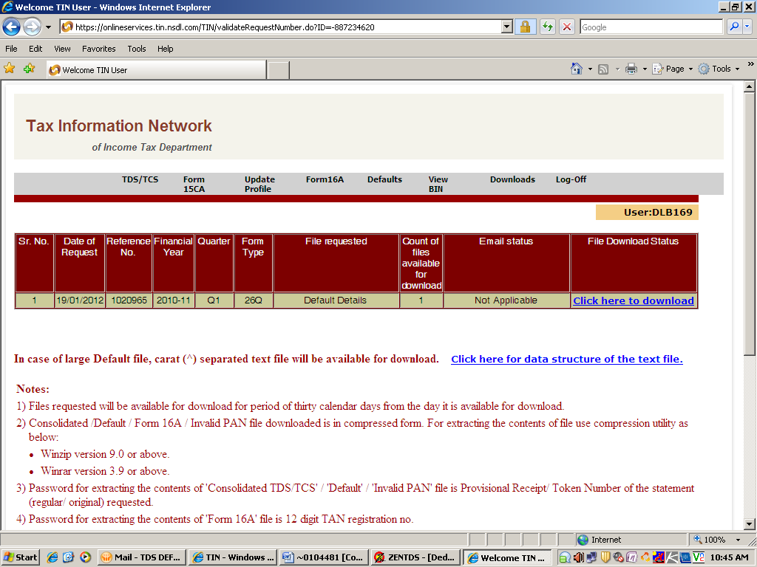

The zip file will be available for download, save the file
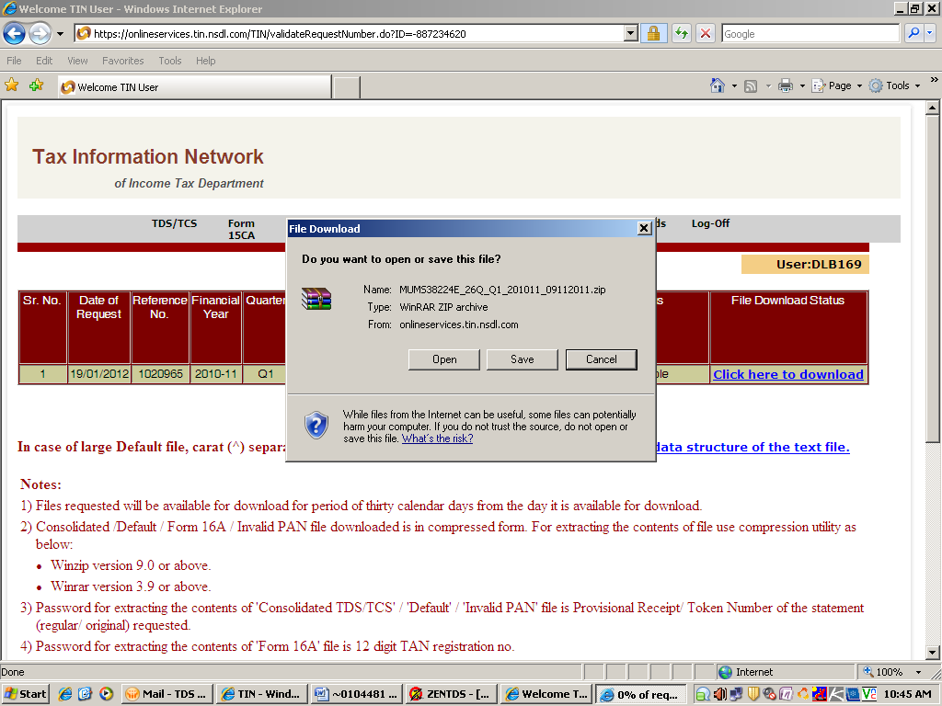

After saving extract the file, while extracting it will request for password,
Password will be the “Provisional receipt number” which you have entered in the beginning,

An excel file will be extracted which will contain the details of defaults.

For removing defaults as mentioned in the excel file extracted you will have to file the revise return (known as “Correction statement”)

For filing revise return (correction statement) you will require “consolidated TDS file” of the return filed earlier, almost steps are same , for knowing the steps please double click on the “e-Tutorial” given below provided by TIN NSDL

After downloading Default file and Consolidated TDS /TCS
File correction statement

Return will be processed by NSDL
Default is removed

