What is MSME?
An MSME (Micro, Small and Medium Enterprise) is defined by RBI/GOI differently for the Manufacturing and the Services Sector, as follows:
Manufacturing Sector
Manufacturing sector refers to enterprises engaged in manufacture or production, processing or preservation of goods. The definition of Micro, Small and Medium Enterprises under the manufacturing sector is based on the Investment in plant and machinery [original cost excluding land and building] and the items specified by the Ministry of Small Scale Industries vide its notification No. S.O. 1722(E) dated October 5, 2006
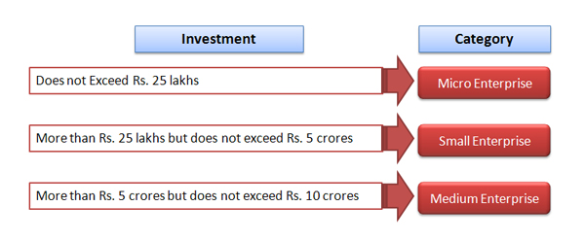
Services Sector
Services sector refers to enterprises engaged in providing or rendering of services. These will include small road & water transport operators (owning a fleet of vehicles not exceeding ten vehicles), small business (whose original cost price of the equipment used for the purpose of business does not exceed Rs.20 lakh) and professional & self employed persons (whose borrowing limits do not exceed Rs.10 lakh of which not more than Rs.2 lakh should be for working capital requirements except in case of professionally qualified medical practitioners setting up of practice in semi-urban and rural areas, the borrowing limits should not exceed Rs.15 lakh with a sub-ceiling of Rs.3 lakh for working capital requirements). The definition of Micro, Small and Medium Enterprises under the services sector is based on the enterprise’s investment in equipments.
