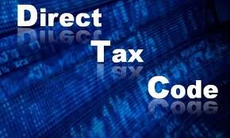
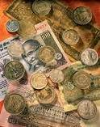
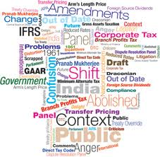
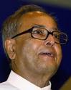
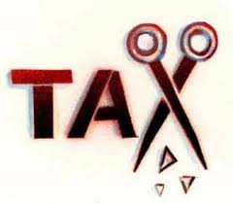
TABLE OF CONTENTS…

INTRODUCTION…………………………………………………………..3
THE NEED OF THE DIRECT TAX CODE…………………………..4
SALIENT FEATURES…………………………………………………….. 5
DEVELOPMENTS SO FAR…………………………………………….. 6
ANALYSIS OF PROVISIONS IN THE ORIGINAL AND PROPOSED DIRECT TAX CODE………………………………………7
HOW IT WILL AFFECT THE PEOPLE PAYING TAXES??......11
DATA CRUNCHING……………………………………………………….11
LOSS TO GOVERNMENT DUE TO DIRECT TAX CODE …….11
INSTEAD WHAT GOVERNMENT COULD HAVE DONE......12
CONCLUSION……………………………………………………………….13

THE DIRECT TAX CODE: a new face of the Indian Taxation System.

INTRODUCTION:
T
he way of taxpayers is hard and the legislature does not go out of its way to make it any easier. To quote Mr. Palkhiwala “The tragedy of India is the tragedy of waste – waste of national time, energy and manpower. Tens of millions of man –hours, crammed with intelligence and knowledge – of taxgatherers, taxpayers and tax advisers – are squandered every year in grappling with the torrential spate of mindless amendments. The feverish activity achieves no more good than a fever.”
The Income tax Law represents the tolerance power of our population. The taxpayers withstand with mute silence, year after year, the onslaught of amendments which in the garb of simplification more often confuse the law.
One of the most critical drafts of Indian statutes was Income tax Act, 1961. In order to simplify the current tax structure government of India comes with a proposal of introduction of Direct Tax Code (DTC).
The new Tax draft has given Common man more than what he had expected; it is not only beneficial to individual tax payer, but also corporate houses and foreign houses. There is a drastic reduction (at least, it looks like that prima facie) on the amount of taxes most of the employed people will pay going forward.
When come to international taxation, as of now we are enjoying the benefits of tax heavens, treaty agreement and other DTAA. Due to proposed DTC a lot changes might taking place and somehow cause hard ship to assesses dealing in international taxation.
The draft is available to the public for the discussions and suggestions and there are nine critical areas identified for modification. In the current topic we will discuss both beneficial and critical areas in DTC.

The need of the Direct Tax Code

To simplify the taxation system in respect of income tax.

To reduce the complexities of the compliance mechanisms prevalent in the present Income Tax Act in the proposed legislature.

To remove the obsolete provisions present in the statute and to incorporate elements of taxation in foreign countries.

Therefore it was felt that a taxation system is needed that should be easier to comprehend, understand and analyze.It should reduce the dependence of non expert assesses over professionals. In order to achieve these objectives THE DIRECT TAX CODE was framed and is expected to replace the existing Income Tax Act, 1961.

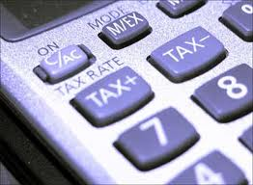

SALIENT FEATURES AND THE OVERALL DRAFT

DTC (2010) bill was tabled in parliament on 3oth August, 2010. There are big changes now in monsoon session and there are now much less benefits as compared to what were in the original proposal.
The New Direct Tax Code (DTC) is said to replace the existing Income Tax Act of 1961 in India. It was expected to be passed in the monsoon session of 2010 and was expected to be enforced from April 2011. During the budget 2010 presentation, the finance minister Mr. Pranab Mukherjee reiterated his commitment to bringing into fore the new direct tax code (DTC) into force from 1st of April, 2011, but same could not be fulfilled and now it is expected to be applicable form April 2012.

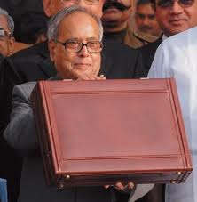
Figure 1: Finance minister Pranab Mukherjee with the Direct Tax Code bill

DEVELOPMENTS SO FAR

The Minister of Finance published a draft of the Indian Direct Tax Code 2009, which should take effect from 1 April 2012 for public discussion, 20 August 2009. New code replaces outdated Indian Income Tax Act of 1961. This is an important step in the long-awaited tax reforms in India and aims to simplify the entire tax system radically.
All direct taxes such as income, assets and dividends Distribution under uniform code Direct taxes in line with other countries like USA, UK and Germany covered. In contrast to the previous Income Tax Act of 1961, the language of the new code is very simple, which makes it easier to understand for the simple people, the provisions of the income tax.

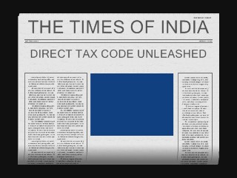

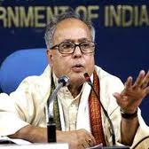

ANALYSIS OF PROVISIONS IN THE ORIGINAL AND PROPOSED DIRECT TAX CODE
1. DTC removes most of the categories of exempted income. Unit Linked Insurance Plans (ULIPs), Equity Mutual Funds (ELSS), Term deposits, NSC (National Savings certificates), Long term infrastructures bonds, house loan principal repayment, stamp duty and registration fees on purchase of house property will loose tax benefits.
2. Tax saving based investments:
Original Direct Tax Code:
Limit increased from 1, 00,000 to 3,00,000
Revised Direct Tax Code:
Tax saving based investment limit remains 100,000 but another 50,000 has been added just for pure life insurance (Sum insured is at least 20 times the premium paid), health insurance, mediclaims policies and tuition fees of children. But the one lakhs investment can now only be done in provident fund, superannuation fund, gratuity fund and new pension fund.
3. SLAB RATES:
ORIGINAL PROPOSAL—
UPTO Rs. 160000 | No tax
From 160000 to 1000000 | 10%
10,00,000 TO 25,00,000 | 20%
Above 2500000 | 30%
NEW PROPOSAL—
Annual Income | Tax Slab
Up-to INR 200,000 (for senior citizens 250,000) | Nil
Between INR 200,000 to 500,000 | 10%
Between INR 500,000 to 1,000,000 | 20%
Above INR 1,000,000 | 30%
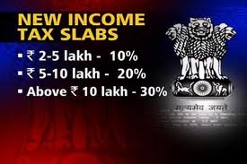
4. INCOME FROM CAPITAL GAINS —
Original Proposal:
Distinction between long-term and short-term capital assets to be eliminated
New Proposal:
Only half of Short-term capital gains will be taxed. e.g. if you gains 50,000, add 25,000 to your taxable income.
Long term capital gains (From equities and equity mutual funds, on which STT has been paid) are still exempted from income tax.

5. SAVINGS, ACCRETIONS AND WITHDRAWALS
NEW PROPOSAL:
As per changes on 15th June, 2010, Tax exemption at all three stages (EEE) —savings, accretions and withdrawals—to be allowed for provident funds (GPF, EPF and PPF), NPS (new pension scheme administered by PFRDA), Retirement benefits (gratuity, leave encashment, etc), pure life insurance products & annuity schemes.
ORIGINAL PROPOSAL:
Earlier DTC wanted to tax withdrawals.

6. INCOME FROM HOUSE PROPERTY
- Deductions for Rent and Maintenance would be reduced from 30% to 20% of the Gross Rent.
- Also all interest paid on house loan for a rented house is deductible from rent.
- Before DTC, if you own more than one property, there was provision for taxing notional rent even if the second house was not put to rent. But, under the Direct Tax Code 2010 , such a concept has been abolished.

7. OTHER IMPORTANT CHANGES
- Surcharge and education cess are abolished.
- Tax exemption on LTA (leave travel allowance) is abolished.
- Tax exemption on Education loan to continue.
- Corporate tax reduced from 34% to 30% including education cess and surcharge.
- Medical reimbursement: Max limit for medical reimbursements has been increased to 50,000 per year from current 15,000 limit.
8.Tax on dividends:
Equity mutual fund will attract 5% dividend distribution tax (DDT). DDT has been removed from debt and non-equity based mutual funds but now dividends on non-equity funds will be taxable in investor’s hand as per his slab rates. There will also be a TDS 0f 10% (20% in case of NRI and companies) if dividend is more than 10,000 Rs for non-equity funds



How it will effect the people paying taxes ??
- Rs. 0 to Rs. 1,60,000 : No difference (Neither they paid earlier, nor would they now)
- Rs. 1,60,000 to Rs 2,00,000 : Earlier they were paying 10% and they dont pay now
- Rs. 2,00,000 to Rs 5,00,000 : Saving of Rs.4000 (Rs.40,000 x 10%)
- Rs. 5,00,000 to Rs. 8,00,000 : Saving of Rs.4000 (Rs.40,000 x 10%)
- Rs. 8,00,000 to Rs.10,00,000 : Earlier they were paying 30% and will now pay only 20%
- Rs. 10,00,000 and above: No difference (They were paying and continue paying 30%)

data crunching: -- how many people paid tax at what rate?
- Total number of tax payees during last year: 3.25 crore people (in 3 slabs of 10, 20 and 30%)
- 95.25% of the total tax payees fall under Rs.1 lakh to Rs.5 lakh slab; contributing 30% of total taxes collected.
- 2.05% of the total tax payees fall under 20% slab; and their contribution is 10% of all taxes collected.
- 2.2% of the total tax payees fall under 30% slab; and their contribution is 60% of the total tax collected.

Loss to government due to Direct Tax Code (DTC)
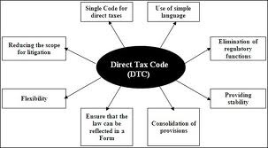
On the other hand, by raising the tax slab from Rs. 8, 00,000 to Rs.10, 00,000 at the rate of 20%, from earlier 30%; it will loose a decent chunk of its tax income as the segment of Rs.8, 00,000 and above contributes around 60% of all taxes collected, though the numbers are only 2.2% of tax payees – this, assuming that the majority chunk of tax contributors likes at the lower band of a tax slab.
what government could have done Instead
For transferring the benefits to people it is equally important to consider two factors:

INCREASE TAX SLABS
Since last decade, we have seen only the taxable slabs going up from Rs. 90,000 to the present Rs.2,00,000. This sure is a welcome gesture from government.
REDUCE TAX RATES
While increasing taxable income ranges liable for paying taxes, the government could have brought down the effective tax rates from 10%, 20% and 30% to 8%,15% and 25% and, so on, gradually upto 5%, 10% and 15% for the above income groups (in line with many developed nations).
This way instead of only two groups of income groups, everybody could have benefited from the exercise.

CONCLUSION

The direct tax code is expected to simplify the taxation system. In the near future Goods And Service Tax will completely replace the system of indirect taxation. Therefore the whole taxation system of India will undergo a drastic change.

THANK YOU

