I would like to share some information about e-Tax Refund.
On 15 Feb.2010, my friend got an email in his yahoo inbox from Income Tax Department of India – Tax Refund. He was just surprised to see this email asking for his bank accounts & Card details with ATM PIN.
For your Information, the intimation emails cannot be sent from any of government websites to any particular person. Later, he finds this email was Fake & the source of this email was from outside INDIA.
Please Beware before filing the Income Tax Returns online.
This was the email in his yahoo mail
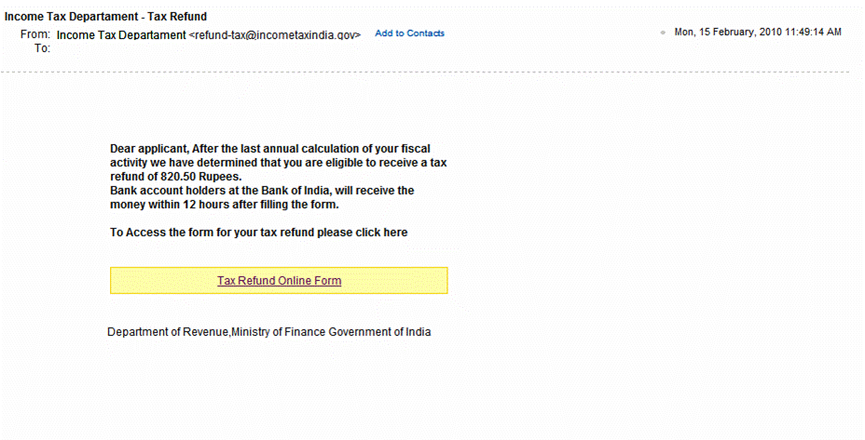
------------------------------------------------------------------------------------------------------------------------------------------------------------------------------------------------
This was the website, he was directed to, after following the link
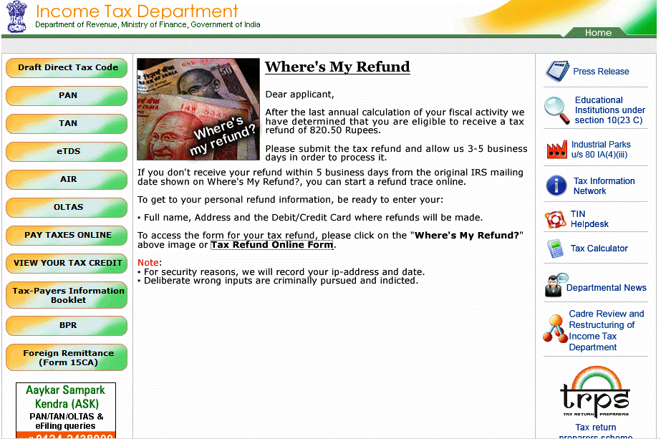
In the Tax Refund Online Form – all fields were compulsory to be filled – like card number, bank account details, Credit card CVV number & ATM PIN etc
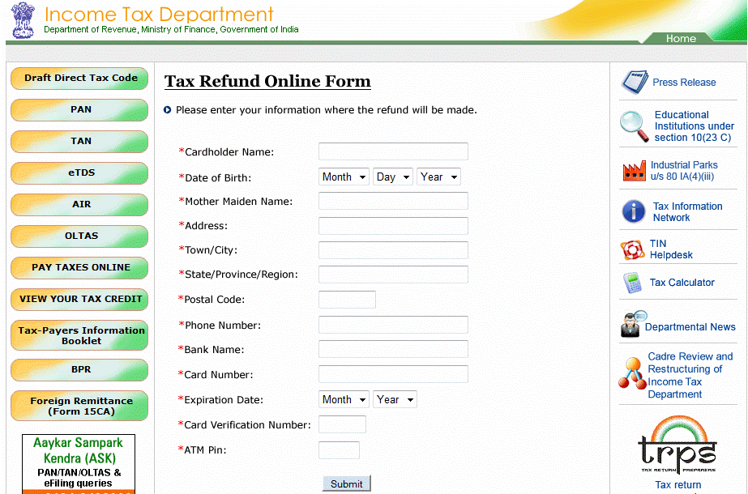

See the difference in web address
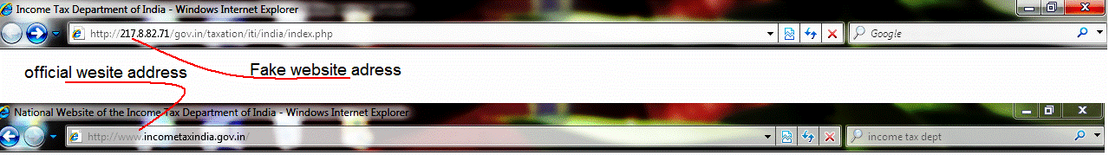
--------------------------------------------------------------------------------------------------------------------------------------------------------------------------------------------------

This is the Official website Income Tax Department of India, see the difference
