PROCEDURE FOR ONLINE REGISTRATION OF TAN’S

The income tax department has asked all deductors to register their TAN on NSDL web site. Once registered, the deductors will be provided User ID and password for authenticated access.
Benefit of registration
The access will result in the following benefits to the deductors:
• View of status of all statements filed;
• Download of consolidated quarterly e-TDS / TCS statement for preparation of correction statement; and
• other functionalities related to quarterly TDS /TCS statement.
Before registration
• Keep Provisional Receipt Number (PRN) of any eTDS Statement filed on or after 01-04-2008.
• Go to “Quarterly Statement Status”. Enter TAN and PRN Number. Ensure that this statement is accepted by TIN. You will have to enter details of such statement during registration.
• Keep PAN details
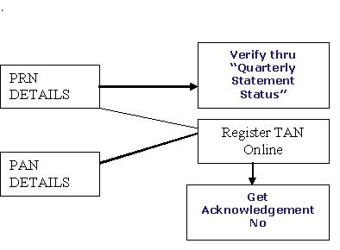
Registration Form
TAN registration should be done online at the website of the Tax Information Network www.tin-nsdl.com. Deductors must register all active TANs.
Use the following link to register the TAN : http://www.tin-nsdl.com/onlinetanintro.asp. Online form will appear. The details to be filled in are explained below :
Details of Deductor
• Enter TAN and Company Name
• Enter PAN. Mention “PANNOTREQD”, in case PAN is not available i.e. deductor is not required to have PAN as per the statute.
• Select appropriate deductor category from the dropdown.
• For Govt deductors additional information is required to be filled in
1. PAO Code and DDO Code are mandatory for deductor category “Central Government”.
2. If PAO Code is not available then mention value “PAOCDNOTAVBL”.
3. If DDO Code is not available then mention value “DDOCDNOTAVBL”.
4. For PAO/ DDO Registration number, mention registration number allotted, if any, by Central Record Keeping Agency (CRA) under New Pension Scheme (NPS).
Contact Details of Deductor
• Mention complete address and contact details of deductor.
• Provide valid email id and telephone no. / Mobile no.
• Provide details of responsible person and designation.
Statement Details
• Mention details of any regular e-TDS / TCS quarterly statement accepted in TIN on or after April 01, 2008.
Generation of Acknowledgement
• After filling up the information, click “submit”. On submission of details if system shows any errors, rectify and re-submit the form.
• A confirmation screen with all the data filled by the user will be displayed. The same can be either confirmed or edited.
• On confirmation, an acknowledgement number will be displayed.
• Print the acknowledgment and preserve the same for future use.
• For future correspondence mention the TAN registration number provided by TIN along with the TAN.
• You can re-generate the “Acknowledgement for TAN Registration” by registering again.
Comments
This is very useful facility and will make the task of deductor simpler.
• The biggest advantage is ability to retrieve eTDS Statement filed earlier. Several deductors do not keep backup of eTDS statement FVU files and when a correction is to be filed, they have no recourse.
• Another problem being faced by deductors is to keep track of original FVU and correction FVU. Many times several correction statements need to be filed e.g. when valid PAN become available. Hopefully, NSDL should be able to provide the updated FVU online for further creation of correction.
• At present, a deductor has to go to several links for information retrieval e.g. Challan Status Enquiry, quarterly statement status, eTDS online filing. With this new facility it is expected that all these services will be available in a single window.

