1. Purchasing is the formal process of buying goods and services. The Purchasing Process can vary from one organization to another, but there are some common key elements.
The process usually starts with a 'Demand' or requirements[1] – this could be for a physical part (inventory) or a service. A requisition is generated, which details the requirements (in some cases providing a requirements speciation) which actions the procurement department. A Request for Proposal (RFP) or Request for Quotation (RFQ) is then raised. Suppliers send their quotations in response to the RFQ, and a review is undertaken where the best offer (typically based on price, availability and quality) is given the purchase order.
Purchase orders (PO) can be of various types,[2] including:
- Standard - a one time buy;
- Planned - an agreement on a specific item at an approximate date; and
- Blanket - an agreement on specific terms and conditions: date and quantity and amount are not specified.
Purchase Orders are normally accompanied by Terms and Conditions[3] which form the contractual agreement of the Transaction. The Supplier then delivers the products/service and the customer records the delivery (in some cases this goes through a Goods Inspection Process). An invoice is sent by the supplier which is cross-checked with the Purchase Order and Document which specifying that the goods received. The payment is made and transferred to GL.

2. Purchasing Process
There are many reasons why a formal process must be followed including the prevention of fraud, cost saving, compliance with regulations, management of risk and control. To understand or to explain why a formal process should be followed it can be useful to think in terms of the 5 As.
- Approved Suppliers
- Approval Process and Segregation of Responsibilities
- Audit Trail
- Accounting
- Automation

Purchasing Process Flowchart
There is sometimes a significant amount of effort required to ensure that a supplier is appropriate for a particular category of goods or services. They should be able to supply goods and services that meet requirements of quality and fit for purpose. They should be reliable financially sound and not present a commercial or reputation risk and their prices should be competitive. It makes no sense to perform the relevant research on a supplier each time goods or services are required. By developing preferred suppliers, longer term sustainable relationships can be developed that deliver a better value for money.

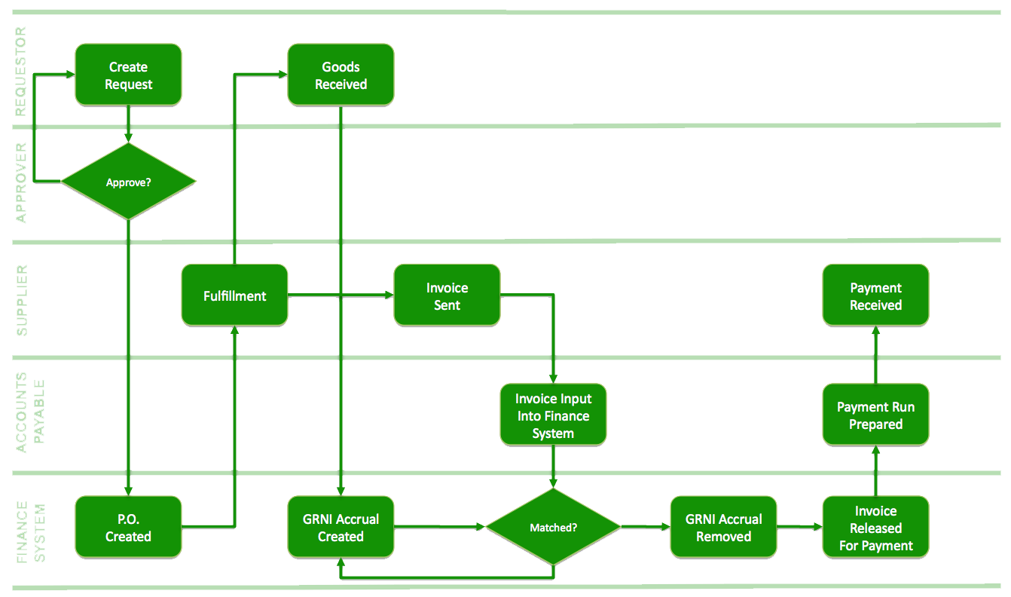
Purchasing Process Flowchart

Approval Process and Segregation of Responsibilities
The principles of approval and segregation of responsibilities provides an organization with a control to reduce the risk of fraud. The requirement for the approval of a purchase requisition prevents inappropriate purchases being made and the separation of responsibilities to unconnected parts of the buying organization helps to reduce the risk of collusion.

Audit Trail
A formal purchasing process that records a predefined set of processes allows the path of events to be examined retrospectively to identify errors or deliberate breaches of policy.

Accounting
All commercial organizations have a legal responsibility to account for their finances including for the goods and services that they procure. It is important therefore that proper records are maintained e.g. to record dates, prices and department details as well as to categorize goods and services appropriately to distinguish between capital goods and expenses for example. This can have a crucial bearing on how the finances of the organization are described which in turn can have a tax and profitability impact.
Automation
A standard process allows for automation and the use of technology which reduces the cost of the process.
3.
A faculty/staff member identifies a buying need. The faculty/staff member may ask Purchasing Services to identify sources and develop procurement descriptions or specifications.
The requirement is entered into IBIS. Any single/sole source justifications should also be submitted at this time.
The purchasing requisition travels electronically through the requesting department’s specified approval path: the Financial Officer, the Budget Administrator, Accounting, and any other approvals the department chooses to establish.
Purchasing Services processes the requisition in accordance with University guidelines and bidding thresholds.
a. The Purchasing Agent must justify the source and the price.
b. The Purchasing Agent is responsible for determining the validity of any sole source justifications.
The Purchase Order is approved and released.
The product or service is delivered to the requester.
An invoice is sent to Purchasing Services.

4. Steps of purchasing procedure: The purchasing generally comprises the following steps:
1) Recognition of the need.
2) Selection of the supplier.
3) Placing the purchase order.
4) Follow up of the order.
5) Receiving and inspection of the materials.
6) Payment of the invoice.
7) Maintenance of the records.
8) Maintenance of the vendor relations.

Navneet Agarwal

