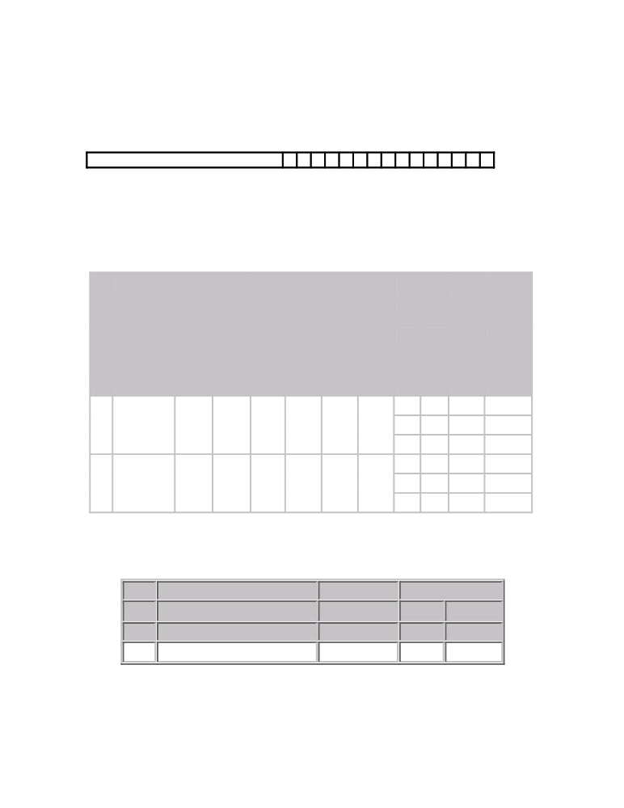

FORM ER-6

{sub-rule (3) of rule 9A of CENVAT Credit Rules, 2004}

1. Name of the manufacturer:

2. PAN based Registration Number:

3. Month to which the return relates:

4. Details of receipt and consumption of principal inputs and finished excisable goods:

TABLE

Sr. Description of Quantity
No. principal inputs Code*

Opening Receipt Taken Remov-Closing
Balance for use ed Balance
in the as
manufac such for
ture of export
dutiable or for
and home
exempte con-
d sumptio
finished n
goods

Finished Quantity
goods manu-code of
factured out finished
of goods*
inputs
S. Descri
No. ption

Quantity
of
finished
goods
manu-
factured

1 2 3 4 5 6 7 8 9(A) 9(B) 10 11

5. Details of waste and scrap arising during manufacture and cleared/destroyed:

TABLE

S.No. Description of waste and scrap Quantity code* Quantity
Cleared Destroyed
1 2 3 4(A) 4(B)

NOTE. - (1) Finished goods mentioned in Column (9B) should be stated in respect of each of the inputs mentioned in Columns (2) and (6).
(2) *Please indicate the abbreviation referred to in Instruction No. 7 mentioned in Form E.R.-1 and Form E.R.-3 specified in the Government of India, Ministry of Finance (Department of Revenue) vide No.25/2004-Central Excise (N.T.), dated the 27th September, 2004 published vide G.S.R.No.643 (E) dated the 25th September, 2004.

6. (i) I/We _________________declare that the particulars declared above have been
compared with the records and books of my/our factory/warehouse and the same are true and correct to the best of my/our knowledge.

(ii) I/we am/are authorized to sign this return.

Place:

Date:

(Name in capital letters and signature
of the assessee or authorized signatory)

ACKNOWLEDGEMENT
Return of receipt and consumption of principal inputs and finished excisable goods for the month ending ____
D D M M Y Y Y Y

Date of receipt

Name and signature of the officer with seal

