- To unblock the account, Assessee can go to the below mentioned hyperlink.

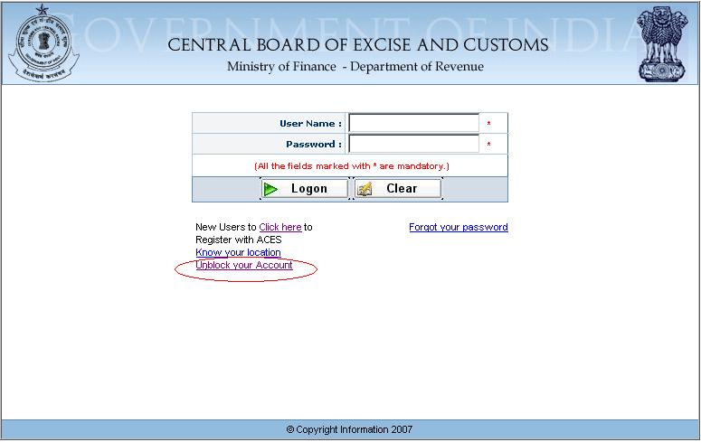

- Please enter the details of Registration number, Hint Question and Hint Answer.
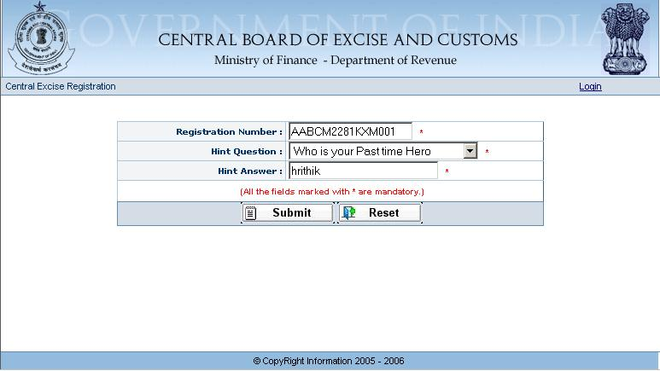

- After Submitting all the details, the below mentioned message will be displayed. The new password will be sent to the registered email-id.
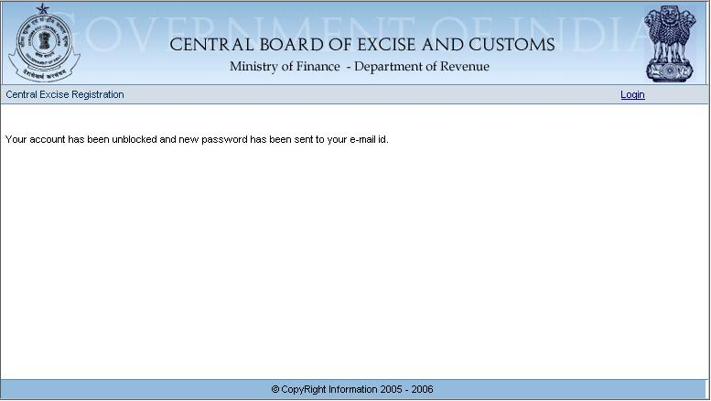

The Message description which is sent to Assessee email-id is as shown as below.
This is to inform you that the user account have been unblocked. The User Name and the Password for the user are : User Name - slalam , Password - iGrpKi

- Now Assessee can login with freshly re-generated username and password
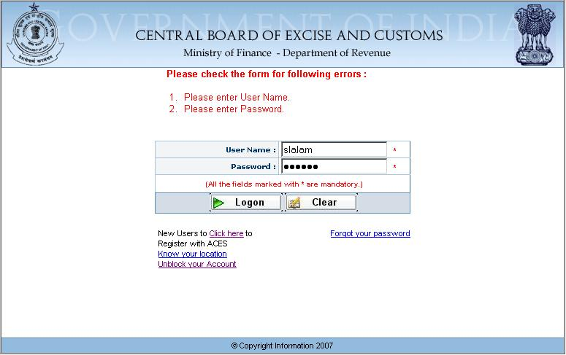

- After Login, Asseessee will find the below screen, where he has to re-set the newly re-generated password for once.
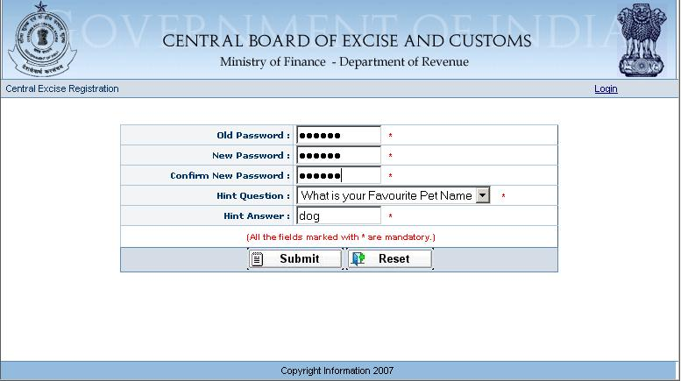
- Please press the Submit button to complete the process.

