GeM -AN OPPORTUNITY FOR CHARTERED ACCOUNTANTS AND BUSINESSMEN

Government e- market place portal is a great initiative by the government of India opening up the avenues for the chartered accountants as well as businessmen.

What is gem portal?
Gem stands for government e market place portal which is initiated by the government of India for procurement of goods and services by the government departments, public sector undertakings and other government owned enterprises through the portal by following the process of bid/tender. The URL of the portal is gem.gov.in.
Objective of gem portal
The objective of gem portal is to enhance the transparency and objectivity in the process of procurement of goods and services. This process has enhanced the chances of fair competition among the vendors and suppliers of goods and services.
Process of bids/tendering on gem
The vendor or supplier of goods and services have to register themselves on the portal gem.gov.in. After registration the vendors can login and participate in bids of relevant categories in which they have registered themselves up.
- The vendor/ seller/ supplier after signing up, have to complete their profile by providing the following documents:

- Pan of the business
- Aadhar of the proprietor or partner or director etc
- Last 3 year’s income tax return
- Caution money depending on the turnover of last year.
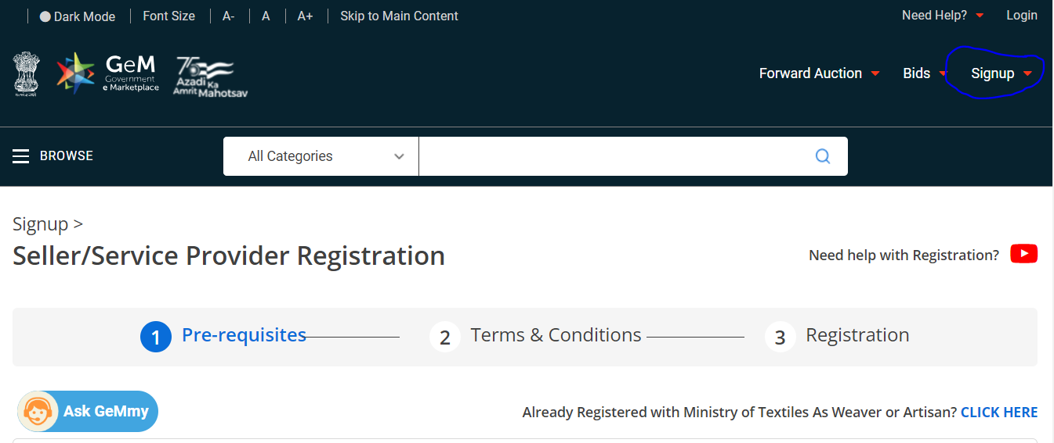
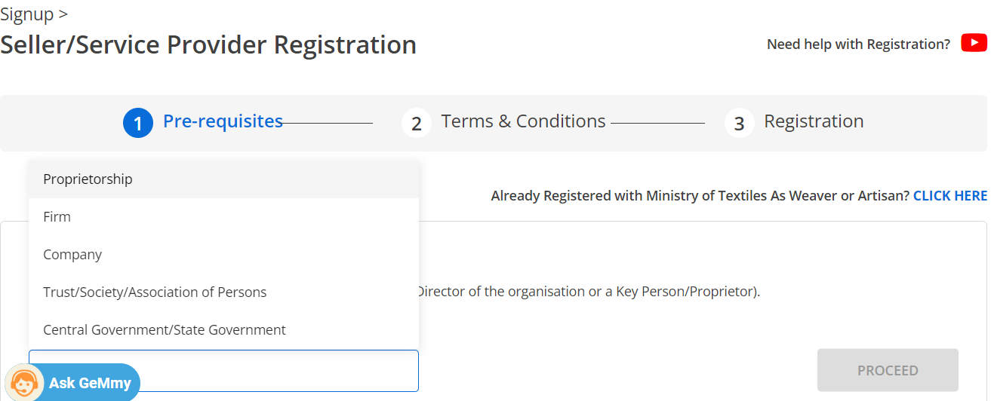

- After logging in, the vendor can see the bids of his relevant category in the list of bids, search and advanced search filter can be used for exact search.
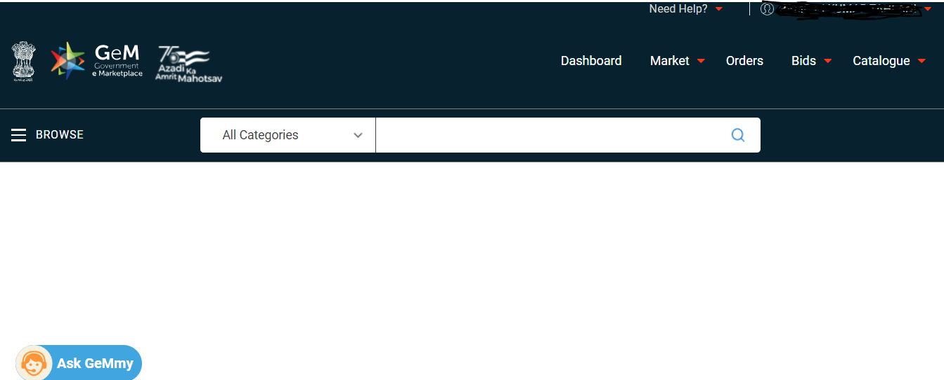
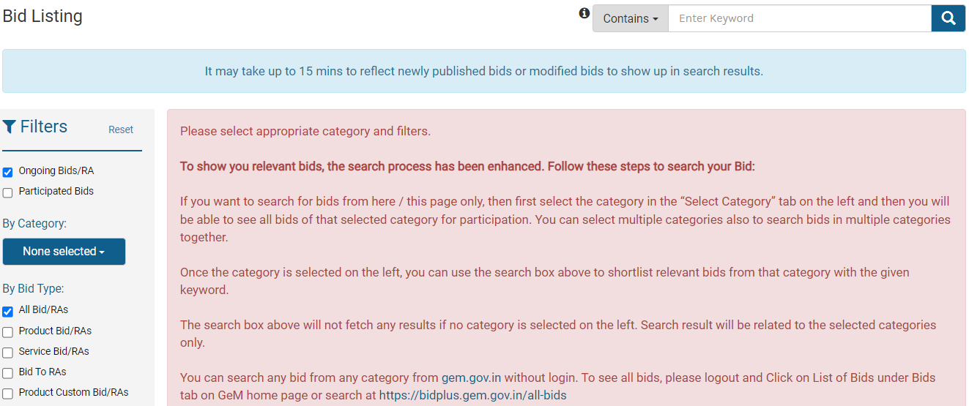
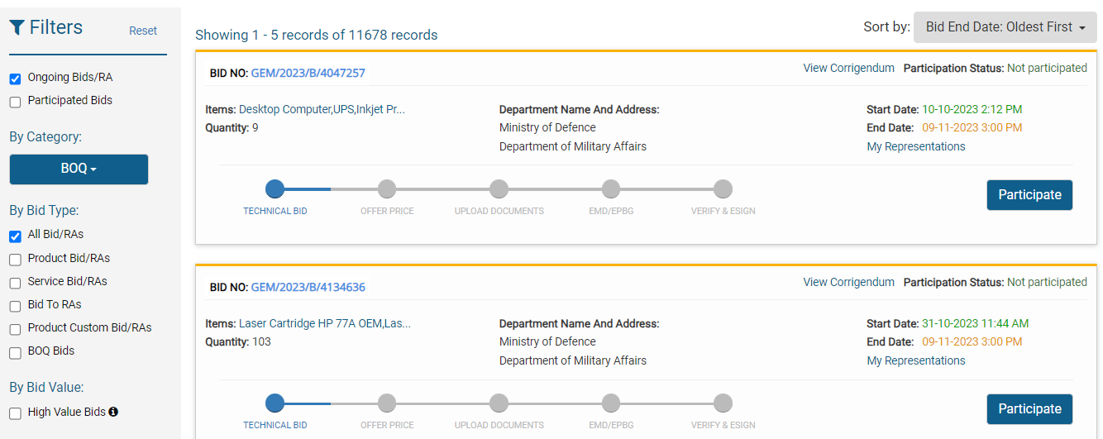

- On the bid being searched, vendor can participate in the bid, by fulfilling the technical documents which involves a compilation of documents like audited financial statements, agreement /integrity pact, past performance certificate, MSME ca certificate, bid value, etc.

- After, verifying the documents technical feasibility, the bidders are either awarded tender or rejected on the basis of qualification in the lower bid criteria.

- Any technical disqualification is allowed by the tenderer to be corrected by the vendor in a span of 48 hours.

- This way, the goods or services are being procured by the government departments / PSU’S in a fair and transparent manner.

CATALOUGE MANAGEMENT

AFTER SIGNING UP AND LOGGING IN, BUT BEFORE PARTICIPATION, THE THING YOU HAVE TO DO IS PRESENT YOUR GOODS OR SERVICES THAT YOU WANT TO OFFER, SIMILARLY LIKE WE DO IN A PHYSICAL PLACE OR PREMISE. THAT IS YOU HAVE TO PREPARE A CATALOUGE OF GODDS OR SERVICES THAT YOU WANT TO OFFER.LETS SEE HOW DO WE DO IT:
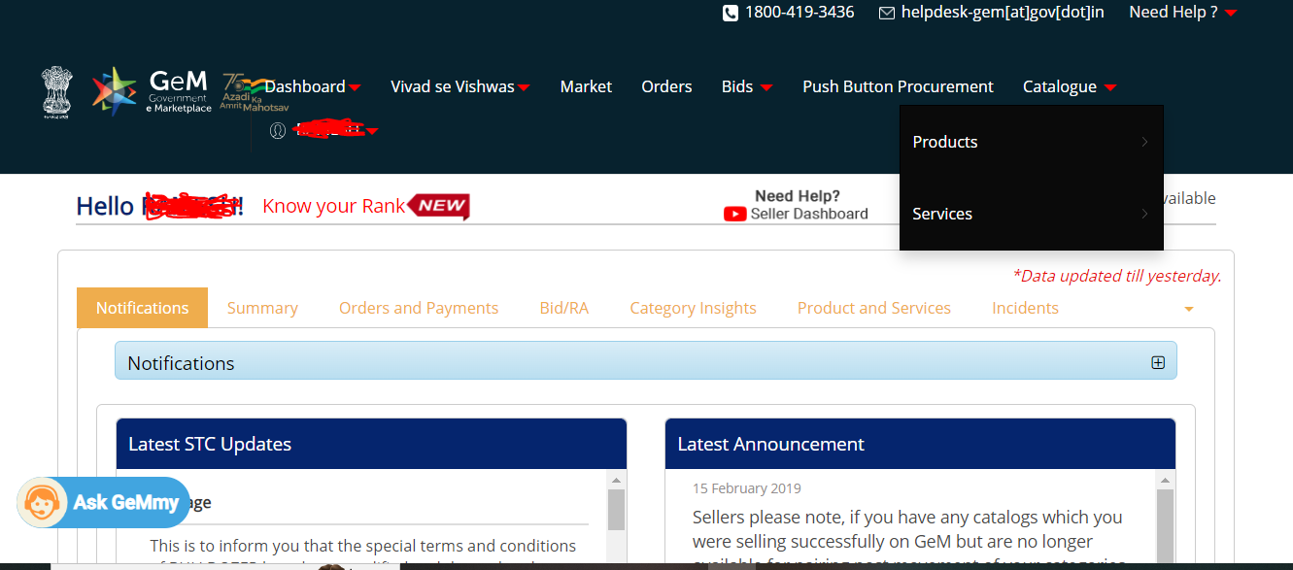
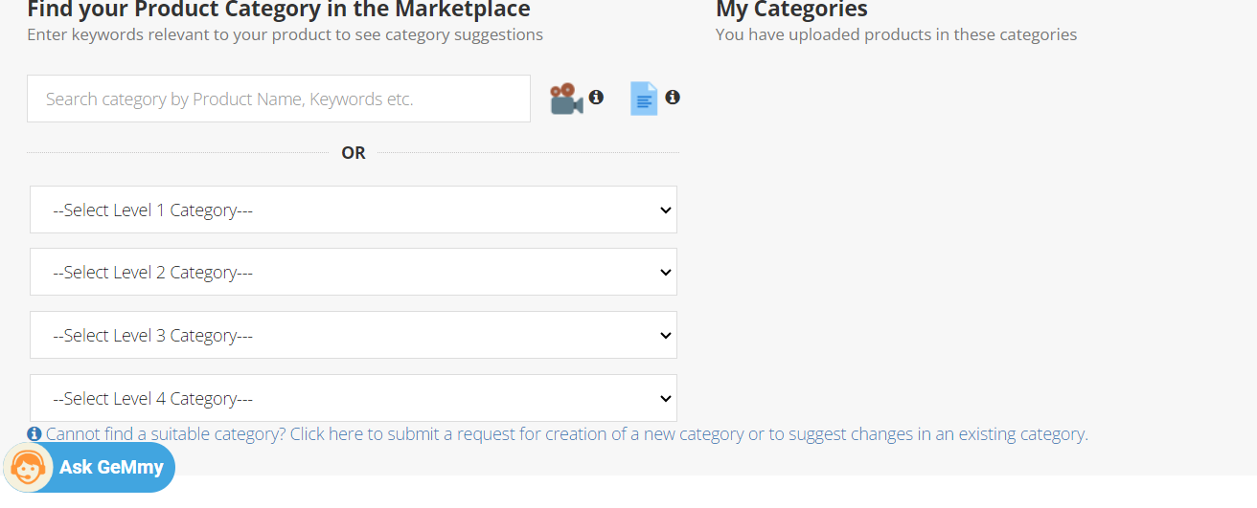

THIS WAY YOU CAN SELECT THE PRODUCT FROM THE CATEGORIES OR YOU CAN RAISE A REQUEST FOR NEW CATEGORY OF PRODUCT OR SERVICE.
AFTER SELECTING THE PRODUCT, YOU HAVE TO FILL SOME GENERAL INFORMATION ABOUT THE PRODUCT:
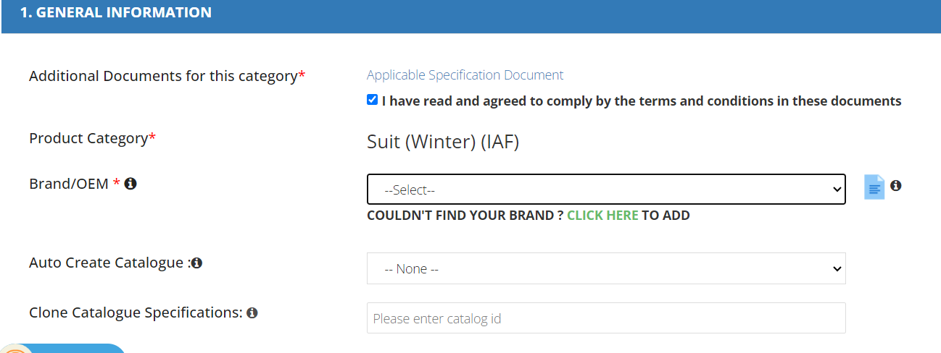
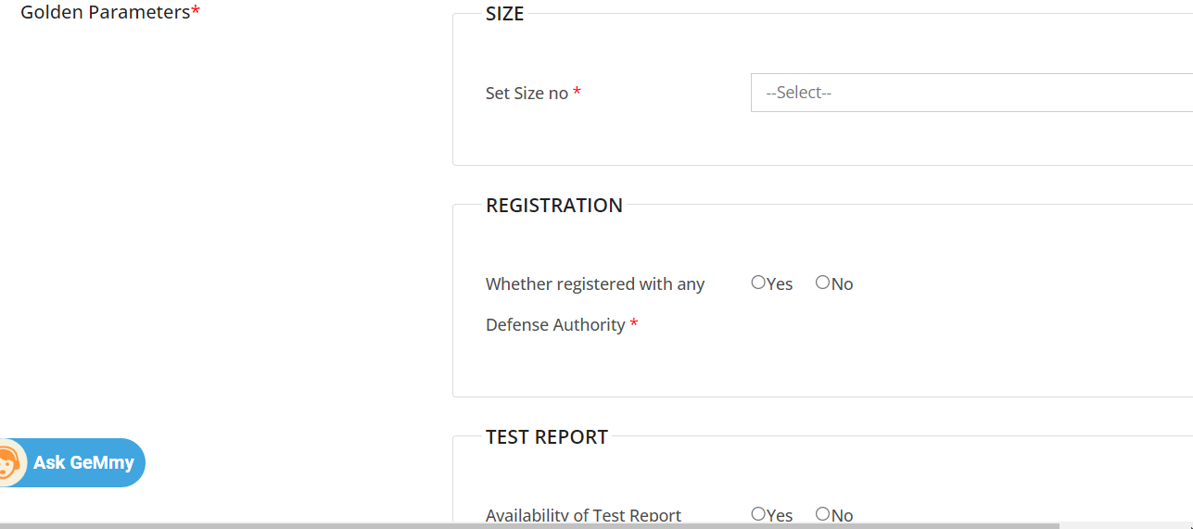
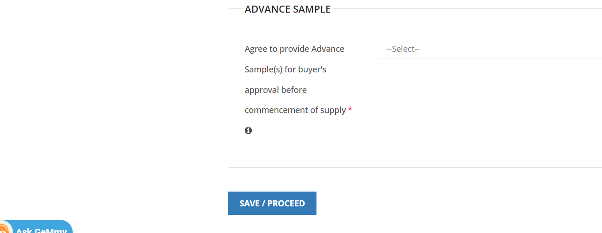

THE OTHER THINGS WE HAVE TO FILL TO COMPLETE A CATALOUGE ARE
PRICE AND QUANTITY
PRODUCT SPECIFICATIONS
UPLOAD THE IMAGES OF THE PRODUCT

AFTER COMPLETION OF THE CATALOUGE, WE ARE READY TO PARTICIPATE IN BIDS.
Opportunity for businessmen

Gem has come out a great opportunity for all sorts of businessmen whether it be small or medium or even the big business houses. The small and medium enterprises can expand their area of work by expanding the boundaries of their local areas to supplying to departments like railway, defense, atomic, education, maharatna, navratna, and what not.

Without this online or digital transparency, the small and medium enterprises cannot think of reaching these departments because of bureaucracy and other security reasons.

So, the country businessmen should come up with their goods and services and enhance the potential and explore themselves to new avenues. I feel it is the vision of a person and potential to explore the opportunities which can make him big. Search for the opportunities and grab them. Open up new businesses and take the government initiative’s advantage like subsidies, make in India/startup, reduce import and promote export of Indian goods and services.

Opportunity for chartered accountants

Gem has turned out as a tremendous opportunity for practicing chartered accountants.

Practicing chartered accountants have limited themselves into traditional practicing areas like audit and taxation, bank finance etc.
Gem is a new avenue for a practicing-chartered accountants to enhance the knowledge of their clients when it comes to technical requirements and financial requirements to be fulfilled by the client.

- Signing and certifying MSME certificates
- Providing audit reports
- Filing returns
- Complying with the documents required
- Participating in the tender
- Registering on gem
- Complying with the deficiency part of technical disqualification

Again, I believe, limiting yourself, would not make you big, search for opportunities around you and grab them. The client only knows how to do business, we are the one who can comply with the technical and legal compliances.

Moreover, if we grow ourselves by taking advantage of such platforms like gem, then only we will be able to make contribution to our growing digital economy.
Recent hosting of G20 by India has filled me with thrill, that this is our time, let’s do something big and align our vision with that of the economy – one earth- one family- one future.
The opportunity lies in making India a developed country from a developing only.
Imagine the avenues you can use to grow yourself and our country.

THANKS
HAPPY READING!!
The Author is a practicing chartered accountant and can be reached @ krtahlani@gmail.com , @9222228499.

