s Iz8
_{TAX CONNECT}

429th Issue: 19th November 2023-25th November 2023
12017

sssss

Knowledge Partner:



TAX CONNECT :

Mumbai : Unit No. 312, Omega Business Park, Near-Kaamgar Hospital, Road No. 33, Wagle Industrial Estate,
Thane (West), Maharashtra – 400604
Bengaluru : 951, 24th Main Road, J P Nagar, Bengaluru, Karnataka – 560078.
Delhi (NCR) : B-139, 2ndFloor, Transport Nagar, Noida-201301 (U.P)
Kolkata : 6, Netaji Subhas Road, 3rd Floor, Royal Exchange Building, Kolkata – 700001
- Room No. 119, 1stFloor, “Diamond Arcade” 1/72, Cal Jessore Road, Kolkata – 700055
- Tobacco House, 1, Old Court House St, Radha Bazar, Corner, Kolkata, West Bengal 700001
Dubai : Azizi Feirouz, 803, 8th Floor, AL Furjan, Opposite Discovery Pavillion, Dubai, UAE

Contact : +91 7003384915

Website : www.taxconnect.co.in
Email : info@taxconnect.co.in

Friends,
Consider a society or any other charitable institution or a mere association of persons formed for public welfare. Does the Income Tax Law debar it from getting registered until it is registered under another Law? This question of law was answered in favour of the dept. by The ITAT in the case of INCOME TAX APPELLATE TRIBUNAL BAR ASSOCIATION, SURAT Vs COMMISSIONER OF INCOME TAX, (EXEMPTION), AHMEDABAD [2023-VIL-1478-ITAT-SRT]. However, considering the vide ramifications of the case for Charitable Institutions, it seems that this matter will travel to higher forums. Understanding the case further in detail, Rule 17A(2)(c) of Income Tax Rules requires the assessee to furnish certified copy with registration of companies, or registration of farm or society or registrar of public trust, as the case may be for registration u/s 12A as a charitable institution and reads as under–

“(2) The application under sub-rule (1) shall be accompanied by the following documents, as required by Form Nos.10A or 10AB, as the case may be, namely:-

(c) self-certified copy of registration with Registrar of Companies or Registrar of Firms and Societies or Registrar of Public Trusts, as the case may be;”

The question is whether the registration in other law as per requirement in Rule 17A(2)(c) is mandatory to get a registration u/s 12A of The Income Tax Act as a charitable institution. What about a case when the Institution is not so registered as they are not otherwise required to be so registered under those laws. It does seem that the mandatory provision laid down under Rule 17A(2)(c), that institution should be registered with registrar of Companies or registration of firms or society or registrar of Public Trust, is defective as it bars an association from to get registered under Income Tax Act unless it is registered under another act. Can an assessee not get the benefit of exemption from Income Tax just because it is not registered under another law, whereas its object is the same as another such entity which may be registered? Can The Income Tax Act compel a person to avail registration under another law? These are questions of law which may be needed to be tested.

The Ld.DRs contention is that in case such entity is not registered under any other law, there will not be any legal obligation on the part of trust or institution to maintain any record of the activities; that there would be no control on the activities of such unregistered entities. However, it is a fact that the Income Tax Act itself requires that the same will be tested every five years while renewing the registration.

Hence it does seem that there is still some water to flow under the bridge unless the matter is set to rest.

Just to reiterate that we remain available over telecom or e-mail.

Editor:
Vivek Jalan
Partner - Tax Connect Advisory Services LLP

Co-Editor:
Rohit Sharma
Director – Tax Connect Advisory Services LLP

S.NO. | TOPICS | PAGE NO.
1] | TAX CALENDER | 4
2] | INCOME TAX | 5
CASE LAW | VALIDITY OF THE REASSESSMENT PROCEEDINGS - ASSESSMENT OF A SUM RECEIVABLE BY APPELLANT PURSUANT TO AN ARBITRATION AWARD AS IN THE NATURE OF INCOME : BOMBAY HIGH COURT
3] | GST | 6
ADVISORY | ITC REVERSAL ON ACCOUNT OF RULE 37(A)
ADVISORY | ADVISORY FOR ONLINE COMPLIANCE PERTAINING TO ITC MISMATCH -GST DRC-01C
4] | FEMA | 7
CASE LAW | VIOLATION OF PROVISIONS OF SECTION 10(6) OF THE FEMA ACT - RESPONSIBILITY OF AUTHORISED PERSON - GOODS HAD ARRIVED IN INDIA, BUT THE COMPANY FAILED TO SUBMIT BILL OF ENTRY AND DID NOT TAKE DELIVERY OF THE GOODS) : SUPREME COURT
5] | CUSTOMS | 8-12
NOTIFICATION | RATE OF EXCHANGE OF ONE UNIT OF FOREIGN CURRENCY EQUIVALENT TO INDIAN RUPEES
NOTIFICATION | RATE OF EXCHANGE OF ONE UNIT OF FOREIGN CURRENCY EQUIVALENT TO INDIAN RUPEES - SWEDISH KRONER
NOTIFICATION | FIXATION OF TARIFF VALUE OF EDIBLE OILS, BRASS SCRAP, ARECA NUT, GOLD AND SILVER
NOTIFICATION | SEEKS TO IMPOSE ANTI-DUMPING DUTY ON TOUGHENED GLASS FOR HOME APPLIANCES IMPORTED FROM CHINA PR FOR A PERIOD OF 5 YEARS
6] | DGFT | 13
NOTIFICATION | INCORPORATION OF POLICY CONDITION FOR EXPORT OF NON-BASMATI RICE UNDER HS CODE 10063090
TRADE NOTICE | NOTICE FOR CALCINED PETROLEUM COKE(CPC) MANUFACTURERS REGARDING IMPORT OF RAW PET COKE
7] | TAX PLEADING AND PRACTICE JOURNAL | 14
8] | GST PLEADING AND PRACTICE: WITH SECTION-WISE GST CASES & GST NOTICES AND THEIR REPLIES | 15
9] | HANDBOOK ON GST 2022 | 16
10] | HOW TO HANDLE GST LITIGATION: ASSESSMENT, SCRUTINY, AUDIT & APPEAL | 17
11] | LET’S DISCUSS FURTHER | 18

Due Date | Form/Return/Challan | Reporting Period | Description
20th November | GSTR-3B | October 2023 | GST Filing of returns by a registered person with aggregate turnover exceeding INR 5 Crores during the preceding financial year.
20th November | GSTR-5A | October 2023 | Summary of outward taxable supplies and tax payable by a person supplying OIDAR services.

CASE LAW
Validity of the reassessment proceedings - assessment of a sum receivable by appellant pursuant to an arbitration award as in the nature of income : BOMBAY HIGH COURT
OUR COMMENTS: It was held that bare perusal of the reasons shows that there was no mention as to whether and how the amount as per the arbitration Award was in the nature of income.
The information reveals that the said receipt was towards appellant’s retirement from the said Firm. Therefore, justification given by respondent no. 1 in the order for taxability of the said receipt as not relating to appellant’s retirement from the said Firm was contrary to the information/material available with him.
In the absence of any statement in the reasons recorded for reopening the assessment regarding taxability of the said receipt and in view of non-sustainability of the justification provided by respondent no. 1 in the order for the reassessment proceedings initiated u/s 148 of the Act, in our view, will be bad in law.
It is also well settled that for the purposes of adjudicating the validity of assumption of jurisdiction under Section 148 of the Act, one has to only look at the reasons recorded by the Assessing Officer before reopening the assessment. Such reason cannot be supplemented or improved subsequently. For Assessment Year 2008-2009 also appellant had received similar amounts from the said Firm. After scrutinising the character of such receipt, it was held by the predecessor of respondent no. 1 that the receipt was not taxable in nature. Therefore, the formation of the belief that the amount received for the current year was taxable, in our view, tantamounts to a change of opinion which is not permissible in law.
Having considered the consent terms with the arbitration award and the statement of claim, it is clear, the amount of Rs. 28 Crores was receivable by appellant in terms of the arbitration award dated 25th September 2009. As per the award, appellant has relinquished all her claims against the partnership firm . as well as the partners.
Real dispute between the parties related to the termination of appellant’s partnership interest in the said Firm. The consent terms were arrived at between the parties with a view to settle this dispute. It goes without saying that when appellant's rights and claims in the said Firm were settled by the consent terms and the arbitration award, there could not be her continuance as a partner with the said Firm. Therefore, the arbitration award was receivable by appellant in respect of her retirement from the said Firm.
The Tribunal has failed to appreciate that there was a dispute between appellant and her brothers with respect to her wrongful retirement from the said Firm. For invocation of arbitration proceedings the matter was carried right upto the Hon'ble Supreme Court. The settlement amount was receivable by appellant for relinquishment of her rights and claims as a partner of the said Firm. In these circumstances, though there may be no mention of her retirement from the said Firm in the consent terms or the arbitration award, the only inference possible would be that she no longer continued as a partner of the said Firm after such settlement. It is also not anybody’s case that appellant has not played any role in the said Firm or received any share from the said Firm after the settlement.
Even if we go alongwith the Tribunal that appellant had received the amount of Rs. 28 Crores under the arbitration award for transfer of a composite bundle of rights, it was not open to assess the entire amount of the award as income from other sources. The dominant component in the settlement was appellant’s separation from the said Firm. The Tribunal ought to have considered each component of the rights and claims which were relinquished and withdrawn by appellant and bifurcated the amount of arbitration award between each of such rights and claims. Instead of doing this exercise and considering whether the amount was capital or revenue in nature, the ITAT has simplicitor accepted the conclusion reached by the CIT (A) to the effect that such receipt is of an income nature chargeable to tax as income from other sources. The Tribunal has failed to consider this issue in a proper perspective.
The Tribunal interestingly holds that it is judicially settled that the amount should be considered as special income and it must be considered in its wider sense. The Tribunal failed to appreciate that a receipt on capital account cannot be assessed as income unless it was specifically brought within the scope of the definition of the term “income” in Section 2(24) of the Act as held by the Apex Court in CIT V/s. D. P. Sandhu Bros. The Tribunal erred in evolving a concept of “special income” when no such concept exists either in the Act or in the jurisprudence and saying that the same is judicially settled.
Thus we answer the substantial questions of law as framed in favour of appellant. The Tribunal ought to have held respondent no. 1 had assumed jurisdiction u/s 147 of the Act without fulfilling the jurisdictional pre-conditions and hence, the reassessment proceedings were without jurisdiction. Further, on the facts and in the circumstances of the case and in law, the Tribunal ought to have held that the amount Crores received by appellant as per the arbitration award was not chargeable to tax.

ADVISORY
ITC REVERSAL ON ACCOUNT OF RULE 37(A)
OUR COMMENTS: The GSTIN vide advisory dated 14-11-2023 advised that :
1. Vide Rule 37A of CGST Rules, 2017 the taxpayers have to reverse the Input Tax Credit (ITC) availed on such invoice or debit note, the details of which have been furnished by their supplier in their GSTR-1/IFF but the return in FORM GSTR-3B for the said period has not been furnished by their supplier till the 30th day of September following the end of financial year in which the Input Tax Credit in respect of such invoice or debit note had been availed.
2. The said amount of ITC is required to be reversed by such taxpayers, while furnishing a return in FORM GSTR-3B on or before the 30th day of November following the end of such financial year, as part of this legal obligation.
3. To facilitate the taxpayers, such amount of ITC required to be reversed on account of Rule 37A of CGST Rules for the financial year 2022-23 has been computed from system and has been communicated to the concerned recipient. The email communication to this effect has been sent on the registered email id of the taxpayer.
4. The taxpayers are advised to take note of it and to ensure that such ITC, if availed by them, is reversed as per rule 37A of CGST Rules before 30th of November, 2023 in Table 4(B)(2) of GSTR-3B while filing the concerned GSTR-3B.
[For further details please refer the advisory]

ADVISORY
ADVISORY FOR ONLINE COMPLIANCE PERTAINING TO ITC MISMATCH -GST DRC-01C
OUR COMMENTS: The GSTIN vide advisory dated 14-11-2023 advised that :
1. It is informed that GSTN has developed a functionality to generate automated intimation in Form GST DRC-01C which enables the taxpayer to explain the difference in Input tax credit available in GSTR-2B statement & ITC claimed in GSTR-3B return online as directed by the GST Council. This feature is now live on the GST portal.
2. This functionality compares the ITC declared in GSTR-3B/3BQ with the ITC available in GSTR-2B/2BQ for each return period. If the claimed ITC in GSTR 3B exceeds the available ITC in GSTR-2B by a predefined limit or the percentage difference exceeds the configurable threshold, taxpayer will receive an intimation in the form of DRC-01C.
3. Upon receiving an intimation, the taxpayer must file a response using Form DRC-01C Part B. The taxpayer has the option to either provide details of the payment made to settle the difference using Form DRC-03, or provide an explanation for the difference, or even choose a combination of both options.
4. In case, no response is filed by the impacted taxpayers in Form DRC-01C Part B, such taxpayers will not be able to file their subsequent period GSTR-1/IFF.
[For further details please refer the advisory]

CASE LAW
Violation of provisions of Section 10(6) of the FEMA Act - Responsibility of Authorised person - goods had arrived in India, but the Company failed to submit Bill of Entry and did not take delivery of the goods) : SUPREME COURT
OUR COMMENTS: It was held that in the present case, the finding of fact is that the import of goods for which the foreign exchange was procured and remitted was not completed as the Bill of Entry remained to be submitted and the goods were kept in the bonded warehouse and the Company took no steps to clear the same. As a result, Section 10(6) of the FEMA Act is clearly attracted being a case of not using the procured foreign exchange for completing the import procedure. It is also possible to take the view that the Company should have taken steps to surrender the foreign exchange to the authorised person within the specified time as provided in Regulation 6 of the Foreign Exchange Management (Realisation, Repatriation and Surrender of Foreign Exchange) Regulations, 2000 (for short, “the FEMA Regulations”) issued by the Reserve Bank of India
Contravention referred to in Section 10(6) of the FEMA Act is a continuing actionable offence. If so, the Company and the persons managing the affairs of the Company remain liable to take corrective measures in right earnest. Considering the admitted fact that the appellant took over the management of the Company on 22.10.2001 and was fully alive to the default committed by the Company, yet failed to take corrective steps in right earnest. Notably, being conscious of such contravention, the appellant had sought indulgence of the authorities for more time.
Appellant cannot now be heard to contend that no liability could be fastened on him individually. Indeed, regulation 6 of the FEMA Regulations provides for the period within which the foreign exchange ought to be surrendered if the Company was not wanting to take delivery of the goods imported. That, however, does not mean that the contravention ceased to exist beyond the specified period. On the other hand, after the specified period as predicated in regulation 6 had expired, it would be a case of deemed contravention until rectified.
It is not the case of the appellant that he is not an officer or a person in charge of and responsible to the Company for the conduct of the business of the Company, as well as, the Company on or after 22.10.2001. Considering the fact that the appellant admittedly became aware of the contravention yet failed to take corrective measures until the action to impose penalty for such contravention was initiated, he cannot be permitted to invoke the only defence available in terms of proviso to subSection (1) of Section 42 of the FEMA Act that the contravention took place without his knowledge or that he exercised all due diligence to prevent such contravention. In the reply filed to the show-cause notice by the appellant, no such specific plea has been taken.
We hold that no error has been committed by the adjudicating authority in finding that the appellant was also liable to be proceeded with for the contravention by the Company of which he became the Managing Director and for penalty therefor as prescribed for the contravention of Section 10(6) read with Sections 46 and 47 of the FEMA Act read with paragraphs A-10 and A-11 (Current Account Transaction) of the Foreign Exchange Manual 200304. The first appellate authority and the High Court justly affirmed the view so taken by the adjudicating authority.
NOTIFICATION
Rate of exchange of one unit of foreign currency equivalent to Indian rupees
OUR COMMENTS: The Ministry of Finance, Department of Revenue vide notification no 84/2023-Customs(N.T) dated 16.11.2023 notified that In exercise of the powers conferred by section 14 of the Customs Act, 1962 (52 of 1962), and in supersession of the Notification No. 81/2023-Customs(N.T.), dated 2nd November, 2023 except as respects things done or omitted to be done before such supersession, the Central Board of Indirect Taxes and Customs hereby determines that the rate of exchange of conversion of each of the foreign currencies specified in column (2) of each of Schedule I and Schedule II annexed hereto, into Indian currency or vice versa, shall, with effect from 17th November, 2023, be the rate mentioned against it in the corresponding entry in column (3) thereof, for the purpose of the said section, relating to imported and export goods.
SCHEDULE-I
Sl.  No. | Foreign Currency | Rate of exchange of one unit of foreign  currency equivalent to Indian rupees
(1) | (2) | (3)
 |  | (a) | (b)
 |  | (For Imported Goods) | (For Export Goods)
1. | Australian Dollar | 55.10 | 52.75
2. | Bahraini Dinar | 228.15 | 214.20
3. | Canadian Dollar | 61.75 | 59.70
4. | Chinese Yuan | 11.65 | 11.30
5. | Danish Kroner | 12.30 | 11.90
6. | EURO | 91.75 | 88.60
7. | Hong Kong Dollar | 10.85 | 10.50
8. | Kuwaiti Dinar | 278.20 | 261.60
9. | New Zealand Dollar | 51.15 | 48.85
10. | Norwegian Kroner | 7.80 | 7.55
11. | Pound Sterling | 104.80 | 101.40
12. | Qatari Riyal | 23.55 | 22.15
13. | Saudi Arabian Riyal | 22.90 | 21.50
14. | Singapore Dollar | 62.60 | 60.55
15. | South African Rand | 4.70 | 4.40
16. | Swedish Kroner | 8.00 | 7.75
17. | Swiss Franc | 95.50 | 91.85
18. | Turkish Lira | 3.00 | 2.80
19. | UAE Dirham | 23.35 | 22.00
20. | US Dollar | 84.10 | 82.35
SCHEDULE-II
Sl. No. | Foreign Currency | Rate of exchange of 100 units of foreign currency equivalent to Indian rupees
(1) | (2) | (3)
 |  | (a) | (b)
 |  | (For Imported Goods) | (For Export Goods)
1. | Japanese Yen | 55.90 | 54.15
2. | Korean Won | 6.60 | 6.20

[For further details please refer the notification]
NOTIFICATION
Rate of exchange of one unit of foreign currency equivalent to Indian rupees - Swedish Kroner
OUR COMMENTS: The Ministry of Finance, Department of Revenue vide notification no 83/2023-Customs(N.T) dated 15.11.2023 notified that In exercise of the powers conferred by section 14 of the Customs Act, 1962 (52 of 1962), the Central Board of Indirect Taxes and Customs hereby makes the following amendments in the Central Board of Indirect Taxes and Customs Notification No. 81/2023-CUSTOMS (N.T.), dated 2nd November, 2023 with effect from 16th November, 2023.
In the SCHEDULE-I of the said Notification, for serial No.16 and the entries relating thereto, the following shall be substituted, namely: -
SCHEDULE-I
Sl. No. | Foreign Currency | Rate of exchange of one unit of foreign currency equivalent to Indian rupees
(1) | (2) | (3)
 |  | (a) | (b)
 |  | (For Imported Goods) | (For Export Goods)
16. | Swedish Kroner | 7.95 | 7.70
[For further details please refer the notification]
NOTIFICATION
Fixation of Tariff Value of Edible Oils, Brass Scrap, Areca Nut, Gold and Silver
OUR COMMENTS: The Ministry of Finance, Department of Revenue vide notification no 82/2023-Customs(N.T) dated 15.11.2023 notified that In exercise of the powers conferred by sub-section (2) of section 14 of the Customs Act, 1962 (52 of 1962), the Central Board of Indirect Taxes & Customs, being satisfied that it is necessary and expedient to do so, hereby makes the following amendments in the notification of the Government of India in the Ministry of Finance (Department of Revenue), No. 36/2001-Customs (N.T.), dated the 3rd August, 2001, published in the Gazette of India, Extraordinary, Part-II, Section-3, Sub-section (ii), vide number S. O. 748 (E), dated the 3rd August, 2001, namely:-
In the said notification, for TABLE-1, TABLE-2, and TABLE-3 the following Tables shall be substituted, namely: -
“TABLE-1
Sl. No. | Chapter/ heading/sub-heading/tariff item | Description of goods | Tariff value  (US $Per Metric Tonne)
(1) | (2) | (3) | (4)
1 | 1511 10 00 | Crude Palm Oil | 849
2 | 1511 90 10 | RBD Palm Oil | 861
3 | 1511 90 90 | Others – Palm Oil | 855
4 | 1511 10 00 | Crude Palmolein | 865
5 | 1511 90 20 | RBD Palmolein | 868
6 | 1511 90 90 | Others – Palmolein | 867
7 | 1507 10 00 | Crude Soya bean Oil | 1001
8 | 7404 00 22 | Brass Scrap (all grades) | 4633
TABLE-2
Sl. No. | Chapter/ heading/ sub-heading/tariff item | Description of goods | Tariff value  (US $)
(1) | (2) | (3) | (4)
1. | 71 or 98 | Gold, in any form, in respect of which the benefit of entries at serial number 356 of the Notification No. 50/2017-Customs dated 30.06.2017 is availed | 634 per 10 grams
2. | 71 or 98 | Silver, in any form, in respect of which the benefit of entries at serial number 357 of the Notification No. 50/2017-Customs dated 30.06.2017 is availed | 723 per kilogram
3. | 71 | (i) Silver, in any form, other than medallions and silver coins having silver content not below 99.9% or semi-manufactured forms of silver falling under sub-heading 7106 92;  (ii) Medallions and silver coins having silver content not below 99.9% or semi-manufactured forms of silver falling under sub-heading 7106 92, other than imports of such goods through post, courier or baggage.  Explanation. - For the purposes of this entry, silver in any form shall not include foreign currency coins, jewellery made of silver or articles made of silver. | 723 per kilogram
4. | 71 | (i) Gold bars, other than tola bars, bearing manufacturer’s or refiner’s engraved serial number and weight expressed in metric units;  (ii) Gold coins having gold content not below 99.5% and gold findings, other than imports of such goods through post, courier or baggage.  Explanation. - For the purposes of this entry, “gold findings” means a small component such as hook, clasp, clamp, pin, catch, screw back used to hold the whole or a part of a piece of Jewellery in place. | 634 per 10 grams
TABLE-3
Sl. No. | Chapter/ heading/ sub-heading/tariff item | Description of goods | Tariff value  (US $ Per Metric Ton)
(1) | (2) | (3) | (4)
1 | 080280 | Areca nuts | 8068(i.e., no change)”
2. This notification shall come into force with effect from the 16th day of November, 2023.
[For further details please refer the notification]

NOTIFICATION
Seeks to impose anti-dumping duty on toughened glass for home appliances imported from China PR for a period of 5 years
OUR COMMENTS: The Ministry of Finance, Department of Revenue vide notification no 11/2023-Customs(ADD) dated 17.11.2023 notified that Whereas, in the matter of “Toughened Glass for Home Appliances having thickness between 1.8 MM to 8 MM and area of 0.4 SqM or less” (hereinafter referred to as the subject goods), falling under chapter 70 of the First Schedule of the Customs Tariff Act, 1975 (51 of 1975) (hereinafter referred to as the Customs Tariff Act), originating in, or exported from People’s Republic of China (hereinafter referred to as subject country) and imported into India, the designated authority in its final findings, vide notification F. No. 06/10/2022-DGTR, dated the 28th August, 2023, published in the Gazette of India, Extraordinary, Part I, Section 1, dated the 28th August, 2023, has come to the conclusion, inter alia, that-
i. the product under consideration has been exported to India at a price below the normal value, resulting in dumping;
ii. the imports from the subject country have increased in absolute as well as relative terms throughout the injury investigation period;
iii. the domestic industry has accordingly suffered material injury. The injury caused to the domestic industry is not on account of any other known factor,
and has recommended imposition of anti-dumping duty on imports of the subject goods, originating in, or exported from the subject country and imported into India, in order to remove injury to the domestic industry.
Now, therefore, in exercise of the powers conferred by sub-sections (1) and (5) of section 9A of the Customs Tariff Act 1975 (51 of 1975) read with rules 18 and 20 of the Customs Tariff (Identification, Assessment and Collection of Anti-dumping Duty on Dumped Articles and for Determination of Injury) Rules, 1995, the Central Government, after considering the aforesaid final findings of the designated authority, hereby imposes on the subject goods, the description of which is specified in column (3) of the Table below, falling under the tariff items of the First Schedule to the Customs Tariff Act as specified in the corresponding entry in column (2), originating in the countries as specified in the corresponding entry in column (4), exported from the countries as specified in the corresponding entry in column (5), produced by the producers as specified in the corresponding entry in column (6), which are imported into India, an anti-dumping duty at the rate equal to the amount as specified in the corresponding entry in column (7), in the currency as specified in the corresponding entry in column (9) and as per unit of measurement as specified in the corresponding entry in column (8) of the said Table, namely :-
Sl.No. | Tariff Item | Description | Country of origin | Country of export | Producer | Amount of duty | Unit | Currency
(1) | (2) | (3) | (4) | (5) | (6) | (7) | (8) | (9)
1 | 70071900,70072900, 70134900, 70139900, 70199000, 70200019  70200029, 70200090 | Toughened glass for home appliances* | China PR | Any country including China PR | Foshan Shunde Dehong Glass Industry Co., Ltd | NIL | MT | USD
2 | -do- | -do- | China PR | Any country including China PR | Zhongshan Huangpu Jinfulai Glass Craft Factory | NIL | MT | USD
3 | -do- | -do- | China PR | Any country including China PR | Chuzhou Xinjiang Glass Appliances Co. Ltd. | 144.3 | MT | USD
4 | -do- | -do- | China PR | Any country including China PR | Foshan Shunde Gaohua Glass Technology Co., Ltd. | NIL | MT | USD
5 | -do- | -do- | China PR | Any country including China PR | Zhangjiagang Weiyu Glassware Co., Ltd. | 41.8 | MT | USD
6 | -do- | -do- | China PR | Any country including China PR | SCHOTT Glass Technologies Suzhou) Co., Ltd. | NIL | MT | USD
7 | -do- | -do- | China PR | Any country including China PR | Benxi Chengxin Chengxin Electrical Co., Ltd. | 135.3 | MT | USD
8 | -do- | -do- | China PR | Any country including China PR | Lianyungang Chengxin Glass Products Co., Ltd | 135.3 | MT | USD
9 | -do- | -do- | China PR | Any country including China PR | Jiangsu Xiuqiang Glasswork Co., Ltd | NIL | MT | USD
10 | -do- | -do- | China PR | Any country including China PR | Jiangyin Suifeng Glass Co., Ltd | NIL | MT | USD
11 | -do- | -do- | China PR | Any country including China PR | Zhongshan Meiyi Appliance Co. Ltd | NIL | MT | USD
12 | -do- | -do- | China PR | Any country including China PR | Any other producer excluding producers mentioned in Sl. No. (1) to (11) above. | 243 | MT | USD
13 | -do- | -do- | Any country other than China PR | China PR | Any | 243 | MT | USD
* “Toughened glass for home appliances having thickness between 1.8 MM to 8 MM and area of 0.4 SqM or less” excluding:
a) Toughened glass used in glass lids of utensils
b) Toughened glass used in electronic switch and switch board panels
c) Curved coloured glass for washing machines
d) Toughened glass used in Double Glazed Unit (DGU)
e) Dome shaped toughened glass
f) Grooved Toughened glass
2. The anti-dumping duty imposed under this notification shall be levied for a period of five years (unless revoked, superseded or amended earlier) from the date of publication of this notification in the Official Gazette and shall be payable in Indian currency.
Explanation.-For the purposes of this notification, rate of exchange applicable for the purpose of calculation of such anti-dumping duty shall be the rate which is specified in the notification of the Government of India, in the Ministry of Finance (Department of Revenue), issued from time to time, in exercise of the powers conferred by section 14 of the Customs Act, 1962 (52 of 1962), and the relevant date for the determination of the rate of exchange shall be the date of presentation of the bill of entry under section 46 of the said Customs Act.
[For further details please refer the notification]

NOTIFICATION
Incorporation of Policy Condition for export of Non-basmati rice under HS Code 10063090
OUR COMMENTS: The Ministry of Commerce and Industry vide notification no. 43/2023 dated 11.11.2023 notified The Central Government, in exercise of powers conferred by Section 3 read with section 5 of the Foreign Trade (Development & Regulation) Act, 1992 (No. 22 of 1992), as amended, read with Para 1.02 and 2.01 of the Foreign Trade Policy, 2023, hereby incorporates the following Policy Condition for export of Non-basmati rice against ITC (HS) code 1006 30 90 of Chapter 10 of Schedule 2 of the ITC (HS) Export Policy, as under:
ITC HS Codes | Description | Export Policy | Policy condition
1006 30 90 | Non-basmati white rice (Semi-milled or wholly milled rice, whether or not polished or glazed: Other) | Prohibited | One time exemption from ‘Prohibition’ is granted to Patanjali Ayurved Limited for export of 20 MT of Non-basmati white rice (Semi-milled or wholly milled rice, whether or not polished or glazed: Other) as donation to Nepal for earthquake victims.
2. Effect of this Notification:
One time exemption from ‘Prohibition’ is granted to Patanjali Ayurved Limited for export of 20 MT of Non-basmati white rice (Semi-milled or wholly milled rice, whether or not polished or glazed: Other) under HS Code 1006 30 90 as donation to Nepal for earthquake victims.
[For further details please refer the notification]
TRADE NOTICE
Notice for Calcined Petroleum Coke(CPC) Manufacturers regarding import of Raw Pet Coke
OUR COMMENTS: The Ministry of Commerce and Industry vide trade notice no. 34/2023-24 dated 16.11.2023 notified Reference is drawn to the Hon’ble Supreme Court order dated 10.10.2023 in Writ Petition (Civil) No. 13029 of 1985 in the matter of "M.C. Mehta Vs. Union of India & Ors.", delegating certain matters related to import of 'Raw Petroleum Coke' to the Commission for Air Quality Management (CAQM), including the issue of allocation of 'Raw Petroleum Coke' to calciners. Accordingly, the Commission has constituted a Sub-Committee in the matter.
2. Calcined Petroleum Coke (CPC) Manufacturing industries, who wish for allocation of imported Raw Petroleum Coke (RPC), are accordingly directed to provide requisite details as per the Annexure enclosed in the notice.
3. CPC manufacturing industries may submit details through email at caqm-ncr@gov.in with a copy to import-dgft@gov.in, latest by 20.11.2023. It is pertinent to note that in cases where, any CPC manufacturing industry / unit does not provide the requisite details within stipulated time, it shall be presumed that the unit has nothing to state to the Sub-Committee constituted by CAQM.
This is issued with the approval of Competent Authority.
[For further details please refer the trade notice]

:IN STANDS

TAX PLEADING AND PRACTICE JOURNAL
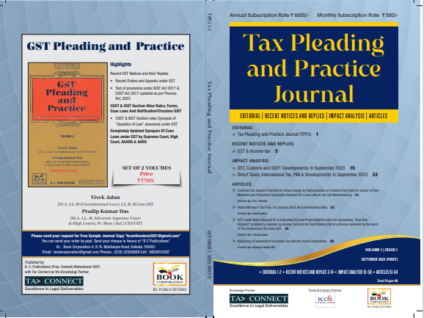

CONTENTS
- Recent Notices and replies on GST & Income Tax
- Impact Analysis on GST, Customs and DGFT Developments: In September 2023
- Impact Analysis on Direct Taxes, International Tax, PMLA Developments: In September 2023
- Articles

Author:
Vivek Jalan
[FCA, LL.M (Constitutional Law), LL.B, B.Com(H)]

S.K. Panda
[IRS-Retd.; Ex-Member CBIC & Special Secretary – GoI]

P.K. Das
[IRS-Retd.; Ex-Member CBDT & Special Secretary – GoI]

Published by: In Association With:
BOOK CORPORATION TAX CONNECT ACADEMY
4, R. N. Mukherjee Road 6, Netaji Subhas Road,
Kolkata 700001 Kolkata 700001
Phones: (033) 64547999 Cell: 7003384915 Cell: 9830010297, 9331018333 Order by email: info@taxconnect.co.in
Order by email:bookcorporation@gmail.com Website : www.taxconnect.co.in
Website :www.bookcorporation.com

:IN STANDS

GST PLEADING AND PRACTICE: With Section-wise GST Cases & GST Notices and their Replies
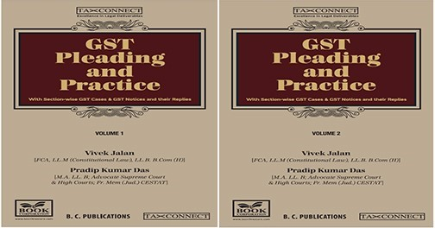

ABOUT THE BOOK: This publication includes:
- Recent GST Notices and their Replies
• Recent Orders and Appeals under GST
• Text of provisions under IGST Act 2017 & CGST Act 2017 updated as per Finance Act, 2023

- CGST & IGST Section-Wise Rules, Forms, Case Laws And Notification/Circulars GIST
• CGST & IGST Section-wise Synopsis of “Question of Law” answered under GST

- Completely Updated Synopsis Of Case Laws under GST by Supreme Court, High Court, AAARS & AARS

Authors:
Vivek Jalan
[FCA, LL.M (Constitutional Law), LL. B, B. Com(H)]

Pradip Kumar Das
[M.A. LL. B; Advocate Supreme Court & High Courts; Fr. Mem (Jud.) CESTAT]

Published by: In Association With:
BOOK CORPORATION TAX CONNECT ACADEMY
4, R. N. Mukherjee Road 6, Netaji Subhas Road,
Kolkata 700001 Kolkata 700001
Phones: (033) 64547999 Cell: 7003384915 Cell: 9830010297, 9331018333 Order by email: info@taxconnect.co.in
Order by email:bookcorporation@gmail.com Website : www.taxconnect.co.in
Website :www.bookcorporation.com
:IN STANDS

HANDBOOK ON GST 2022
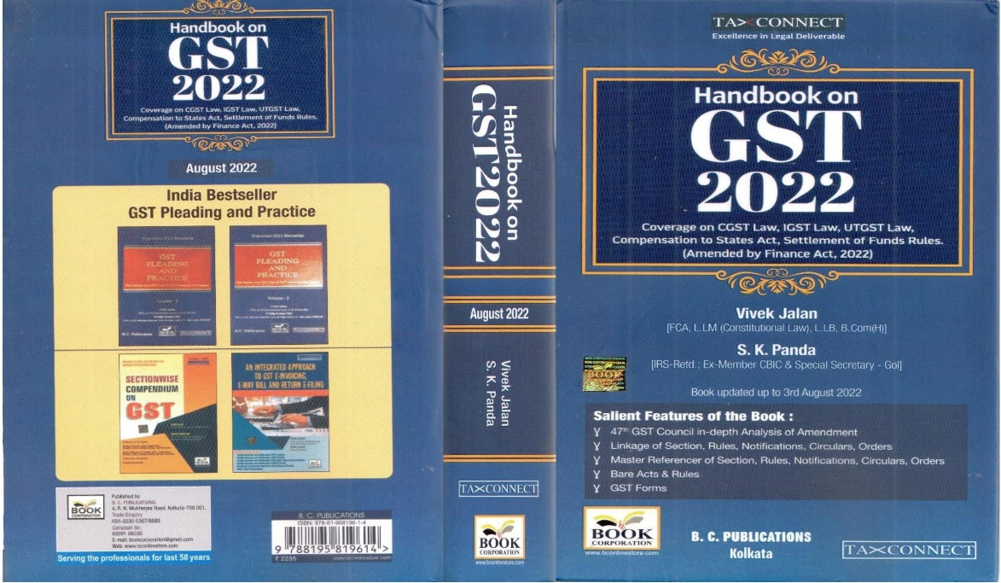

CONTENTS
- 47th GST Council in-depth Analysis of Amendment
- Linkage of Section, Rules, Notifications, Circulars, Orders
- Master Reference of Section, Rules, Notifications, Circulars, Orders
- Bare Acts & Rules
- GST Forms
Author:
Vivek Jalan
[FCA, LL.M (Constitutional Law), LL.B, B.Com(H)]

S.K. Panda
[IRS-Retd.; Ex-Member CBIC & Special Secretary – GoI]

Published by: In Association With:
BOOK CORPORATION TAX CONNECT ACADEMY
4, R. N. Mukherjee Road 6, Netaji Subhas Road,
Kolkata 700001 Kolkata 700001
Phones: (033) 64547999 Cell: 7003384915 Cell: 9830010297, 9331018333 Order by email: info@taxconnect.co.in
Order by email:bookcorporation@gmail.com Website : www.taxconnect.co.in
Website :www.bookcorporation.com

:IN STANDS

How to Handle GST LITIGATION: Assessment, Scrutiny, Audit & Appeal
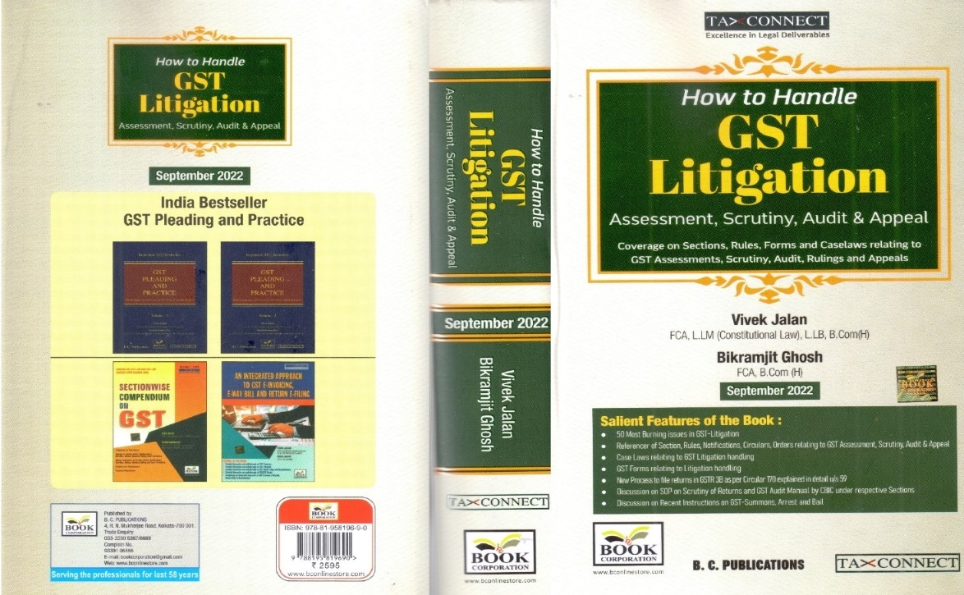

CONTENTS
1. 50 Most Burning issues in GST-Litigation
2. Reference of Section, Rules, Notifications, Circulars, Orders relating to GST Assessment, Scrutiny, Audit & Appeal
3. Case Laws relating to GST Litigation handling
4. GST Forms relating to Litigation handling
5. New process to file returns in GSTR 3B as per circular 170 explained in details u/s 59
6. Discussion on SOP on Scrutiny of Returns and GST Audit Manual by CBIC under respective Sections
7. Discussion on Recent Instruction on GST-Summons, Arrest and Bail

Authors:
Vivek Jalan
[FCA, LL.M (Constitutional Law), LL. B, B. Com(H)]

Bikramjit Ghosh
[FCA, B. Com(H)]

Published by: In Association With:
BOOK CORPORATION TAX CONNECT ACADEMY
4, R. N. Mukherjee Road 6, Netaji Subhas Road,
Kolkata 700001 Kolkata 700001
Phones: (033) 64547999 Cell: 7003384915 Cell: 9830010297, 9331018333 Order by email: info@taxconnect.co.in
Order by email:bookcorporation@gmail.com Website : www.taxconnect.co.in
Website :www.bookcorporation.com

LET’S DISCUSS FURTHER!



OUR OFFICES:
MUMBAI
Unit No. 312, Omega Business Park, Near Kaamgar Hospital, Road No. 33, Wagle Industrial Estate, Thane West,
Maharashtra- 400604

Contact Person: Priyanka Vishwakarma
Email:priyanka.vishwakarma@taxconnect.co.in
BENGALURU
951, 24th Main Road, J P Nagar, Bengaluru, Karnataka – 560078.

Contact Person: Anil Pal

Email:anil.pal@taxconnectdelhi.co.in

DELHI (NCR)
B-139, 2nd Floor, Transport Nagar,
Noida-201301 (U.P)

Contact Person: Poonam Khemka

Email:poonam.khemka@taxconnect.co.in



DUBAI
Azizi Feirouz, 803, 8th Floor, AL Furjan, Opposite Discovery Pavillion,
Dubai, UAE

Contact Person: Rohit Sharma

Email:rohit.sharma@taxconnect.co.in

KOLKATA
R No 119; 1st Floor; Diamond Arcade; 1/72, Cal Jessore Road,
Kolkata – 700055

Contact Person: Uttam Kumar Singh

Email:uttam.singh@taxconnect.co.in
KOLKATA
6, Netaji Subhas Road, 3rd Floor, Royal Exchange Building,
Kolkata - 700001

Contact Person: Tithly Roy

Email:tithly.roy@taxconnect.co.in

Disclaimer:
This e-bulletin is for private circulation only. Views expressed herein are of the editorial team and are based on the information, explanation and documents available on Government portal platforms. Tax Connect or any of its employees do not accept any liability whatsoever direct or indirect that may arise from the use of the information contained herein. No matter contained herein may be reproduced without prior consent of Tax Connect. While this e-article has been prepared on the basis of published/other publicly available information considered reliable, we do not accept any liability for the accuracy of its contents.
Tax Connect 2022. All rights reserved.

