Growth of Retailing beyond the Boundaries
CA & CMA K Ranganatha Achar

In the Year 2015, during the hot month of August, I was on our company-related work trip to a small town in Jordan known as Aqaba, and in the supermarkets, I found the products of Dabur India Limited & Godrej Consumer Products Limited (GCPL) occupying the shelves of the Supermarket and I felt really proud about our country and its products being sold beyond the boundaries of India, normally FMCG companies have an All India presence and they go to newer markets to expand their presence and turnover for consisting growth and profits. Let us quickly analyze some of the very big names in the FMCG sector in India which are as follows

List of Top 10 FMCG Companies in India
- Hindustan Unilever Ltd. ...
- ITC Ltd. ...
- Nestle India Ltd. ...
- Britannia Industries Ltd. ...
- Godrej Consumer Products Ltd. ...
- Patanjali Ayurveda Limited. ...
- Dabur India Ltd. ...
- Marico Ltd.

For our research purposes let us take the example of GCPL as to how it has expanded its footprint from India to the rest of the world

Godrej Consumer Products Ltd

ABOUT GODREJ CONSUMER PRODUCTS
Godrej Consumer Products is a leading emerging markets company. As part of the 125-year young Godrej Group, fortunate to have a proud legacy built on the strong values of trust, integrity, and respect for others. At the same time, they are also growing fast and have exciting ambitious aspirations. Today, the Group enjoys the patronage of 1.20 billion consumers globally, across different businesses ranked among the largest Household Insecticide and Hair Care players in emerging markets. In Household Insecticides, they are the leader in India, the second largest player in Indonesia, and are expanding its footprint in Africa. They are also the leader in serving the Hair Care needs of women of African descent, the number one player in Hair Colour in India and Sub-Saharan Africa, and among the leading players in Latin America. They rank number two in Soaps in India and are the number one player in Air Fresheners and Wet Tissues in Indonesia, it is very important that besides their strong financial performance and innovative, much-loved products, they remain a good company. Approximately 23 percent of the promoter holding in the Group is held in trusts that invest in the environment, health, and education. They are also bringing together the passion and purpose to make a difference through the 'Good & Green' approach to create a more inclusive and greener India. At the heart of all of this, is their talented team. They take much pride in fostering an inspiring workplace, with an agile and high-performance culture. They are also deeply committed to recognizing and valuing diversity across teams. Let us see the Important Numbers in Brief which are as below.

USD 1.6 Bn

Revenues (FY22) (Rs 12,738 Crores )

USD 10.1 Bn

Market cap (FY22)

90+

Presence in Countries

1.2 Bn

In line with the 3 by 3 approach to international expansion at Godrej Consumer Products, building a presence in three emerging markets (Asia, Africa, and Latin America) across three categories (Home care, Personal care, and Haircare). The Company is Among the Top FMCG Companies in India and Ranked among the largest household insecticide and hair care players in emerging markets. In household insecticides, the leader in India and Indonesia is expanding its footprint in Africa. Ranked number two in soaps in India, the number one player in air fresheners in India and Indonesia, and a leader in wet tissues in Indonesia.

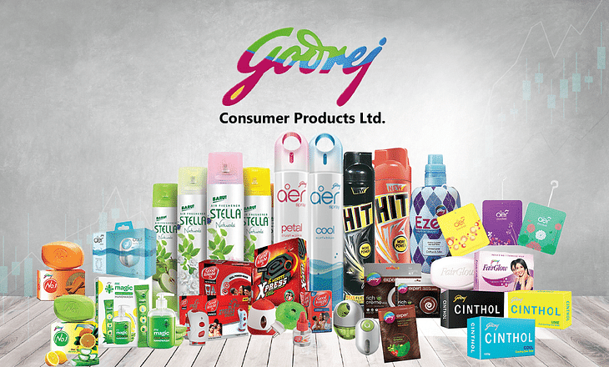

The product mix of GCPL can be broadly classified into Homecare, Personal care, Hair care & Beauty Care which has been illustrated in the following chart.

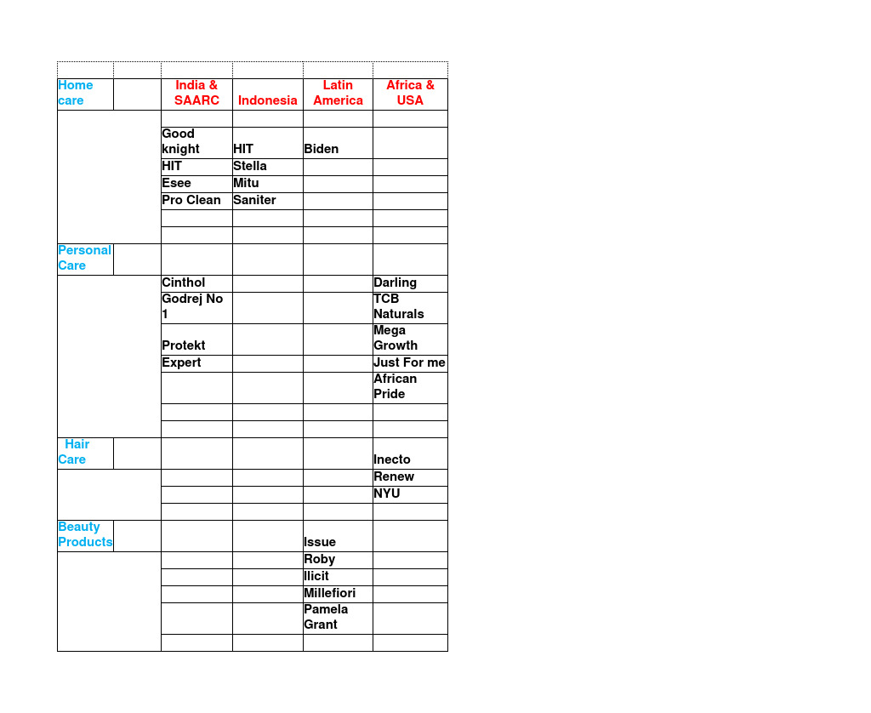

Products offered by Godrej Consumer Products Limited:

GCPL provides products in various product lines which are as follows:

- Soap
- Toiletries
- Hair Colourants
- Liquid Detergents
- Premium Beauty Products

Strengths of Godrej Consumer Products Limited

Strengths are things an organization excels at, which provide it with an advantage over those of its competitors.

- Strong Brand Portfolio– Godrej Consumer Products Limited Company is the topmost leading company with a broad company portfolio in the FMCG industry, there is a clear distinction between the products offered in India & SAARC Countries, Indonesia, Latin America, Sub Saharan Africa, USA, So the product portfolio is tuned in to the needs of the Particular Market in to which they penetrate and they are not the same differing from country to country as we saw in the Chart Mentioned above.

- Loyal Customer Base– Godrej Consumer Products has a strong market position in the market with the products like soaps, hair colour, and hand sanitizers as well. There are more than 100 customer-trusted products in the market. The Godrej Company can make an immediate presence in customers. as they have their customer presence in 60 countries which have been established over a period of time.

- Innovation– The GCPL is a very innovative company and always search for a broad portfolio by spreading globally, with revenue nearing almost $1.6 Billion

- Strong Reach– The Godrej consumer products limited company has a big geographical reach all over the world and has a quality consumer base, and conserves and maintains a strong brand identity in every place.

Opportunities of Godrej Consumer Products Limited

Opportunities are external factors that can contribute to the growth of an organization if worked upon at the right time.

- Multi-dimensional – The Godrej Consumer Products Limited company is a multidimensional company as they have a presence in over 60 countries. They have inorganic expansion.
- Technology– The ruler market is expanding fast because of technology; the Godrej Consumer Products company can maintain and supply the products to the consumer; it gets capitalized hence the company can improve its bottom line on marketing.
- Increasing Demand– As the lifestyle of the people increases, there would be a change in demand for the products, hence the increase in the demand for the product is the increase in purchasing power of the consumer and there is a huge price differentiation in whatever product category they are in to, in India take for example the soaps category you have Godrej No 1 which is considered as a mass product but Cinthol is considered a Premium Product, so you have the soaps in both economic and premium category which is normally followed by all FMCG’s across all product categories.

- Expansion Opportunity – Godrej consumer company business has the window of opportunity of expanding demand by entering into various Countries and what I have noticed is that A Cinthol Soap in UAE is available at a much Cheaper Rate than it is available in India if you make An apple to apple comparison because the taxes on inputs are far less in UAE as compared to India and Cinthol Soap was an all-time favorite Soap for me since my childhood days when the dashing star Vinod Khanna was its model and this soap has a unique fragrance to it. A Cinthol Lime soap costs 38 Paise vs 33 Paise / Per gram vis a vis India and UAE market as of date.
- 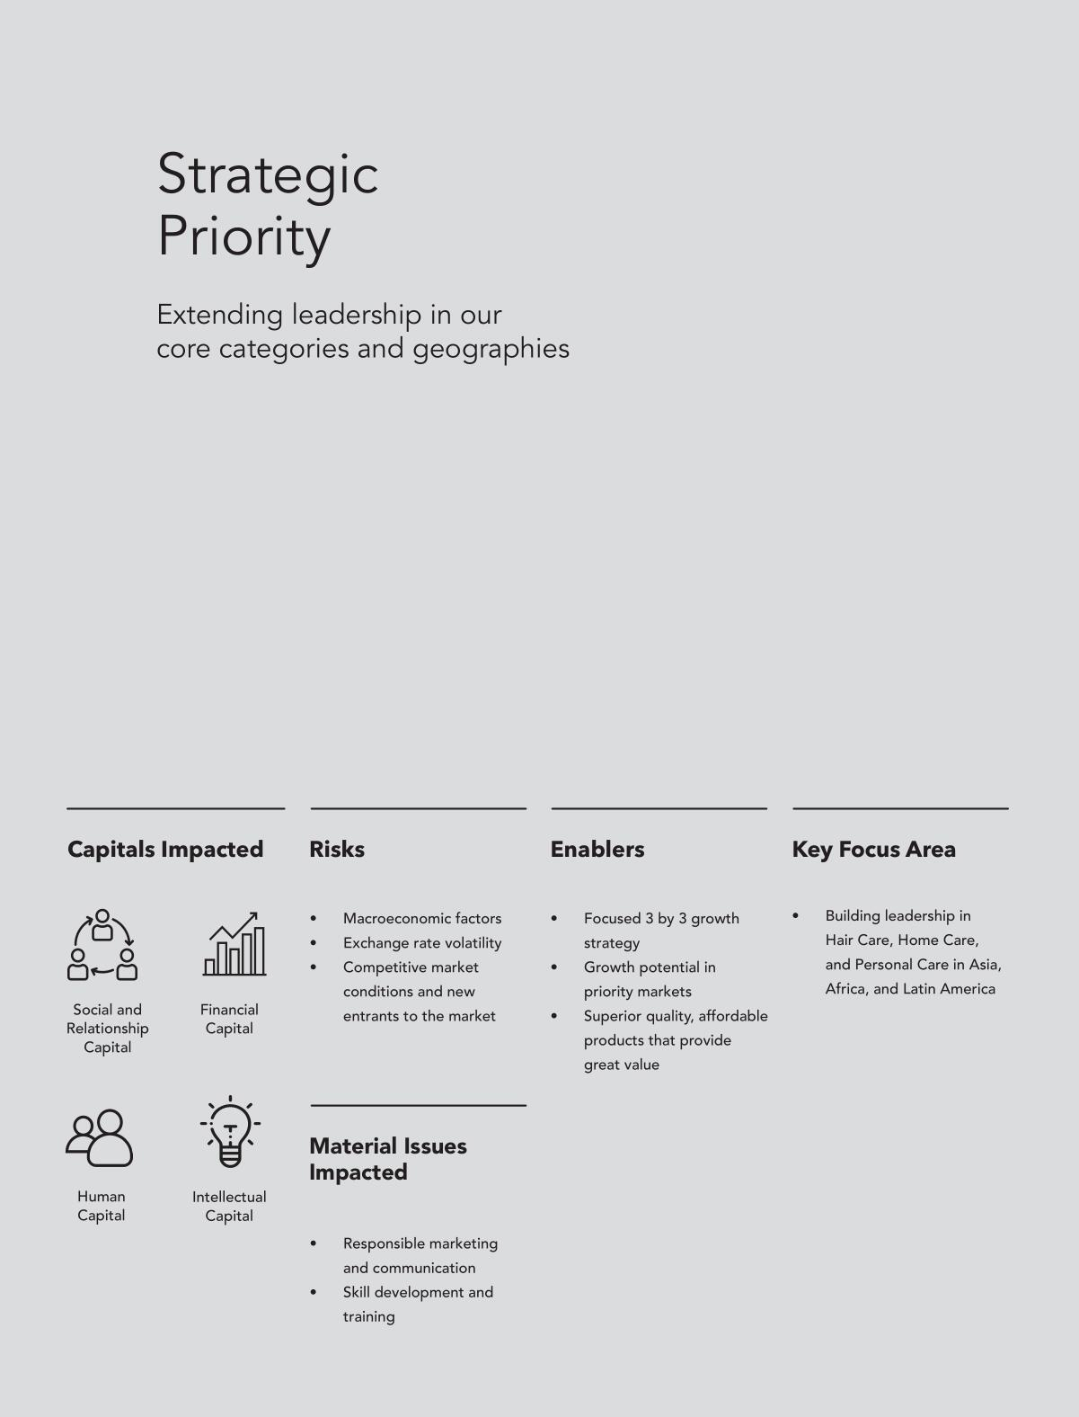

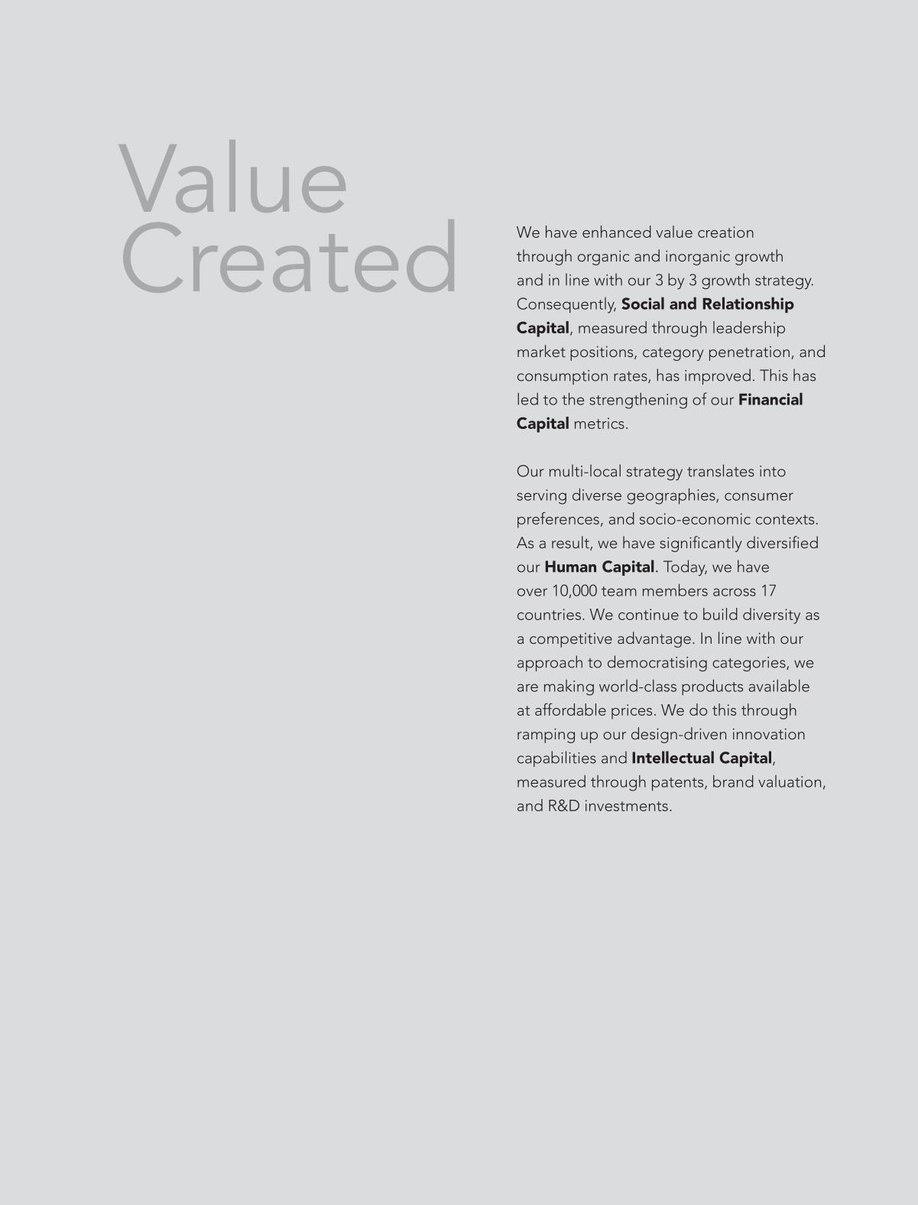

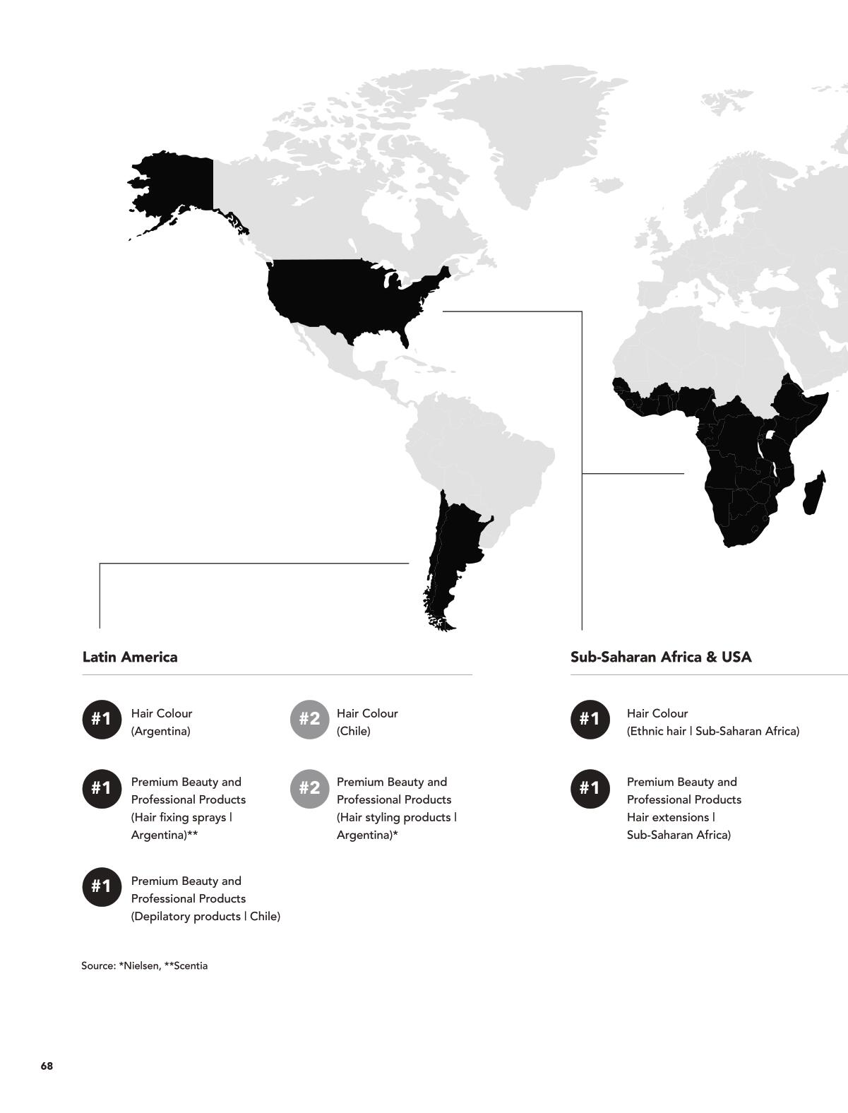

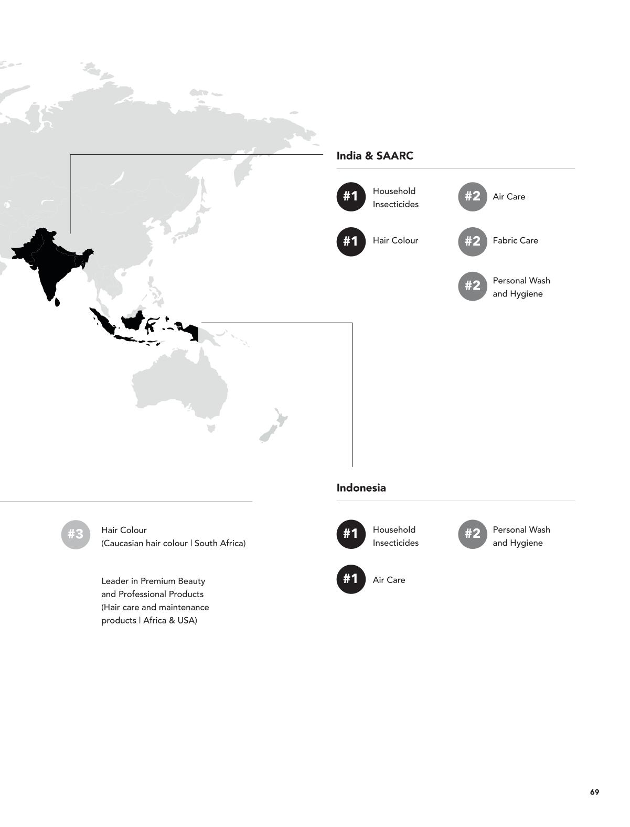
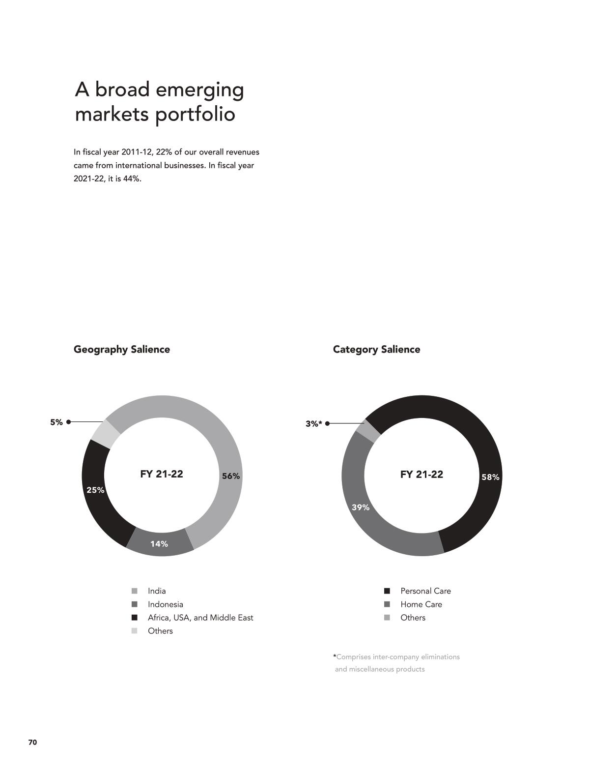

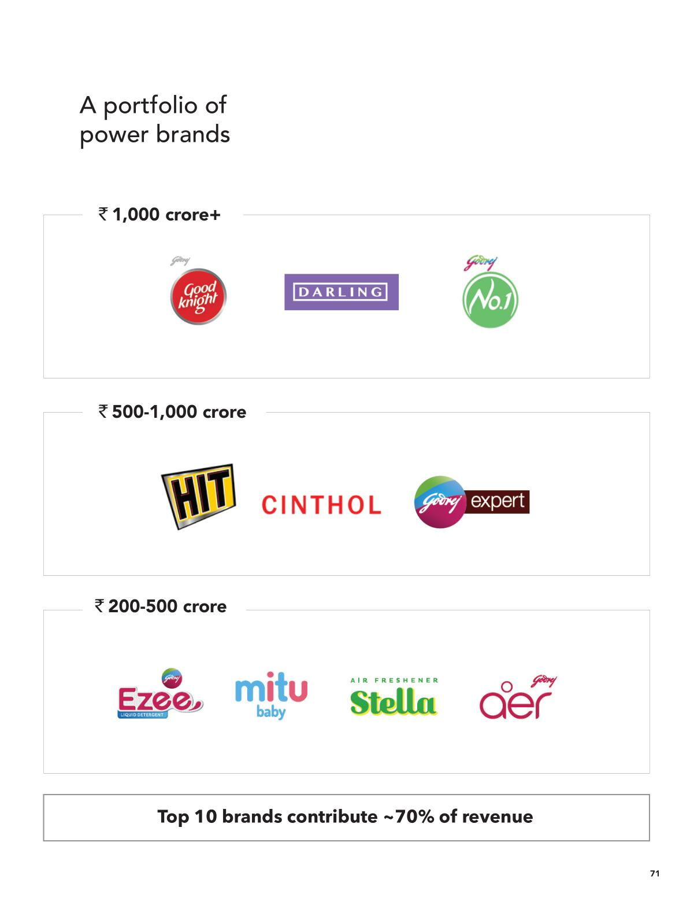

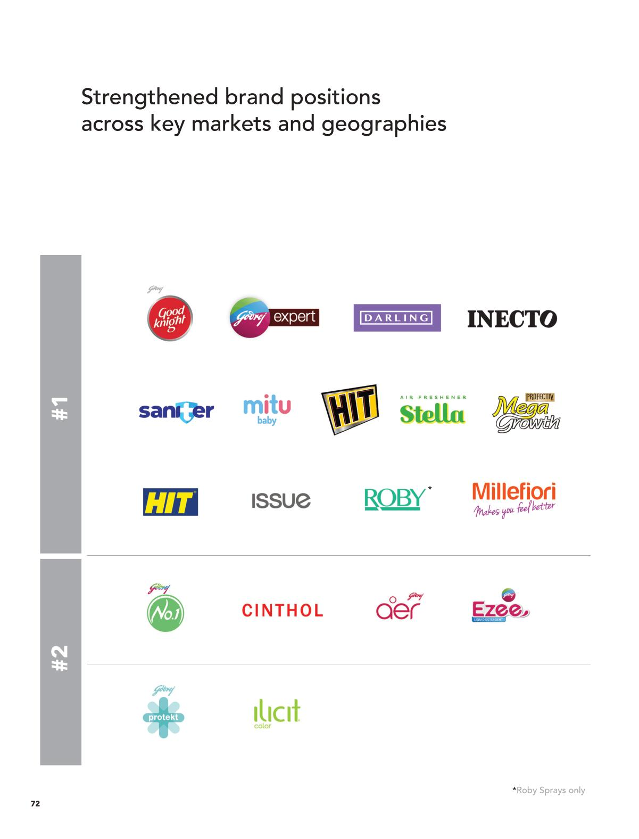

What the Top Management has to say about GCPL and the road ahead, Let us find out directly from the CEO who spoke after presenting the 1 st quarter results of this FY 2022-2023

Commenting on the business performance of 1Q FY 2022-2023, Mr. Sudhir Sitapati, Managing Director and CEO, GCPL, said: We delivered a steady performance in 1Q FY 2022. Overall sales grew by 8% with a 3-year CAGR in double digits. However, this growth was driven by pricing. We continue to believe that with the relatively non-discretionary, mass pricing of our portfolio and very good performance on market shares, volume growth will return in the medium term. Our overall EBITDA declined by 13% (without one-offs) driven by unprecedented global commodity inflation, upfront marketing investments, and a weak performance in our Indonesia and Latin America & SAARC businesses. PAT without exceptional items and one-offs declined by 16%. From a geography perspective, India grew steadily at 12%. Our Africa, USA, and Middle East businesses continued their robust growth trajectory, growing at 12% in INR and in constant currency terms. Performance in our Indonesian business was weak, declining by 9% in INR and 12% in constant currency terms. From a category perspective, in India, we saw continued momentum in Personal Care, which grew by 25%. Home Care delivered a soft performance and declined by 4%. With inflationary pressures abating, we expect a recovery in consumption and gross margins alongside continued higher marketing investments with a significant focus on reducing controllable costs. We continue to have a healthy balance sheet and our net debt to equity ratio continues to drop. We are on a journey to reduce inventory and wasted costs and are deploying this to drive profitable and sustainable volume growth across our portfolio through category development. We remain committed to our purpose of bringing the goodness of health and beauty to consumers in emerging markets.

Category Review
Home Care declined by 4% with a 2-year CAGR of 8%. While we delivered a soft performance in Household Insecticides, on the back of a high base and relatively muted season, we continued to deepen penetration and gain market share on a MAT basis. We are seeding in category development initiatives to drive sustainable growth. We launched a new campaign for good knight liquid vaporizer #NeendoKoNazarNaLage and for HIT. Our non-mosquito portfolio continues to deliver strong growth momentum. Air Fresheners witnessed a strong performance, led by an uptick in the category, and we continue to gain market share on a MAT basis. Our category development initiative around driving relevance for Aer Power Pocket and premiumization through Aer Matic (‘If bathrooms/rooms could talk’) is receiving encouraging consumer responses.
Personal Care: Personal Care grew by 25% with a 2-year CAGR of 21%. Personal Wash & Hygiene maintained its growth momentum, delivering double-digit sales growth and a 2-year CAGR in double digits. We continue to gain market share on a MAT basis and deepen penetration led by category development initiatives. We are strengthening our value-for-money and green proposition with the launch of the affordable and sustainable ready-to-mix Magic Bodywash priced at INR 45.
Hair Color witnessed strong growth driven by category uptick with a 2-year CAGR in double digits. Godrej Expert Rich Crème continues to perform well and gain market share, backed by strong marketing campaigns. Furthermore, the initial response to Godrej Expert Rich Crème at INR 15 is encouraging.
Some of our short-term challenges such as continued unprecedented global commodity inflation and the performance of our Indonesia business, as highlighted in the previous quarter, continued to play out in this quarter as well, impacting consumption and margins. The Indian FMCG industry continued to remain soft during the quarter. It continued to be hit hard by inflation levels aggravating due to geopolitical tensions, leading to successive price increases and impacting volumes. Rural markets witnessed slower growth compared to urban. However, the recent correction in commodity prices and the forecast of a good monsoon are encouraging. We remain competitive given the relatively non-discretionary mass pricing of our portfolio. In India, we expect to deliver early double-digit sales growth on a high base. Our 3-year CAGR remains robust and in the early double-digits. We would have mid-single digit volumes drop on a high base, with a 3-year volume CAGR close to mid-single digits. We witnessed a mixed performance in our Personal Care and Home Care categories. Personal Care sustained its strong double-digit growth trajectory with a 2-year CAGR also in double-digits, led by both Personal Wash and Hair Colours. Home Care witnessed a low single-digit sales drop on a high base. However, the 2-year CAGR remained at a high single-digit figure. In Indonesia, with Hygiene performance waning after COVID-19 and a large Hygiene comparator in base, we expect a high single-digit sales decline. The sales performance excluding Hygiene was largely flat. While reported sales were weak, we continued to reduce stocks with channel partners, resulting in positive sales growth on sell-outs excluding Hygiene during the quarter. We are putting building blocks in place to drive category development and general trade distribution to ensure gradual recovery in the medium term. In Godrej Africa, the USA, and the Middle East, we continued our growth momentum across most of our key countries of operations. We expect to deliver double-digit sales growth, with a continued focus on driving sustainable, profitable sales growth.

Conclusion:
I do remember the words of one of my ex-colleague Projects manager Engineer Rami Hamad who was telling me that his mother used to apply Dabur amla hair when they were in Lebanon during his childhood days and this Amla Oil was coming from Dabur Egypt Factory, so the reach of Indian FMCG has grown beyond the boundaries of the Indian subcontinent and if a product is made with an honest attitude they can reach the world market as the perception of India and its product outside India is very good, they refer to us Al-Hind in the Middle East and there is an air of happiness and aura when they see and address us and we should try to capture the enormous goodwill we have which we earned by the constant and long history of harmonious trading outside the shores of India. I see a bright future for homegrown FMCG outside India and believe in the slogan Atmanirbhar Bharath & Make in India moving beyond India.

