In Finance bond is an instrument of ineptness of the bond issuer to the holder. The Bond is a debt security, under which the issuer owns the holder a debt and (depending on the terms of the bond)is obliged to pay them interest (the coupon) or to repay the principal at a later date, terms the maturity date. Interest is usually payable at fixed intervals (semiannually, annual, and sometimes monthly). Very often the bond is negotiable, that is the ownership of the instruments can be transferred in the Secondary market.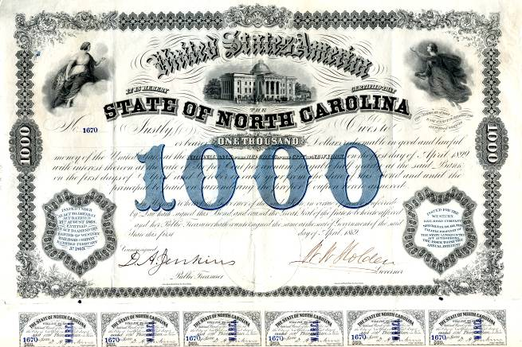
FINANCIAL INSTRUMENTS-BONDS
FEATURES:
- Principal: Nominal, Principal, Par, or Face amount is the amount on which the issuers pay interest, and which most commonly has to be repaid at the end of the term.
- Maturity: The issuer has to repay the nominal amount on the maturity date. As long as all date payments have been made, the issuer has no further obligation to the bond holder after the maturity date. There are the categories of bond maturities:-

- Short term (Bills):- Maturity between zero and one year.
- Medium term (Notes):- Maturity between one and ten years.
- Long term (Bonds):-Maturity between ten and thirty years.
- Perpetual: - Which has no maturity period.
- Coupon: The coupon is the interest rate that the issuers pay to the holder. Usually, the rate is fixed throughout the life of the bond. It can also vary with a money market Index, such as LIBOR or it can be even more exotic.
- Yield: The yield is rate of return received from investing in the bond. It’s usually refer either to :
- The current Yield or running yield which is simply the annual interest payment dividend by the current market of the bond.
- The Yield of Maturity or redemption yield, which is more useful, measures of the return of the bond. It is equivalent to the internal rate of return of a bond.
- Credit Equality: The quality of the issuers refers to the probability that the bond holders will receive the amounts promised at the due dates. In other words, credit quality tells investor how like the borrower is going to default.
- Market Price: The market Price of tradable bond will be influenced among other factors, by the amount and capital repayment due, the quality of the bond and the available redemption yield of the other comparable bonds which can be traded in the market.

TYPES OF BONDS:-
- There are many different types of bonds. They vary according to who issues them length, units, maturity, interest rate and risk.
- The safest are short term U.S. Treasury Bills, but they also pay at least interest.
- Long term Treasury like the benchmark 10 – year not offers slightly less risk and marginally higher yields.
- Municipal Bonds: are issued by the cities and localities. They return a little more than Treasure but are a bit riskier.
- Corporate Bonds: are issued by the companies. They have more risk than government bond because corporation can’t raise taxes to pay for the bonds. The risk and return depend on how credit-worthy the company is. The highest paying and highest risk ones are called Junk bonds.

HOW BONDS WORK:
The Borrowing organization promise to pay the bond back at an agreed – upon date. Until then, to the borrower makes agreed-upon interest payment to the shareholder. People who own bonds are also called creditors or debt holders. In the old days, when people kept paper bonds, they would redeem the interest payment by clipping coupon. Today, this is all done electronically.
Of course, the debtor repays the principal, called the face value, when the bond matures. Most bondholders resell them before maturity at the end of the loans period. They can only do this because there is a Secondary market for bonds. Bonds are either publically traded on exchange or sold privately between a broker and the creditor. Since they can be resold, the value of a bond rises and falls until its measure.
EXAMPLE:
Imagine the Reliance wanted to borrow $ billion from investor to acquire a large tea company in Asia. It believes that market will allow it to set the coupon rate at % p.a. for its desired maturity date, which is years in the future. It’s issued each bond at a par value of $1000 and promise to pay pro-rate interest semi-annually. Through an investment bank, it approaches investors who invest in the bonds. In this case company to sell 10 million bonds at $1000 each to raise it desired $10 billion before paying the fees it would incur.
Each $1000 bond is going to receive $25 per year in interest. Since the interest payment is semi-annually, it is going to arrive at $12.50 every six months. If all goes well at the end of 10 years the original $1000 will be returned on the maturity date and the bond will cease to exist.

