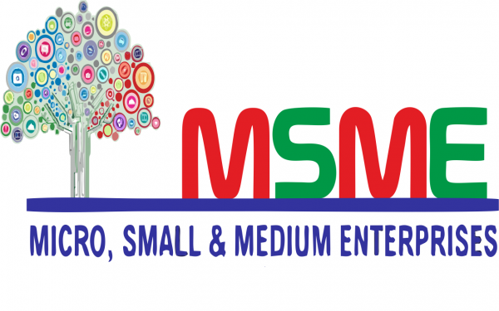

OPPORTUNITIES
OUT OF CRISIS

- The Prime Minister, has launched a historic support and outreach programme for the Micro, Small and Medium Enterprises (MSME) sector.

- MSMEs are one of the principal employment generators in India and the Prime Minister recalled the glorious Indian traditions of small scale industry.
- However, MSME Sector are facing some difficulties and need a booster to uplift the Indian economy.

What is MSME

The Micro, Small and Medium Enterprises Development (MSMED) Act, 2006 was enacted in year 2006 defining Micro, Small and Medium enterprises asenterprises engaged in the manufacture or production, processing or preservation of goods, providing or rendering of services as may be specified.

- The definition of MSME has been revised by the Government of India under the Scheme of Atma Nirbhar Bharat which is launched due the Covid-19 Pandemic.
A comparative definition is stated as below:

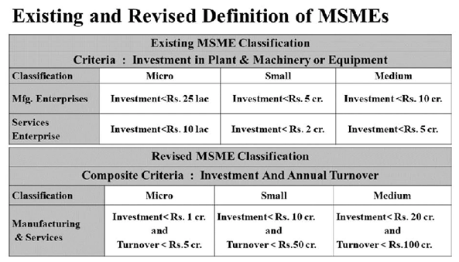
What are the benefits to MSME

Scenario before MSME Act:

Earlier when there was no such concept of MSMEs, basic business terms were same for all irrespective of size of business:

- Be it on aspects of taking loan from banks;
- Be it on aspect of Import/Export;
- Be it for filing of application for Trademark/Patent/ Copyright etc.;
- Be it tension of delay in payment or even their default etc.
- Less job Opportunities
- No reduction of interest in overdraft facilities
- No concession on electricity Bills
- No subsidy on patent registration and few trademark
- No reimbursement of ISO certification
- Credit for Minimum alternative tax (MAT) for 10 years
- No collateral free loans

Introduction of MSMEs:

When it was realized that small scale business were facing difficulties in doing their business, concept of MSMEs was introduced.

Today MSMEs gets immense benefits which helps to boost their business:

- Collateral free loans;
- Credit Guarantees;
- Easy recovery of money with a handsome interest;
- Incentives in exports etc;;
- Post Covid, e-linkage market is being provided to MSMEs.
- 1% interest reduction in overdraft loans and other loans.
- Concessions on electricity bills
- Subsidy on Patent, Trademark etc;
- ISO Certification Charges reimbursement;
- Allows Credit for Minimum Alternate Tax (MAT) to be carried forward upto 15 years instead of 10 years;
- Business registered under MSME are given higher preferencefor Govt. license and certification;
- Incentives for employment generation;
- Generator Subsidy;

Registration of an entity as MSME is not legally mandatory but highly recommended because it will reap several benefits from the government including credit at low interest rate, incentives on products for exports, excise exemption, statutory aid such as reservations and the interest on the delayed payments.

- Collateral free loans to be provided to MSMEs worth Rs 3 Lakh Crore. These have a 4-year tenor and no repayment for first 12 months.This scheme can be availed before October 31, 2020.

- Rs 20,000 crore subordinated debt for stressed MSMEs facing an equity problem. It will help functioning MSMEs which are either NPA (non performing assets) or are economically stressed. Around Rs 2 lakh MSMEs qualify under this category.

- Rs. 50,000 crore Equity infusion for MSMEs through Funds of Funds, it will help to expand size as well as capacity of MSME

- The government will provide Rs 4,000 crore partial credit guarantee support to banks

- Promoters of the MSMEs will be given debt by banks in the form of equity infusion

- Statutorily bind the Debtors to pay to the MSME supplier within the statutory due date (within 45 days of the acceptance of the goods/service rendered). Else, the law provide for penal interest in case debtor makes default in making payment to MSME (The buyer is liable to pay compound interest with the monthly rests to the MSME supplier on the amount at the three times of the bank rate notified by RBI)

- At the time of filing of application for Trademark or Patent, 50% relaxation on Government Fees is given to MSME

- Special Incentives for companies Manufacturing COVID-19 products like- COVID Testing Kits, Sanitizers(Alcohol Based),Ventilators, PPE Kits, 3Ply Surgical Masks/ N95 Masks , Hospital Mattresses& Pillows Medical Oxygen.
- There are many Government Tenders which are only open to the MSME industries.

- Business registered under MSME are given special preferences for Government License and Certification.

- ….. and a lot more benefits to MSME which is the future of self-reliant India.

Role of Sigma Legal for availing all these benefits

.



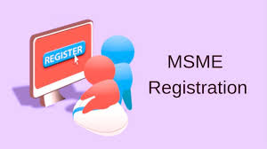

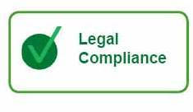
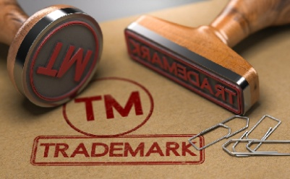


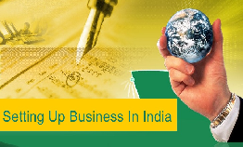
To know more, visit our website: http://www.sigmalegal.in/

Disclaimer: The contents of the above article are based on the personal interpretation of the prevalent law, which may differ from person to person. The laws stated therein have been derived from various legal documents and sources e.g., Bare Acts, Rules, Regulations etc. The laws stated in Article are subject to amendments and notification made by the legislative authorities or departments. We have tried to compile the best updated information available and every effort has been taken to avoid errors, still we will not be responsible for any consequences of any action taken based solely on this article. Hence, the readers are expected to take expert opinion before placing reliance on this article. All Copyrights, IPR and Proprietary rights owned and reserved by Sigma Legal Group.

