- Meaning and definition – As per the MSMED (Micro, Small and Medium Enterprises) ACT-2006 there are two classes of MSME which are as follows -
- Manufacturing Enterprises – These are the enterprises which are engaged in the production and manufacturing of goods and merchandise or help in value addition in the final product by employing plant and machinery.
- Service Enterprises- These is the enterprises engaged in rendering or providing services, the categorization of the enterprises are based on the investment in the plant and machinery.

- Classification of Micro, Small and Medium Enterprises – This classification has been amended by the finance minister Mrs. Nirmala Sitharaman in the latest stimulus of 3lakhs crores announced on 13th May, 2020.
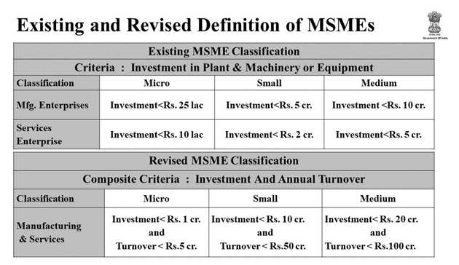

- Contribution in the Indian Economy –It contributes significantly in terms of economic growth and GDP of the country. Some of the contributions made by the MSME sector in the economy are -:
- Contribution in country GDP- With more than 36.1 million units throughout the country, MSME contribute 6.11% of the manufacturing GDP and 24.63% of the service sector GDP.
- Contribution in Exports- MSME sector contributes around 45% of overall exports of the country.
- Employment generation- This sector provide large employment opportunities in the country , this sector is the second most employment generating sector in country providing employment to around 120millions people.

- Benefits for MSME- There are many benefits of taking registration as MSME these are as follows -:
- Loans from banks are to be taken at a cheaper rate of interest that is interest benefit of up to 2%. Also collateral free loans up to Rs 50 lakhs is to provide to these enterprises.
- Various Tax rebates are also to be offered by the government from time to time.
- Many Government tenders are only open for the enterprises having registration as MSME
- The expenses for registrations of the patent and taking several marks of the ISO are to be reimbursed to these enterprises subject to the limits.
- Get easy access to the credit
- There is scheme of MSME Samadhaan under which these enterprises get protection against the credit terms as maximum 45 days credit is allowed for buyer, and default in payment within 45 days leads to the interest implication at the rate specified from time to time.

- Registration Procedure- To register as MSME here is the brief process you must follow these are -:

- Documents required- Here are the list of documents required these are as follows -:
    - Business Address Proof
    - Copy of Sale and Purchase bill
    - Deed of Partnership in case of partnership business , in case of companies one must require to upload MOA( Memorandum of Association) and AOA( Articles Of Association)
    - Bills of purchase of plant and machinery and copy of licenses if taken.

- Procedure for Registration- To register as MSME one has to follow the under mentioned process-:
    - Step 1- The person has to furnish the application online on www.udyogaadhaar.gov.in

    - Step 2- Then fill the Aadhaar number and Name of the Entrepreneur of the proprietor, director or partner as the case may be and then click on Validate and Generate OTP as given in the screenshot below-:

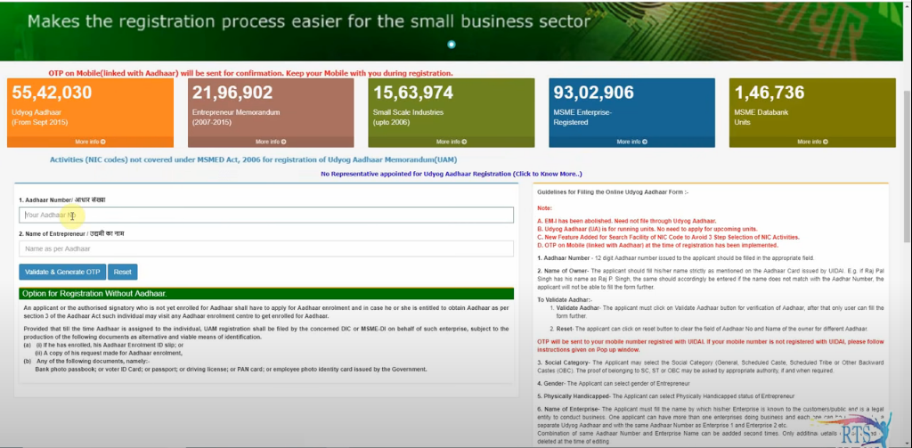

    - Step 3-After completing the second step validate the OTP , after successful validation of the OTP full application is opened on the screen , then you have to full the required details the interface of the form opened after validation is as below -:

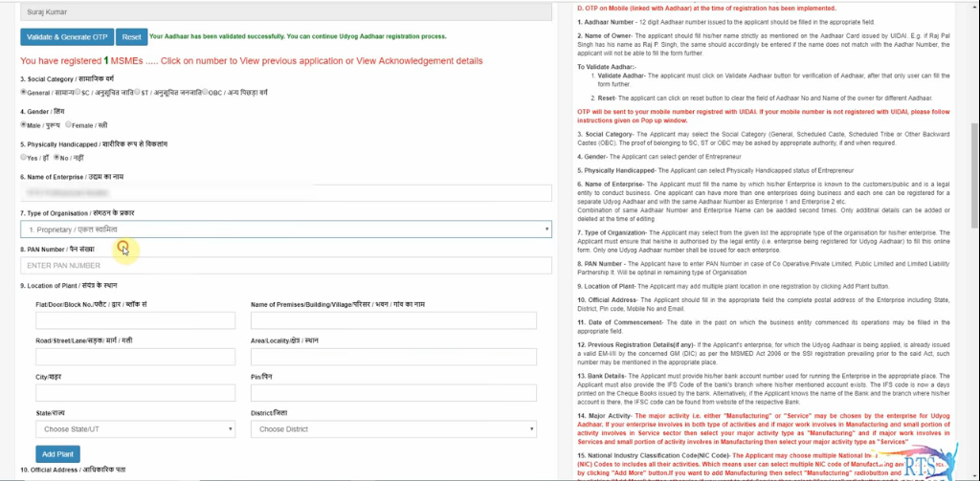

    - Step 4- After filling all the details required in the form then person need to submit the application after submitting the application one OTP is send to your number , then enter the OTP received and the verification code shown on the screen for final submission as shown in the screenshot below-: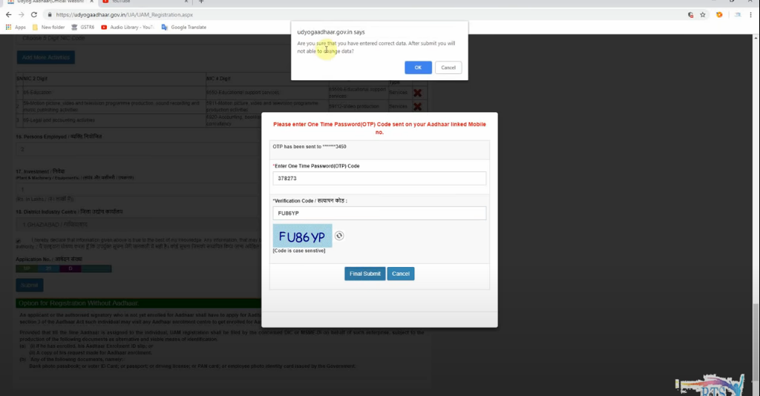

    - Step 5-After Final Submission you will receive UAM Number and Certificate of MSME registration which would be same as shown in the figure-: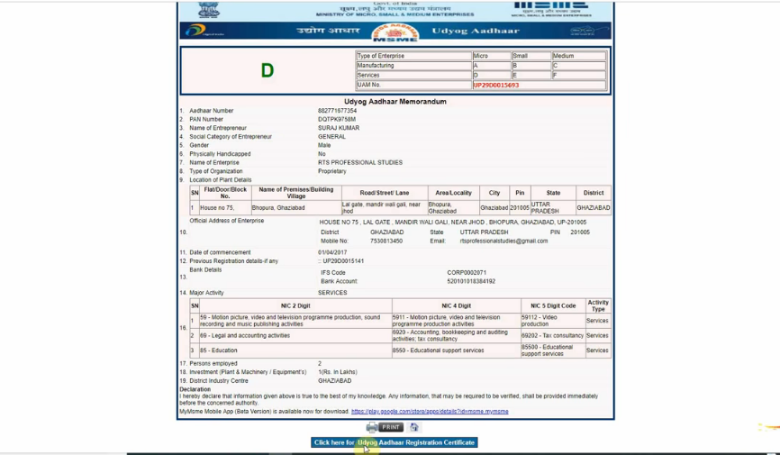

- Government Schemes for MSME- Here is the list of different schemes launched by the government for doing ease of business for the enterprises registered as MSME these are -:

- MSME Samadhaan- For giving MSME’s securities against the sale made on credit basis, here 45 days credit is allotted to the buyer for payment default of which will lay burden of compound interest on the buyer which is equal to three times the RBI rate.

- Udyami Mitra Portal- To give easy access of credit and to improve the flow of credit to the MSME this scheme is launched by SIDBI in 2017.

- Credit Linked Capital Subsidy Scheme (CLCSS) – This scheme is launched in order to promote the technological advancement in the country .In this scheme enterprises are given capital subsidy by the government for up gradation of their technology.
- UDYOG AADHAAR-: Any owner of MSME having AADHAAR card can register under this scheme. But this scheme is now merged with MSME scheme as person registering under this scheme is to be considered to be registered under MSME also and can avail all the benefits related to Udyog Aadhaar scheme.

- Zero Defect Zero Effect- Under this scheme the enterprises registered under MSME get concessions and rebate some of which are-: 0.5% concession in the loan interest rate, Rs. 25 Lakhs for adopting the technology, Rs. 10 Lakhs for registration of domestic patent, Extra 80%, 60% and 50% subsidy on the ZED certification over and above the subsidy provided by the government etc. This scheme benefits are availed on basis of state policies .

- Women Entrepreneurship- To encourage women to start their own business this scheme is launched. Under this scheme the government will provide capital , training, counseling and delivery methods and techniques to these women so that they could effectively manage their business and expand it in the future.

