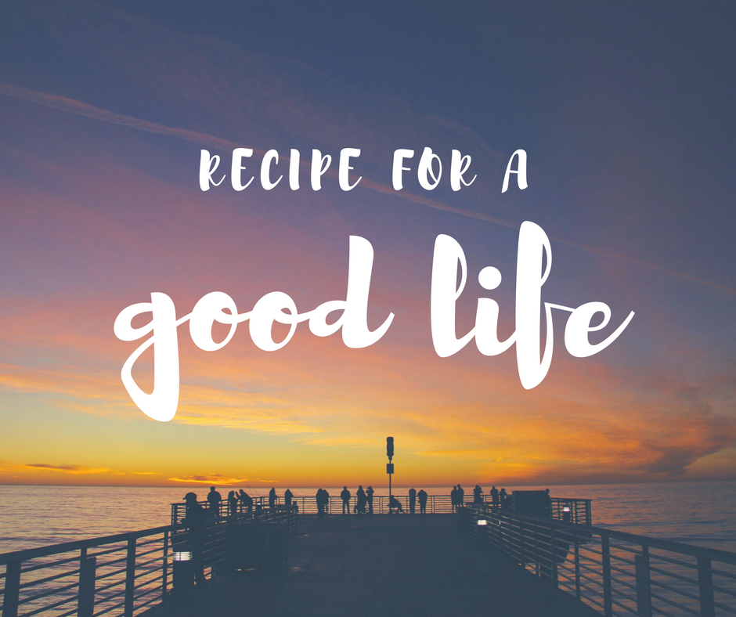

Hello Everyone,
“RECIPE FOR A GOOD LIFE” quite interesting title, right?
Don’t worry this article is not about any food. This article is about small things or acts everyone should do in order to have a better or you can say quality life. Everyone have same 24 hours in a day, but some spend it like they are there is no greater suffering than living it whereas some spend it like it’s the best day of their life.
The perception we have of things that happen to is different for each of us. It’s like looking at half-filled glass of water; some people will say it’s “Half-filled” while some people will say it’s “Half-empty” and some may say “Let’s just drink the water and end the argument”.
Below is short list of tips that can help us all on the road to a happier, healthier and better life. Including them in your everyday activities will surely enhance and improve you and quality of your life. Some of them are easy to do, some can be done only with well-founded commitment towards improvement of yourself.
Here we go then:
- Read books.
- Always keep a Journal/Diary.
- Always plan or schedule your week.
- Note down 5 highest priorities of your life.
- Have a vision for your life. Write it down and read it daily.
- Have a set of values and live by them.
- Be passionate.
- Always talk with love.
- Be the best person you know.
- Always make good first Impressions.
- Be a great teammate.
- Stop comparing yourself with others.
- Learn how to say no without guilt.
- Exercise daily.
- Always Smile at Children.
- Wake up early.
- Keep a hobby.
- Say sorry for own mistakes.
- Thank everyone who’ve helped you in any way.
- Make friends and be honest with them.
- Don’t rely too much on others.
- Remember people’s name.
- Do all of the above in some sort of order on a regular basis.

I hope you find it interesting and quite useful. Do try it. This is just a short list you can add many others that you feel are as good as these.

