Disquisition- Startup India Initiative

STARTUP INDIA INITIATIVE BY DEPARTMENT OF INDUSTRIAL POLICY & PROMOTION, MINISTRY OF COMMERCE & INDUSTRY, GOVERNMENT OF INDIA.

• MISSION

“Startup India Initiative is designed to foster innovation, create jobs and facilitate investment. Government is committed to make this initiative a scalable reality and to improve an environment for our startups to thrive in”- Smt. Nirmala Sitharaman, Minister of State for Commerce & Industry.

• STARTUP RECOGNITION

Under the Start-up India Action Plan, start-ups that meet the definition as prescribed under the G.S.R. notification 180 (E), are eligible to apply for recognition under the program. The Start-ups have to provide support documents, at the time of application.

EXTRACT OF G.S.R. NOTIFICATION 180(E) DATED 17 FEBRUARY 2016
MINISTRY OF COMMERCE AND INDUSTRY
(Department of Industrial Policy and Promotion)

G.S.R. 180(E)-The Government of India has announced 'Start-up India' initiative for creating a conducive environment for start-ups in India. The various Ministries of the Government of India have initiated a number of activities for the purpose. To bring uniformity in the identified enterprises, an entity shall be considered as a 'start-up'-

a) Up to five years from the date of its incorporation/registration,
b) If its turnover for any of the financial years has not exceeded Rupees 25 crore, and
c) It is working towards
Innovation | Development | Deployment or | Commercialization of:-
New products, processes or services driven by technology or intellectual property;

What is Intellectual Property?
Intellectual property (IP) refers to creations of the mind, such as inventions; literary and artistic works; designs; and symbols, names and images used in commerce.
• Provided that any such entity formed by splitting up or reconstruction of a business already in existence shall not be considered a 'start-up';

• Provided further that in order to obtain tax benefits a start-up so identified under the above definition shall be required to obtain a certificate of an eligible business from the Inter-Ministerial Board of Certification consisting of:
a) Joint Secretary, Department of Industrial Policy and Promotion,
b) Representative of Department of Science and Technology, and
o) Representative of Department of Biotechnology.

Disquisition- Startup India Initiative

STARTUP INDIA INITIATIVE BY DEPARTMENT OF INDUSTRIAL POLICY & PROMOTION, MINISTRY OF COMMERCE & INDUSTRY, GOVERNMENT OF INDIA.

Explanation:

- An entity shall cease to be a start-up on completion of five years from the date of its incorporation/registration or if its turnover for any previous year exceeds Rupees 25 crore.

- Entity means a private limited company (as defined in the Companies Act, 2013), or a registered partnership firm (registered under section 59 of the Partnership Act, 1932) or a limited liability partnership (under the Limited Liability Partnership Act, 2002).

- Turnover is as defined under the Companies Act, 2013.

- An entity is considered to be working towards innovation, development, deployment or commercialization of new products, processes or services driven by technology or intellectual property if it aims to develop and commercialize:

a. A new product or service or process, or
b. A significantly improved existing product or service or process that will create or add value for customers or workflow.

Provided that the mere act of developing:
- products or services or processes which do not have potential for commercialization, or
- undifferentiated products or services or processes, or
- Products or services or processes with no or limited incremental value for customers or workflow would not be covered under this definition.

- The process of recognition as a 'start-up' shall be through mobile app/portal of the Department of Industrial Policy and Promotion. Start-ups will be required to submit a simple application with any of following documents:
a) A recommendation (with regard to innovative nature of business), in a format specified by Department of Industrial Policy and Promotion, from any Incubator established in a postgraduate college in India; or
b) A letter of support by any incubator which is funded (in relation to the project) from Government of India or any State Government as part of any specified scheme to promote innovation; or
c) A recommendation (with regard to innovative nature of business), in a format specified by Department of Industrial Policy and Promotion, from any incubator recognized by Government of India; or
d) A letter of funding of not less than 20 per cent in equity by any Incubation Fund,/Angel Fund/Private Equity Fund/Accelerator/Angel Network duly registered with Securities and Exchange Board of India that endorses innovative nature of the business. Department of Industrial Policy and Promotion may include any such firm in a negative list for such reasons as it may deem fit; or
e) A letter of funding by Government of India or any State Government as part of any specified
Scheme to promote innovation; or

Disquisition- Startup India Initiative

STARTUP INDIA INITIATIVE BY DEPARTMENT OF INDUSTRIAL POLICY & PROMOTION, MINISTRY OF COMMERCE & INDUSTRY, GOVERNMENT OF INDIA.

f) A patent filed and published in the Journal by the Indian Patent Office in areas affiliated with
the nature of business being promoted.

For more information on recognition, please visit http://startupindia.gov.in/startup-recognition.php

• INCENTIVES TO START-UPS

√ 100% Income tax exmption of three years u/s 80-1ac of income tax act, 1961.

Section - 80-IAC, Income-tax Act, 1961

(1)Where the gross total income of an assessee, being an eligible start-up, includes any profits and gains derived from eligible business, there shall, in accordance with and subject to the provisions of this section, be allowed, in computing the total income of the assessee, a deduction of an amount equal to one hundred per cent of the profits and gains derived from such business for three consecutive assessment years.
(2) The deduction specified in sub-section (1) may, at the option of the assessee, be claimed by him for any three consecutive assessment years out of ⁶³[five] years beginning from the year in which the eligible start-up is incorporated.
(3) This section applies to a start-up which fulfils the following conditions, namely:—
(i) it is not formed by splitting up, or the reconstruction, of a business already in existence:
Provided that this condition shall not apply in respect of a start-up which is formed as a result of the re-establishment, reconstruction or revival by the assessee of the business of any such undertaking as referred to in section 33B, in the circumstances and within the period specified in that section;
(ii) it is not formed by the transfer to a new business of machinery or plant previously used for any purpose.
Explanation 1.—For the purposes of this clause, any machinery or plant which was used outside India by any person other than the assessee shall not be regarded as machinery or plant previously used for any purpose, if all the following conditions are fulfilled, namely:—
(a) such machinery or plant was not, at any time previous to the date of the installation by the assessee, used in India;
(b) such machinery or plant is imported into India;
(c) no deduction on account of depreciation in respect of such machinery or plant has been allowed or is allowable under the provisions of this Act in computing the total income of any person for any period prior to the date of the installation of the machinery or plant by the assessee.

Disquisition- Startup India Initiative

STARTUP INDIA INITIATIVE BY DEPARTMENT OF INDUSTRIAL POLICY & PROMOTION, MINISTRY OF COMMERCE & INDUSTRY, GOVERNMENT OF INDIA.
Explanation 2.—Where in the case of a start-up, any machinery or plant or any part thereof previously used for any purpose is transferred to a new business and the total value of the machinery or plant or part so transferred does not exceed twenty per cent of the total value of the machinery or plant used in the business, then, for the purposes of clause (ii) of this sub-section, the condition specified therein shall be deemed to have been complied with.
(4) The provisions of sub-section (5) and sub-sections (7) to (11) of section 80-IA shall apply to the start-ups for the purpose of allowing deductions under sub-section (1).
Explanation. For the purposes of this section,—

- "Eligible business" means a business which involves innovation, development, deployment or commercialisation of new products, processes or services driven by technology or intellectual property;

(ii) "Eligible start-up" means a company or a limited liability partnership engaged in eligible business which fulfils the following conditions, namely:—
(a) It is incorporated on or after the 1st day of April, 2016 but before the 1st day of April, 2019;
(b) The total turnover of its business does not exceed twenty-five crore rupees in any of the previous years beginning on or after the 1st day of April, 2016 and ending on the 31st day of March, 2021; and
(c) It holds a certificate of eligible business from the Inter-Ministerial Board of Certification as notified in the Official Gazette by the Central Government;

(iii) "limited liability partnership" means a partnership referred to in clause (n) of sub-section (1) of section 2 of the Limited Liability Partnership Act, 2008 (6 of 2009).]

Disquisition- Startup India Initiative

STARTUP INDIA INITIATIVE BY DEPARTMENT OF INDUSTRIAL POLICY & PROMOTION, MINISTRY OF COMMERCE & INDUSTRY, GOVERNMENT OF INDIA.
√ OTHER BENEFITS

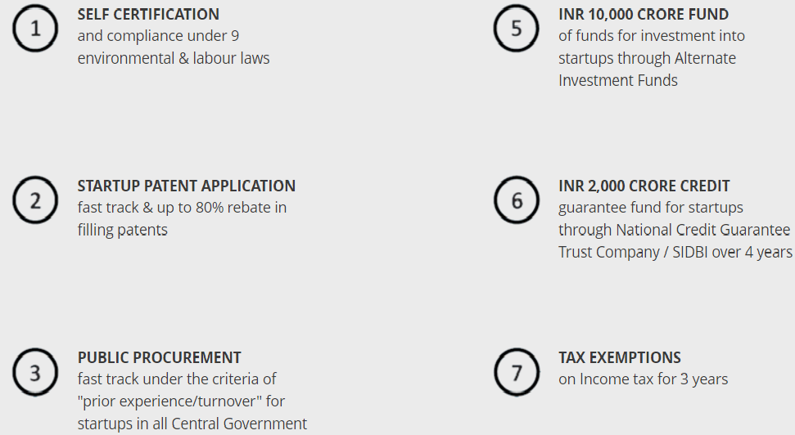

• INCUBATOR RECOGNITION
In order to avail the benefits announced in the Startup India Action Plan, an entity would be required to be recognized as a Startup. To this effect, it would be required to submit an application along with a relevant recommendation/ support/ endorsement letter. One of the options available to the registering entities is to obtain a recommendation letter from any incubator recognized by Government of India.
Incubator Recognition is provided under the Startup India initiative to recognize and identify incubators that are eligible to provide the said recommendation letter. This would enable Startups to access a wider base of incubator(s) to obtain the same.
For more information on guidelines, application & validation please visit:-
http://startupindia.gov.in/incubator-recognition.php

Disquisition- Startup India Initiative

STARTUP INDIA INITIATIVE BY DEPARTMENT OF INDUSTRIAL POLICY & PROMOTION, MINISTRY OF COMMERCE & INDUSTRY, GOVERNMENT OF INDIA.

• ADVERTISEMENT
Startup India is a flagship initiative of the Government of India, intended to build a strong eco-system for nurturing innovation and Startups in the country. Under this initiative a Startup India Portal has been set up which shall serve as a platform for facilitation of Startup recognition, access to information related to incubators, mentors, Angel Funds, Venture Funds etc.
As a step ahead, we are looking forward to provide advertisement space for Startups on the Startup India portal. If you are a Startup and wish to advertise your product/ services with us, send us the requisite information in the format prescribed below.
Advertise with us

http://startupindia.gov.in/advertisement.php

• REQUEST FOR STARTUP INDIA LOGO
http://startupindia.gov.in/startup-logo-details.php

STARTUP LEARNING CENTRE (To educate & Train yourself)

http://startupindia.gov.in/learning-development/

SOURCE OF INFORMATION:-http://startupindia.gov.in

In case of any query,

- Contact me :-
pradeepgoyal@kcsassociates.in
Mobile:-+91-9811777103

- You can also Contact at :-

Start-up India Hub
Toll Free Number: 1800115565 Working Hours: 10:00 AM to 5:30 PM (Monday to Friday)
Email: dipp-startups@nic.in
Or write at http://startupindia.gov.in/contact.php

Disquisition- Startup India Initiative

STARTUP INDIA INITIATIVE BY DEPARTMENT OF INDUSTRIAL POLICY & PROMOTION, MINISTRY OF COMMERCE & INDUSTRY, GOVERNMENT OF INDIA.

- You can contact at below twitter handles also:-

https://twitter.com/DIPPGOI
https://twitter.com/CimGOI
https://twitter.com/EODB_India
https://twitter.com/rabhishek1982
https://twitter.com/nsitharaman
https://twitter.com/PradeepGoyalCA

TO FIND OUT HOW TO WRITE A BUSINESS PLAN, VISIT:-

http://www.bplans.com/sample_business_plans.php

LINK TO GET IDEA ABOUT CREATION OF FINANCIAL PROJECTION:-

http://quickbooks.intuit.com/r/business-planning/how-to-create-financial-projections-for-your-startup/

